RepRequest
Architecture, Software Design and Requirements Specification
A multi-tenant maintenance and repair-request platform for company-owned machinery
Contents
1. System overview
2. Diagram 1 — Project Architecture Diagram
3. Diagram 2 — Software Design Diagram (2a classes · 2b state machine)
4. Diagram 3 — Perspective Model Diagram (3a context · 3b/3c sequence)
5. Functional requirements
6. Non-functional requirements
7. Requirement summary and traceability

1. System overview
RepRequest is a web application that a machine-shop owner buys, registers for, and then runs for their own company. Each company gets its own isolated space inside one shared deployment. An owner registers the company and becomes its Company Administrator; the administrator then creates Crew Employee and Technician accounts for their staff.
The working loop the product exists to support is short. A crew member standing at a broken CNC machine scans the QR label on that machine with their phone. The scan opens a form that already knows which machine it is, so the employee only chooses a severity — low, medium or high — and describes the problem. Submitting that form places a repair request into the company's repair queue. A technician works the queue: claiming a request, moving it from Action Needed to In Progress, and finally to Repair Complete or Down. Before a request can be closed the technician files a maintenance log — what was done, which parts were used, how long it took — and that log is kept permanently against the machine, so anyone can later read the machine's full service history.

1.1 What exists today
The Flask application factory, the database schema and its Alembic migrations, the Company and User models, the three-role system, company registration, login and logout, and the full administrator workflow for creating, editing, listing and deleting employees are all implemented and covered by a pytest suite. That suite includes explicit security tests proving that one company's administrator cannot reach another company's employees and that a non-administrator receives HTTP 403 on administrator routes. Accounts are currently created with a temporary password typed by the administrator; the front end is plain HTML with no stylesheet yet.

1.2 What is planned
The machine registry and its QR tokens, repair-request submission, the technician repair queue and its state machine, maintenance logs and machine history, e-mailed temporary passwords and forced password change, and a CSS layer for the front end. Throughout the three diagrams that follow, solid blue marks what is implemented today and dashed amber marks what is planned.

1.3 Technology stack
Language and framework — Python 3 · Flask (application-factory pattern, Blueprints)
Persistence — Flask-SQLAlchemy ORM · Flask-Migrate / Alembic migrations · SQLite in development, PostgreSQL planned for production
Identity — Flask-Login for authentication · a project authorization module of role decorators for authorisation · Werkzeug PBKDF2 password hashing
Presentation — Jinja2 templates organised per feature; a CSS layer is planned
Testing — pytest with an in-memory SQLite database and a per-test application fixture

2. Diagram 1 — Project Architecture Diagram
Four views in one picture. Logical: the four horizontal layers, each of which may call only the layer below it. Physical: the three tiers — browsers, one Flask application server, one shared database. Process: the note at the top of Tier 2. Development: the footnote — one Blueprint package, service, model and template folder per feature, which is what lets several people add features in parallel without merge conflicts. The red column holds the concerns that cut across every layer at once.
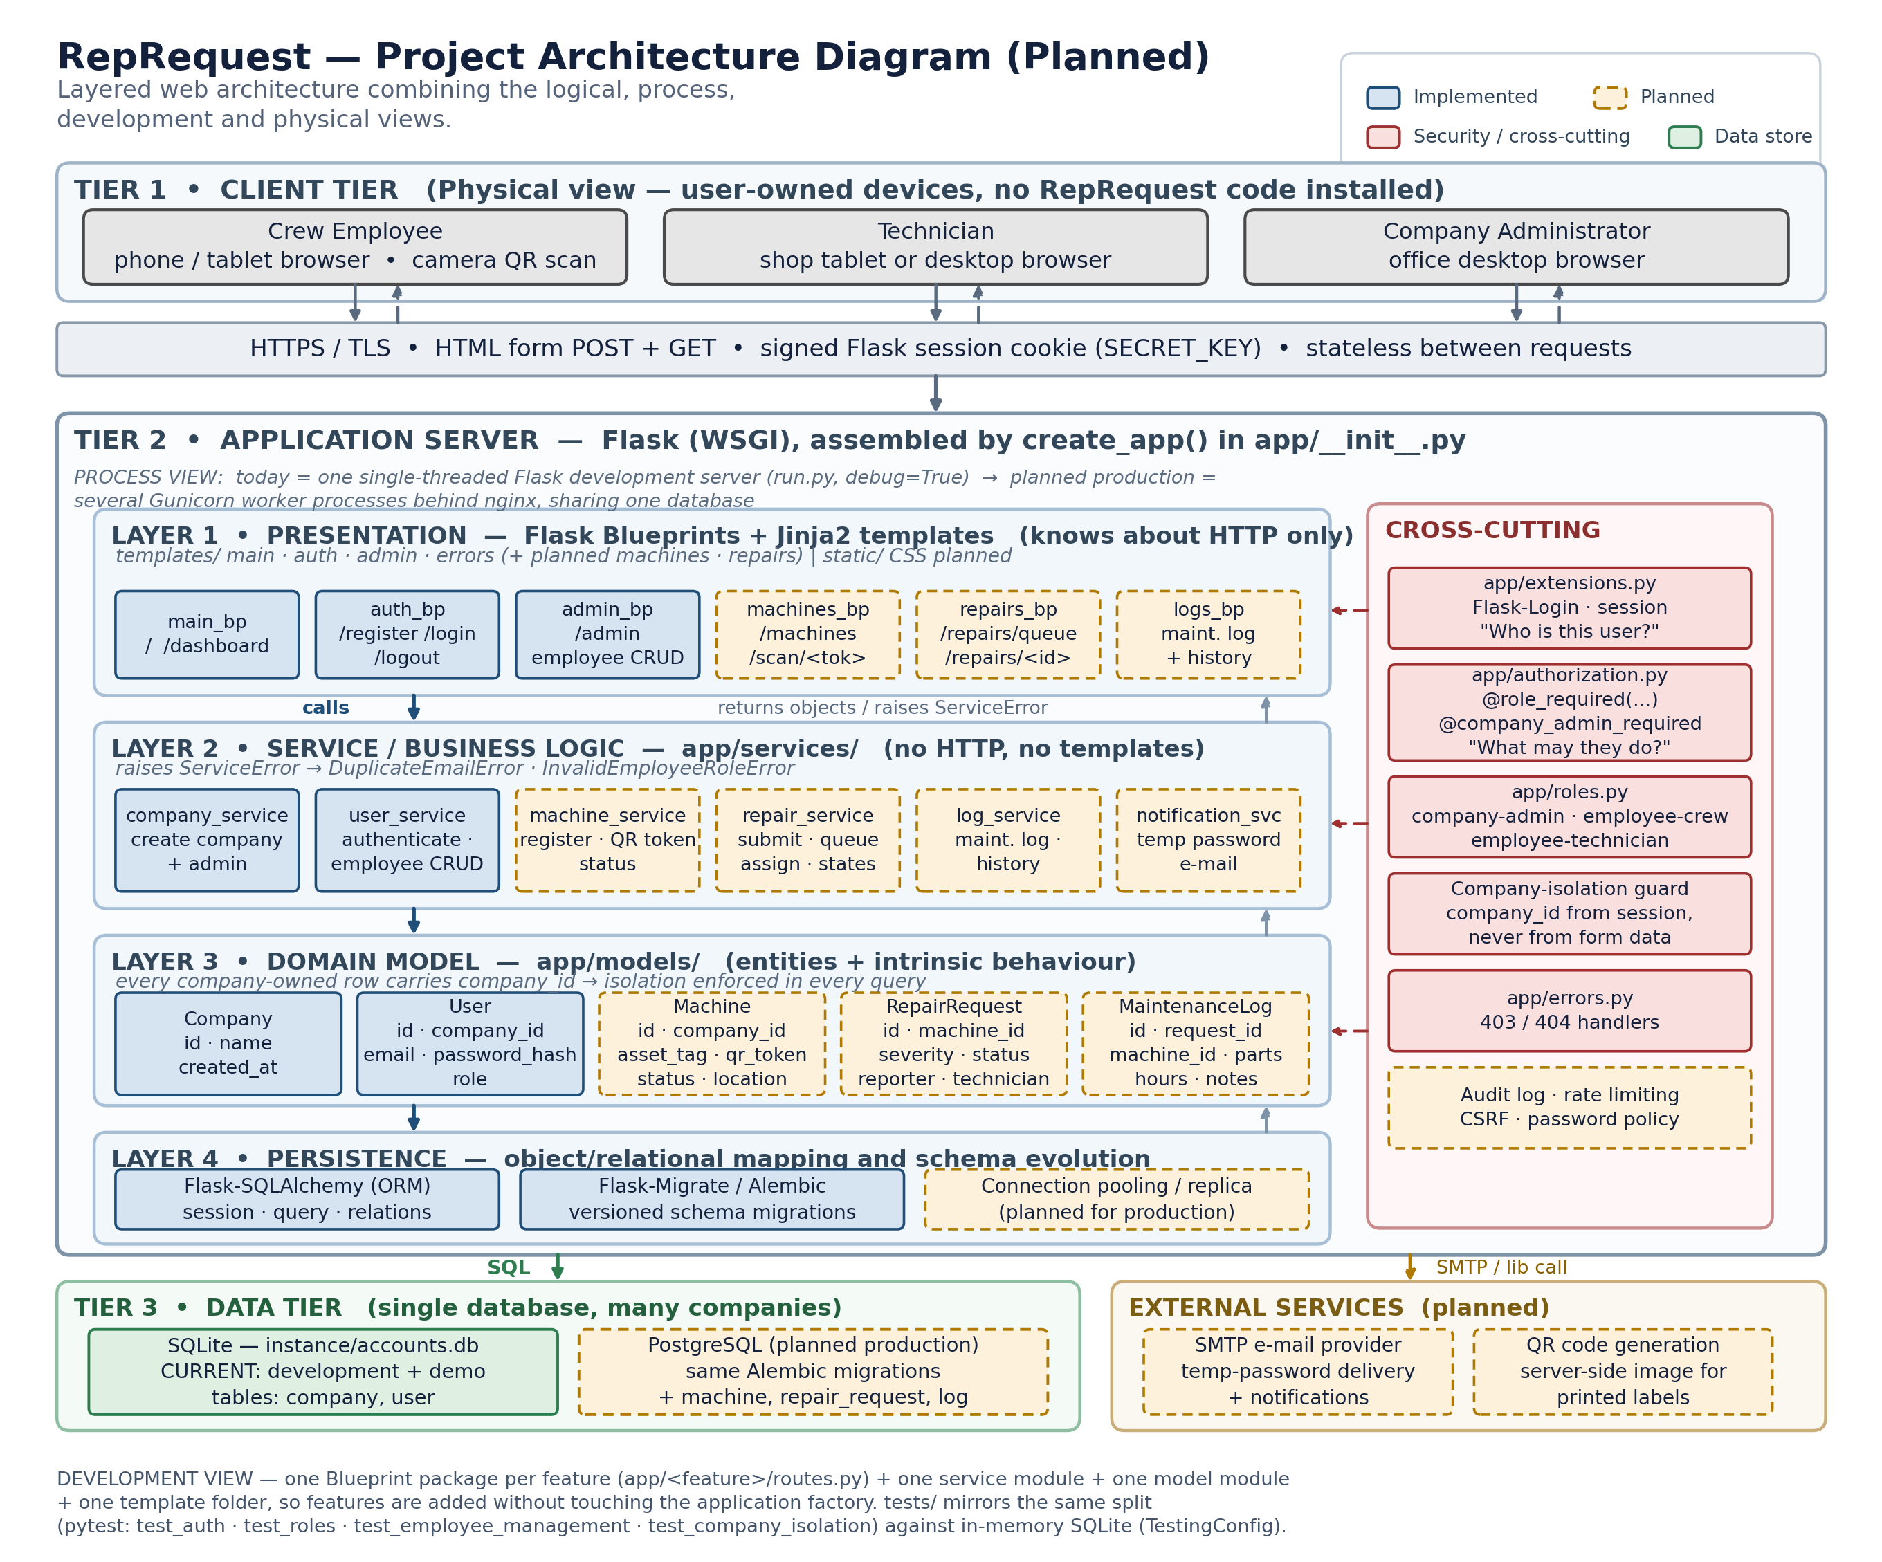

3. Diagram 2 — Software Design Diagram (2a classes · 2b state machine)
Diagram 2a shows how the code is organised: what each Blueprint exposes, what each service provides, the attributes and behaviour of each entity, and the associations between entities. The right-hand column holds the supporting modules and the service-layer exception hierarchy — services raise the error, routes decide how it is presented, so a rule is never written twice. Diagram 2b, on the next page, is the state machine that governs a repair request.
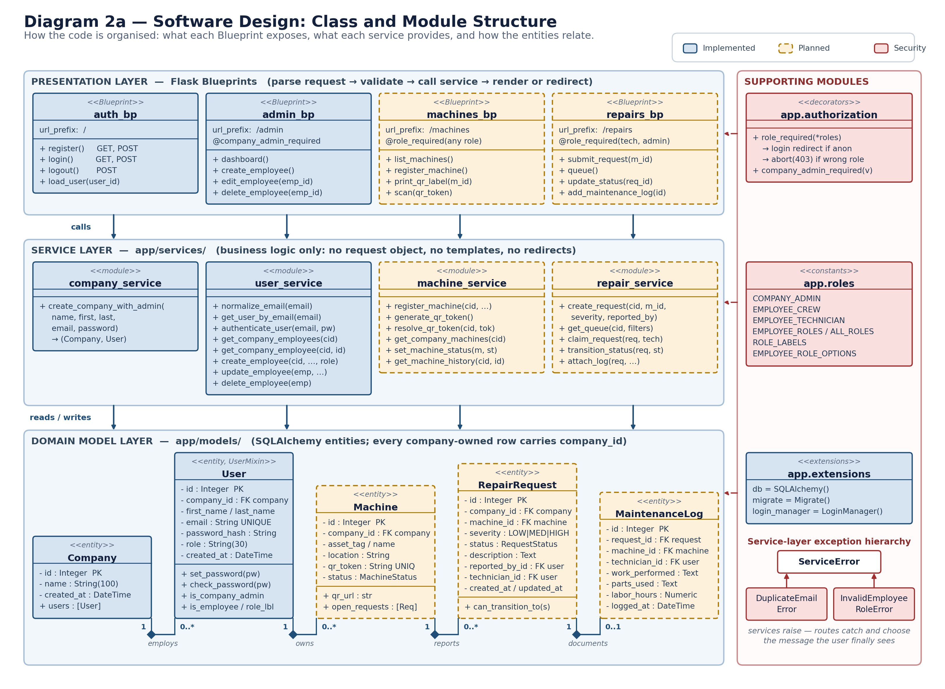

3.1 Diagram 2b — RepairRequest state diagram
A repair request may only move along the transitions drawn here, and repair_service.transition_status() rejects anything else without changing stored data. A request cannot reach Repair Complete until a maintenance log has been filed, and a completed request is never re-opened — a recurring fault raises a new request, so the machine accumulates a complete and unedited service history.
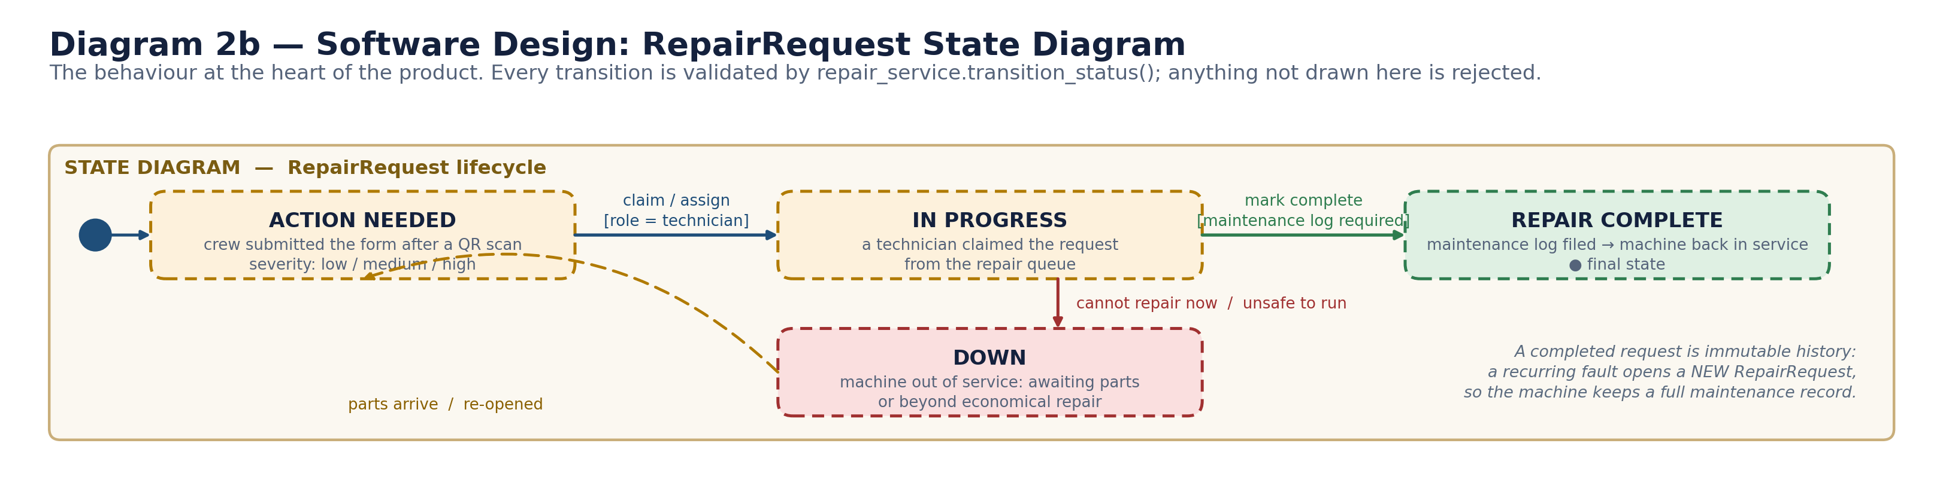

A combined single-page version of Diagram 2, showing the class structure and the state machine together, is supplied as diagram2_design.png alongside this document.

4. Diagram 3 — Perspective Model Diagram (3a context · 3b/3c sequence)
Two perspectives on the same system. Diagram 3a below is the external / context and data-flow view: who sits outside the system boundary, what data each of them pushes across it, which stores sit behind it, and the one planned external service. Diagrams 3b and 3c on the following pages are the interaction view — a sequence diagram of the complete primary scenario, split into the two phases it naturally has.
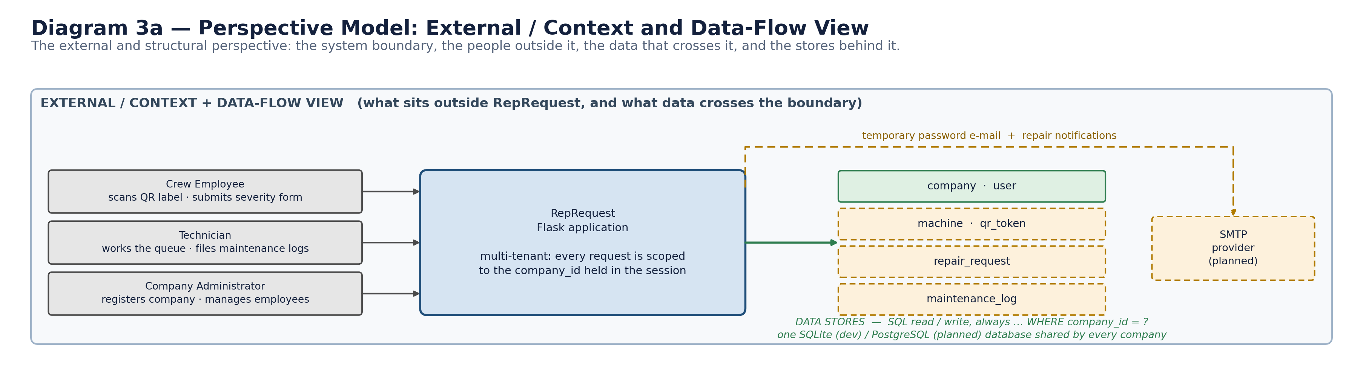

4.1 Diagram 3b — Interaction view, phase 1: a crew employee reports a fault
Read left to right, this also shows the layer discipline from Diagram 1 in motion: the Blueprint never touches the database directly, and the company_id used in every query comes from the session rather than from anything the browser sent. A QR token belonging to another company resolves to nothing, so the response is an ordinary 404 rather than a message that confirms the machine exists.
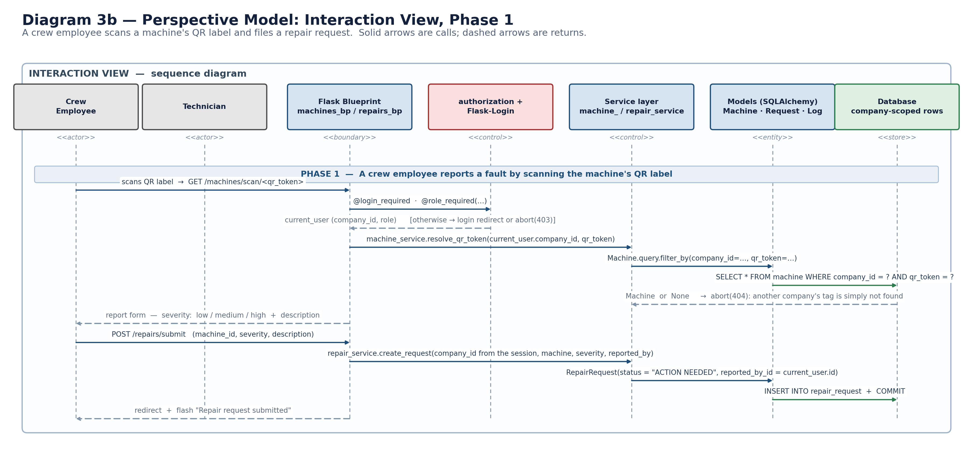

4.2 Diagram 3c — Interaction view, phase 2: a technician works the queue
The technician half of the scenario, ending with the maintenance log and machine-status update committed in a single transaction so that a machine can never be marked operational without the log that justifies it.
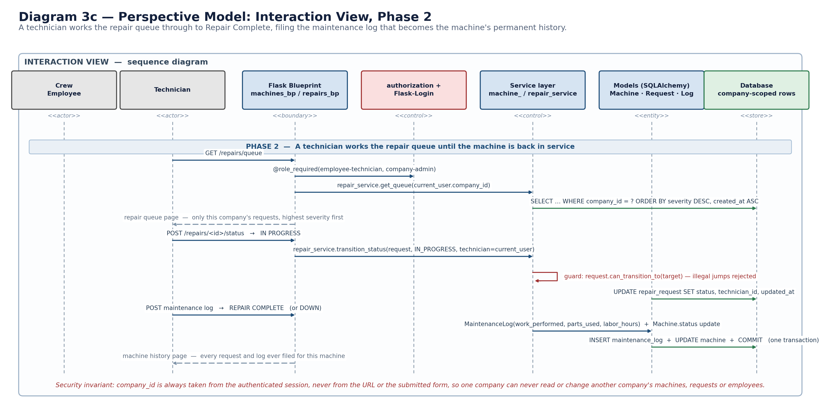

A combined single-page version of Diagram 3, showing the context view and the full sequence together, is supplied as diagram3_perspective.png alongside this document.

5. Functional requirements
What the system must do. Each requirement is marked Implemented where it is already working in the current codebase and covered by the test suite, or Planned where it is part of the design but not yet built.

FR-1 Company account and administrator registration
ID | Requirement | Status
FR-1.1 | The system shall let a company owner self-register a company by supplying a company name, first name, last name, e-mail address and password on the /register page. | Implemented
FR-1.2 | On registration the system shall create exactly one Company record and one User record with the role company-admin, linked by company_id, inside a single database transaction. | Implemented
FR-1.3 | The system shall reject a registration whose e-mail address already belongs to any existing account and shall redisplay the form with the message "An account with that email already exists." | Implemented
FR-1.4 | The system shall reject a registration in which any required field is blank and shall redisplay the form with the message "All fields are required." | Implemented
FR-1.5 | The system shall normalise every e-mail address to lower case and trim surrounding whitespace before storing or searching for it. | Implemented
FR-1.6 | The system shall support a paid subscription per company, including a plan tier, billing contact and subscription state that gates access to the application. | Planned

FR-2 Authentication and session management
ID | Requirement | Status
FR-2.1 | The system shall authenticate a user from an e-mail address and password on the /login page and shall establish a server-side session on success. | Implemented
FR-2.2 | The system shall return the single message "Invalid email or password." for both an unknown e-mail address and a wrong password, so that valid e-mail addresses cannot be enumerated. | Implemented
FR-2.3 | The system shall redirect an already-authenticated user who requests /login to the dashboard rather than presenting the login form again. | Implemented
FR-2.4 | The system shall end the session on a POST to /logout and redirect the user to the login page. Logout shall not be reachable by GET. | Implemented
FR-2.5 | The system shall redirect an unauthenticated user who requests a protected page to the login page. | Implemented
FR-2.6 | The system shall allow an authenticated user to change their own password by supplying the current password and a new password twice. | Planned
FR-2.7 | The system shall mark an account created by an administrator as holding a temporary password and shall force that user to set a new password before any other page becomes available. | Planned
FR-2.8 | The system shall provide a self-service "forgot password" flow that e-mails a single-use, time-limited reset link. | Planned

FR-3 Employee management by the company administrator
ID | Requirement | Status
FR-3.1 | The system shall let a company administrator view a list of the employee accounts belonging to their own company, ordered by last name then first name. | Implemented
FR-3.2 | The employee list shall exclude company-administrator accounts and shall never include a user belonging to another company. | Implemented
FR-3.3 | The system shall let a company administrator create an employee account by supplying first name, last name, e-mail address, an initial password and a role. | Implemented
FR-3.4 | When creating an employee the system shall take company_id from the authenticated administrator's session and shall ignore any company identifier present in the submitted form or URL. | Implemented
FR-3.5 | The system shall let a company administrator edit an existing employee's first name, last name, e-mail address and role. | Implemented
FR-3.6 | The system shall let a company administrator delete an employee account and shall confirm the deletion with a flash message naming the deleted employee. | Implemented
FR-3.7 | The system shall respond with HTTP 404 when an administrator requests, edits or deletes an employee identifier that does not exist, belongs to another company, or is not an employee account. | Implemented
FR-3.8 | The system shall reject an employee create or edit that would duplicate an e-mail address already held by another account. | Implemented
FR-3.9 | The system shall reject any role value that is not one of the defined employee roles. | Implemented
FR-3.10 | The system shall generate a random temporary password for a new employee and e-mail it to the employee's address instead of requiring the administrator to invent one. | Planned
FR-3.11 | The system shall let an administrator deactivate an employee account instead of deleting it, so that the employee's historical repair requests and maintenance logs remain attributable. | Planned

FR-4 Roles and authorisation
ID | Requirement | Status
FR-4.1 | The system shall support three roles: Company Administrator (company-admin), Crew Employee (employee-crew) and Technician (employee-technician). | Implemented
FR-4.2 | All role values, role groupings and human-readable role labels shall be defined in one module so that no role string is hard-coded elsewhere in the Python code. | Implemented
FR-4.3 | The system shall restrict every /admin route to users holding the company-admin role and shall return HTTP 403 to any other authenticated user. | Implemented
FR-4.4 | The system shall enforce authorisation on the server for every protected route. Hiding a link in a template shall never be the only control protecting a route. | Implemented
FR-4.5 | The system shall allow both crew employees and technicians to submit a repair request, and shall restrict claiming a request, changing its status and filing a maintenance log to technicians and company administrators. | Planned
FR-4.6 | The system shall allow a company administrator to perform every technician action, so that a small company can operate with a single account. | Planned

FR-5 Machine registry and QR codes
ID | Requirement | Status
FR-5.1 | The system shall let a company administrator register a machine with an asset tag, display name, location and machine type. | Planned
FR-5.2 | The system shall assign every machine a unique, non-guessable QR token on creation and shall associate that token with exactly one machine of exactly one company. | Planned
FR-5.3 | The system shall generate a printable QR label for a machine that encodes the URL /machines/scan/<qr_token>. | Planned
FR-5.4 | The system shall resolve a scanned QR token only within the authenticated user's company and shall respond with HTTP 404 when the token belongs to another company. | Planned
FR-5.5 | The system shall maintain a machine status of Operational, Action Needed, In Progress or Down and shall derive that status from the machine's open repair requests. | Planned
FR-5.6 | The system shall let an administrator edit and retire a machine without deleting its repair history. | Planned

FR-6 Repair request submission
ID | Requirement | Status
FR-6.1 | The system shall present a repair-request form immediately after a successful QR scan, without requiring the employee to search for the machine. | Planned
FR-6.2 | The repair-request form shall require a severity of Low, Medium or High and shall accept a free-text description of the problem. | Planned
FR-6.3 | The system shall create every repair request with the status Action Needed and shall record the machine, the severity, the reporting user and the creation timestamp. | Planned
FR-6.4 | The system shall take the company_id of a new repair request from the authenticated session, never from the submitted form. | Planned
FR-6.5 | The system shall confirm a successful submission with a flash message and shall return the employee to their dashboard. | Planned
FR-6.6 | The system shall allow an employee to attach one or more photographs of the fault to a repair request. | Planned

FR-7 Repair queue and technician workflow
ID | Requirement | Status
FR-7.1 | The system shall present technicians with a repair queue containing only their own company's open repair requests, ordered by severity (High first) and then by age. | Planned
FR-7.2 | The system shall let a technician filter and sort the queue by machine, severity, status and assigned technician. | Planned
FR-7.3 | The system shall let a technician claim a repair request, recording that technician as the assignee. | Planned
FR-7.4 | The system shall let a technician move a repair request between the statuses Action Needed, In Progress, Repair Complete and Down. | Planned
FR-7.5 | The system shall permit only the transitions defined in the repair-request state diagram and shall reject any other transition without changing stored data. | Planned
FR-7.6 | The system shall require a maintenance log to be filed before a repair request may be moved to Repair Complete. | Planned
FR-7.7 | The system shall record the acting user and a timestamp for every status change. | Planned
FR-7.8 | The system shall treat a Repair Complete request as immutable history; a recurring fault shall be raised as a new repair request. | Planned
FR-7.9 | The system shall let a technician reassign a request to a different technician in the same company. | Planned

FR-8 Maintenance logs and machine history
ID | Requirement | Status
FR-8.1 | The system shall let a technician file a maintenance log against a repair request recording the work performed, the parts used and the labour hours. | Planned
FR-8.2 | The system shall store every maintenance log against both the repair request and the machine, together with the filing technician and timestamp. | Planned
FR-8.3 | The system shall present a per-machine history page listing every repair request and every maintenance log ever recorded for that machine, newest first. | Planned
FR-8.4 | The system shall make the machine history readable by technicians and company administrators of the owning company only. | Planned
FR-8.5 | The system shall let a company administrator export a machine's history as a CSV or PDF file. | Planned

FR-9 Notifications
ID | Requirement | Status
FR-9.1 | The system shall e-mail a newly created employee their temporary password and a link to the login page. | Planned
FR-9.2 | The system shall notify technicians when a High-severity repair request is submitted for their company. | Planned
FR-9.3 | The system shall notify the reporting employee when their repair request reaches Repair Complete or Down. | Planned
FR-9.4 | A failure to send an e-mail shall not prevent the underlying operation from completing or roll back committed data. | Planned

FR-10 Dashboards, navigation and error handling
ID | Requirement | Status
FR-10.1 | The system shall present an authenticated user with a dashboard whose content and navigation reflect that user's role. | Implemented
FR-10.2 | The system shall render a dedicated, friendly page for HTTP 403 rather than a default server error page. | Implemented
FR-10.3 | The system shall register application-wide handlers for HTTP 403, 404 and 500 in one place rather than in each feature module. | Planned
FR-10.4 | The system shall show a company administrator a summary of machines currently in each status and the count of open repair requests by severity. | Planned

6. Non-functional requirements
Qualities the system must have rather than features it must provide: how secure, how reliable, how usable, how fast, how maintainable, how testable and how portable it has to be.

NFR-1 Security
ID | Requirement | Status
NFR-1.1 | Passwords shall never be stored or logged in plaintext. The system shall store only a salted hash produced by werkzeug.security.generate_password_hash and shall verify using check_password_hash. | Implemented
NFR-1.2 | Multi-tenant isolation: every query for a company-owned record shall be constrained by the company_id taken from the authenticated session. The system shall never trust a company identifier supplied in a URL, form field or cookie. | Implemented
NFR-1.3 | An attempt to reach another company's record shall be indistinguishable from the record not existing (HTTP 404), so that record identifiers cannot be probed. | Implemented
NFR-1.4 | Session cookies shall be cryptographically signed with a SECRET_KEY. In production the key shall be supplied by an environment variable and shall never be the development fallback value. | Implemented
NFR-1.5 | Authentication and authorisation shall remain separate concerns: Flask-Login answers who the user is; the authorization module answers what that user may do. | Implemented
NFR-1.6 | Every state-changing operation shall be reachable only by HTTP POST, so that it cannot be triggered by a link or a prefetched URL. | Implemented
NFR-1.7 | All traffic shall be served over HTTPS in production, with session cookies marked Secure, HttpOnly and SameSite=Lax. | Planned
NFR-1.8 | Every form that changes state shall carry a CSRF token that the server validates. | Planned
NFR-1.9 | The system shall enforce a minimum password length of 12 characters and shall reject passwords found in a common-password list. | Planned
NFR-1.10 | The system shall rate-limit login attempts per e-mail address and per source IP address to slow credential-stuffing attacks. | Planned
NFR-1.11 | QR tokens shall be generated from a cryptographically secure random source and shall be long enough that guessing a valid token is impractical. | Planned
NFR-1.12 | Debug mode shall be disabled in production and stack traces shall never be shown to end users. | Planned

NFR-2 Reliability and data integrity
ID | Requirement | Status
NFR-2.1 | Operations that touch more than one table shall be committed in a single transaction, so a partial company/administrator or request/log pair can never be persisted. | Implemented
NFR-2.2 | The database schema shall enforce its own constraints: non-null columns, foreign keys to company and user, and a unique constraint on e-mail address. | Implemented
NFR-2.3 | Schema changes shall be applied through versioned Flask-Migrate (Alembic) migrations that can be replayed on any environment, never by hand-editing a database. | Implemented
NFR-2.4 | Validation shall be enforced in the service layer as well as in the HTML form, so that a crafted request cannot bypass a client-side control. | Implemented
NFR-2.5 | Repair requests and maintenance logs shall be retained for the life of the machine record and shall survive the deletion or deactivation of the employee who created them. | Planned
NFR-2.6 | The production database shall be backed up daily with a documented, tested restore procedure. | Planned

NFR-3 Usability and accessibility
ID | Requirement | Status
NFR-3.1 | Reporting a fault shall take a crew employee no more than three interactions after the QR scan: choose severity, type a short description, submit. | Planned
NFR-3.2 | All pages shall be usable on a phone-sized screen, since crew employees scan QR codes at the machine. | Planned
NFR-3.3 | Severity and status shall be distinguishable by text and shape as well as by colour, so the interface remains usable for colour-blind users and in poor shop-floor lighting. | Planned
NFR-3.4 | Every error message shown to a user shall state what went wrong and what to do next; raw exception text shall never be shown. | Implemented
NFR-3.5 | Pages shall meet WCAG 2.1 Level AA for contrast, keyboard navigation, form labelling and focus order. | Planned
NFR-3.6 | A consistent stylesheet shall be applied across all templates so that the application presents one visual identity. | Planned

NFR-4 Performance and scalability
ID | Requirement | Status
NFR-4.1 | A page request under normal load shall complete server-side processing in under 500 ms at the 95th percentile. | Planned
NFR-4.2 | The repair queue shall remain responsive with at least 10,000 repair requests per company, using indexed columns and pagination rather than loading the whole table. | Planned
NFR-4.3 | Indexes shall exist on user.email, user.company_id, machine.qr_token, machine.company_id and repair_request.(company_id, status, severity). | Planned
NFR-4.4 | The application shall hold no per-user state in process memory, so that it can be run as several worker processes behind a load balancer. | Implemented
NFR-4.5 | The system shall support at least 200 companies and 50 concurrent users on a single application server. | Planned

NFR-5 Maintainability and modifiability
ID | Requirement | Status
NFR-5.1 | The application shall keep strict layer boundaries: routes know about HTTP, services know about business operations, models know about stored entities, templates know about presentation. | Implemented
NFR-5.2 | A service module shall never render a template or issue a redirect, and a route shall never contain reusable business logic or direct session commits. | Implemented
NFR-5.3 | The application shall be assembled by an application factory, so that a new feature can be added without editing shared start-up code beyond one Blueprint registration. | Implemented
NFR-5.4 | Each feature shall live in its own Blueprint package with its own service module, model module and template folder, to keep merge conflicts rare on a team project. | Implemented
NFR-5.5 | Business-rule failures shall be signalled by named service exceptions, so that a route decides how the failure is presented without duplicating the rule. | Implemented
NFR-5.6 | Architecture and contribution guidance shall be kept in the repository and updated whenever a structural decision changes. | Implemented

NFR-6 Testability
ID | Requirement | Status
NFR-6.1 | Business logic shall be callable and testable without simulating an HTTP request. | Implemented
NFR-6.2 | The automated test suite shall run against a temporary in-memory SQLite database and shall never read or modify the developer's instance/accounts.db. | Implemented
NFR-6.3 | Each test shall receive a freshly created and torn-down database, so tests can run in any order. | Implemented
NFR-6.4 | The suite shall include security regression tests proving that one company's administrator cannot view, edit or delete another company's employees, and that an employee receives HTTP 403 on administrator routes. | Implemented
NFR-6.5 | Every new feature shall ship with tests covering the success path, the validation-failure path and the authorisation-failure path. | Planned
NFR-6.6 | The test suite shall run automatically on every push through continuous integration, and a failing suite shall block merging. | Planned

NFR-7 Portability and deployability
ID | Requirement | Status
NFR-7.1 | All configuration that differs between environments shall be read from environment variables with development-only fallbacks. | Implemented
NFR-7.2 | The application shall run on SQLite for development and on PostgreSQL in production without source changes, by using the ORM rather than database-specific SQL. | Planned
NFR-7.3 | Runtime dependencies shall be pinned in a requirements file so that an identical environment can be rebuilt. | Planned
NFR-7.4 | Deployment shall be repeatable from a documented procedure: apply migrations, then start the WSGI server. | Planned

NFR-8 Auditability and traceability
ID | Requirement | Status
NFR-8.1 | Every record shall carry a creation timestamp. | Implemented
NFR-8.2 | Every repair-request status change shall record who made it and when, and that record shall not be editable through the user interface. | Planned
NFR-8.3 | Administrative actions on accounts — create, edit, delete, deactivate — shall be written to an audit log. | Planned
NFR-8.4 | Application logs shall never contain passwords, password hashes, session cookies or QR tokens. | Planned

NFR-9 Privacy and compliance
ID | Requirement | Status
NFR-9.1 | The system shall store only the personal data needed to operate the service: name, work e-mail address and role. | Implemented
NFR-9.2 | One company's staff shall never be able to see the existence, names or e-mail addresses of another company's staff. | Implemented
NFR-9.3 | A company shall be able to request export and deletion of its own data, and deletion shall remove or irreversibly anonymise personal data. | Planned
NFR-9.4 | The published data-retention period for repair and maintenance history shall be honoured by an automated process. | Planned

7. Requirement summary and traceability
Requirement class | Implemented | Planned | Total
Functional (FR-1 … FR-10) | 25 | 40 | 65
Non-functional (NFR-1 … NFR-9) | 26 | 27 | 53
All requirements | 51 | 67 | 118

7.1 Where each requirement class is realised
FR-1, FR-2 registration and authentication — auth_bp (app/auth/routes.py) → company_service.create_company_with_admin(), user_service.authenticate_user() → Company, User. Tested by tests/test_auth.py.
FR-3 employee management — admin_bp (app/admin/routes.py) → user_service.create/update/delete_employee(), get_company_employee() → User. Tested by tests/test_employee_management.py.
FR-4 roles and authorisation — app/roles.py defines the role values; app/authorization.py enforces them through @role_required and @company_admin_required. Tested by tests/test_roles.py.
FR-5, FR-6 machines, QR codes and request submission — Planned machines_bp and repairs_bp → machine_service, repair_service → Machine, RepairRequest. Shown in Diagrams 3b and 3c.
FR-7, FR-8 technician workflow and history — Planned repair_service.transition_status() enforcing the state machine in Diagram 2b, plus MaintenanceLog and the machine history page.
NFR-1.2, NFR-1.3 multi-tenant isolation — Every service query filters on the company_id read from current_user, and a miss returns HTTP 404. Tested by tests/test_company_isolation.py.
NFR-5 maintainability — The layer boundaries drawn in Diagram 1 and documented in docs/architecture.md; verified by code review on every change.
NFR-6 testability — tests/conftest.py builds a fresh application and in-memory database per test using TestingConfig.

