**Gurukula FV tests project**

1) Prerequisites:

1) Eclipse with Maven Plugin Installed  
If you don’t have maven plugin follow below steps:

1. Open Eclipse IDE
2. Click Help -> Install New Software...
3. Click Add button at top right corner
4. At pop up: fill up Name as "M2Eclipse" and Location as "<http://download.eclipse.org/technology/m2e/releases>" or <http://download.eclipse.org/technology/m2e/milestones/1.0>
5. Now click OK

After that installation, would be started.

Another way to install Maven plug-in for Eclipse:

1. Open Eclipse
2. Go to Help -> Eclipse Marketplace
3. Search by Maven
4. Click "Install" button at "Maven Integration for Eclipse" section
5. Follow the instruction step by step

After successful installation do the followings in Eclipse:

1. Go to Window --> Preferences
2. Observe, Maven is enlisted at left panel

Finally,

1. Click on an existing project
2. Select Configure -> Convert to Maven Project

2) TestNG plugin is installed. If not refer

|  |
| --- |
| <http://testng.org/doc/download.html>  Or   1. Go to eclipse Help → eclipse Marketplace |

2. 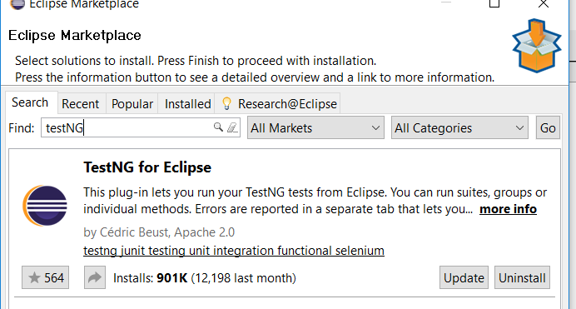

**Import Automation test suite:**

1) Import the project into workspace

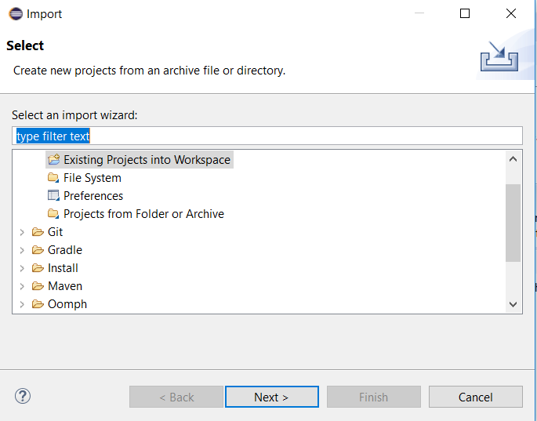

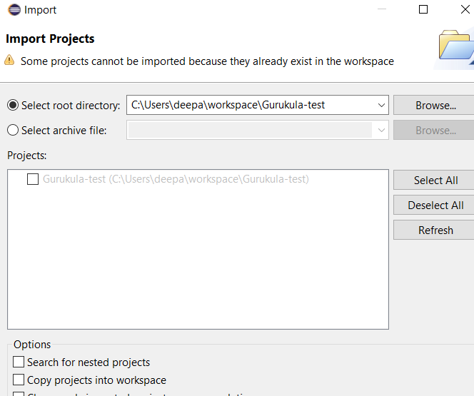

2) You will see this view  
  
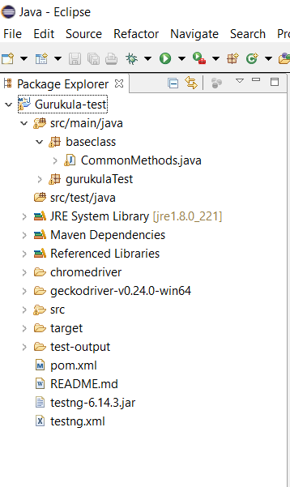

3) Right click on testng.xml and run as testNG suite.  
  
2) Automation Environment : Explanation:

The framework is testng which is inspired from JUNIT and it uses annotations (keywords with @)

1. It consists of reusable code defined in class CommonMethods.java
2. All the tests are defined in class FVTests.java
3. Pom.xml is used to add dependencies
4. testng .xml is used to define the test methods or test cases and the input variables
5. Annotations used in the project

@Test : Marks a class or a method as part of the test.

@BeforeMethod:The annotated method will be run before each test method.

@Parameters:Describes how to pass parameters to a @Test method.

@DataProvider :Marks a method as supplying data for a test method. The annotated method must return an Object[][] where each Object[] can be assigned the parameter list of the test method. The @Test method that wants to receive data from this DataProvider needs to use a dataProvider name equals to the name of this annotation.

@AfterMethod: The annotated method will be run after each test method.

6. The test report is a HTML which is generated under test-output folder as emailable-report.html.