Network Diagram
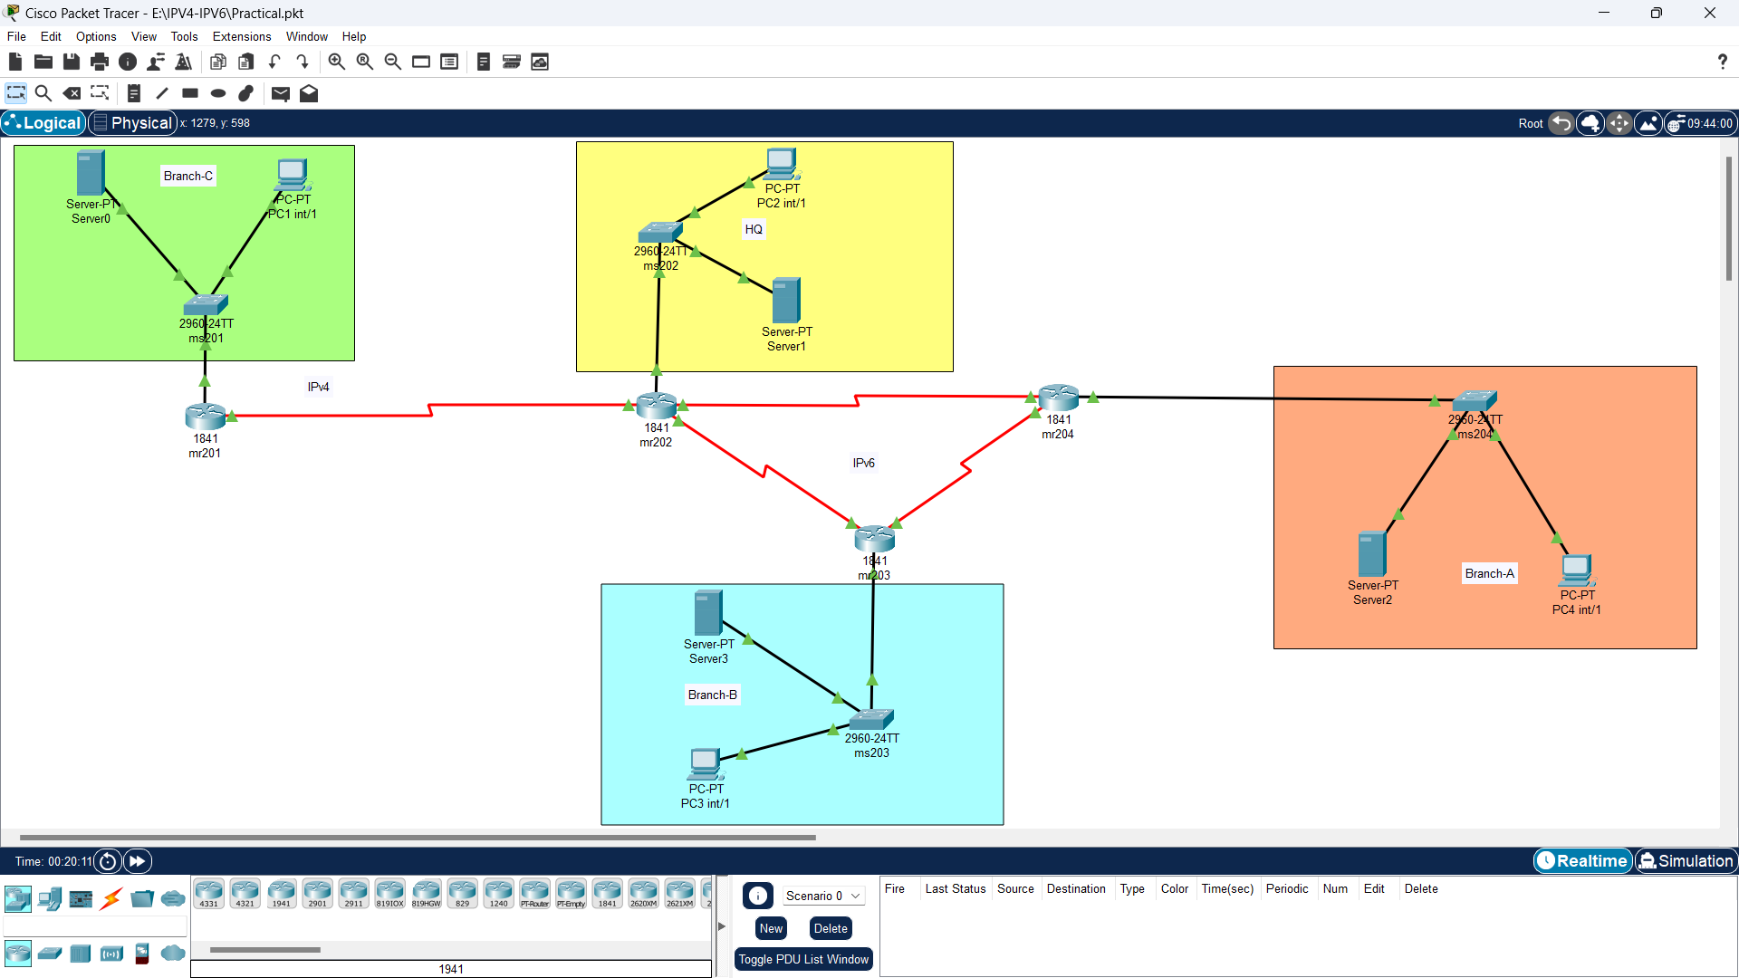

2.1 Address Planning

IPv6-Address Table

Network-Name | IPv6 Subnet Address
Company HQ | AB12:4216:1000::0/64
Branch A | AB12:4216:6000::0/64
Branch B | AB12:4216:4000::0/64

IPv4 Address and IPv6 Address Table

Sr# | Device | Interface | IP Address | Subnet Mask | Default Gateway
1 | mR201 | Se0/1/0 | 150.50.16.2 | 255.255.255.252 | N/A
1 | mR201 | Fa0/0 | 150.50.16.65 | 255.255.255.192 | N/A
2 | Server0 | Fa0 | 150.50.16.67 | 255.255.255.192 | 150.50.16.65
3 | PC1 | Fa0 | 150.50.16.66 | 255.255.255.192 | 150.50.16.65
4 | mR202 | Se0/0/1 | 150.50.16.1 | 255.255.255.252 | N/A
4 | mR202 | Se0/0/0 | AB12:4216:2000::1/64 | /64 | N/A
4 | mR202 | Se0/1/0 | AB12:4216:3000::1/64 | /64 | N/A
4 | mR202 | Fa0/0 | AB12:4216:1000::1/64 | /64 | N/A
5 | Server1 |  | AB12:4216:1000::3/64 | /64 | FE80::1
6 | PC2 |  | AB12:4216:1000::2/64 | /64 | FE80::1
7 | mR203 | Se0/0/1 | AB12:4216:5000::1/64 | /64 | N/A
7 | mR203 | Se0/0/0 | AB12:4216:3000::2/64 | /64 | N/A
7 | mR203 | Fa0 | AB12:4216:4000::1/64 | /64 | N/A
8 | Server2 | Fa0 | AB12:4216:4000::3/64 | /64 | FE80::1
9 | PC3 | Fa0 | AB12:4216:4000::2/64 | /64 | FE80::1
10 | mR204 | Se0/0/1 | AB12:4216:5000::2/64 | /64 | N/A
10 | mR204 | Se0/0/0 | AB12:4216:2000::2/64 | /64 | N/A
10 | mR204 | Fa0/0 | AB12:4216:6000::1/64 | /64 | N/A
11 | Server3 | Fa0 | AB12:4216:6000::3/64 | /64 | FE80::1
12 | PC4 | Fa0 | AB12:4216:6000::2/64 | /64 | FE80::1

2.2 IPv4 Routing Configuration

mR201
router eigrp 10
network 150.50.16.0 0.0.0.3
network 150.50.16.64 0.0.0.63
mR202
router eigrp 10
network 150.50.16.0 0.0.0.3

2.3 IPv6 Routing Configuration

mR202
ipv6 unicast-routing
interface FastEthernet0/0
ipv6 address FE80::1 link-local
ipv6 address AB12:4216:1000::1/64
ipv6 eigrp 10
interface Serial0/0/0
ipv6 address AB12:4216:2000::1/64
ipv6 eigrp 10
interface Serial0/1/0
ipv6 address AB12:4216:3000::1/64
ipv6 eigrp 10
clock rate 2000000
router eigrp 10
network 150.50.16.0 0.0.0.3
ipv6 router eigrp 10
eigrp router-id 2.2.2.2
mR203
ipv6 unicast-routing
interface FastEthernet0/0
ipv6 address FE80::1 link-local
ipv6 address AB12:4216:4000::1/64
ipv6 eigrp 10
interface Serial0/0/0
ipv6 address AB12:4216:3000::2/64
ipv6 eigrp 10
interface Serial0/0/1
ipv6 address AB12:4216:5000::1/64
ipv6 eigrp 10
ipv6 router eigrp 10
eigrp router-id 3.3.3.3
mR204
ipv6 unicast-routing
interface FastEthernet0/0
ipv6 address FE80::1 link-local
ipv6 address AB12:4216:6000::1/64
ipv6 eigrp 10
interface Serial0/0/0
ipv6 address AB12:4216:2000::2/64
ipv6 eigrp 10
interface Serial0/0/1
ipv6 address AB12:4216:5000::2/64
ipv6 eigrp 10
ipv6 router eigrp 10
eigrp router-id 4.4.4.4

2.4 IPv4IPv6 Network NAT-PT
ipv6 nat v4v6 source 150.50.13.100 AB12:4216:1000::3
ipv6 nat v6v4 source AB12:4216:8000::1 150.50.16.1
interface Loopback0
ipv6 address AB12:4216:8000::1/64

2.5 Verification

PINGING Router Mr203 with Branch B PC
