ASSIGNMENT 1.2 Manual Test Plan

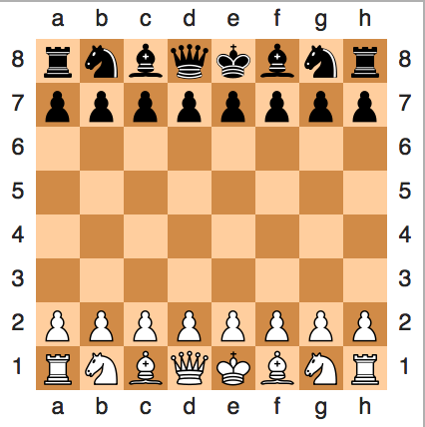 (From Wikipedia “Chess”)

The GUI will consist of a chess board like this above.

The outer grid will either be numbered from 1-8, a-h or simply 0-7 on both sides.

Each piece will be clickable by the user whose color matches the corresponding piece. The game will not allow you to click the opponent’s pieces and may display an error message.

After selecting a piece, the user will select a square.

A valid square will move the piece there immediately and perhaps display a message in the vein of “White Pawn moves to 3,2”. If a piece captures another, it should display a message in the vein of “Black Rook captures White Bishop”.

An invalid square will lead to an error message telling the user that that move is invalid for that piece, and will prompt the user to select another.

If the King from either side is in check or checkmate at any point, that message should be displayed warning that user.

At any point, a user can forfeit their game. This results in a win for the other user.

A checkmate will also result in a win for the other player.

A score will be kept for multiple games and will be persistent above the board.

There will be a button that allows for a custom game configuration that uses custom chess pieces.