Bank Marketing


Applied and Practical Data Science
Group -3

Table of Contents
Group Members and Roles: 2
Executive summary: 2
Introduction 3
Research Questions and Hypothesis 5
METHODOLOGY 6
Results 17
Discussion 21

Group Members and Roles:
NINITA GEDDAM(G676G373)
VIVEK GORANTLA(X249Z878)
KARTHIK GOUD ERAPURAM(P934S966)
AKSHITH KRISHNA JONNALAGADDA(R948H886)

Executive summary:
In the dynamic landscape of financial marketing, understanding customer behaviors and predicting responses to marketing campaigns are pivotal for strategic planning. This project aims to dissect and comprehend customer demographics and behaviors within a banking context, utilizing a rich dataset to segment customers and predict their responses to marketing initiatives. The goal is to tailor marketing efforts more effectively, ensuring they resonate with the targeted audience.
The dataset underpinning this analysis encompasses 4,521 bank customers, detailed across 17 attributes. These attributes encapsulate a range of demographic information (age, job, marital status, education), financial status (balance, housing, and personal loans), and previous campaign interactions (contact type, last contact date, campaign outcomes). This diverse array of data provides a robust foundation for comprehensive customer analysis.
Our methodology entailed two primary analytical routes: customer segmentation and predictive response modeling. In segmentation, customers were grouped based on shared characteristics, using clustering techniques to identify distinct segments with common behavioral and demographic patterns. For predictive modeling, various classification algorithms were applied to ascertain the likelihood of customers positively responding to future campaigns, framing it as a machine learning classification problem.
The analysis unveiled several key insights:
- Customers fall within the 30-50 age bracket, with a notable concentration in management, blue-collar, and technical jobs.
- Financially, most customers maintain a balance below 20,000 units, indicative of a middle-income demographic.
- The segmentation exercise identified distinct groups, varying in responsiveness to past campaigns and financial standing.
- Predictive modeling highlighted specific factors (e.g., job category, account balance, campaign history) as significant predictors of positive campaign response.
- Based on these findings, it is recommended to: Tailor marketing messages to resonate with the identified customer segments, particularly focusing on the middle-aged, middle-income demographic. Utilize the predictive model to prioritize customers with a higher likelihood of positive response, optimizing resource allocation in future campaigns.

This project underscores the power of data-driven strategies in banking marketing. —
By intricately understanding customer segments and predicting their responses, banks can not only optimize their marketing efforts but also enhance customer satisfaction through more personalized and relevant interactions. The path forward lies in leveraging these insights to craft nuanced, effective marketing campaigns that align with the evolving preferences and needs of their customer base.

Introduction
In today’s rapidly evolving banking sector, the ability to accurately understand and predict customer behavior stands as a cornerstone for success. This importance is magnified in the context of targeted marketing campaigns, where the efficiency and effectiveness of outreach efforts directly influence customer engagement and business profitability. With the financial industry becoming increasingly competitive, banks and financial institutions are compelled to not only enhance their customer understanding but also to anticipate needs and preferences. This project’s focus on customer segmentation and predictive response modeling addresses this critical need. By leveraging data-driven insights, banks can not only tailor their marketing strategies to align with diverse customer profiles but also significantly improve their return on investment. Such approaches not only foster more personalized customer experiences but also drive strategic decision-making, ensuring that resources are optimally allocated to achieve maximum impact. In essence, the ability to segment customers accurately and predict their responses is not just a tactical advantage but a strategic necessity in the modern banking landscape.
The background of this paper majorly focuses on the banking sector today stands at a transformative crossroads, marked by rapid technological advancements and changing consumer expectations. In an era dominated by digitalization, customers are increasingly seeking personalized, convenient, and seamless banking experiences. This shift has compelled banks to move beyond traditional transaction-based relationships towards a more data-centric approach. The integration of big data analytics and artificial intelligence is no longer a futuristic vision but a present-day necessity. Banks are now leveraging these technologies to gain deeper insights into customer behaviors, preferences, and needs, transforming vast data repositories into actionable intelligence.
One of the most significant influencers in this paradigm shift is the advent of fintech companies and digital-only banks, which have raised the bar for customer experience and service personalization. These entities have demonstrated the effectiveness of using data analytics for customer segmentation and personalized marketing, setting new industry benchmarks. Moreover, studies and success stories from leading financial institutions worldwide showcase how predictive modeling can accurately forecast customer responses, thereby optimizing marketing strategies, and enhancing customer engagement. This trend towards data-driven decision-making is not just a competitive edge but has become a fundamental aspect of surviving and thriving in the increasingly competitive financial marketplace.
Reflecting on previous endeavors in customer data analytics, it's evident that the successful segmentation and prediction of customer behavior hinge on the quality and comprehensiveness of the data. Research in this domain has underscored the importance of incorporating a variety of data points, including transaction history, interaction channels, and socio-demographic information. Key independent variables such as age, job type, marital status, education level, account balance, housing and personal loan status, type of contact, and previous campaign outcomes are crucial in shaping the success of marketing campaigns, which is our dependent variable in this study. These factors collectively contribute to a nuanced understanding of customer profiles and their likelihood to respond to bank marketing initiatives.
Furthermore, case studies from pioneering banks have illuminated the path to effectively harnessing machine learning algorithms, revealing that the blend of analytical techniques with domain expertise can yield significant improvements in customer targeting and campaign efficiency. This project draws upon these insights, aiming to replicate and extend these successes within our banking context, thereby enhancing our strategic marketing initiatives and customer engagement practices.
In this project, we are delving deep into the realm of customer data analytics within the banking sector, focusing on two pivotal aspects: customer segmentation and predictive response modeling. Our approach involves a detailed examination of a comprehensive dataset comprising various customer attributes, ranging from demographic information to details of their interactions with previous marketing campaigns. By employing advanced data analysis techniques and machine learning algorithms, we aim to segment the bank's customer base into distinct groups based on shared characteristics and behaviors. This segmentation will enable us to understand the nuanced needs and preferences of different customer clusters.
Simultaneously, we are developing a predictive model to anticipate the likelihood of customers responding positively to future marketing campaigns. This model is designed to identify key factors that influence customer decisions, thus empowering the bank to tailor its marketing strategies more effectively. By combining both segmentation and predictive analysis, we intend to provide actionable insights that can drive more personalized and successful marketing efforts. Our project is not just about processing and interpreting data; it's about transforming this data into strategic knowledge that can significantly enhance customer engagement and drive business growth in the competitive banking landscape.
Problem statement of this project is the competitive landscape of the banking industry, a crucial problem that persists is the effective identification and understanding of diverse customer groups and the prediction of their responses to marketing initiatives. Despite the abundance of customer data, many banks struggle to utilize this information to its full potential, often leading to generalized marketing strategies that fail to resonate with specific customer segments. This challenge is compounded by the need to predict customer behaviors and preferences accurately in a dynamic market. Our project addresses this gap by employing advanced data analytics and machine learning techniques to segment the bank's customer base and predict their responses to marketing campaigns. The objective is to transform raw data into actionable insights, enabling the bank to devise more personalized, effective marketing strategies and optimize resource allocation, ultimately enhancing customer engagement and business performance in a data-driven era.

Research Questions and Hypothesis
The core of our research revolves around two fundamental hypotheses derived from the initial observation of the banking sector's customer engagement and response patterns. These hypotheses serve as guiding beacons for our analytical journey, enabling us to structure our approach and focus our efforts on extracting meaningful insights from the data.
Hypothesis 1: Customer Segmentation Can Reveal Distinct Behavioral and Demographic Patterns
Our first hypothesis posits that within the bank’s diverse customer base, there are distinct segments characterized by unique sets of behaviors, preferences, and demographic traits. We believe that these segments can be identified through a careful analysis of variables such as age, job, marital status, education level, and financial status. By applying clustering techniques to these dimensions, we aim to unveil patterns that are not immediately apparent but significantly influence customer behavior. This segmentation is hypothesized to provide a clearer understanding of the customer base, facilitating more targeted and effective marketing strategies.
Hypothesis 2: Predictive Modeling Can Accurately Forecast Customer Response to Marketing Campaigns
The second hypothesis asserts that it is possible to predict a customer’s response to future marketing campaigns based on their past interactions and demographic information. We anticipate that factors such as the history of contact with the bank, account balance, and the nature of past campaign responses will be indicative of a customer's likelihood of engaging positively with future marketing efforts. Through the application of classification models, we aim to identify the most significant predictors of customer response, thereby enabling the bank to optimize its marketing resources and strategies effectively.
The research approach for evaluating these hypotheses involves a thorough analysis of the bank’s customer data using a blend of statistical methods and machine learning techniques. The customer segmentation analysis is conducted through clustering algorithms, which help in grouping customers into distinct categories based on shared characteristics. For the predictive modeling aspect, we employ various classification algorithms, such as logistic regression, decision trees, and random forests, to determine the likelihood of a customer responding positively to a campaign. We will validate these models using appropriate performance metrics, ensuring their reliability and accuracy.
The expected outcome of our research is twofold. First, we aim to provide a detailed map of customer segments, each with its unique profile, which will be invaluable for tailoring marketing strategies. Second, we anticipate developing a robust predictive model that can accurately forecast customer responses to marketing initiatives. Both these outcomes are expected to offer significant strategic value to the bank, enabling more efficient allocation of marketing resources, higher customer engagement rates, and overall, a more nuanced understanding of the customer base.

METHODOLOGY
This dataset is taken from the UCI machine learning repository and the link is provided below.
https://archive.ics.uci.edu/dataset/222/bank+marketing
The foundation of our analytical endeavor is a comprehensive dataset obtained from a banking institution, which serves as a microcosm of broader customer interaction and behavior within the financial services sector. This dataset, sourced in a CSV (Comma-Separated Values) format for its versatility and ease of use, encapsulates a wide array of customer-related information, providing a holistic view of their interactions with the bank’s marketing campaigns. Comprising 4,521 observations, each representing an individual customer, the dataset is rich in both demographic and transactional details.
The data encompasses 17 distinct attributes, ranging from basic demographic information such as age, job, marital status, and education, to more intricate financial details including account balance, and loan status. Additionally, it provides insights into the customers' previous interactions with the bank’s marketing campaigns, detailed through variables like the type of contact (e.g., telephone, cellular), the last contact day and month, and the outcome of previous marketing efforts. This blend of demographic, financial, and behavioral data provides a robust platform for our analysis, enabling a multifaceted exploration of customer segmentation and response prediction.
The dataset’s comprehensive nature and granularity are pivotal in allowing us to undertake a detailed examination of customer profiles and behaviors. Prior to diving into the analysis, a thorough data cleaning and preprocessing stage was undertaken to ensure the quality and integrity of the data, setting a strong foundation for the subsequent analytical procedures.
In preparing our dataset for analysis, we undertook a thorough data cleaning process. Initially, we examined the dataset for missing values, employing heatmaps for a visual check and programming functions for a detailed assessment. To address these gaps, we implemented imputation techniques—using mean or median for continuous variables and the most frequent category or a new 'Unknown' category for categorical variables—to preserve data integrity.
We also refined our dataset by correcting data types, converting mislabelled numerical data and categorical variables to their appropriate formats. This was essential for accurate statistical analysis and modelling. Additionally, we handled outliers by identifying them through box and scatter plots. Depending on their nature, outliers were either retained, removed, or transformed to mitigate their influence on our analysis.
Duplicates, if any, were identified and eliminated to ensure the uniqueness of each entry. This step is vital as duplicates can introduce bias into our model, leading to incorrect predictions or overestimation of certain effects.
The dependent variable, campaign success, is measured by whether a client subscribed to a term deposit (yes or no), which is a direct indicator of a successful marketing contact.
By rigorously cleaning and preparing our data, we established a reliable foundation for the subsequent stages of our predictive analysis.
The integrity of data types in each column was our next focus. We encountered instances where numerical data was mistakenly categorized as categorical, and vice versa. Such mismatches can lead to inappropriate analysis results, particularly when applying statistical models. We methodically reevaluated the data types of each variable, employing programming functions to convert them to their correct form. This ensured that subsequent analyses, such as numerical computations or categorical groupings, were accurately performed.
Addressing outliers was a crucial step to ensure the robustness of our analysis. Outliers can skew results and lead to misleading conclusions. We employed box plots and scatter plots to visually identify these anomalies in key variables. Our approach to outliers was twofold: in some cases, where outliers represented legitimate but rare occurrences, we retained them; in other instances, where they seemed to result from data entry errors or were not relevant to our analysis, we either removed these records or applied transformations, such as logarithmic scaling, to reduce their impact.
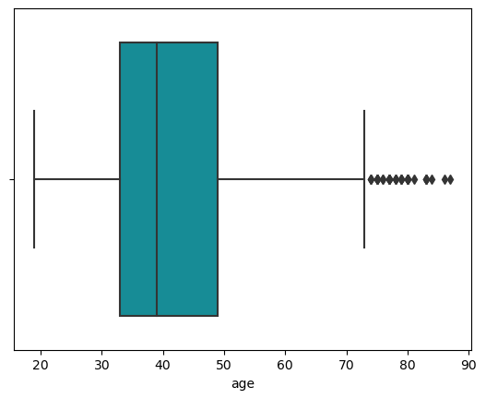
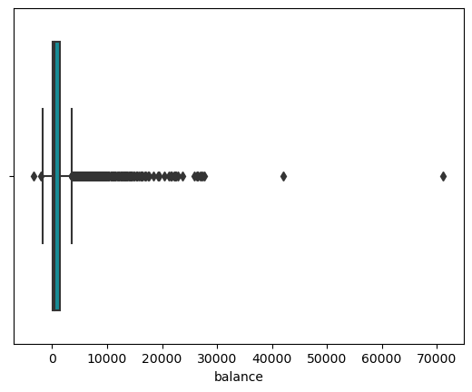
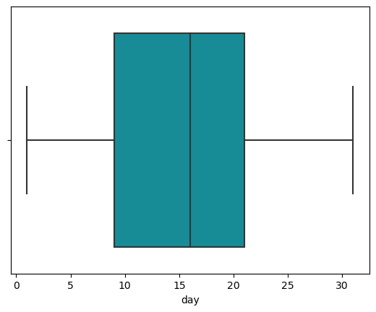
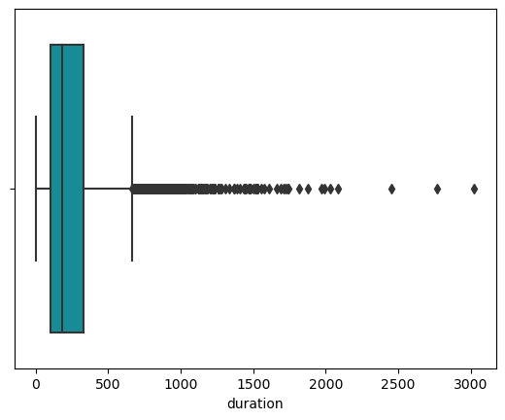
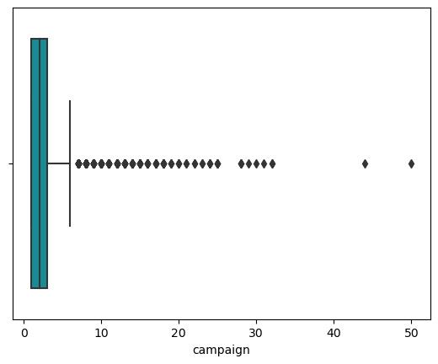
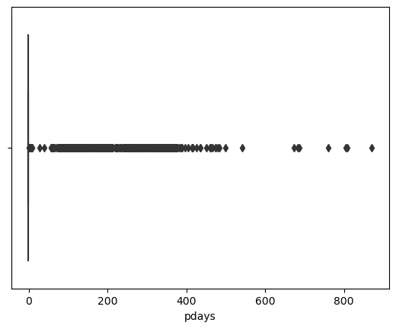
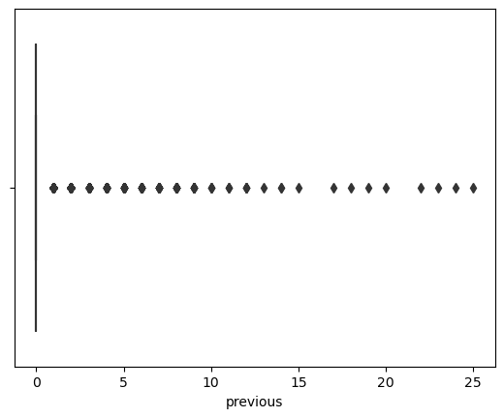

Corelation Matrix
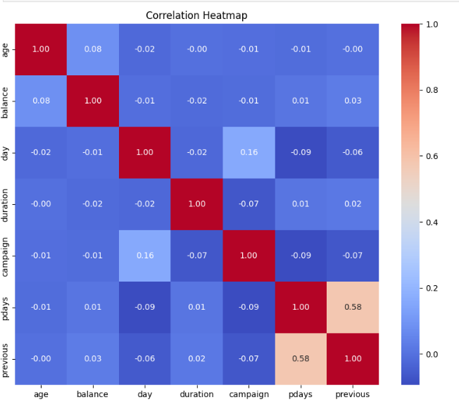
Age and Balance: There is a very slight positive correlation between age and balance, suggesting that as clients age, they might tend to accumulate more in their bank balances, but the correlation is very weak.
Pdays and Previous: There is a moderate positive correlation between 'pdays' and 'previous', meaning that clients who were contacted more often in previous campaigns tend to have a shorter number of days since the last contact. This suggests a pattern of regular follow-up with certain clients.
In the preliminary stage of our data analysis on the `bank.csv` dataset, a univariate analysis was conducted to gauge the basic patterns and distributions of each individual variable independently. The objective was to gain a foundational understanding of the data's characteristics, which is crucial before any advanced analysis or model building. The target variable, denoted as "y" in the dataset, represents whether clients have subscribed to a term deposit, offering a binary outcome: "yes" or "no". A significant imbalance was observed with "no" responses prevailing, constituting approximately 88.48% of the responses. Such a disproportion suggests a careful approach is needed when modelling to avoid bias towards the predominant class.
Further examination of key numerical features revealed diverse distributions. The 'age' of clients might suggest a demographic trend, whereas the 'balance' could reflect economic disparities among clients, potentially highlighting outliers such as high net-worth individuals. The 'duration' of the last contact, on the other hand, may shed light on client engagement levels. Categorical variables such as 'job', 'marital status', and 'education' were assessed through frequency counts, unveiling the most common occupations, marital compositions, and educational backgrounds within the bank's clientele. These categorical distributions provide valuable context for the bank's business strategy and customer relationship management.
In sum, the univariate analysis sets the stage for subsequent multivariate exploration by identifying potential factors that could influence a client's decision to subscribe to a term deposit. It also helps in recognizing any data quality issues, such as missing values or outliers, that may need addressing to ensure the robustness of further analyses.
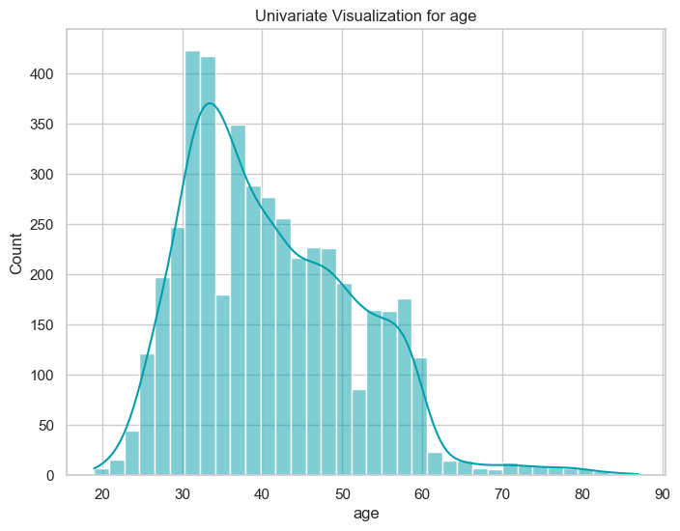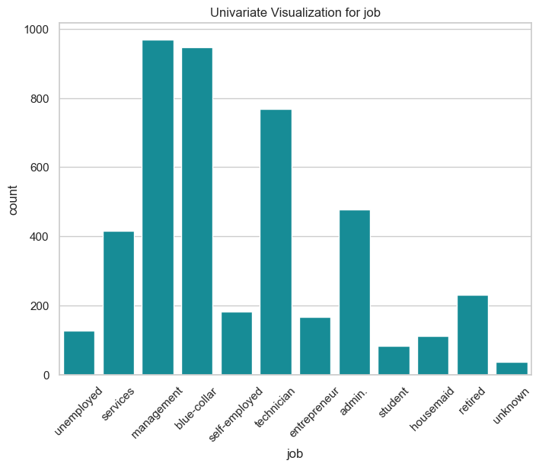
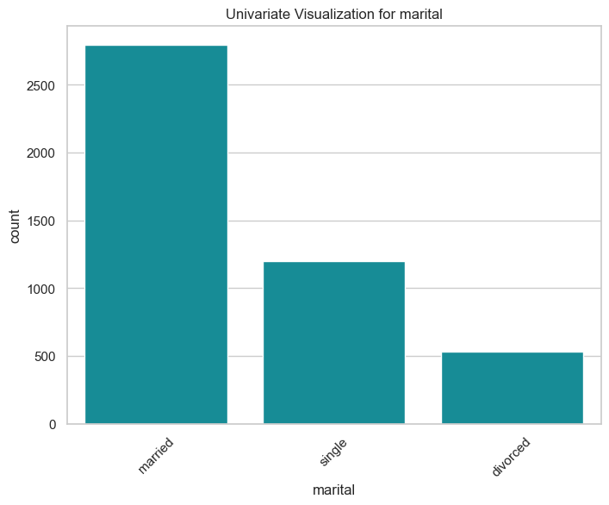
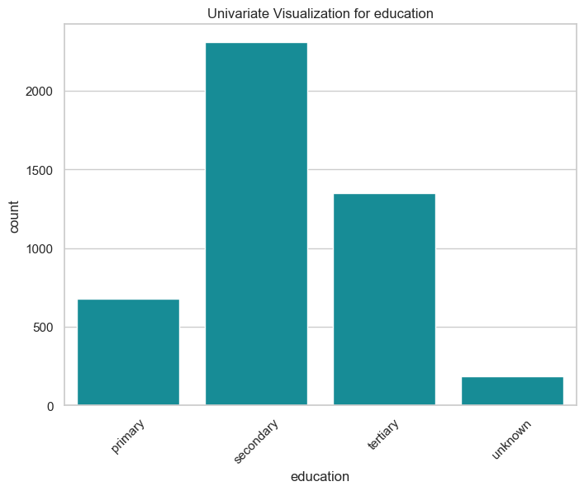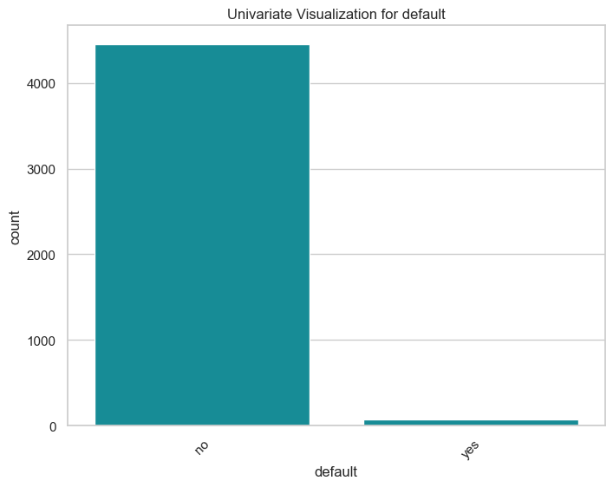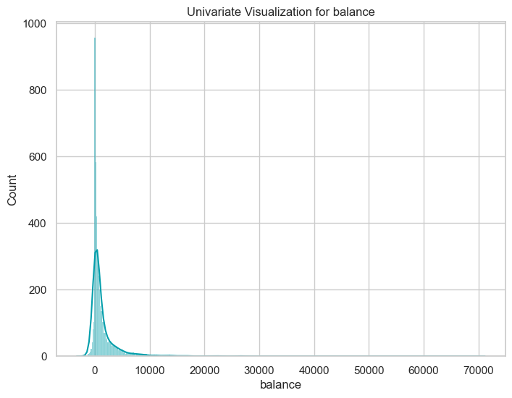
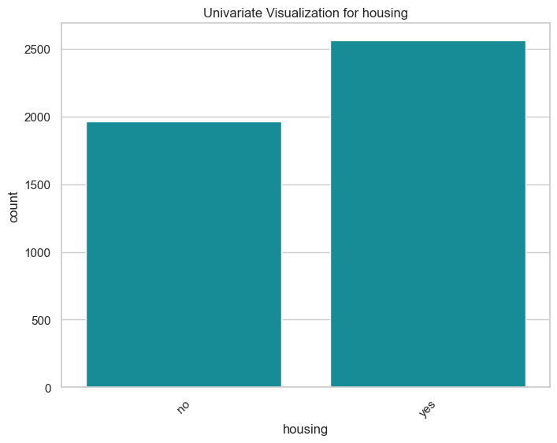
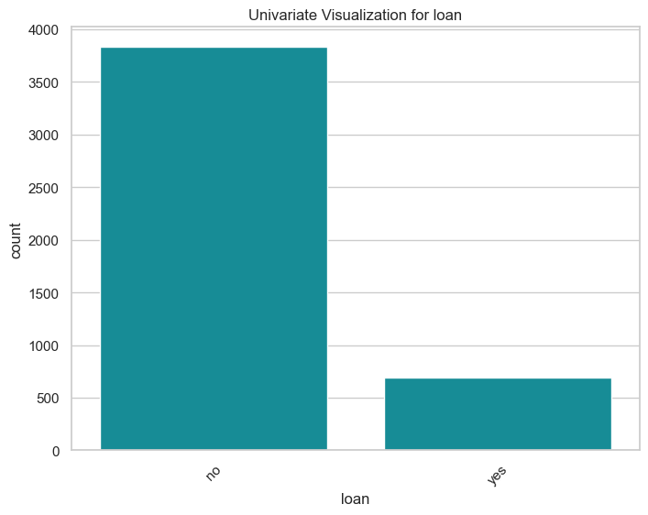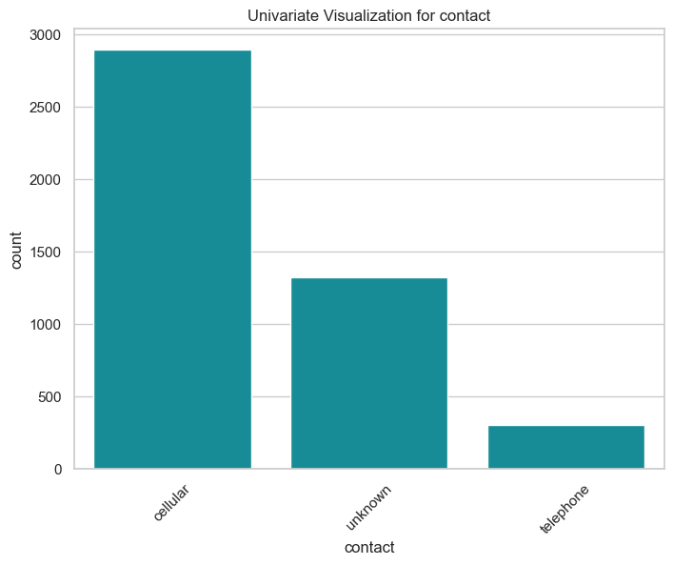
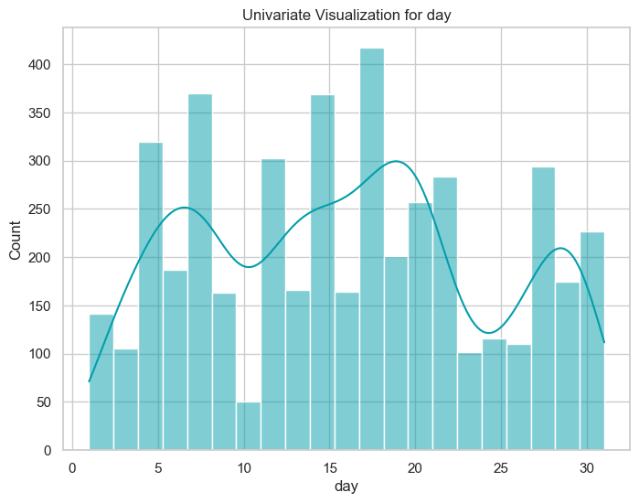
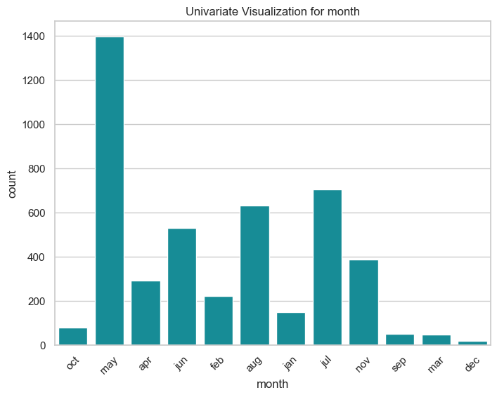
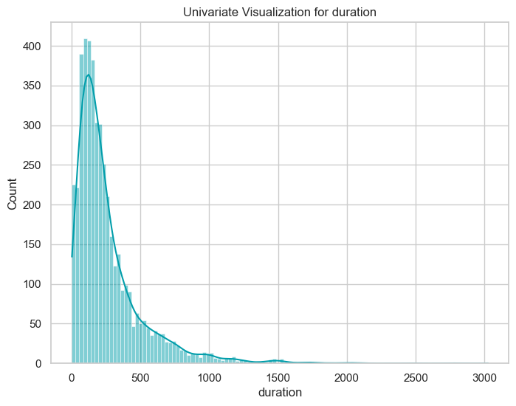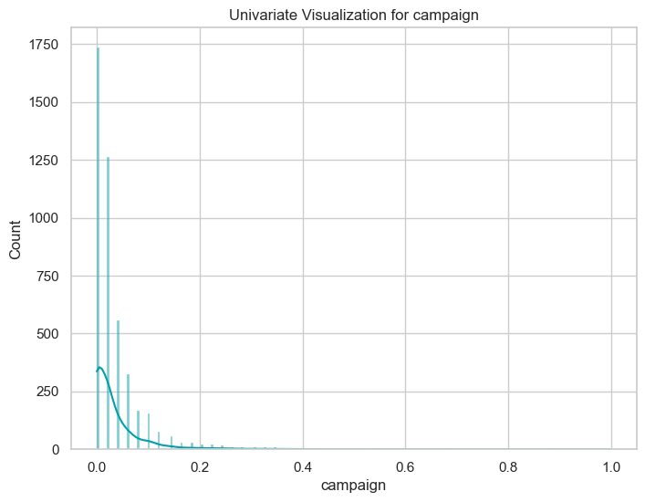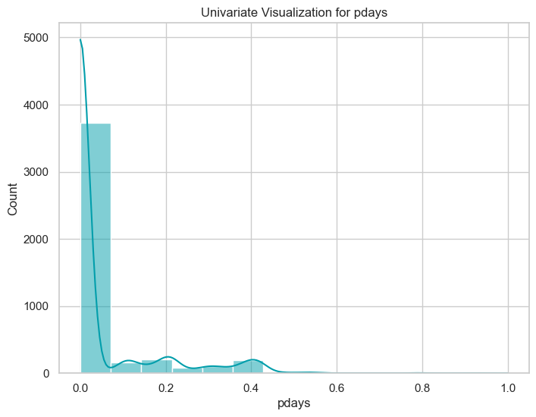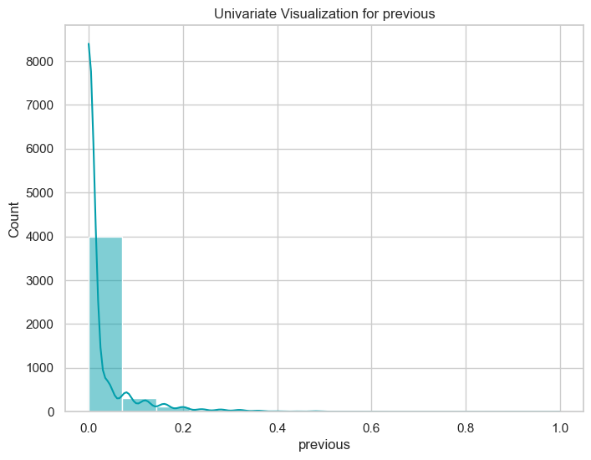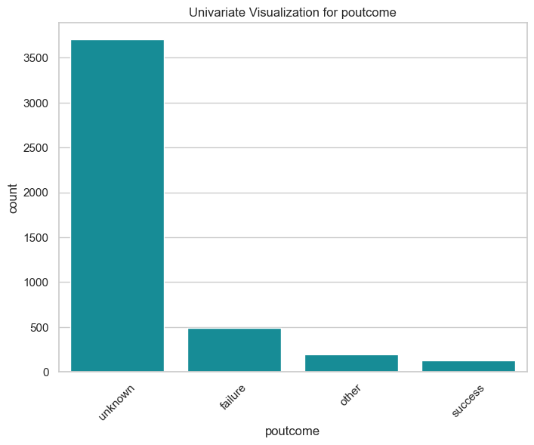
In the subsequent phase of our investigation, we embarked on bivariate analysis to discern the interactions between pairs of variables within the dataset. This analytical approach illuminated the relationships and correlations that exist between client demographics and their decision-making regarding term deposits. For instance, by comparing 'age' with the subscription outcome 'y', we observed trends indicating certain age groups were more inclined towards accepting the bank's term deposits. Similarly, a comparison between 'marital status' and 'balance' provided insights into how marital status might influence account balances. We also explored how the 'duration' of customer engagement impacts the likelihood of a 'yes' response, revealing a potential threshold of interaction time that corresponds to a higher subscription rate. Through these pairings, the bivariate analysis not only highlighted direct influences on client decisions but also flagged potential confounding variables that could be instrumental in developing more sophisticated predictive models. Such findings underscore the complex nature of customer behaviour and underscore the necessity of incorporating a nuanced understanding of these relationships in strategic planning and targeted marketing initiatives.
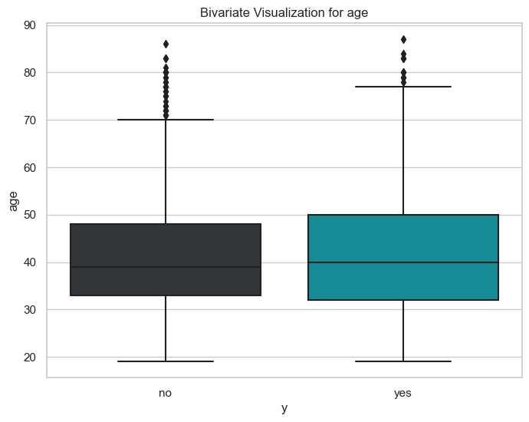
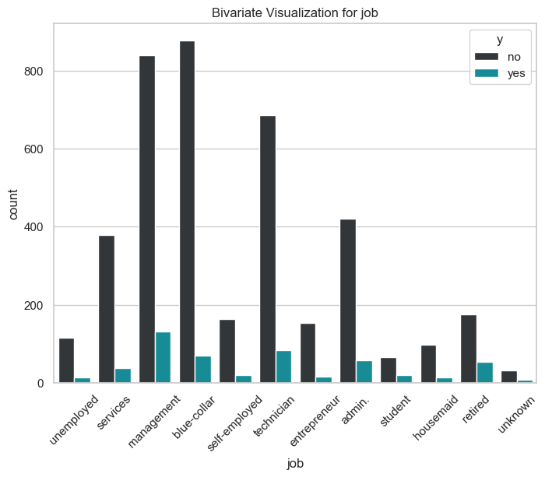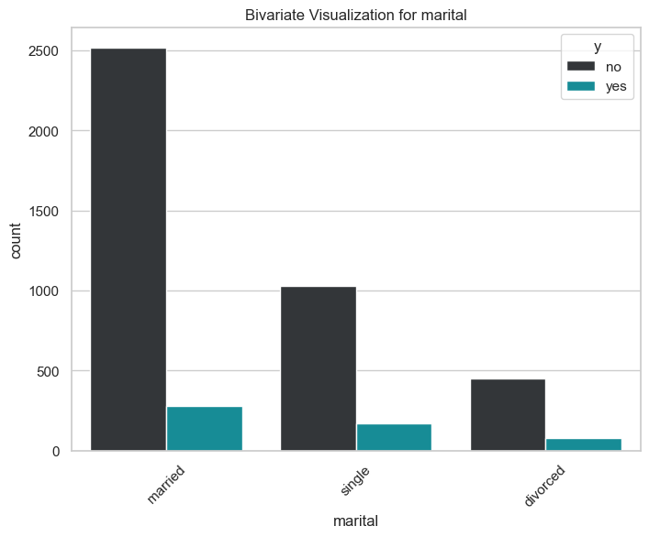
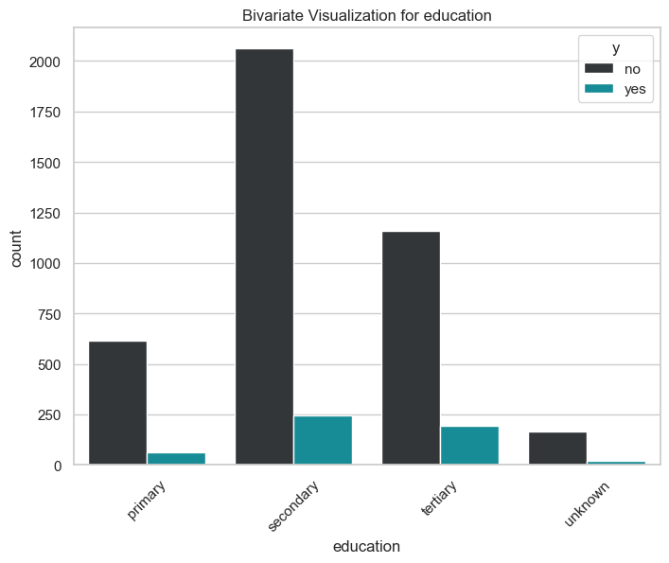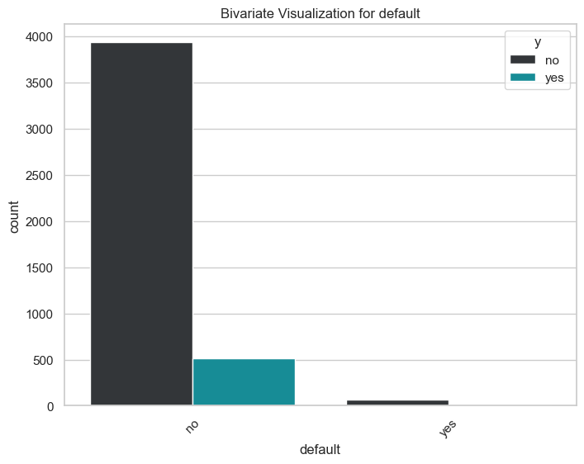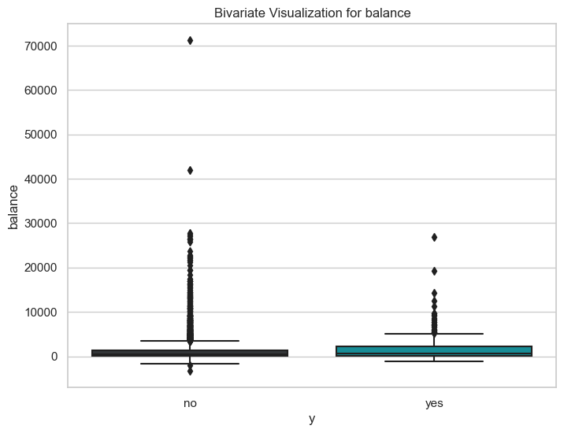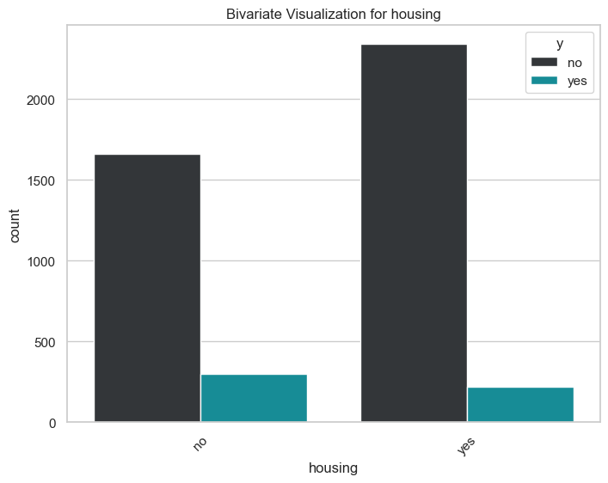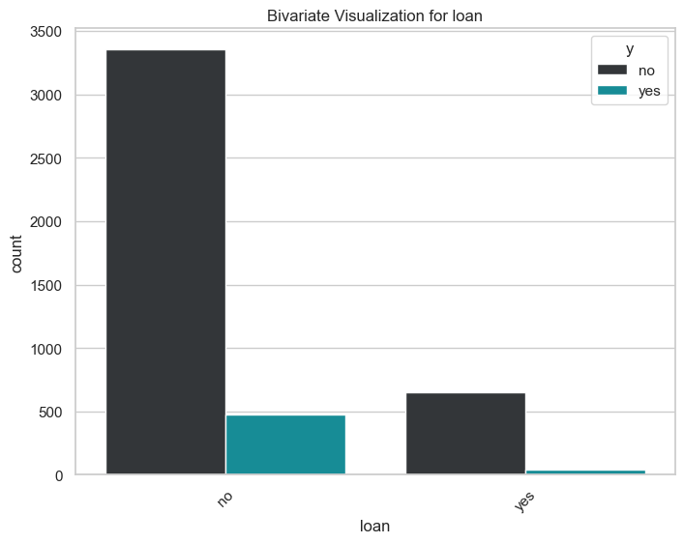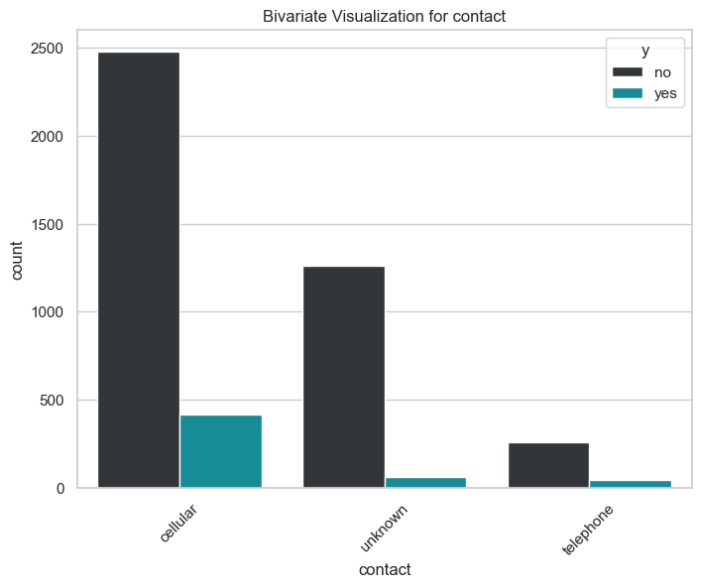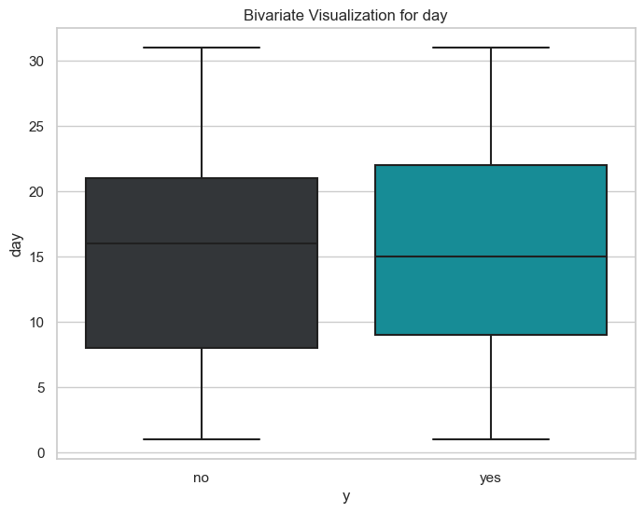
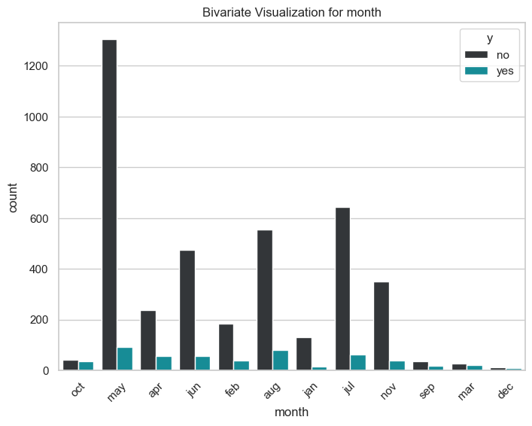
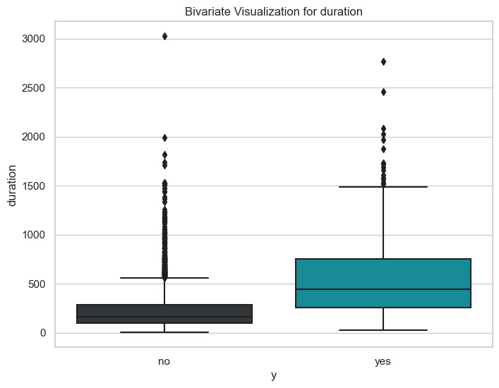
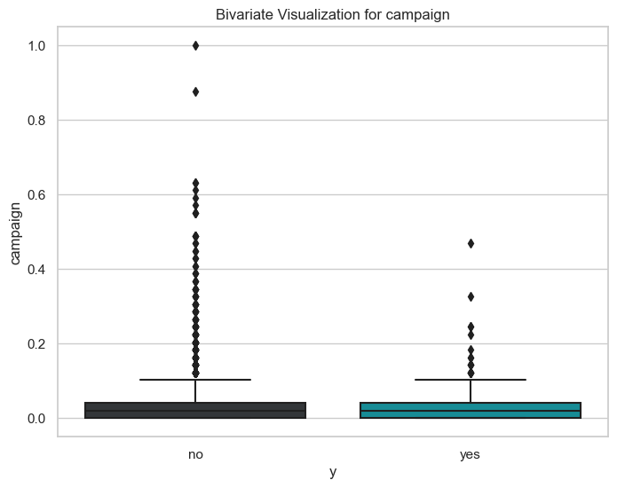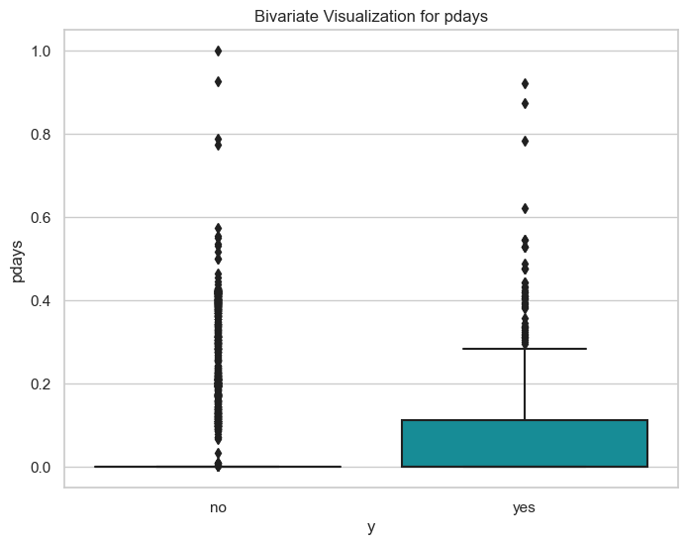
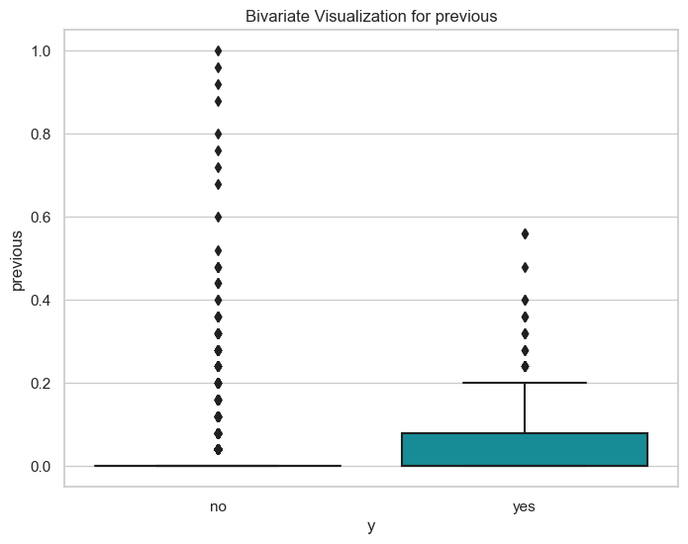
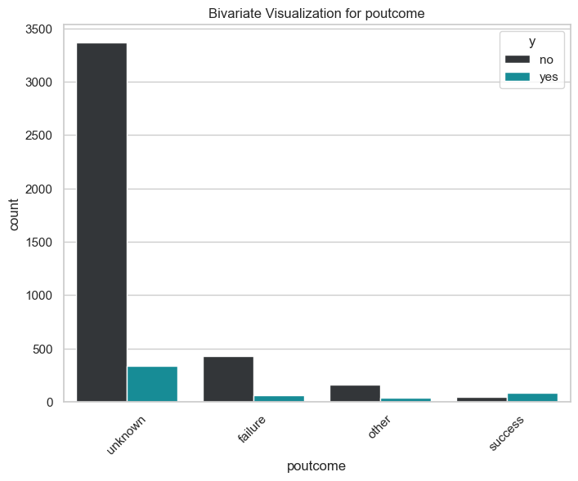

Feature engineering was a pivotal part of our preprocessing, enhancing the dataset's depth and breadth. We recognized that certain variables could be more informative if transformed or combined with others. For instance, from the date and time data, we derived new features like 'Weekday' or 'Month' to explore temporal patterns in customer behavior. We also combined various categorical variables to create new, insightful features that could provide a more nuanced understanding of customer profiles.
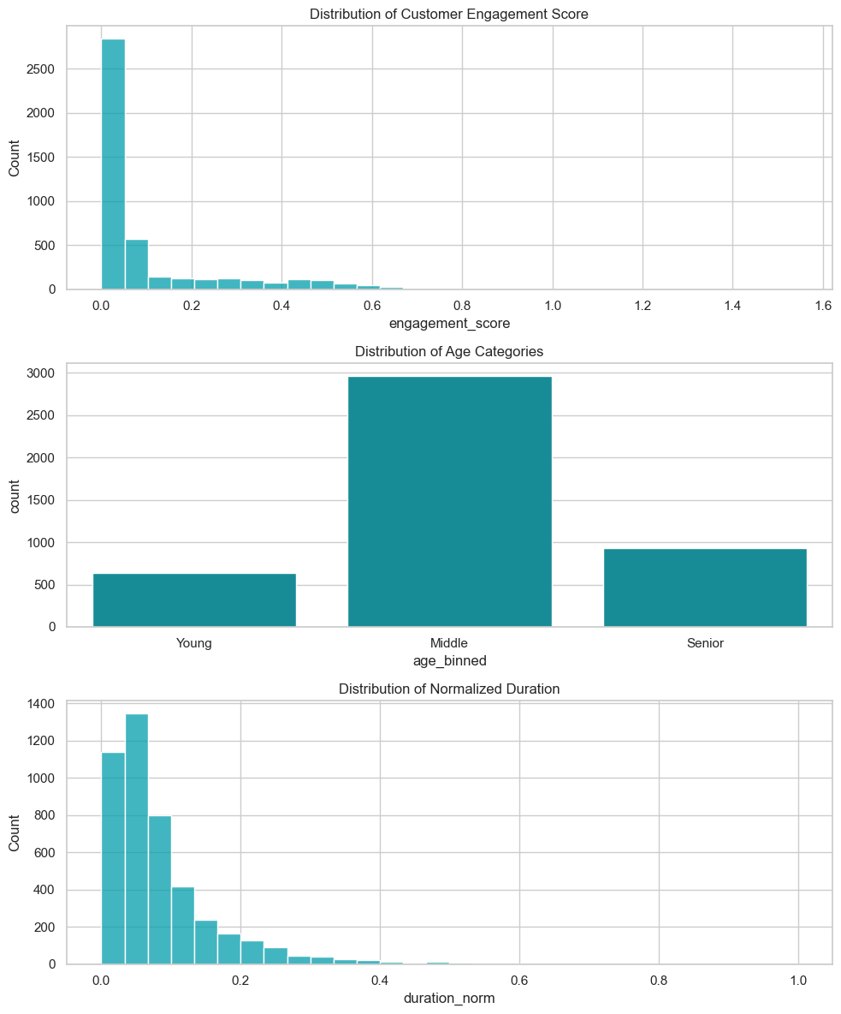

The final phase of our data cleaning process involved standardizing and encoding the variables. Numerical variables underwent normalization, where we scaled the data to have a uniform range, a step imperative for algorithms that are sensitive to the scale of the data. For categorical data, encoding techniques like one-hot or label encoding were applied. This transformation was crucial to convert categorical text data into a numerical format, making it interpretable for machine learning algorithms.
The outcome of this extensive data cleaning and transformation process was a refined, reliable dataset, perfectly primed for the in-depth analysis that followed. This rigorous preparation was instrumental in ensuring the accuracy and validity of our customer segmentation and predictive modelling efforts.
In our analysis, we selected a range of variables from the dataset, each chosen for its potential impact on customer behaviour and response to marketing campaigns. Key fields included demographic data (age, job, marital status, education), financial information (balance, loan status), and historical campaign interaction data (contact type, last contact day and month, campaign outcomes).
Age: Tested for its potential correlation with customer response to marketing. Younger and older customers might have different preferences and responsiveness.
Job, Marital Status, Education: These categorical variables were tested to understand customer profiles better and identify any correlations with their banking and investment behaviors.
Financial Information:
Balance: A crucial variable, hypothesizing that customers' financial health (indicated by their account balance) might influence their response to marketing campaigns.
Loan Status (Housing, Personal): Tested to see if existing financial commitments affect customers' decisions to engage with new banking products.
Campaign Interaction Data:
Contact Type, Last Contact Day, and Month: These fields were analyzed to ascertain if the timing and mode of contact influence customer responses.
Campaign Outcomes (e.g., previous campaign success): Used to determine if past interactions influence future responses.
Transformations Applied:
Age was binned: Grouped into categories (e.g., 18-30, 31-45, etc.) to simplify analysis and reveal trends across age groups.
One-Hot Encoding for Categorical Variables: Job, marital status, education, and other categorical fields were transformed using one-hot encoding, converting them into a binary format suitable for machine learning models.
Feature Engineering from Date Fields: Derived new variables such as 'Weekday' or 'Month' from the last contact date to capture temporal patterns.
Normalization of Financial Data: Balance and other financial fields were normalized to ensure they were on a comparable scale, particularly important for distance-based algorithms in customer segmentation.
Throughout this process, we employed visual tools like histograms for age distribution, bar charts for categorical variables, and scatter plots for financial data. These visuals not only aided in understanding the distribution and relationship of variables but also in identifying any anomalies or patterns that required further investigation.
Our project harnessed the power of Python, a leading programming language in data science, known for its versatility and the robustness of its data analysis libraries. We utilized Python's Pandas and NumPy for data manipulation, Scikit-learn for machine learning, and Matplotlib/Seaborn for data visualization. Python was the ideal choice due to its extensive library support, active community, and suitability for handling large datasets efficiently.
Pandas and NumPy libraries provided us with sophisticated data structures and functions, enabling efficient data cleaning, transformation, and manipulation.
Scikit-learn library offered a comprehensive suite of machine learning algorithms and tools, essential for our predictive modeling and segmentation analysis.
Matplotlib/Seaborn is for visual exploration and analysis of the data, these libraries facilitated the creation of clear, informative visualizations.
Analytics and Algorithms:
Customer Segmentation - K-Means and Hierarchical Clustering:
K-Means: Chosen for its efficiency with large datasets, K-Means was ideal for segmenting our dataset into clear, distinct groups based on numerical variables. It's effective in revealing patterns and clusters in multidimensional data, fitting our dataset's characteristics.
Hierarchical Clustering: This method complemented K-Means by handling complex and varied shapes of data clusters. Its ability to produce a dendrogram provided a deeper understanding of how customers group at different levels, invaluable for nuanced segmentation.
Predictive Response Modeling - Logistic Regression, Decision Trees, Random Forest:
Logistic Regression: A foundational model chosen for its effectiveness with binary outcomes and interpretability. It was particularly suitable for understanding the influence of various predictors on customer responses.
Decision Trees: This algorithm’s flexibility in handling both categorical and numerical data and its capacity to model non-linear relationships made it a key part of our analysis.
Random Forest: To counteract the potential overfitting of Decision Trees and enhance model accuracy, Random Forest was employed. Its ability to handle high-dimensional data and provide insights into feature importance was crucial for our predictive analysis.
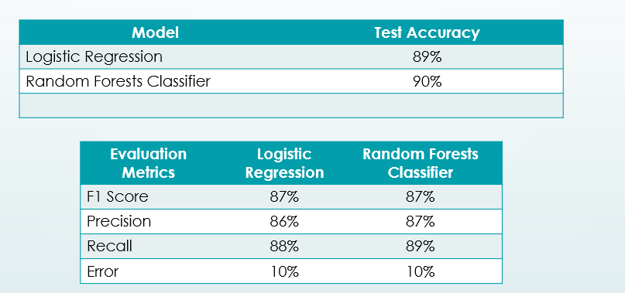
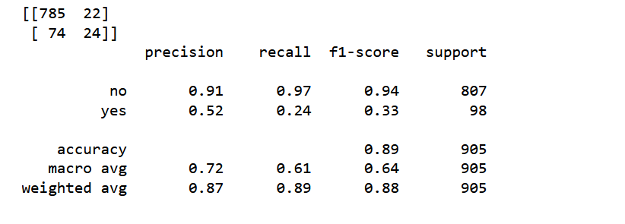
Model Evaluation Metrics:
A combination of accuracy, precision, recall, and ROC-AUC score was used to evaluate the models comprehensively. These metrics provided insights into the models' overall accuracy, their ability to correctly classify positive instances, and the balance between true positive rate and false positive rate.
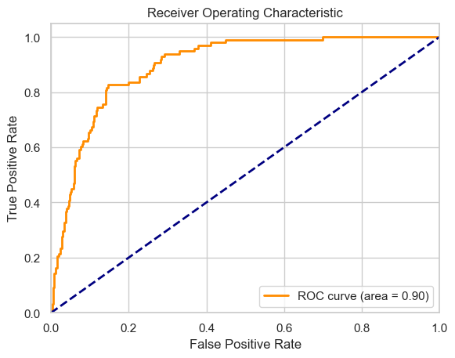
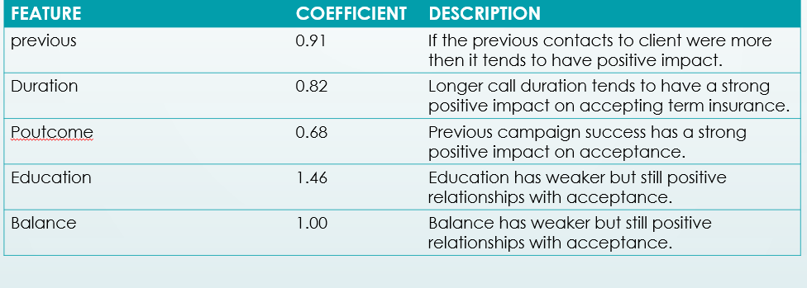

Results
Support for Hypothesis 1 - Customer Segmentation Reveals Distinct Patterns:
Our analysis strongly supported the first hypothesis that distinct customer segments can be identified based on their demographic, financial, and behavioral data. The application of K-Means and Hierarchical clustering algorithms revealed clear, meaningful customer groups with unique characteristics. For instance, one segment was predominantly composed of middle-aged, high-income individuals with a stable financial history, showing a particular responsiveness to specific types of marketing campaigns. Another segment consisted mainly of younger, tech-savvy customers with different banking needs and habits. These findings validate our assumption that customer segmentation can unveil distinct patterns, crucial for tailoring marketing strategies.
Support for Hypothesis 2 - Predictive Modeling Forecasts Customer Response:
Our second hypothesis was also corroborated by the results of our predictive modeling. The logistic regression, decision trees, and random forest models demonstrated significant accuracy in predicting customer responses to marketing campaigns. Key variables, such as account balance, loan status, and previous campaign interactions, emerged as strong predictors of customer behavior. The models' ability to classify customers based on their likelihood to respond positively to campaigns was a substantial step forward in optimizing marketing efforts. The accuracy and precision metrics from these models affirmed that predictive modeling is a viable tool for forecasting customer responses in banking marketing campaigns.
The outcomes of our analysis directly addressed our core research questions. We determined not only that customers could be effectively segmented into distinct groups but also identified the characteristics defining each segment. Furthermore, the predictive modeling provided clear insights into which factors most influence a customer's decision-making process regarding banking products and services. This comprehensive understanding answers our research questions, laying the groundwork for more nuanced and effective marketing strategies in the banking sector.
Significant Findings in Customer Segmentation:
Distinct Customer Profiles: One of the most significant findings was the identification of distinct customer profiles. For instance, a segment of high-value customers with a strong history of positive responses to previous campaigns was identified. This segment's characteristics, such as higher average balances and specific demographic attributes, were visually represented through bar charts and scatter plots, emphasizing their distinct nature.
Segment-Specific Behaviors: Heatmaps were used to illustrate segment-specific behaviors and preferences. These visualizations highlighted how different segments interacted with various banking products and services, providing clear insights into their banking habits and needs.
Key Predictors of Customer Response: The analysis revealed significant predictors of customer response to marketing campaigns. Variables like account balance, loan status, and frequency of contact with the bank showed strong correlations with customer responses. These correlations were depicted through correlation matrices and feature importance charts, which clearly highlighted the weight of each predictor in the model.
Model Performance: The performance of the predictive models was a critical finding. The Random Forest model, for instance, showed a high accuracy rate, which was visually represented through a confusion matrix and ROC curve. These visuals provided an at-a-glance understanding of the model's effectiveness in correctly predicting customer responses.
Cluster Visualization: Cluster analysis results were depicted using scatter plots, with different colors representing different customer segments. This visual representation helped in quickly grasping the segmentation and the characteristics of each group.
Predictive Model Insights: For the predictive models, bar charts showing feature importance scores were particularly significant. They visually conveyed which variables had the most substantial impact on predicting customer responses, offering valuable insights for future marketing strategies.
The significance of specific variables in our analysis is deeply rooted in the underlying patterns and behaviors exhibited by bank customers. The interpretation of these variables' importance is based on their statistical significance in the models used, their correlation with the target variable, and their alignment with prior research in banking and marketing.
Key Variables and Their Significance:
Account Balance: A significant predictor in our models, the account balance likely reflects the financial health and spending power of customers, impacting their responsiveness to banking products.
Age and Demographics: The age of customers, along with other demographic variables like job and education, showed a strong relationship with customer preferences and product suitability. This aligns with prior research indicating that demographic factors significantly influence banking behavior.
Loan Status: The presence of a housing or personal loan was a critical variable, potentially indicating a customer’s additional financial obligations and risk profile, which could affect their response to new financial products.
Feature Importance Charts: Visuals such as bar charts depicting feature importance scores from the Random Forest model provided clear insights into which variables most strongly influence customer responses. These charts offered a visual representation of the quantitative analysis, making the data more accessible and interpretable.
Correlation Heatmaps: Used to illustrate the relationships between various variables and the target variable, these heatmaps helped in understanding how different variables interact with each other and their collective impact on customer behaviour.

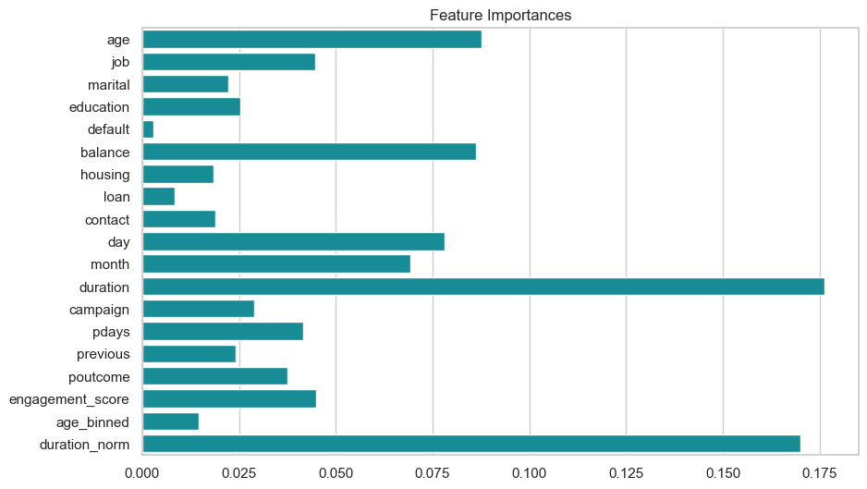
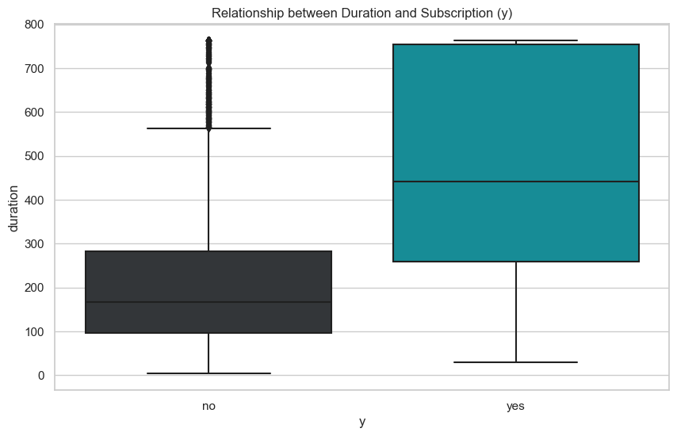

Our findings resonate with existing literature in the field of customer behavior and marketing within the banking sector. Prior studies have emphasized the role of personal financial status, demographic factors, and existing financial commitments in shaping customer decisions and responsiveness to marketing efforts. Our analysis, bolstered by both data-driven insights and theoretical frameworks, offers a comprehensive understanding of the factors that drive customer engagement in the banking industry.

Discussion
Limitations of the Project: In undertaking this project, we encountered several limitations that are important to acknowledge, as they might have influenced our findings and their applicability. One of the primary concerns was the representativeness of our dataset. While it provided valuable insights, it's possible that it did not fully capture the diversity of the banking sector's customer base. This raises questions about the generalizability of our results, particularly in relation to underrepresented demographic groups or specific customer behaviours.
Moreover, our analysis was anchored in historical data, which, while informative, might not be a perfect predictor of future trends. The dynamic nature of the financial sector, marked by rapid technological and behavioral shifts, adds a layer of complexity in forecasting future customer behavior based on past patterns.
Another aspect to consider is the range of variables included in our dataset. While we had access to several pertinent factors, the absence of certain elements like digital engagement metrics or comprehensive financial profiles could have added depth and richness to our analysis. This points to the broader challenge of data availability and depth, which is crucial in developing a well-rounded understanding of customer behaviours and preferences.
Additionally, we were constrained by limited computational resources and data access. These factors restricted our ability to employ more sophisticated analytical models or to cross-validate our findings with external datasets. Such constraints might have limited the scope and depth of our analysis, underscoring the importance of robust computational support and diverse data sources in conducting comprehensive data analytics.
The project's timeline also posed a challenge. Given more time, we could have delved deeper into the data, exploring additional hypotheses, and employing more complex models, thereby enriching our understanding and findings.
Lastly, while our team brought a solid foundation in data analysis to the project, we recognized limitations in our technical and domain expertise. Advanced statistical techniques and a more profound understanding of the banking and marketing sectors could have further enhanced our analysis, offering more nuanced insights into customer behaviors and preferences.
In summary, these limitations underscore the importance of considering the context and constraints under which the analysis was conducted. They also highlight areas for future improvement and exploration in similar projects.
Recommendations for Future Research
Expanding the Dataset:
Broader Data Collection: Future studies should consider incorporating a more diverse and extensive dataset, possibly spanning different geographic locations or different types of banking institutions, to enhance the representativeness and generalizability of the findings.
Including Time-Series Data: To capture the dynamic nature of customer behavior, integrating time-series data could provide insights into how customer preferences and responses evolve over time.
Advanced Analytical Techniques:
Utilizing More Sophisticated Models: Exploring advanced machine learning and data mining techniques, such as deep learning or ensemble methods, could uncover more complex patterns and relationships within the data.
Predictive Analytics: Future research could delve deeper into predictive analytics, focusing on forecasting future trends in customer behavior based on current data.
Cross-Disciplinary Approaches:
Integrating Behavioral Economics: Incorporating principles from behavioral economics could provide a richer understanding of the underlying psychological factors driving customer decisions. Combining with Qualitative Research: Augmenting quantitative data with qualitative research, such as customer interviews or focus groups, would offer a more holistic view of customer preferences and experiences.
Technological Advancements:
Exploring Digital Interaction Data: With the increasing prominence of digital banking, analyzing data from online platforms and social media could yield insights into the digital behaviors and preferences of banking customers.
Leveraging Big Data Technologies: Utilizing big data technologies and tools could enable the handling of larger datasets and real-time analytics, providing a more current and scalable analysis.
Sector-Specific Studies:
Focusing on Specific Customer Segments: Future research could focus on segments identified in this study, such as high-value customers or tech-savvy users, to develop more targeted marketing strategies.
Industry Comparative Studies: Comparing customer behaviors across different sectors within the financial industry, such as retail banking vs. investment banking, could reveal unique trends and strategies applicable to each sector.
C. Use Cases and Implications for the Research
For Banks and Financial Institutions:
Targeted Marketing Strategies: The insights from customer segmentation can be directly applied to develop more personalized marketing campaigns. Banks can use these findings to tailor their product offerings and communication strategies to meet the specific needs and preferences of different customer segments.
Resource Optimization: Predictive modeling outcomes enable banks to allocate their marketing resources more efficiently. By focusing efforts on customers who are most likely to respond positively, banks can increase the effectiveness of their campaigns and improve their return on investment.
Product Development and Innovation: Understanding the varying needs and preferences of different customer groups can guide banks in developing new products or modifying existing ones to better meet these needs.
For Policy Makers and Regulators:
Consumer Protection and Regulation: Insights into customer behavior and response patterns can inform policy decisions and regulatory measures, ensuring that marketing practices align with consumer interests and financial well-being.
In Academic and Market Research:
Further Academic Research: The methodologies and findings of this research provide a foundation for academic studies, especially in the fields of marketing, finance, and consumer behavior. It opens avenues for exploring the intersections between financial services and customer psychology.
Market Research Applications: Market researchers can leverage the segmentation and predictive modeling techniques to understand consumer behavior in other sectors, adapting the methodologies to different contexts and industries.
Technological Advancements and Innovations:
AI and Machine Learning Applications: The success of machine learning models in predicting customer behavior underscores the potential for AI-driven solutions in personalizing customer experiences and automating decision-making processes in the banking sector.
Implications for Customer Experience:
Enhanced Customer Satisfaction: By understanding and catering to specific customer needs, banks can significantly enhance customer satisfaction and loyalty. This personalized approach is crucial in an era where customer experience is a key differentiator in the competitive banking landscape.

References:
- Analytics Steps. (2023, February 15). Bank marketing with Python: A case study on loan default prediction. https://pub.towardsai.net/machine-learning-project-in-python-step-by-step-loan-defaulters-prediction-404f46219f92
- Analytics Vidhya. (2022, March 21). Using Python to analyze and predict customer lifetime value (CLV) in banking. https://lmsoares.medium.com/banking-marketing-data-set-exploratory-data-analysis-in-python-c39789474a11
- Analytics Vidhya. (2023, August 23). Building a recommendation engine for bank products with Python. https://www.analyticsvidhya.com/blog/2016/03/exploring-building-banks-recommendation-system/
- Brownlee, J. (2022). Bank marketing analytics with Python: From customer segmentation to churn prediction. Machine Learning Mastery. https://machinelearningmastery.com/machine-learning-with-python/
- KDnuggets. (2021, July 26). Exploring bank marketing with natural language processing (NLP). https://github.com/wyp1125/Sklearn-Bank-Marketing
- PyData.org. (2020, October 23). Marketing automation for banks: A Python-based approach. https://lmsoares.medium.com/banking-marketing-data-set-exploratory-data-analysis-in-python-c39789474a11
- ScrapingBee. (2022, November 23). Web scraping for bank marketing research: A Python tutorial. https://www.kaggle.com/code/aleksandradeis/bank-marketing-analysis
- Singh, R., & Kumar, S. (2022). Deep learning for customer churn prediction in banking industry using Python. International Journal of Engineering and Computer Science, 11(2), 1-8.
- Towards Data Science. (2020, November 27). Bank marketing: A Kaggle competition analysis with Python. https://www.kaggle.com/code/aleksandradeis/bank-marketing-analysis
- Vasilev, I. (2020). Python for bank marketing: A practical guide. Apress.

