**Exoplanets:**

For Project 2, our group would like to explore the known universe to determine if there are exoplanets capable of supporting human life. If these planets exist, how far away are they and how do they compare to Earth.

**Data Set:**

These datasets we will be using can be found [here](https://exoplanetarchive.ipac.caltech.edu/cgi-bin/TblView/nph-tblView?app=ExoTbls&config=planets) and [here](https://exoplanetarchive.ipac.caltech.edu/cgi-bin/TblView/nph-tblView?app=ExoTbls&config=compositepars).

**Visuals:**

For our presentations, our group would like to incorporate the following visuals:

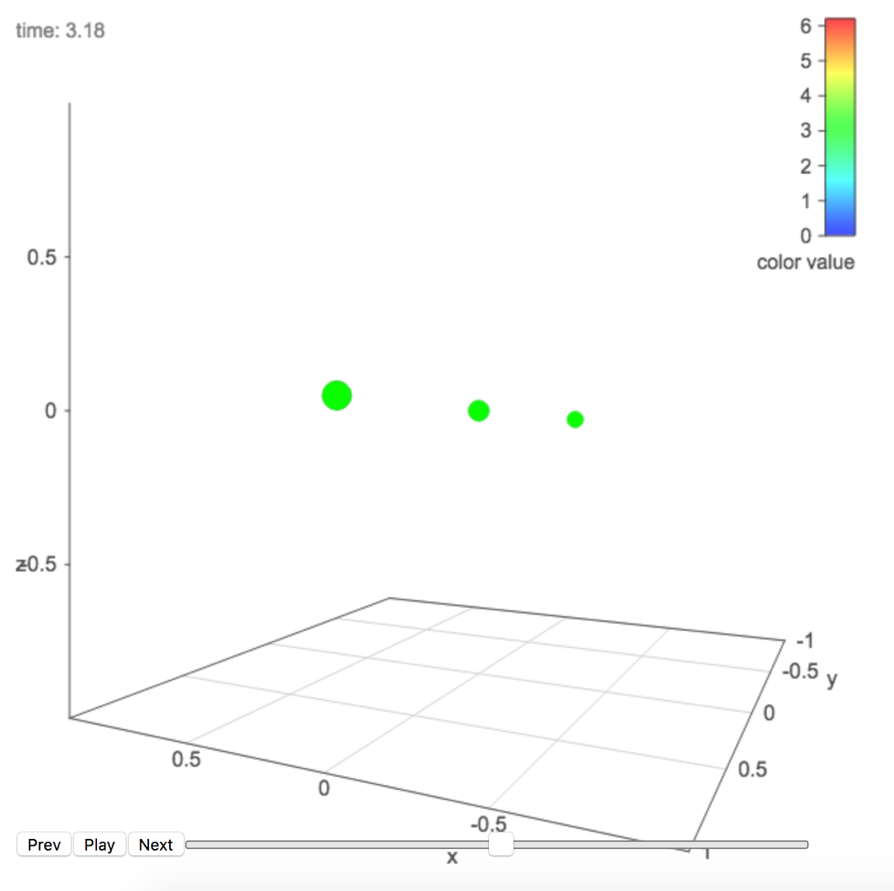

1. This is a d3 library that will do animations of circles which will be useful for showing orbits.

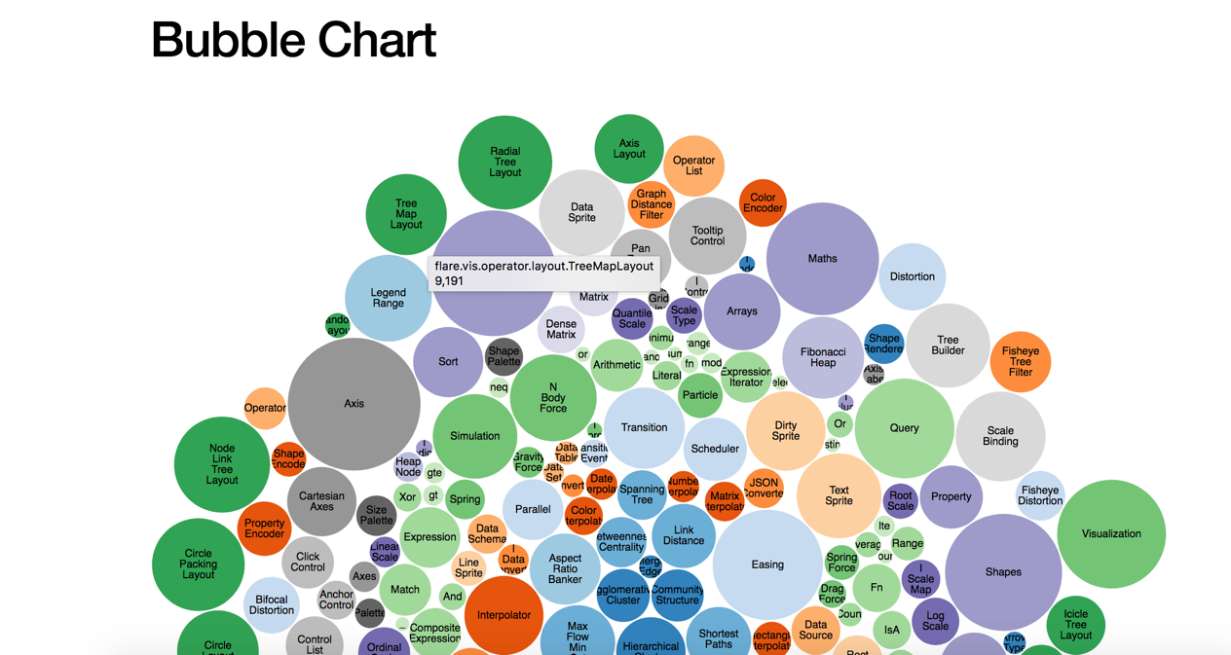

1. This bubble chart will be useful when comparing sizes of either the planets or the stars they orbit.

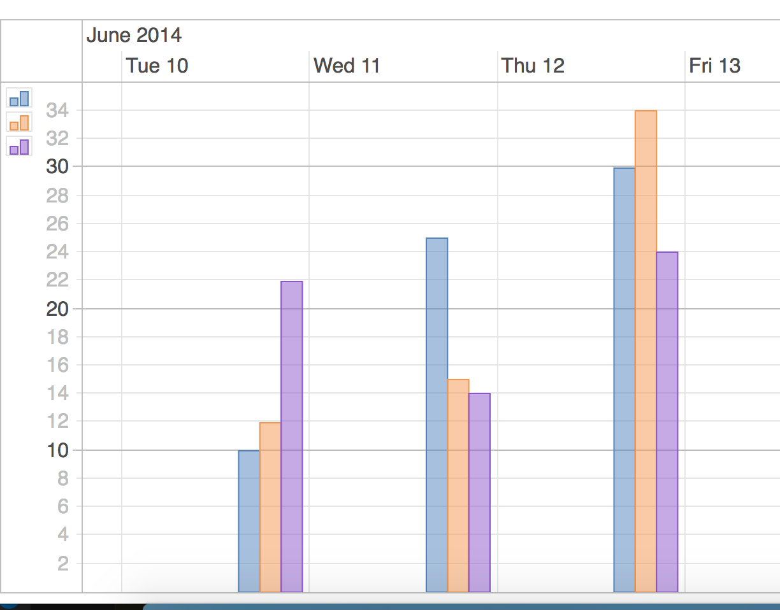

1. Our group would also like to use bar graphs in some of our visualizations.

**Our design:**

TO DO:

* + A sketch of the final design
  + A link to the primary GitHub repository you'll be housing your work in