DOCUMENTATION

DOMAIN:CHAT BOT

ARTIFICIAL INTELLIGENCE

1:a branch of computer science dealing with the simulation of intelligent behavior in computers

**2**: the capability of a machine to imitate intelligent human behavior

CHAT BOT

a computer program designed to simulate conversation with human users, especially over the Internet.

PROCESS FLOW OF A CHAT BOT

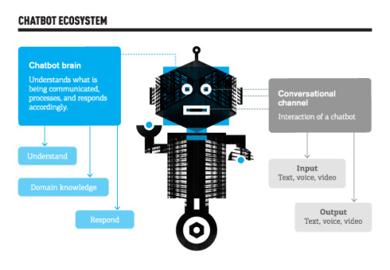

FRAMEWORK USED: Recast.ai

PROJECT TITLE: BANKING BOT

TEAM MEMBERS:

S.DHARSHINI (711714104016)

S.GOWRI GAYATHRI (711714104021)

K.KHAVYA (711714104030)

N.KOWSALYA (711714104031)

FACULTY GUIDE:

Ms.PRSCILLA JOY

INDUSTRY GUIDE:

Mr.VASANTH.N

MODULE SPLIT UP:

1. ADDING A BENEFICIERY (K.KHAVYA)
2. FUND TRANSFER (S.DHARSHINI)
3. MINI STATEMENT (S.GOWRI GAYATHRI)
4. BALANCE (N.KOWSALYA)

PROJECT FLOW:

START CONVERSATION

VERIFIED?

VERIFY CRENDITIALS

SIGNUP/SIGNIN

NO

YES

MODULES:

1. ADDING BENEFICIERY
2. FUND TRANSFER
3. MINI STATEMENT
4. BALANCE
5. FAQ

CONTINUE UNTILL CONVERSATION ENDS

LOGOUT

DISPLAY THE MOST SIMILAR RESPONSE

FETCH FROM THE DATABASE AND DISPLAY THE RELEVANT ANSWER

QUESTION PROMPTED?

YES NO