Kanyakorn Kitisopakul 18582950

Once upon a time, deep inside forest in an unknown planet, there was a hidden spaceport. The scene showed Zack aliens patrolling the port at night time. Zack noticed their masters have returned thus prepared to greet the masters. Halolist, a rare faceless and bodyless species, came out of the spaceship. The teapot has been empty and brought back. Zack helped the Halolist by passing the teapot to another Zack who is waiting to transfer the teapot to the shelter area.

The additional animated system is a bridge which is used to transport the teapot to another side. A spot light on Zack alien. Physics models projectile motion of Halolist. A custom-built model designed using vertex coordinates and polygon definitions. The whole spaceship except the door, Zack’s head, and Zack’s foot are created and modelled by me. I have attached my sketches in PDF file. Skybox of the forest.

The problem encountered is when trying to turn the teapot again, the rotation does not work properly. This is solved by swapping with another teapot.

Use code from http://stackoverflow.com/questions/327043/how-to-apply-texture-to-glutsolidcube to create solid cube which could use texture.

F5 - Default view
F6 - Bridge
F7 - Spaceship
F8 - Overall
L - land spaceship

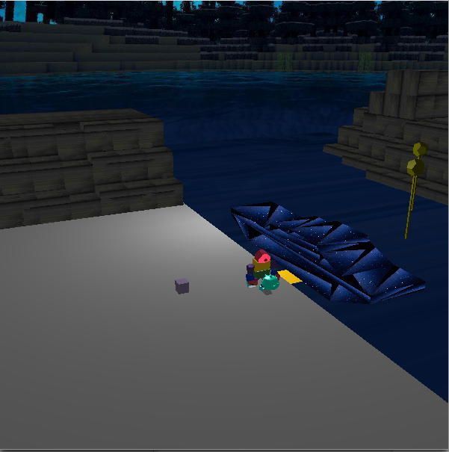

Figure 1: Zack picking up teapot and Halolists jumping

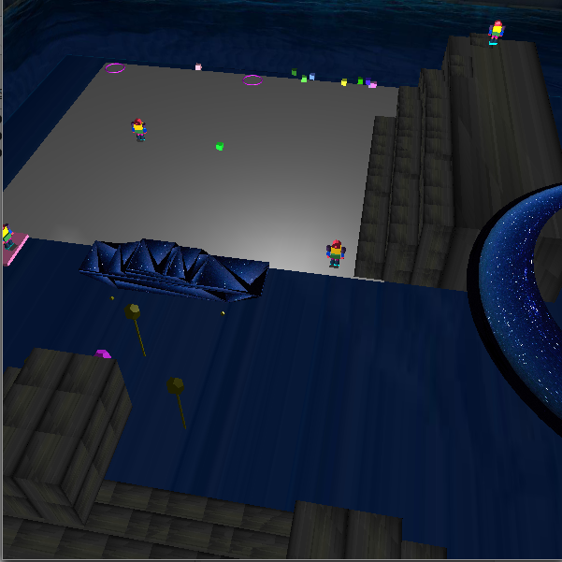

Figure 2: Halolists celebrates their comeback

