**Semestral**

**Report**

**First Semester**

**CY 2021- 2022**

**BRIDGETINE’S**

**YOUNG INFORMATION TECHNOLOGY SOCIETY**

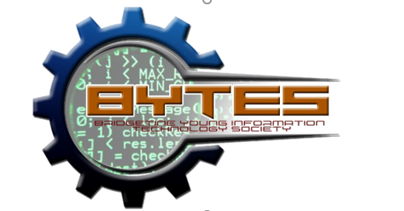

Ronnel Jr. D. Bautista

***President***

Giselle P. Manalo

***Vice President***

Irish Nicole Garcia

***Secretary***

Angeli Parsaso

***Treasurer***

**BYTES Club Moderator**

Mr. Ace Zheridan S. Gutierrez

**BYTES CLUB CONSTITUTION AND**

**BY-LAWS**



**VISION**

St. Bridget College Batangas is Catholic evangelizing educational institution

Founded by the religious of the Good Shepherd

Inspired by the compassion of Jesus,

And the zeal of St. John Eudes and St. Mary Euphrasia.

We form Christian communities

Through education that strengthens faith and morals

And uplifts human dignity.

Impelled by merciful love,

We participate actively in building a transformed society

Characterized by the love of God and neighbor

Justice, peace, reconciliation and integrity of creation.

**MISSION**

St. Bridget College Batangas is a center for excellence

Offering and education with programs and services

That are person and community oriented

Anchored in Christian faith and values

And supported by appropriate resources and technology.

We form competent, committed and integrated persons

Who live the Good Shepherd charism of compassion

And the values of St. Bridget College

Drawing from our tradition of caring

We create a culture of reconciliation, justice and peace

Responsive to societal and cosmic needs.

**PREAMBLE**

We, the Information Technology students of Saint Bridget College Department, in order to secure our interest and well-being and to be able to express ourselves in one voice and spirit, do hereby promulgate this constitution and by-laws.

**RATIONALE**

BYTES is an organization solely for the students taking the program Bachelor of Science in Information Technology. It aims to provide activities that will help students to develop and enhance mastery in IT knowledge and skills acquired in the classroom.

**ARTICLE1  
NAME AND PLACE OF ORGANIZATION**

Section 1:

The name of the organization shall be Bridgetines Young Information Technology Educators Society (BYTES). The main office of the organization shall be located in St. Bridget College, Batangas City.

**ARTICLE II  
OBJECTIVES**

**Section 1:**

The organization aims to:

A. To identify opportunities for skill enhancement.

B. To help the students get better job opportunities and be recognized Worldwide through their knowledge in IT.

**ARTICLE III  
OFFICER AND MEMBER**

**Section 1: Officers**

The major officers of BYTES shall be composed of the President, Vice President, Secretary and Treasurer. There shall be one representative from each year level.

**Section 2: Qualifications of Officers**

* For President

A. Should be an incoming an second year student

B. Must be a regular student

C. Should have no failing grades

D. Must be able to garner the highest number of votes of the members

E. Should be responsible, committed and honest

* For Vice President, Secretary and Treasurer

A. Must be regular student

B. Should have no failing grades

C. Must be able to garner the highest number of votes of the member

D. Should be responsible, honest and committed

**Section 3: The Representatives**

There should be an election for BYTES representatives for each year level.

**Section 4: Membership**

A. Those students who are enrolled under Bachelor of Science in Information Technology

B. A member must fill out an application form for membership and pay corresponding membership fees

**ARTICLE IV  
ELECTION AND TERM OF OFFICE**

Section 1: Election of Officers of the Organization

A. The election of the major officers shall take place during the last week of March.

B. The manner of election for the officers of the organization is through secret balloting.

Section 2: Tenure of the Officers

1. The elected officer shall serve for a term of one year. The previous officers may be re-elected.

**ARTICLE V  
DUTIES OF THE OFFICERS**

**Section 1: Duties of the President**

A. Call everything through the secretary

B. Preside over the meeting

C. Preserve order; define the rights and prerogative of the members

D. Order all the payments authorized by the association.

E. See to it that the constitution and the by-laws are strictly compiled with.

F. Channel the complains or suggestion of any member of the organization of the people concerned.

**Section 2: Duties of the Vice President**

The Vice President shall take place of the president in case of the latter absence or temporary inability to hold the office. He shall in the case of power and obligation of the President.

**Section 3: Duties of the Secretary**

The secretary shall keep in his\her the duplicate copy of all agenda, minutes and resolutions approved in every meeting and the records personal information of the members.

* Section 4: Duties of the Treasurer

1. Keep all the funds of the organization and all account necessary dues, fees and aids.
2. Keeps a register book showing the names of all members of the organization with respective payment for fees.
3. Submit a report on the financial status of the organization every semester

**Section 5: Duties of Representatives**

1. Inform the members about the resolution approved in every meeting
2. Attend every meeting
3. Submit all records delegated to them by the treasurer

**ARTICLE VI  
DUES**

Each member should pay P50.00 for the membership fee. Old members should pay P25.00.

**ARTICLE VII  
RIGHTS, PRIVILEGES AND OBLIGATIONS OF MEMBERS**

Section 1: Rights and Privileges

A. Have the right to participate in the deliberations of the general assembly an to vote on pertinent matters.

B. Attend different computer trainings and activities as schedule.

Section 2: Obligations of the Members

A. Every member binds to obey the rules and regulations of his\her organization as set forth in this constitution and by-laws.

B. Shall promptly pay all dues and contribution.

C. Attend every trainings and activities.

**ARTICLE VIII  
MEETINGS**

Section 1: Meetings

A. There shall be general assembly of all members of the organization every semester.

B. There shall be regular meeting of the major officers every first Friday of the month.

C. In case of emergency, the President may call a special meeting of the organization.

**BYTES**

**SEMESTRAL REPORT**

***First Semester***

***SY: 2021 – 2022***

**SUMMARY**

**OF**

**ACTIVITIES**

Note: Some of the activities are not accomplished due to time constraint and activities that are prioritized by the College Department.

|  |  |  |
| --- | --- | --- |
| **ACTIVITY** | **TITLE** | **REMARKS** |
| **1** | General Meeting & Socialization | Accomplished |
| **2** | Webinar: Difference Between Capstone and Thesis | Accomplished |
| **3** | Seminar: 45th Enablement Seminar: Teaching Code Quality | Not Accomplished |

**ACTIVITIES**

**OF**

**OCTOBER**

**BYTES CLUB**

**GENERAL MEETING AND SOCIALIZATION**

To welcome the new member of the club, BYTES officers and moderator conducted the club general meeting and socialization. It was held last October 22, 2021, via MS Teams. The purpose of this activity is for the members to socialize and discussed the proposed project to all the member of BYTES club.

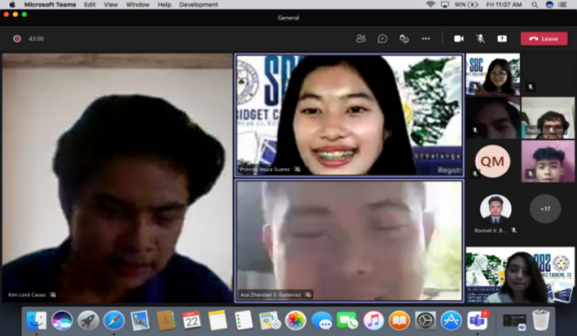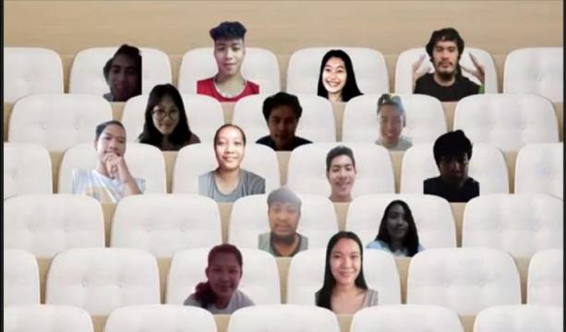The activity was started with an opening prayer led by Ms. Irish Nicole Garcia, BYTES Secretary. Followed by an opening remark of Engr. Leonardo Pedraja, our club chairperson. He gave his warm welcoming remarks to all members of BYTES Club especially to the first-year students. Mr. Ronnel Bautista, BYTES President emphasizes the meaning and the objective of the BYTES club. He also discussed the proposed project for the members. After the introduction of the club, the officer prepared a video from the former IT students at St. Bridget College. The video contains the advice and experiences that they encounter. For the socialization of the member, the officer prepared a wheel of name game. The host of the event facilitate the game. There are 2 wheels for the game. The first one contains all the names of the member and the other wheel consist of all the dares that the member should do. After the game, the officer prepares and present a video consisting of the memories that the IT students created during the face to face and the picture of the new member of the club for their recognition. After that is the part to of the game.

**The Bytes members and officers having a**

**photo opportunity before and after the event.**

Followed by an inspirational and closing remarks of Mr. Ace Zheridan Gutierrez, our club moderator. He inspired us to continue what we start. We had our closing prayer led by Ms. Angeli Parsaso, BYTES Treasurer to officially close our program.

*Prepared by:*

_____________________

**Irish Nicole Garcia**

*Former BYTES Secretary*

*Checked by:*

____________________

**Ronnel Jr. D. Bautista**

*Former BYTES President*

*Noted by:*

_____________________

**Mr. Ace Zheridan S. Gutierrez**

*BYTES Moderator*

**ACTIVITIES**

**OF**

**November**

**Webinar: Webinar (Capstone Vs Thesis)**

This Seminar is a recorded seminar that the officer provides to help our co student to start their Capstone. The exact date of this seminar is October 9, 2021, and the time is 8:00 am to 12: 00 pm. We Play this recording on November 19, 2021, Friday @ 9:30 am in MS Teams. We start with the opening prayer that lead by Ms.Giselle Manalo our Vice president. The Second Mr. Ronnel Jr. D Bautista our President give Introduction on what really will happen that day and the this that our co Student will get when they Finish that Seminar.

The Guess Speaker of this seminar is Dr. Roselie B. Alday she is a Dean in College of computer studies in LPU Batangas. Dr. Roselie Alday shares the experiences and the things to consider when making our capstone. Dr. Roselie also talks about the difference between capstone and thesis also she also gives some advice on what an Information Technology student should get when getting or choosing their Capstone.

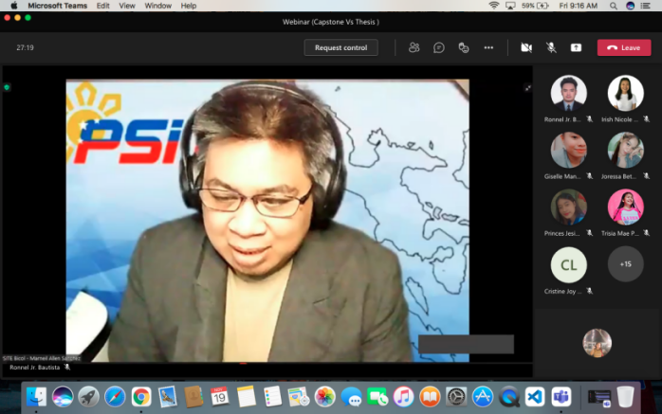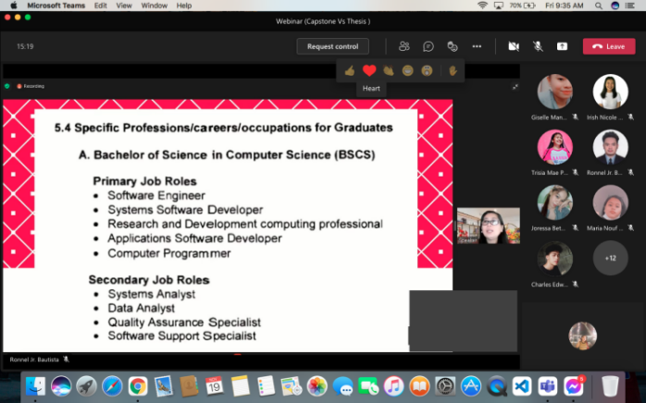 Dr. Rosalie shares some experiences when checking the capstone of the student. She also shares some websites that could help the students to find some information about their research. She also Demo how to use a google scholar this website can help student to find their research. We end this Meeting with the Closing prayer that led by Ms. Angeli Parsaso.

**Introduction of the speaker and topics to be covered.**

*Prepared by:*

_____________________

**Irish Nicole Garcia**

*Former BYTES Secretary*

*Checked by:*

____________________

**Ronnel Jr. D. Bautista**

*Former BYTES President*

*Noted by:*

_____________________

**Mr. Ace Zheridan S. Gutierrez**

*BYTES Moderator*

**GENERAL NARRATIVE OF BYTES CLUB**

The first event that BYTES Club Officers and Mr. Ace Zheridan S. Gutierrez the BYTES club moderator made is the General Meeting with Socialization of the Bytes Club. This Event Happens, October 22, 2021, Friday and this meeting is about the plans of what activities that Bytes Officers Offer to the student of Bytes Club. For our Socialization, this also happened on the same date of the general meeting and the goal of this Socialization is to know other members by the used of games, events and with awesome prizes.

The month of November, the Bytes Club created another Event entitled Webinar: Capstone Vs Thesis. This event is a recorded seminar that Bytes Officers provided. This event happened, November 19, 2021, 9:30 am thru MS teams. The Objective of this event are to share the difference between Capstone and Thesis, how to formulate a Capstone Proposal for an BS in Information Technology and also the last is the demo of how to use a website named Google Scholar that student taking the subject of research.