Ki Duck Kim, Bowen Zhuang, Cameron Huebner

PROFESSOR: Russell Foubert

April 24, 2015

Myo arm band

Project Development - Capstone Project

1. Diagrams 2

1.1 Use Case Diagram 2

1.2 Sequence Diagram 3

1.3 System Diagram 6

2. DB Schema 7

3. Setup Document 8

4. Test Plan 9

4.1 Unit Test 9

4.2 Integration Test 9

# 1. Diagrams

## 1.1 Use Case Diagram

This is the Use Case Diagram.

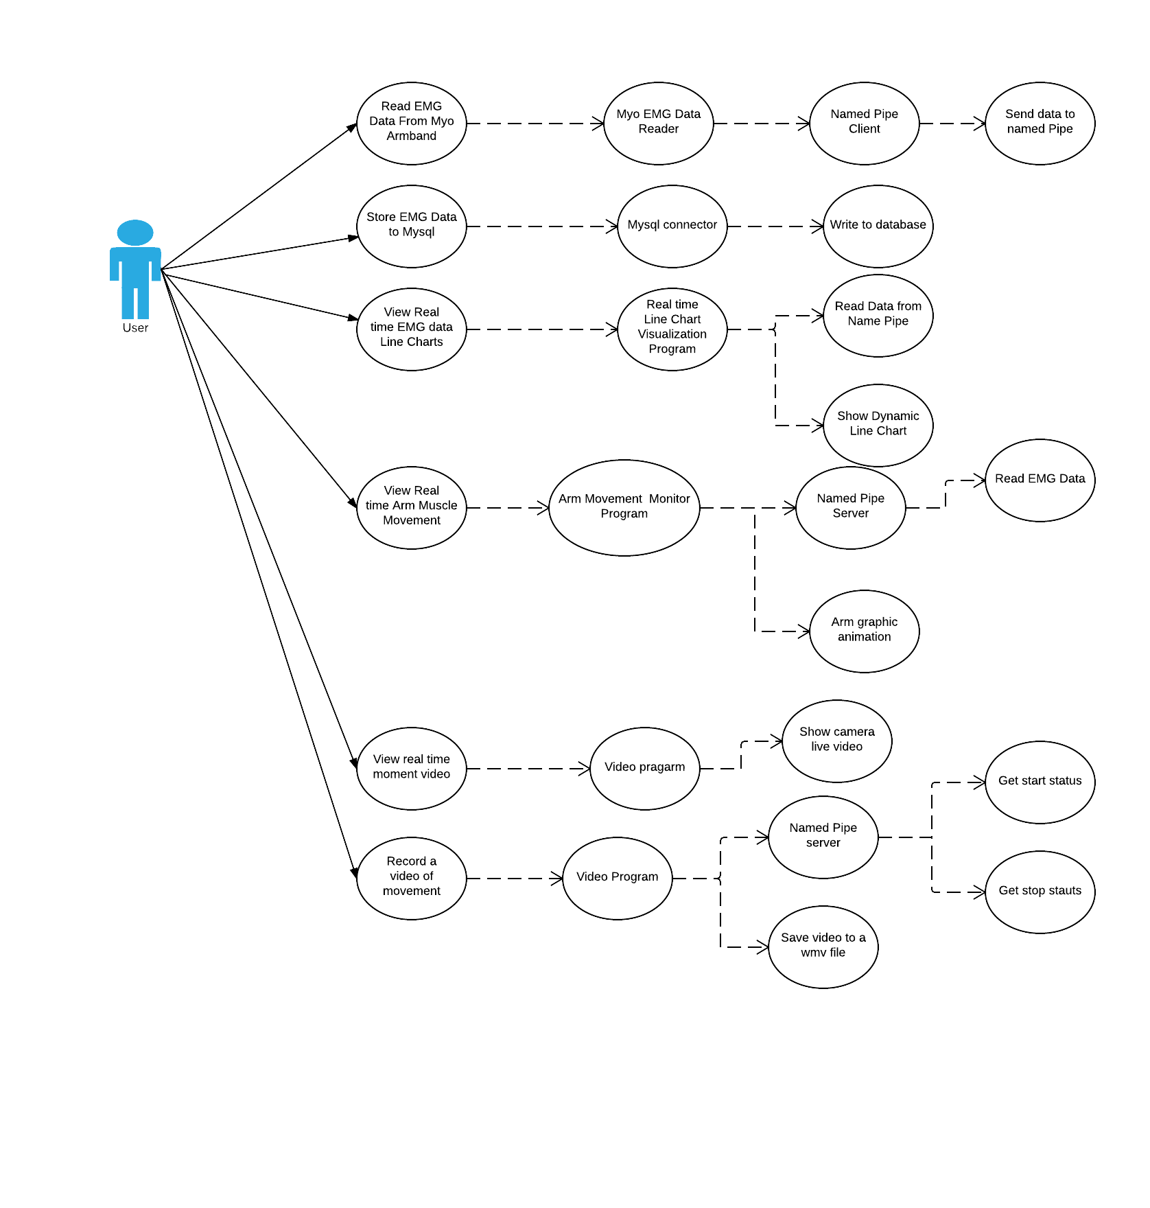

Picture 01. Use Case Diagram

## 1.2 Sequence Diagram

This is Visualization Sequence Diagram

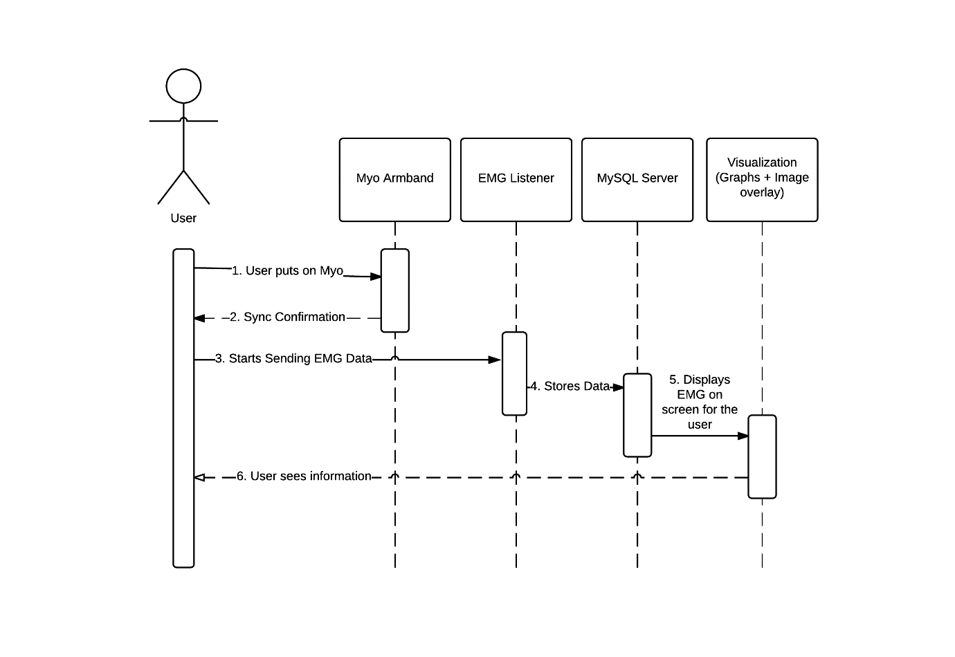

Picture 02. Visualization Sequence Diagram

This is the Diagram of Video Editing

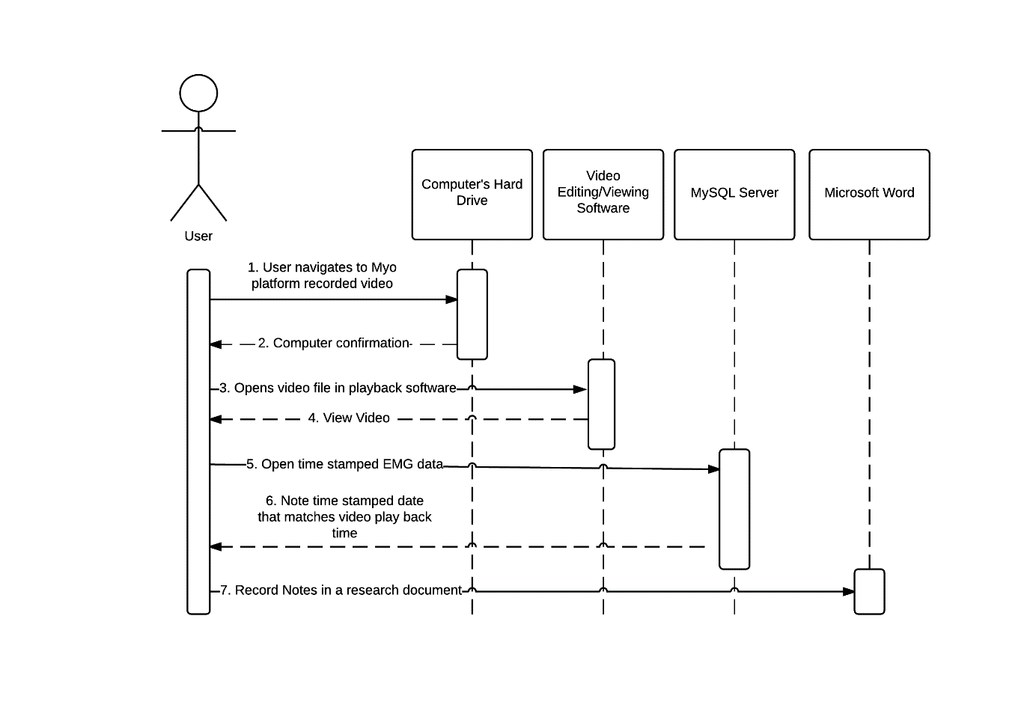

Picture 03. Video Editing Sequence Diagram

This is the Sports Sequence Diagram

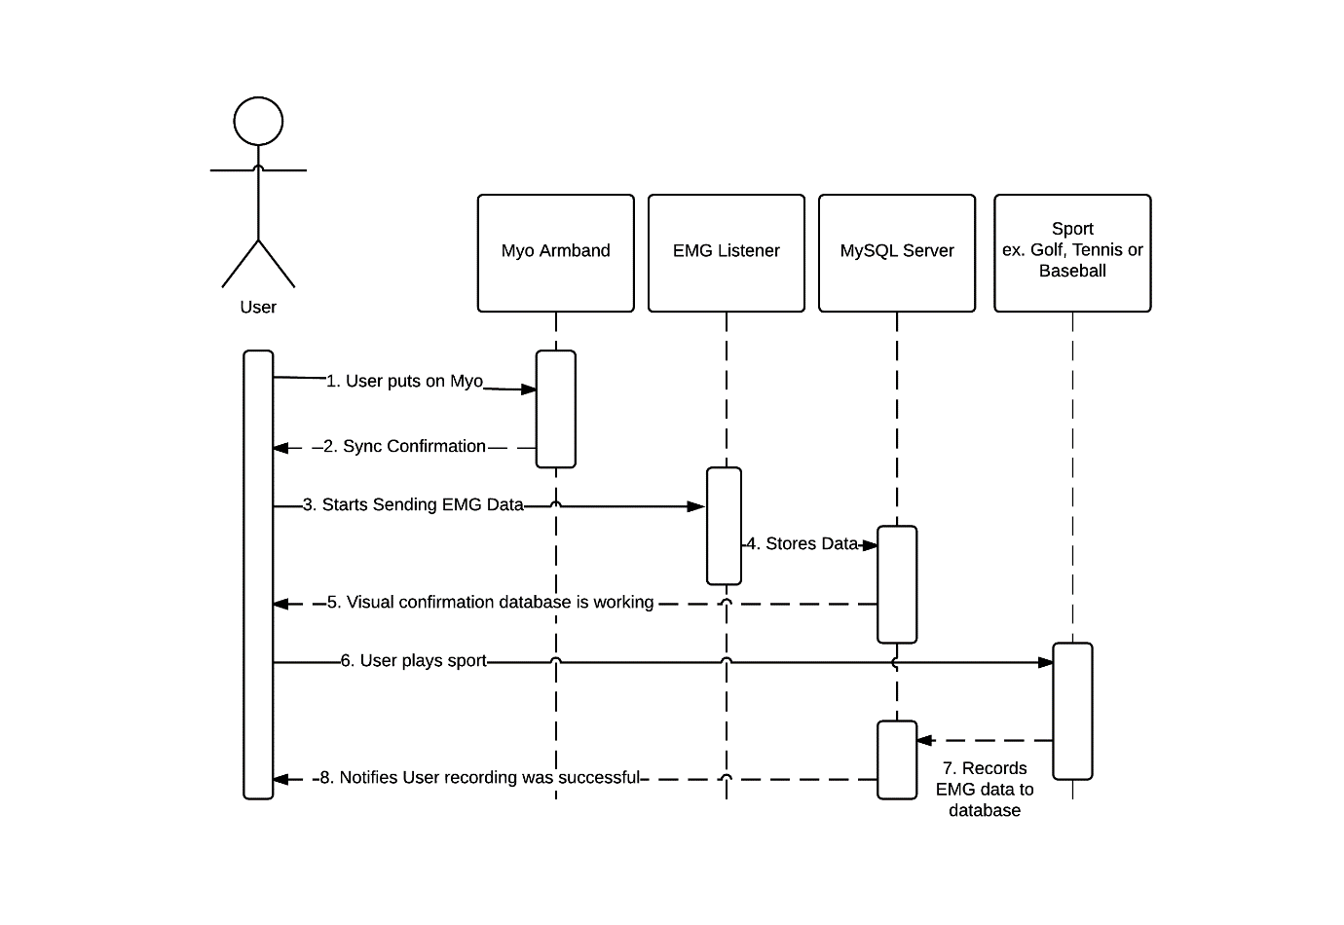

Picture 04. Sports Sequence Diagram

## 1.3 System Diagram

This is the System Diagram

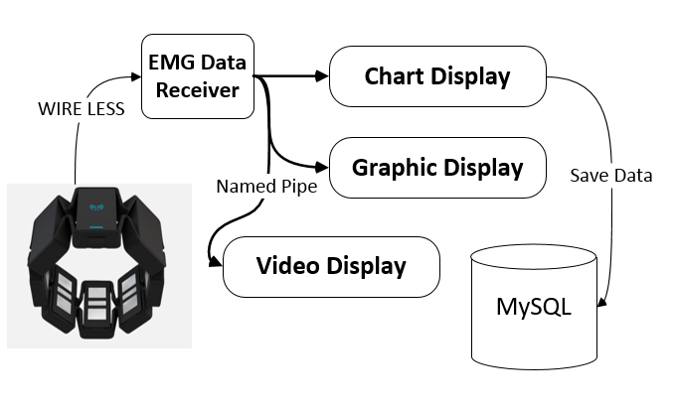

Picture 05. System Diagram.

# 2. DB Schema

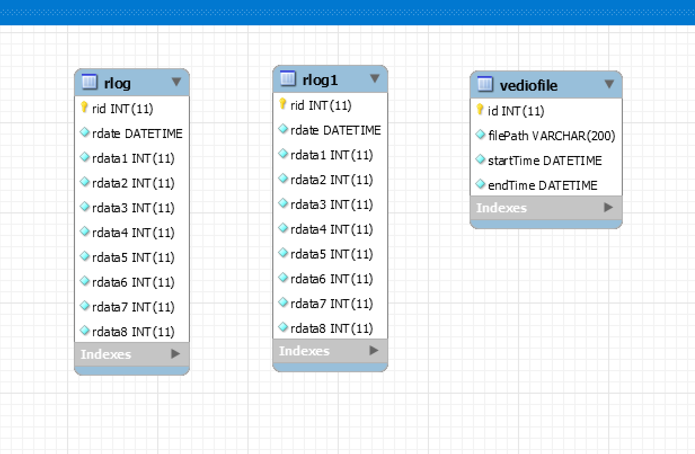

Picture 06 Database Schema

# 3. Setup Document

Initial setup for MYO Armband need to install **Myo Connect Installer.exe**

This program installs the connection library to OS.

MYO Armband program has 4 modules.

1. Myodata

It is the sample program of MYO library. I add the module of inter process communication.

The execution program are consist of **emg-data-sample-VisualStudio2013.exe** and **myo32.dll**

The folder name is myodata.

1. EMG Visualizer

This is a visualizer program, it has the modules of **OpenTK.dll** and **opentk.exe**.

This program need the image of arm it exist in **Content** subfolder.

The folder name is EMG Visualizer

1. PD-Myo2

This is a charting program, it has the module of **GraphLib.dll** and **pd-myo.exe**

The folder name is pd-myo2.

1. Video

This program shows the camera videos.

It includes these modules: **AxInterop.WMPLib.dll, Camera_NET.dll, DirectShowLib-2010.dll, Interop.WMPLib.dll** and **VedioQuiz.exe**

The folder name is Video

There is a folder named “execute module”, include all executable programs.

This is the order of running, the order of running is important because we use named pipe for inter process communication.

* Opentk.exe : display the visualization program
* VedioQuiz.exe : display video.
* pd-myo.exe : display chart.
* emg-data-sample-VisualStudio2013.exe : connect with Myo and start to send data to other program (This program should run at last, because this module open named pipe on starting part, if there are not exist the named pipe opened, then the program occurs error and quit).

# 4. Test Plan

## 4.1 Unit Test

|  |  |  |
| --- | --- | --- |
| Test No | Module | Description |
| UNIT-EMG-01 | EMGDATA | Retrieve the EMG data and display to the screen |
| UNIT-EMG-02 | EMGDATA | Save the EMG data to the file |
| UNIT-CHART-01 | PD-MYO | Read EMG data from file, display to chart |
| UNIT-VISUAL-01 | OPENTK | Read EMG data from file, display to visualization |
| UNIT-VIDEO-01 | VIDEO | Show current image from camera. |
| UNIT-CHART-02 | PD-MYO | Read EMG data from file, save data to MySQL database |
| UNIT-CHART-03 | PD-MYO | Read EMG data from MySQL database and display |

## 4.2 Integration Test

|  |  |  |
| --- | --- | --- |
| Test No | Module | Description |
| INT-CHART-01 | PD-MYO | Create Named Pipe Server |
| INT-CHART-02 | PD-MYO | Read data from Named Pipe |
| INT-CHART-03 | PD-MYO | Display to chart and save to MySQL database |
| INT-VISUAL-01 | OPENTK | Create Named Pipe Server |
| INT-VISUAL-02 | OPENTK | Read data from Named Pipe |
| INT-VISUAL-03 | OPENTK | Display data to Visualization |
| INT-EMG-01 | EMGDATA | Open Named Pipe |
| INT-EMG-02 | EMGDATA | Write the data to Named Pipe |
| INT-CHART-04 | PD-MYO | Set window location |
| INT-VIDEO-01 | VIDEO | Set window location |
| INT-VISUAL-04 | OPENTK | Set window location |