# INTRODUCTION

## OBJECTIVES

**General Objective**

1. To identify the layout of the chemical manufacturing industry involving different departments and to design a chemical manufacturing industry system to monitor and maintain parameters with surrounding environment.

**Specific Objectives**

**Assignment Task 1**

1. To monitor the parameters of input raw materials.

2. To simulate sequential flow process.

3. To account and simulate the dispatch of manufactured products.

**Assignment Task 2**

1. To report events to headquarters via writing to Excel file.

2. To use web publishing tools to make the system monitorable from anywhere in the world.

3. To update the price of raw materials according to the world market.

# THEORY

## Background

Nitric acid (HNO3) is a strong inorganic acid. Nitric acid may be a transparent colorless, or yellowish fuming hygroscopic corrosive liquid (PubChem). The acid is corrosive to metal and tissue, with a boiling point of 181°F at 760 mm Hg and melting point of -44°. The acid is produced in large-scale, traditionally finding the highest application in production of fertilizers (75%), followed by explosives (15%) (Committee, 1964).

A concentration of 68% is popularly commercially available. Nitric acid of 68-95% concentration is referred to as red fuming nitric acid, and is commonly used in rocket fuel industry. Nitric acid above 95% concentration is referred to as white fuming nitric acid, and finds application in etching (chemicalengineeringworld, 2020).

## Production

Nitric acid is essential produced from oxidation of ammonia in the Ostwald process. This process comprises of three main stages:

* Oxidation of ammonia in presence of catalyst to yield nitrogen monoxide
* Oxidation of nitrogen monoxide to yield nitrogen dioxide and nitrogen tetraoxide
* Absorption of nitrogen oxides in water to yield nitric acid

Stage 1: Oxidation of ammonia

First, liquid ammonia is vaporized and filtered to remove traces of impurities. Air is preheated and compressed. Gaseous ammonia is mixed with air in a mixer, then passed on to a converter. Platinum or platinum-rhodium catalyst is used in the converter. In the presence of the catalyst and at optimum conditions of 920°C and 1-1.14 atm, ammonia is oxidized in the presence of oxygen to primarily yield nitrogen monoxide (chemicalengineeringworld, 2020).

4*NH*3+7*O*2→4*NO*+6*H*2*O*

Stage 2: Oxidation of nitrogen dioxide

The product of stage 1, nitrogen monoxide, is first cooled in a first chamber. Further cooling in a second catalytic chamber results to the oxidation of nitrogen monoxide to nitrogen dioxide and nitrogen tetraoxide.

4*NO*+2*O*2→2*NO*2+*N*2*O*4

These gases are passed through a condenser. A small amount of nitric acid is obtained from this, with the bulk of the gasses being passed to the top of an absorption tower.

Stage 3: Absorption of nitrogen oxides in water

A stream of water input is fed to the top of the absorption tower. The oxides of nitrogen dissolve in this, to yield nitric acid which is tapped from the bottom of the tower. The water level is regulated such that the concentration of nitric acid is maintained near 60%.

4*NO*2+2*H*2*O*+*O*2→4*HNO*3

# METHODOLOGY

## Software Used

NI LabVIEW

## Requirements

1. The system is to monitor parameters for input materials and utilities.

2. The system is to simulate sequential flow process.

3. The system is to account for and simulate the dispatch of output product.

4. The system is to report events to the headquarters via the use of Excel file.

5. The system is to use web publishing tools to make the system monitorable from anywhere in the world.

6. The system is to keep track of the world prices of input raw materials via the use of Data Sockets.

## Operating Parameters

The following where the limits of the acceptable parameter values for each utility used in this system. The values were chosen to offer a tolerance around a given optimum value.

|  |  |  |
| --- | --- | --- |
| **Utility** | **Parameter** | **Acceptable Range** |
| Vaporizer | Ammonia flow rate | 3 - 7 |
| Air compressor | Air flow rate | 3 – 7 |
| Converter | Temperature | 850 – 1000 |
| Pressure | 1 – 1.8 |
| Cooler | Temperature | 120 – 180 |
| Condenser | Temperature | 30 – 80 |
| Absorption Tower | Pressure | 9 -11 |
| Water Flow Rate | 3 – 7 |

Table 0.1 - Operating parameters

## Flow Charts

This section develops the flowcharts guiding the logic of the system through various stages.

|  |  |
| --- | --- |
| **Overall System Flowchart**    Figure 1 - System flowchart | **Tank Filling from Absorption Tower**    Figure 2 - Tank filling flowchart |

The overall system flowchart depicts the overall required functionality of the system. The input to the plant is ammonia and air, the output being nitric acid. The tank filling flowchart shows the logic used to simulate the filling of the storage tank with nitric acid obtained from the absorption tower.

|  |  |
| --- | --- |
| **Acid Dispensing Flowchart**    Figure 3 - Acid dispensing flowchart | **Fault-Reporting Flowchart**    Figure 4 - Fault-reporting flowchart |

The acid dispensing flowchart shows the logic designed to simulate the dispensing of nitric acid from the storage tank via the output valves. Two valves (Valve 1 and Valve 2) are considered in this project. The fault-reporting flowchart shows the basic logic needed in order to enter a fault record into an Excel file to be used for reporting to the headquarters.

|  |  |
| --- | --- |
| **Data Socket Flowchart**    Figure 5 - Reading raw material price flowchart |  |

The logic for reading the current market price for raw materials is shown above. Data Sockets are used to accomplish the desired goal.

# IMPLEMENTATION

## 1. Main Program VI

This is the main program. It contains the front panel controls, indicators, graphical representations of utilities and their logics as well.

**Front panel**

The overall front panel view and controls of the Nitric Acid manufacturing plant is shown below.

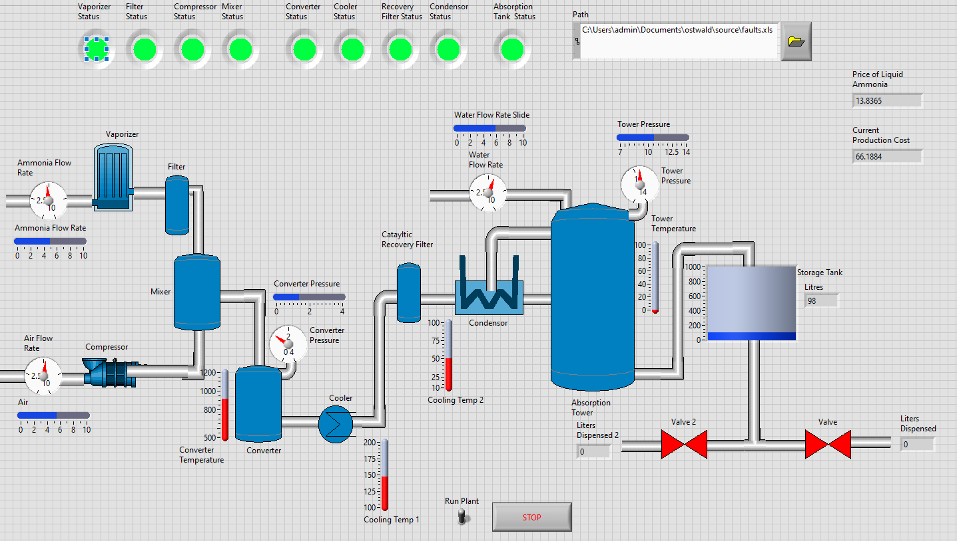

Figure 6 - Front panel

The system is comprised of:

* Vaporizer with liquid ammonia input flow rate being metered
* A filter having vaporized ammonia as input
* An air compressor with the air input flow rate being metered
* A mixer
* A converter with the process temperature and pressure being metered
* A cooler with its temperature being metered
* A catalytic converter
* A condenser with its temperature being metered
* An absorption tower with its temperature, pressure and water input flow rate being metered.
* A storage tank with the volume of store nitric acid being metered
* Two output valves drawing nitric acid from the storage tank

**Block Diagram**

The complete block diagram of the main program VI is shown in figure 7 below.

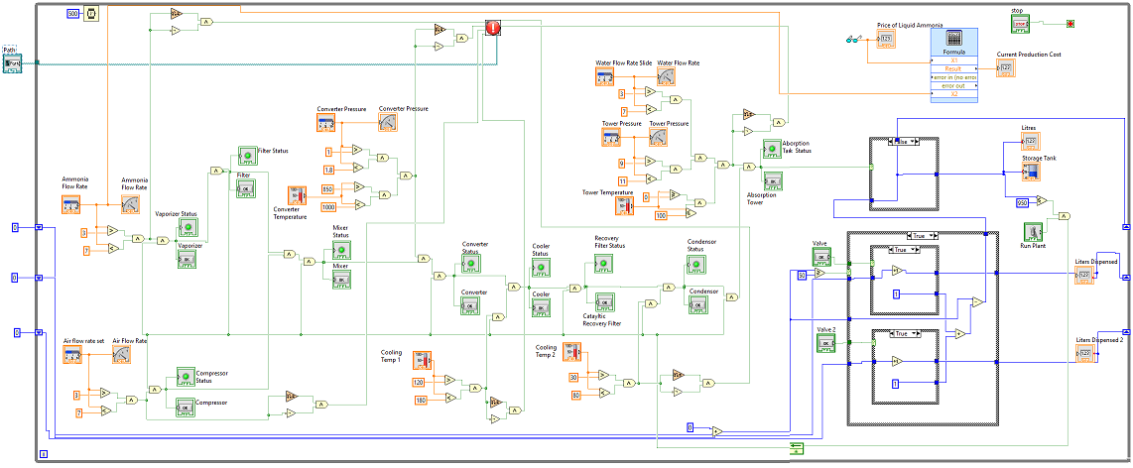

Figure 7 - Main Program VI block diagram

The redacted sections of the complete block diagram are as follows:

A horizontal fill slide was used as control to simulate varying input air flow rates. A guage was used as an indicator to display this value. A “greater than function” was used to check if the input was greater than the minimum pre-set threshold of 3, and a “less than function” to check if the flow rate is below the upper limit of 7. The results of these two comparisons where ANDed, and together with the status of the run plant switch, used to turn on or off the vaporizer. The logic of monitoring ammonia flow rate follows a similar design.

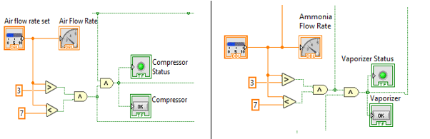

Figure 8 - Left: Compressor parameters monitoring, Right - ammonia input monitoring

In a similar comparison fashion as described for the flow rates, the converter pressure and converter temperature parameters were monitored if within operational limits via the use of comparison functions and Boolean function. The water input flow rate, tower pressure and pressure were monitored in a similar fashion.

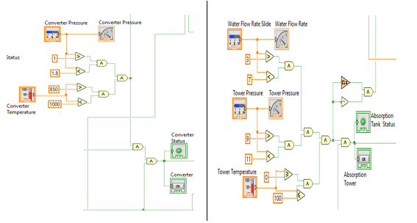

Figure 9 - Left: Converter parameters monitoring, Right - Absorption tower parameters monitoring

The temperature of the cooling chamber and converter were monitored using comparison functions and Boolean functions.

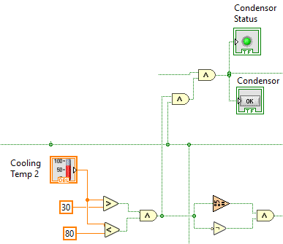

Figure 10 - Condensor parameters monitoring

A case structure was used in simulating the filling in of the storage tank (upper-most case in figure 11. The test condition for this structure was the status of the absorption tower. If the absorption tower was in operation, the level of the tank (tracked by a shift register) was incremented by two. If the absorption tower was offline, the value of the tank remained the same.

Nested case structures were used to keep track of the dispensed nitric acid and consequently update the level of the storage tank as shown in figure 11. The test condition of the outer-most case structure was the result of the comparison of the current tank level and a pre-set lower limit of 50. If the tank level is less than 50, the valves are barred from dispensing the acid, and the tank level isn’t changed in that case structure as shown in figure 12.

If the tank level is greater than 50, the condition of each valve is evaluated in the inner case structures. If a valve is on, the amount of acid dispensed by it is incremented by one, and the current tank level correspondingly decremented by one. The decrementing of the tank level is done after the inner case structures pass control back to the higher case structure, which performs the decrement from the original tank level by considering the constants tunneled to it from the inner case structures.

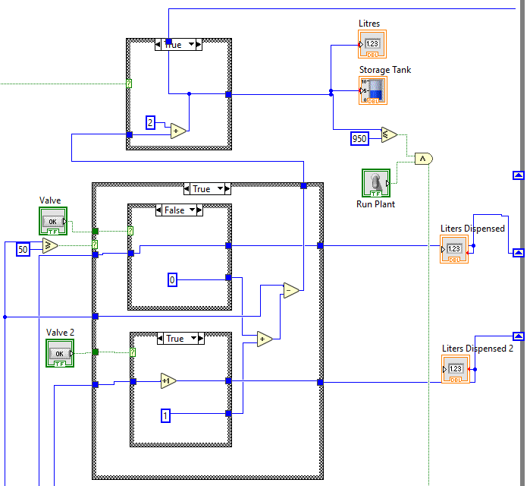

Figure 11 - Tank input and valve output section

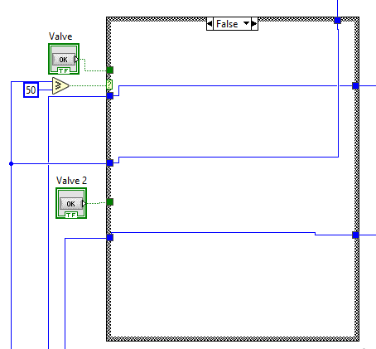

Figure 12 - Tank level less than 50 - deny dispensing

**Input Raw Material Price Update**

The current market price of liquid ammonia is fed into the main program VI via the data-socket VI. The output from this VI is fed to an indicator on the front panel. The current production cost is calculated as the product of the input market price and the ammonia input flow rate summed by a constant price for water input.

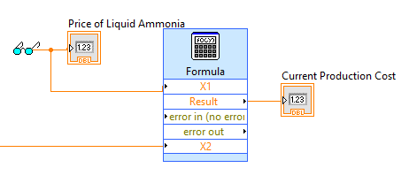

Figure 13 - Liquid ammonia market price update section

**Faults Reporting**

Reporting of faults from the main program is accomplished via the incorporation of the Fault-Reporting VI. The inputs to this are the status of the vaporizer, air conditioner, converter, cooler, condenser and absorption tower.

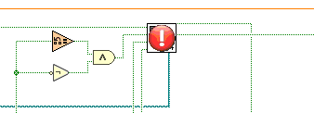

Figure 14 - Fault reporting section

## 2. Fault-Reporting VI

This VI is designed to report faults encountered in the system to the headquarters via an Excel file. The VI reports faults experienced by the vaporizer, compressor, converter, cooler, condenser and absorption tower (when parameters stray away from the acceptable limits).

**Block Diagram**

The block diagram to the VI is shown.

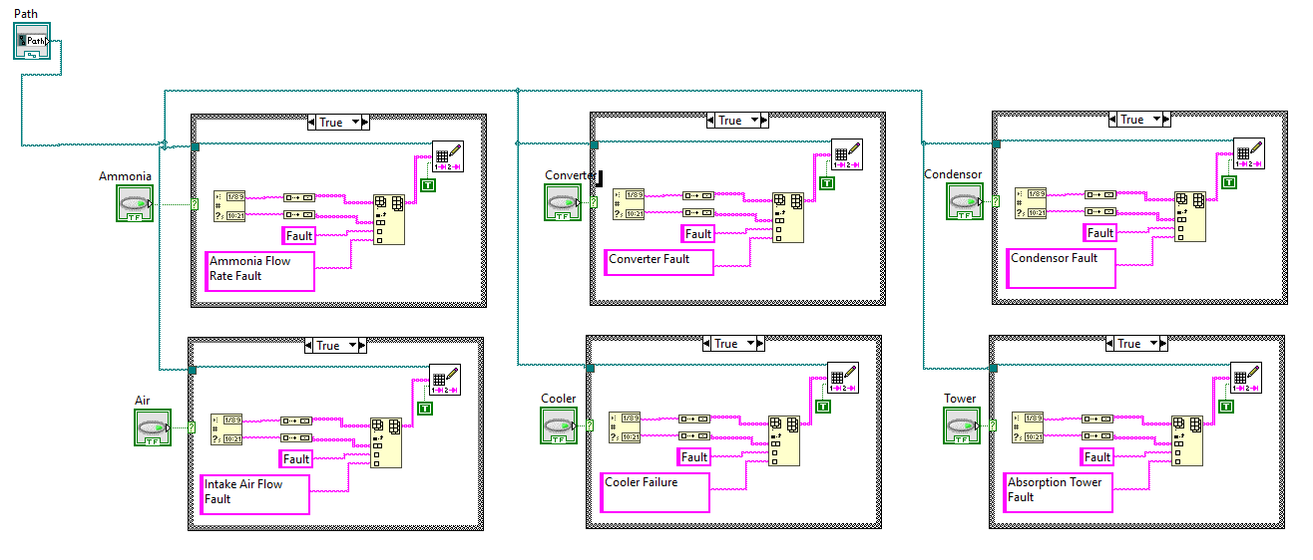

Figure 15 - Fault-Reporting block diagram

The input to the VI are the file path to the Excel file, and Boolean inputs of fault status. If a fault exists on a utility, the Boolean input to its corresponding case structure for reporting its error is true. This logic is accomplished by the following block:

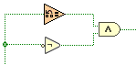

Figure 16 - Logic for checking for utility fault

The status for a utility being observed for faults is fed to a NOT gate and a value change detection function. If the status of the utility is FALSE, this is negated to TRUE by the not gate. If a value change has been noted in that iteration instance of the WHILE loop, then the fault has just occurred and hasn’t been previously noted. Its corresponding reporting case test condition is then driven to TRUE, executing the writ to Excel file for the utility’s fault.

Inside the case structure, the Date and Time are obtained from a “get Date/Time String” object. The type of fault and description of the fault are defined as strings. An array is built from these four variables, and written to the Excel file via “Write Delimited Spreadsheet” function.

## 3. Data Socket VI

This VI is used to read the market price of the raw materials used in the nitric acid manufacturing process (ammonia in this case).

**Block Diagram**

The block diagram for the VI is shown.

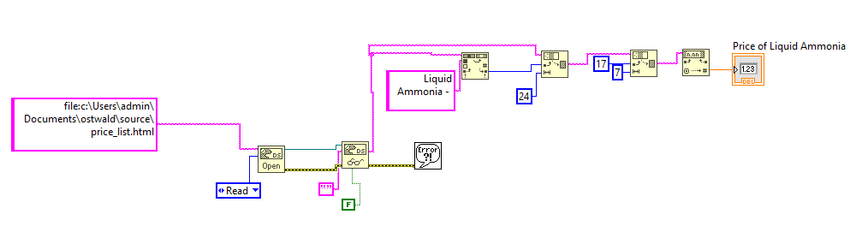

Figure 17 - Block diagram for data socket function for reading price of ammonia

A Data Socket Open function is used to open the file specified in the URL in READ mode. The file protocol is used in this case to read a file found on the local machine containing the prices. The contents of this file are read via a Data Socket Read function. The offset of the keyword “Liquid Ammonia – “ (as precedes the value of the market price in this case), is used by a first Substring function to truncate the whole data read to just “Liquid Ammonia – XX.XXXX” (where XX.XXXX denotes the market price of ammonia). This string is the chopped to just XX.XXXX by a second Substring function (with 17 being the offset to begin the chop and 7 being the length of the 4-decimal price). The resultant string is then converted to a Float, and availed for output.

**Price-Generation Program**

For this project, an HTML file found on the local machine was used to simulate the market price information. This HTML file is read with every iteration of the Main Program VI while loop. In order to generate a dynamic file, the HTML file was generated programmatically via a Python script. The script was designed to generate random numbers within a given range for the market price of liquid ammonia, alongside other dummy products (liquid nitrogen, oxygen and hydrogen). The script updates the HTML file with fresh prices every 10 seconds to simulate the dynamic market prices. The Python script is shown,

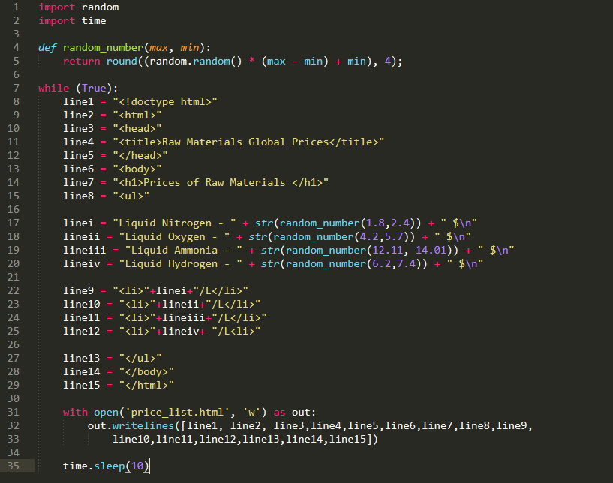

Figure 18 - Price-Generator Python script

## Web Publishing

The front panel was made accessible using web publishing tool to enable remote monitoring and control of the plant. The sequence of steps involved in this configuration using the Web Publishing Tool is shown below.

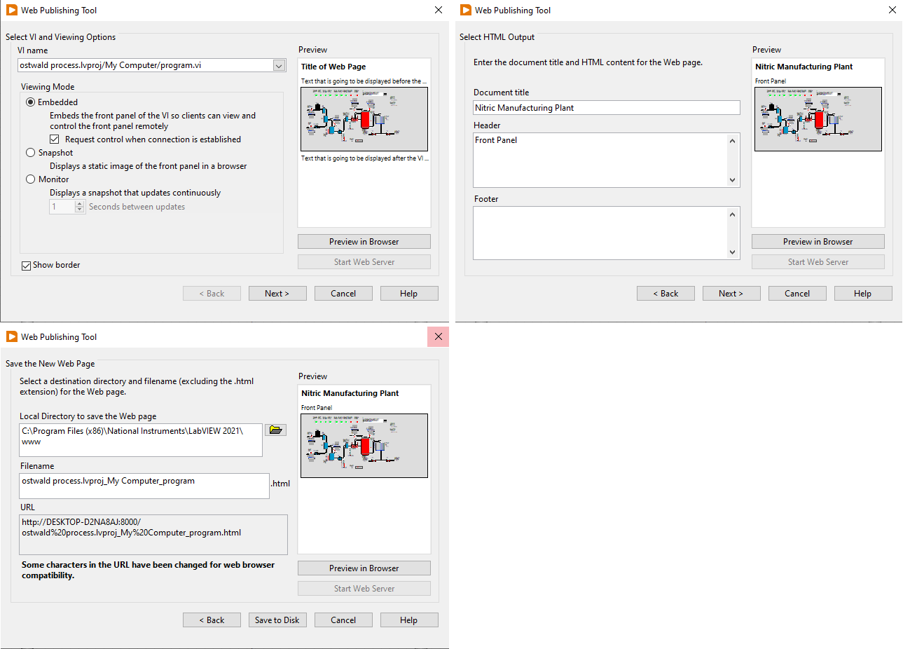

Figure 19 - Sequence of steps for publishing main panel

# RESULTS

This section documents the results of the development and testing of the nitric acid manufacturing plant in accordance with the laid-out objectives.

## Monitoring Input and Utility Parameters

The vaporizer, air compressor, converter, cooler, condenser and absorption tower had their parameters monitored. A thermometer control and a guage indicator were used to display the temperature and pressure of the relevant utility respectively. A horizontal fill scale control was used to simulate variation in pressure. A deviation of operating parameters outside defined acceptable limits resulted to a fault generation (utility turned red from normal blue fill) as shown.

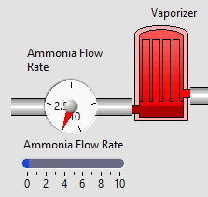

Figure 20 - Ammonia Input Monitoring

## Sequential Flow

A faulty utility resulted to cascaded turning off of other utilities down the line until the source fault was corrected. This sequential operation was conducted in order to prevent the use of faulty input products by the utilities down the production path.

## Output Dispensing

The output to this system was the volume of nitric acid. Two valves were used in this case for dispensing the acid from the storage tank. A valve could only dispense acid provided the level of the tank was greater than 50. Numeric indicators displayed the amount of acid dispensed from each valve. The sample snapshot taken previously showed a case were valve 1 was turned on while valve 2 turned off. Valve 1 had dispensed 61L of acid by that instance with valve 2 correctly having dispensed no acid.

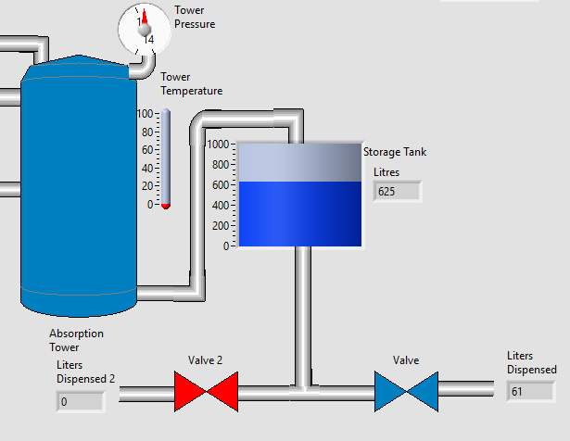

Figure 21 - Product dispensing (Valve 1 open, vale 2 closed)

## Event Reporting

An Excel log was kept for the faults experienced for each utility during the operation of the plant. A faulty (or turned off) utility was visually shown in the front panel by a red solid fill. LEDs at the top of the front panel also displayed the affected utilities. This is shown below.

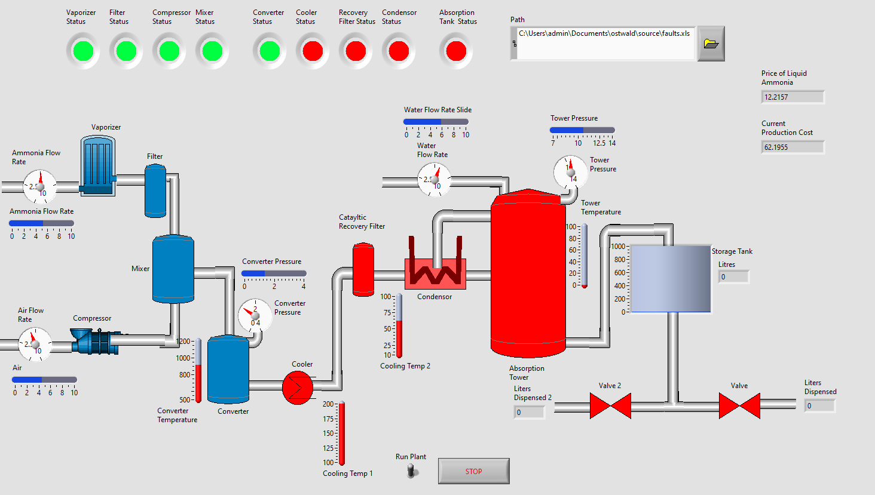

Figure 22 – Sample fault origin at cooler and cascaded turning off of utilities

The Excel log stored the date, time, type of log (only a default “fault” catered to in this system), and description of the fault. A fault was triggered when the operating conditions of the utility parameters veered off acceptable limits. A sample snapshot of the Excel log from simulated faults is shown below.

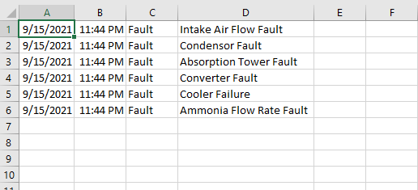

Figure 23 - Sample fault report

## Raw Materials Price Update

The front panel indicator displayed the dynamic market price of liquid ammonia. The current production cost was displayed as expected from the design and implementation.

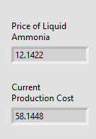

Figure 24 - Sample global price of liquid ammonia and calculated cost of production

## Web Publishing and Monitoring

The main panel was published using the Web Publishing Tool. The plant was then accessed via Internet Explorer browser. The browser took over control of the plant, enabling the user to observe the status of various utilities, and simulate varying conditions from the browser as would be performed in the corresponding physical environment.

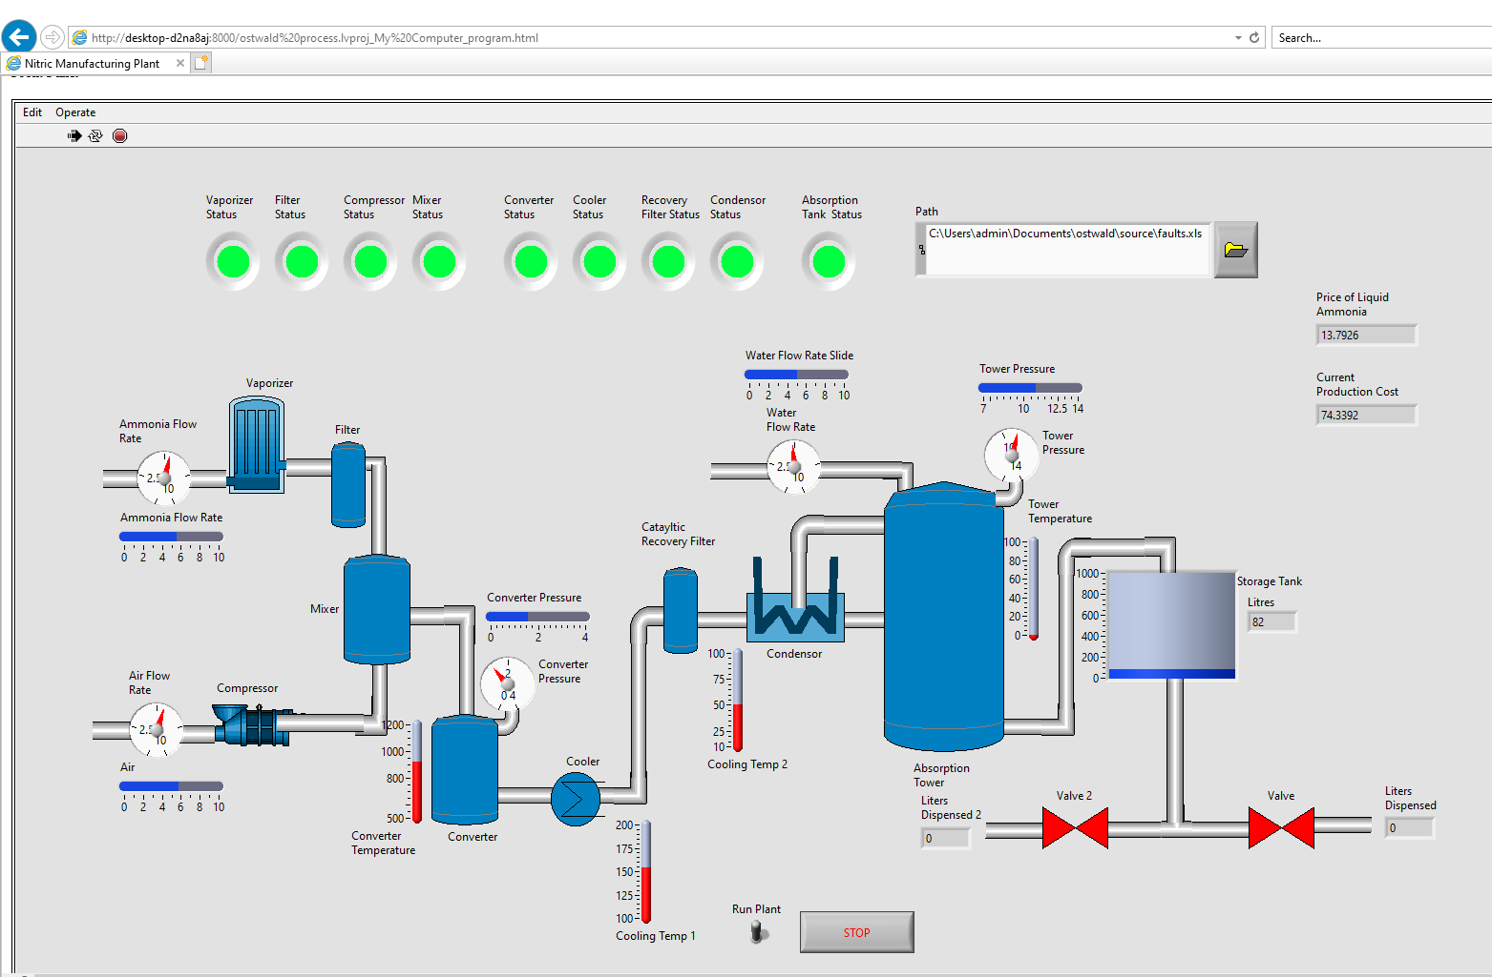

Figure 25 - Monitoring and control from the web

# DISCUSSION

This section seeks to provide an appraisal of the system developed. The discussion of this chapter follows the objectives laid-out for the development.

The following three operations were achieved in the main program VI:

## Monitoring Input Parameters

The input raw material to the nitric acid manufacturing plant is: liquid ammonia, air and water. The flow rates of these materials are simulated using horizontal slide scales as the control objects. For each flow rate, a gauge was used as an indicator to visually monitor the input. The precise optimum flow rates were, however, not previously obtained in the literature review. As such, arbitrary limits were assumed for simulation purposes.

In addition to the inputs, the operating conditions of other plant utilities were monitored. Pressure and temperature were popularly monitored, in order to ensure that the given utility operated in an acceptable range. A thermometer control was used to simulate the utility temperature. A horizontal slide scall was used as the control to simulate the current operating pressure of a given utility, with a corresponding gauge used as an indicator.

When a particular utility was operating in acceptable conditions, the utility was visually represented by an object with a solid blue fill. If either the operating conditions of the utility veered from the acceptable range, or a cascaded utility behind the utility registered a fault, the utility was visually reported to be in an faulty state by a solid red fill.

The monitoring of parameters whether in acceptable range or not was accomplished by the use of comparison functions to test for limit conditions, and Boolean AND functions to get the combined result from each comparison.

## Sequential Flow

The operations of the plant utilities where dependent upon each other in a sequential manner. A utility could only be operational provided the utilities behind in in the production path where in operational state. A faulty utility (registered by a deviation of operating conditions outside acceptable range) resulted to a cascaded turning off of other utilities down the line dependent on the faulty utility. This design was employed in order to prevent the cascaded utilities from operating on erroneous inputs.

The cascading of utilities was accomplished by checking the status of a utility’s immediate previous neighbor, and performing a Boolean AND of this status with the results of the current utility’s operating range test, to yield the current utility’s current state.

## Output Dispensing

The output from this plant was nitric acid. Nitric acid produced from the plant was stored in a storage tank. The level of the storage tank increased while the absorption tank was in operation. When the level of the tank was at 950L, the plant was automatically turned off to avoid overfilling of the storage tank.

Nitric acid was dispensed in this plant via two valves. The valves could only be opened provided the level of the tank was above 50L. The level of the storage tank was decremented while a valve was in operation. Numeric indicators were used to indicate the volume of acid dispensed by each valve.

Case structures were used in the achievement of output dispensing. Nested case structures where particularly employed in the valve operations logic.

Separate Vis were used to achieve event reporting and reading of global prices of raw materials:

## Event Reporting

The events reported in this plant where the faults encountered in the operation of the plant. Vaporizer, air compressor, converter, cooler, condenser and absorption tower faults were reported in this system (when their operating conditions veered from acceptable limits). An Excel file was used to log these errors. Included in the log was the date, time, type and description of the fault.

Six case structures were used in the fault-reporting VI to log the corresponding faults for each utility mentioned above. The “Write Delimited Spreadsheet” function was used to write the log. Arrays were used to in this VI to write the faults to the spreadsheet in tabular form.

While this design provided a decent overview of the fault registered, the exact numerical value of the operating condition that triggered the fault was not able to be logged for this project.

## Raw Materials Price Update

The simulated global price of liquid ammonia was observed in this plant. This price was displayed on the front panel, and the cost of production at that instance of operation computed via a formula function based on the current price.

A “DataSocket Open” function was used to open a data socket to the file specified via the provided URL in READ mode. The FILE protocol was used to access the file, which was located on the local machine. The choice to have the file on a local host environment rather than on the web to be accessed via HTTP or a similar protocol was to provide an expedient implementation. A “DataSocket Read” function was used to read the contents of the file, after which subsequent string manipulation of the read data yielded the market price of the raw product.

To simulate the varying market prices of the raw materials, a HTML file was programmatically generated using Python every 10 seconds. With each generation, the price of the raw materials was set to random value between a predefine lower and upper limit.

## Web Publishing and Monitoring

The front panel to the main program VI was made available over the web via the use of the Web Publishing Tool. This enabled the plant to be monitored and controlled from the internet.

**Overall Appraisal**

The objectives defined for the system were met. In addition to this, multiple Vis, arrays, while loops, file write functionality and data sockets were used in the development of the system.

# CONCLUSION

This assignment set out to develop a nitric acid manufacturing process (in the Ostwald process) system. Thie objectives of the system were to: monitor the input parameters, simulate sequential flow, deliver output product, report events, read global raw input price via data sockets and enable monitoring of the plant from the web were met in this development.

Flow rate, temperature and pressure parameters for different utilities involved in the process were monitored in the system. The operation of the plant’s utilities was sequential, with a given utility down the production path being operational provided its operating conditions were within acceptable range and its immediately preceding neighbor in operational state. The output of this plant, nitric acid, was dispensed via two valves, and the amount dispensed by each shown on the front panel provided conditions were met. An Excel file was used to log faults encountered in the operation of the plant. The simulated global price of liquid ammonia was read using data sockets and displayed on the front panel. Finally, the plant was made monitorable over the web by using Web Publishing Tool to publish the main front panel.

# References

chemicalengineeringworld. (2020, Spetember 20). *Nitric Acid Manufacturing Process*. (chemical engineering world) Retrieved 09 06, 2021, from https://chemicalengineeringworld.com/nitric-acid-manufacturing-process/

Committee, T.-2. C. (1964). Nitric Acid Manufacture. *Journal of the Air Pollution Control Association, 14*(3), 91-93.

PubChem. (n.d.). *Nitric Acid.* Retrieved 09 05, 2021, from https://pubchem.ncbi.nlm.nih.gov/compound/Nitric-acid