Distribution of Public Service of Canada Employees by Designated Group and Region of Work

## checking if our r is working

print("Hello R world")

## Analysis of Table 2

### we are loading required libraries

Loading required libraries

#install.packages(c("readxl", "dplyr", "ggplot2", "tidyr"))  
library(readxl)  
library(janitor)

##   
## Attaching package: 'janitor'

## The following objects are masked from 'package:stats':  
##   
## chisq.test, fisher.test

library(dplyr)

##   
## Attaching package: 'dplyr'

## The following objects are masked from 'package:stats':  
##   
## filter, lag

## The following objects are masked from 'package:base':  
##   
## intersect, setdiff, setequal, union

library(ggplot2)  
library(tidyr)

### loading the data and cleaning the names

we are going to load the data for table 1 and display the first few rows, just to ensure that our data is loaded successfully

we also cleaned the data to use numbers only, excluding the percentages

library(readxl)  
tab02_eng <- read_excel("~/Documents/programming/R/velma/keira/tab02-eng.xls", skip = 4, n_max = 18)

## New names:  
## • `` -> `...4`  
## • `` -> `...6`  
## • `` -> `...8`  
## • `` -> `...10`

head(tab02_eng)

## # A tibble: 6 × 10  
## `Region of Work` `All Employees` Women ...4 `Aboriginal Peoples` ...6   
## <chr> <chr> <chr> <chr> <chr> <chr>  
## 1 <NA> Number Numb… % Number %   
## 2 Newfoundland and Labra… 2784 1177 42.2… 173 6.21…  
## 3 Prince Edward Island 1554 980 63.0… 44 2.83…  
## 4 Nova Scotia 8349 3567 42.7… 412 4.93…  
## 5 New Brunswick 6387 3572 55.9… 233 3.64…  
## 6 Quebec (without the NC… 20427 10669 52.2… 420 2.05…  
## # ℹ 4 more variables: `Persons with Disabilities` <chr>, ...8 <chr>,  
## # `Members of a Visible Minority Group` <chr>, ...10 <chr>

print(dim(tab02_eng))

## [1] 18 10

tab02_eng <- clean_names(tab02_eng)  
selected_colnames <- c("region_of_work", "all_employees", "women", "members_of_a_visible_minority_group","persons_with_disabilities" , "aboriginal_peoples")  
head(tab02_eng)

## # A tibble: 6 × 10  
## region_of_work all_employees women x4 aboriginal_peoples x6   
## <chr> <chr> <chr> <chr> <chr> <chr>  
## 1 <NA> Number Number % Number %   
## 2 Newfoundland and Labrador 2784 1177 42.2… 173 6.21…  
## 3 Prince Edward Island 1554 980 63.0… 44 2.83…  
## 4 Nova Scotia 8349 3567 42.7… 412 4.93…  
## 5 New Brunswick 6387 3572 55.9… 233 3.64…  
## 6 Quebec (without the NCR) † 20427 10669 52.2… 420 2.05…  
## # ℹ 4 more variables: persons_with_disabilities <chr>, x8 <chr>,  
## # members_of_a_visible_minority_group <chr>, x10 <chr>

subset_data <- tab02_eng[, selected_colnames]  
#subset_data <- filter(subset_data, !is.na(region_of_work))  
subset_data <- subset_data[complete.cases(tab02_eng$region_of_work), ]  
head(subset_data)

## # A tibble: 6 × 6  
## region_of_work all_employees women members_of_a_visible_minority…¹  
## <chr> <chr> <chr> <chr>   
## 1 Newfoundland and Labrador 2784 1177 52   
## 2 Prince Edward Island 1554 980 39   
## 3 Nova Scotia 8349 3567 490   
## 4 New Brunswick 6387 3572 154   
## 5 Quebec (without the NCR) † 20427 10669 1999   
## 6 NCR (Quebec) † 24333 13927 3162   
## # ℹ abbreviated name: ¹​members_of_a_visible_minority_group  
## # ℹ 2 more variables: persons_with_disabilities <chr>, aboriginal_peoples <chr>

### visualization of the data

1. Drawing a bar graph showing the different distrbutions of employees categories across regions
2. Converted the data to numerical data
3. Created a bar graph

subset_data <- subset_data %>%  
 mutate_at(vars(all_employees, women, members_of_a_visible_minority_group, persons_with_disabilities, aboriginal_peoples),  
 as.numeric)  
  
subset_data_long <- subset_data %>%  
 gather(key = "category", value = "value", -region_of_work)  
  
ggplot(subset_data_long, aes(x = region_of_work, y = value, fill = category)) +  
 geom_bar(stat = "identity", position = position_dodge(width = 0.8)) +  
 labs(title = "Population Distribution by Region of Work",  
 y = "Population") +  
 theme_minimal() +  
 theme(axis.text.x = element_text(angle = 45, hjust = 1)) +  
 scale_y_continuous(limits = c(0, 16000), breaks = seq(0, 16000, by = 1000))

## Warning: Removed 7 rows containing missing values (`geom_bar()`).

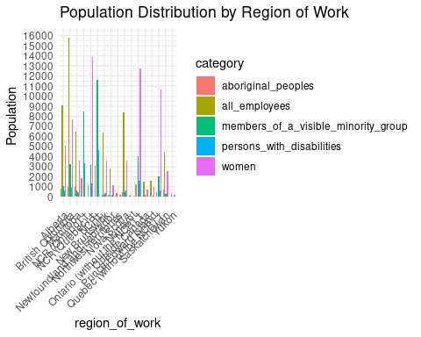

from the bar graph above you can see:

* that women are the second most employed across the different regions

1. distribution of employment across regions

ggplot(subset_data, aes(x = region_of_work, y = all_employees, fill = region_of_work)) +  
 geom_bar(stat = "identity") +  
 labs(title = "Number of All Employees by Region of Work",  
 x = "Region of Work",  
 y = "Number of All Employees") +  
 theme_minimal() +  
 theme(axis.text.x = element_text(angle = 45, hjust = 1))

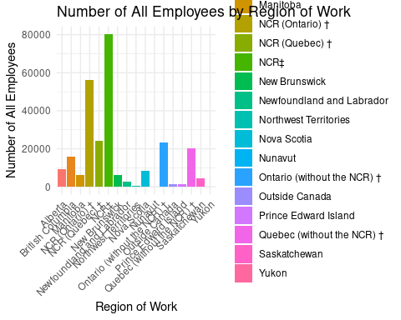

from the bar graph above you can deduce:

* there is a high rate of employment in NCR+ compared to other regions of work

1. Scatter plot for distribution of women across regions of work

ggplot(subset_data, aes(x = region_of_work, y = women)) +  
 geom_point() +  
 labs(title = "Scatter Plot Region of Work vs Women",  
 x = "Region of Work",  
 y = "Women") +  
 theme_minimal() + theme(axis.text.x = element_text(angle = 45, hjust = 1))

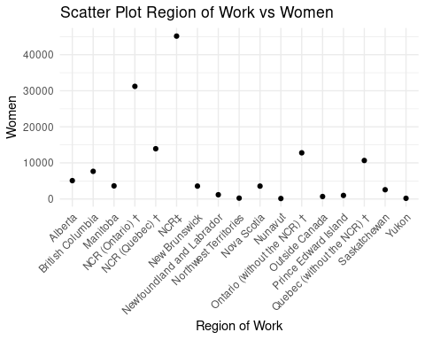

from the scatter plot above we can deduce:

* women employment is under 20,000 in various regions except for NCR‡

1. summary of how the employees are spread out

summary_data <- subset_data %>%  
 summarise(  
 all_employees = sum(all_employees),  
 women = sum(women),  
 members_of_a_visible_minority_group = sum(members_of_a_visible_minority_group),  
 persons_with_disabilities = sum(persons_with_disabilities),  
 aboriginal_peoples = sum(aboriginal_peoples)  
 )  
summary_data_long <- gather(summary_data, key = "category", value = "value")  
ggplot(summary_data_long, aes(x = "", y = value, fill = category)) +  
 geom_bar(stat = "identity", width = 1, color = "white") +  
 coord_polar("y") +  
 labs(title = "Pie Chart of Population Distribution",  
 fill = "Category") +  
 theme_minimal() +  
 theme(axis.text = element_blank(),  
 axis.title = element_blank(),  
 panel.grid = element_blank())

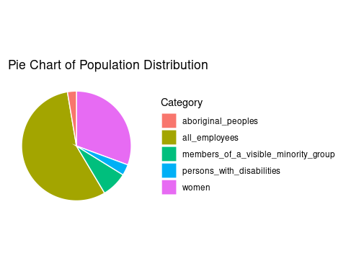

from the pie chart above we can deduce:

* women are the second most employed category
* Aborginal people and person with disabilities have a few representation in the job industry