1. Test tools and environments
   1. Tools

The following will be used:

* Cucumber open source tool as identified for automation testing.
* Git-Hub is open source control version tool.
* Bit Bucket is open source git hub management tool.
* Netbeans is open source IDE.
  1. Automation Testing

Automated test tools are used to address both functional and non-functional automation testing. The functional automation is based on the Cucumber automation framework.

* 1. Environment Usage

|  |  |
| --- | --- |
| **Environment** | **Use** |
| sitwkemea | This environment is used for manual and automation testing. |
| devwkemea | This environment is used for development and unit testing by devs. |

### Automation Process

Following steps are followed in an Automation Process

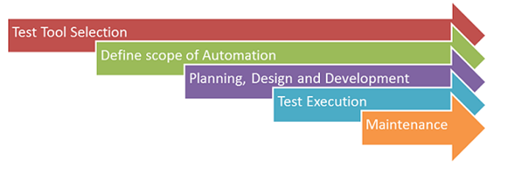

### Planning, Design and Development

During this phase you create  Automation strategy & plan, which contains following details-

* Automation tools selected.
* Framework design and its features.
* In-Scope and Out-of-scope items of automation.
* Automation test bed preparation.
* Schedule and Timeline of scripting and execution.
* Deliverables of automation testing.

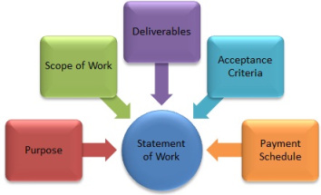

Frame Work Design and structure:

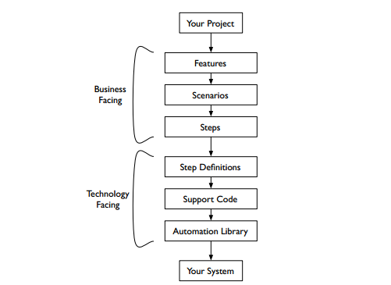

Cucumber Stack

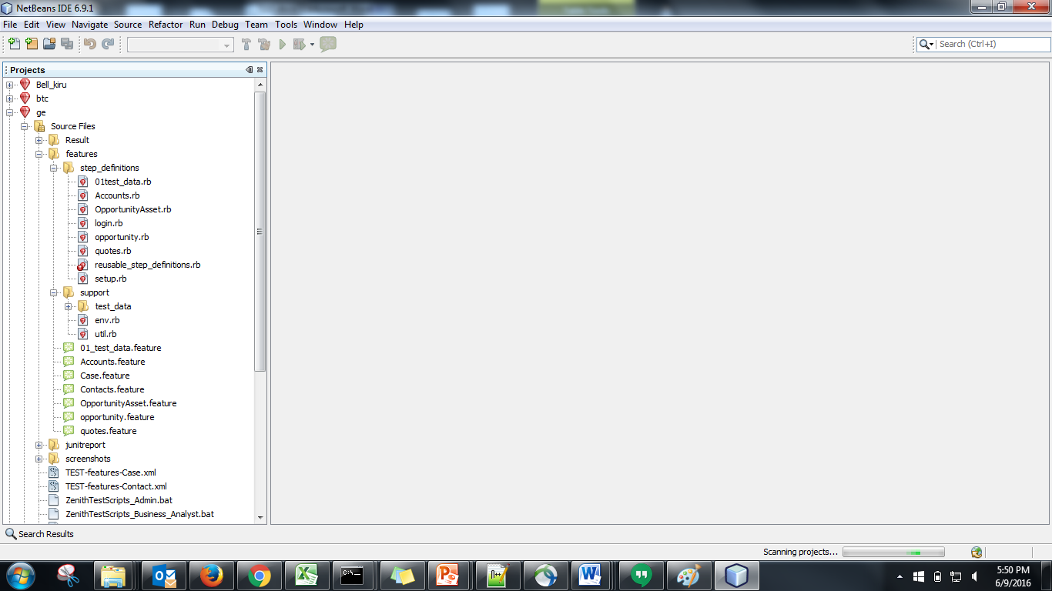

Automation Scripts Test Execution Process:

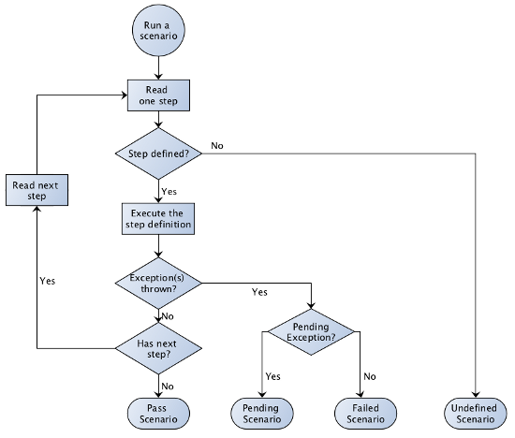

1. Project Roles and Responsibilities
   1. Roles

The table on the following page provides a summary of key responsibilities for the core testing related roles across the Programme.

| **Resource** | **Specific Responsibilities or Comments** |
| --- | --- |
| Testers  (Capgemini) | * Analyse business scope, requirements, user stories and /or use cases * Create manual test scripts based on the scope, requirements, user stories and /or use cases * Execute manual test scripts based on the scope, requirements, user stories and /or use cases * Asses the impacts and risk of the new functionality on the system & advise relevant stake holders * Test analysis – understand requirements for test (review of documentation, attendance at workshops/meetings, cross-team collaboration, etc.) * Test design - generate test conditions and test cases/scenarios/scripts (i.e. ‘what’ to test) * Test implementation – test scripting/procedures (i.e. ’how’ to test) * Test execution – execute tests, including the logging of results and raising of test defects * Execution of regression tests and defect retesting when required * Peer review QA checks of test scripts/test execution of other analysts * Report progress to Capgemini SDM and Technical Lead |
| Performance Test Specialist  (Capgemini) | * Provide Performance testing input to project test plans * Prepare and execute Performance Test scenarios and Scripts * Escalation of any issues affecting progress to the Capgemini test manager * Report progress to the Capgemini test manager |