Automation Smoke Batch Run
Prerequisites:
- Protected Mode is enabled in IE9 (Tools>Options>Security>enable)
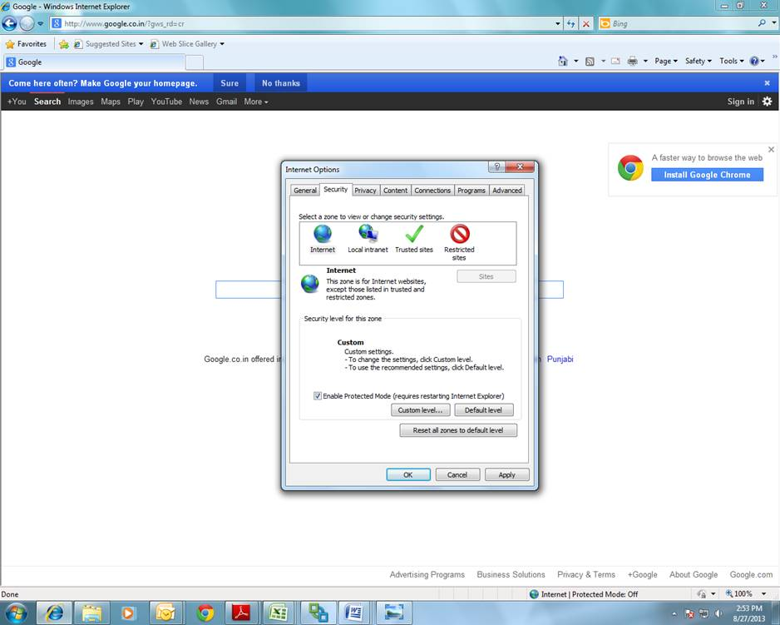

- Zoom Level of Internet Explorer should be 100%.

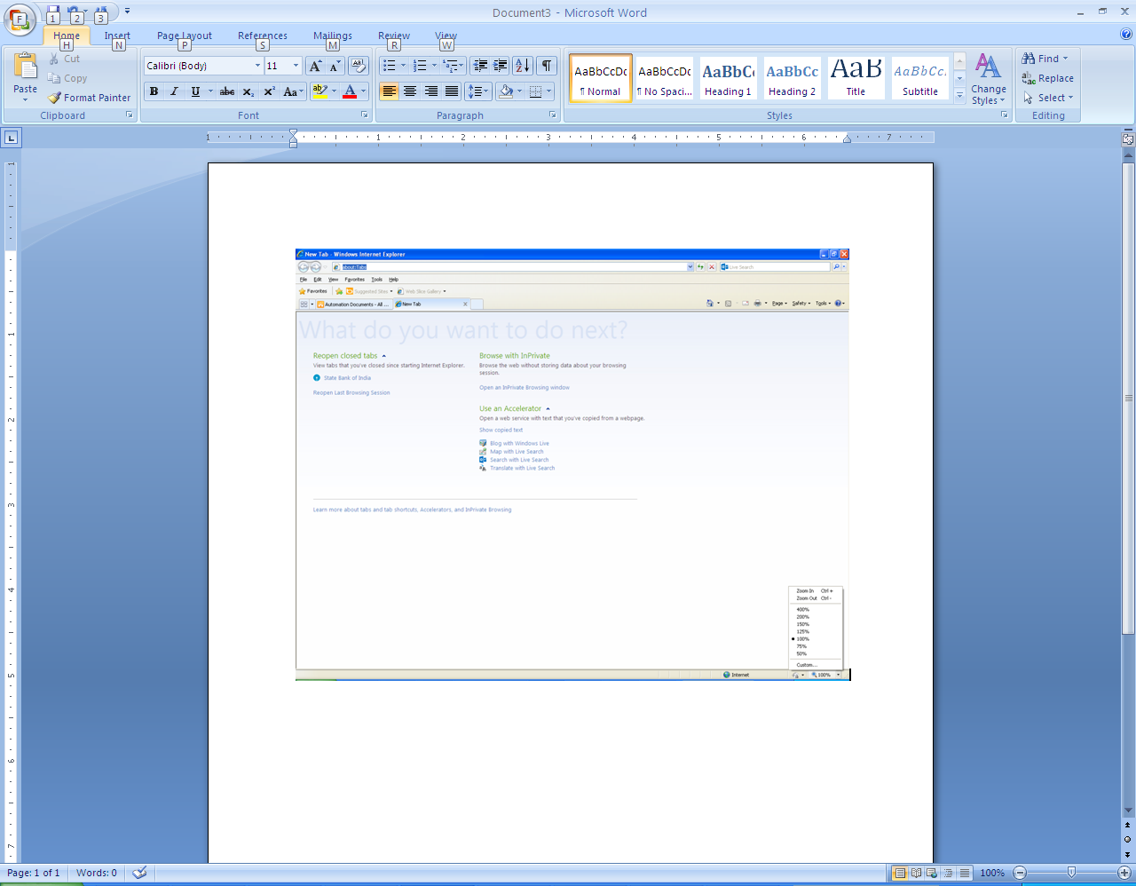
- Download IEdriverServer.exe from the Automation Prerequisites Software Folder placed in Share point at the below path and place in C:\IEDriverServer\
http://intranet.ams.com/tfs/DefaultCollection/Automotive/nxgen/2012%20Documentation/Forms/AllItems.aspx?RootFolder=%2Ftfs%2FDefaultCollection%2FAutomotive%2Fnxgen%2F2012%20Documentation%2FNxGEN%20Automation%20Testing%2FAutomation%20Prerequisite%20Software&FolderCTID=0x01200064450F632EA9B241B22D25C410A334D5&View=%7b993232BA-19ED-4F2F-9B8D-FA77CC8DEB70%7d&InitialTabId=Ribbon%2EDocument&VisibilityContext=WSSTabPersistence
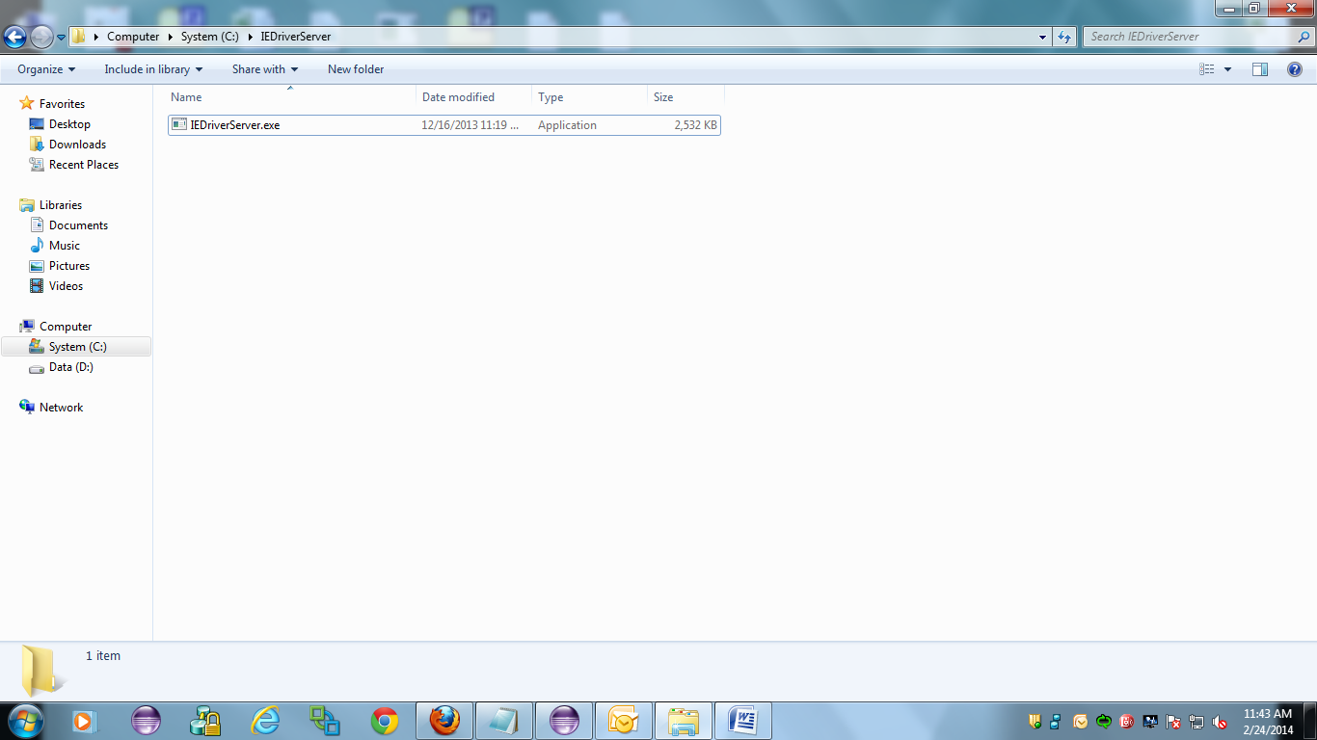

- Download jre-7u40-windows-x64 from the Automation Prerequisites Software Folder placed in Share point at the below path and install on the machine.

http://intranet.ams.com/tfs/DefaultCollection/Automotive/nxgen/2012%20Documentation/Forms/AllItems.aspx?RootFolder=%2Ftfs%2FDefaultCollection%2FAutomotive%2Fnxgen%2F2012%20Documentation%2FNxGEN%20Automation%20Testing%2FAutomation%20Prerequisite%20Software&FolderCTID=0x01200064450F632EA9B241B22D25C410A334D5&View={993232BA-19ED-4F2F-9B8D-FA77CC8DEB70}&InitialTabId=Ribbon%2EDocument&VisibilityContext=WSSTabPersistence

- Download the Automation jar File from the Smoke Batch Run jar folder placed in share point at the below path, unzip and save the file in C:\Automation\
http://intranet.ams.com/tfs/DefaultCollection/Automotive/nxgen/2012%20Documentation/Forms/AllItems.aspx?RootFolder=%2Ftfs%2FDefaultCollection%2FAutomotive%2Fnxgen%2F2012%20Documentation%2FNxGEN%20Automation%20Testing%2FSmoke%20Testing%2FSmoke%20Batch%20Run%20Jar&View=%7b993232BA-19ED-4F2F-9B8D-FA77CC8DEB70%7d&InitialTabId=Ribbon%2EDocument&VisibilityContext=WSSTabPersistence

Folder Structure
Contains 4 folders as shown below: Data, GMSmokeTest_lib, GMSmoketest.jar, Results
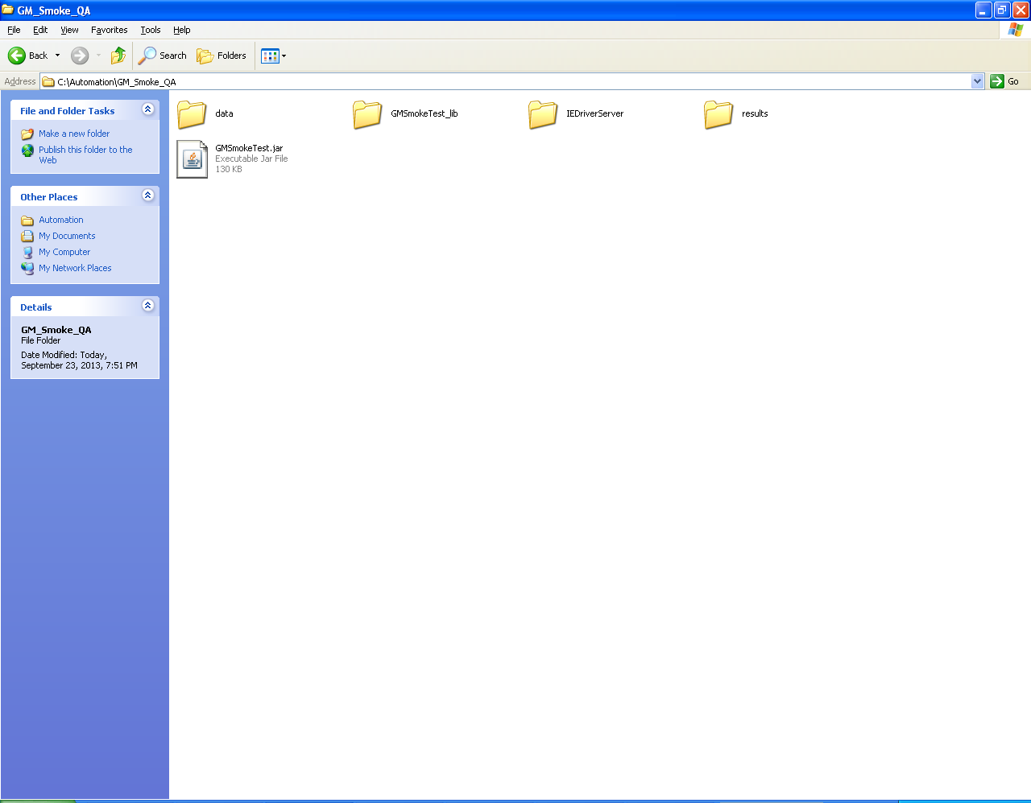

- GMSmokeTest_lib

- Contains all the library files (Selenium-Server-Standalone-2.33.0)

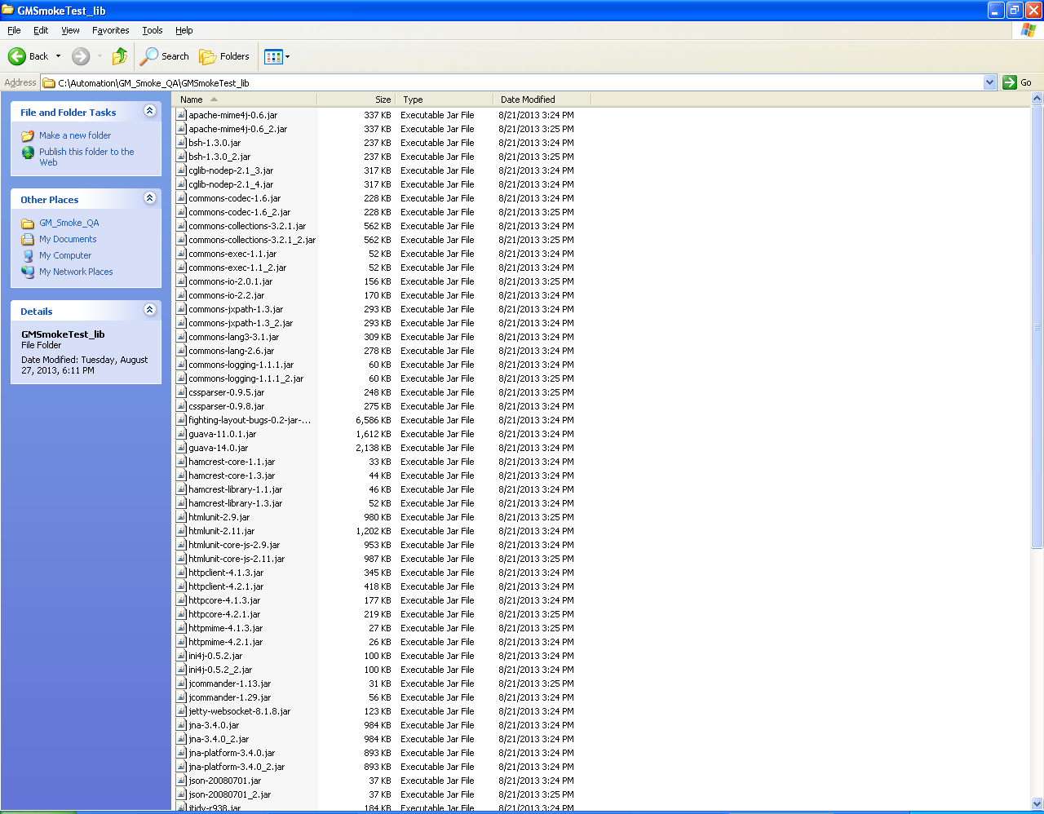

- GMSmokeTest.jar

- Contains the below GM Smoke Test scripts
- Prerequisite
- CMSDeskVerification
- LoginVerification
- PortalNavigation
- CampaignCreationWithSegmentCriteria

- Data

- Contains an xls file “MasterConfig.xls” which contains all the Test Cases and the Execute Parameter as “YES” or “No” which indicates whether the Test Case need to be executed or not.
- Contains separate Folders for each Test Script with the name same as the Test Script which includes::
- XLS file (<Test Script>_Data.xls) containing the input data for Test Case execution.

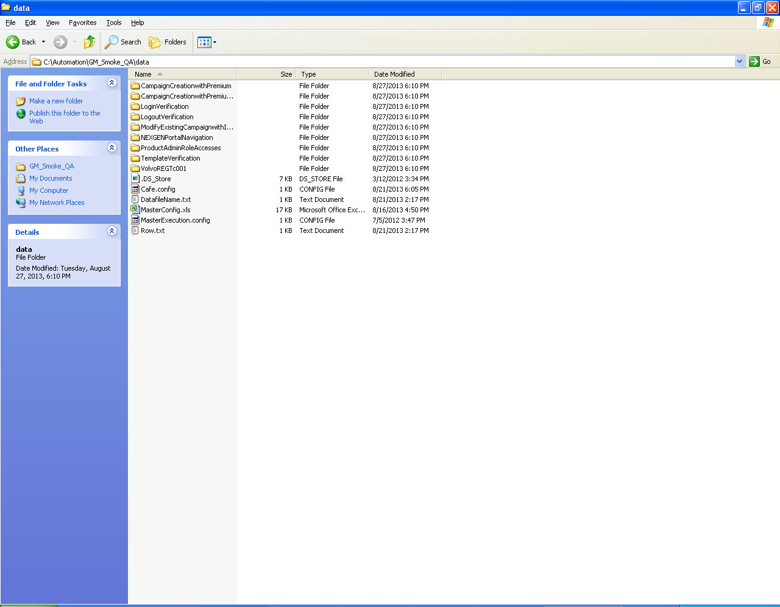

- Results

- Contains separate Folders for each Test Case and the name is same as that of the Test Case and these folders includes the html files which shows the detail result of the execution like Scenario Name, Total Steps, Pass Steps, Fail Steps and Link to Detail Result etc.
- Contains a folder “Screenshot” which contains separate screenshots for each step executed.

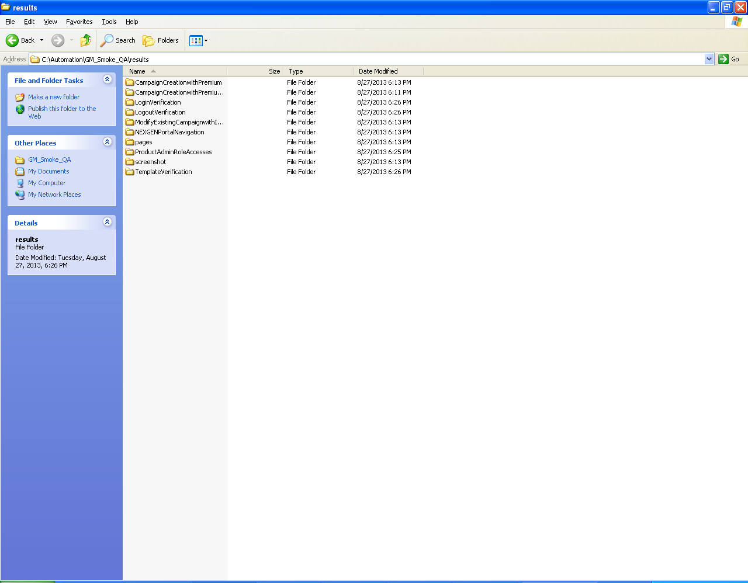

How To Proceed

- Open the MasterConfig.xls placed in Data folder and mark the Execute column as “Yes” for the Test Cases which need to be executed.

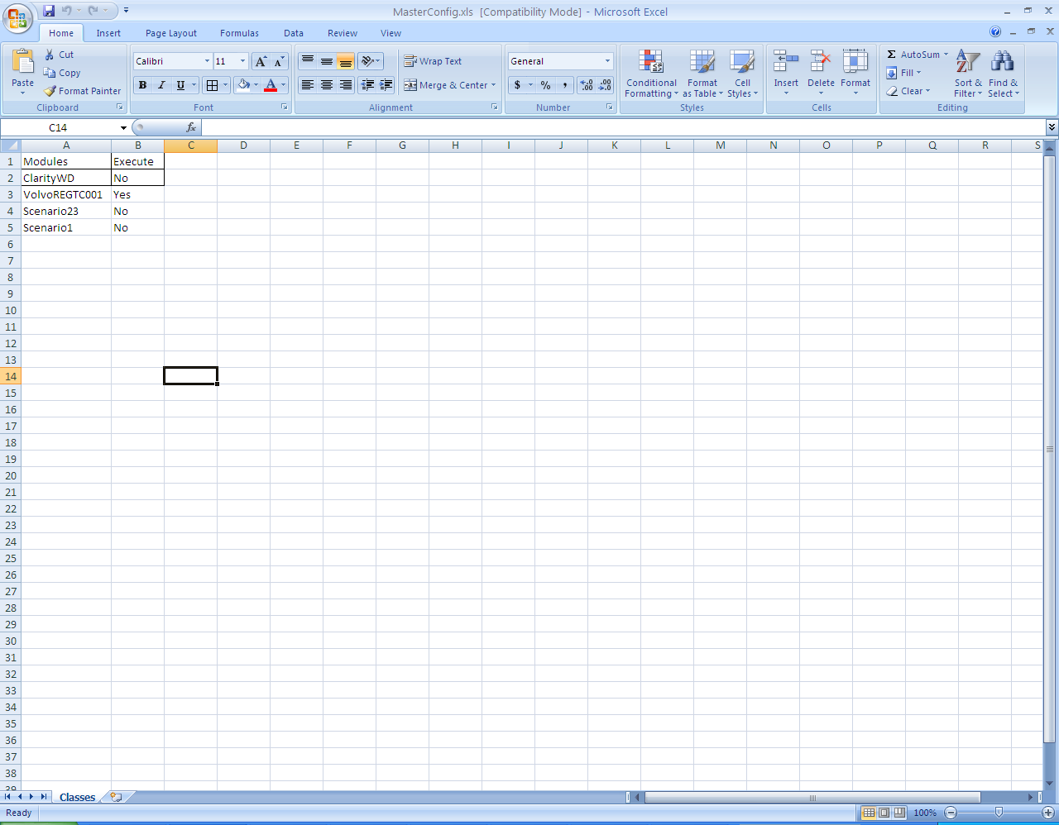

- Double Click on the jar file (e.g. GMSmokeTest.jar)

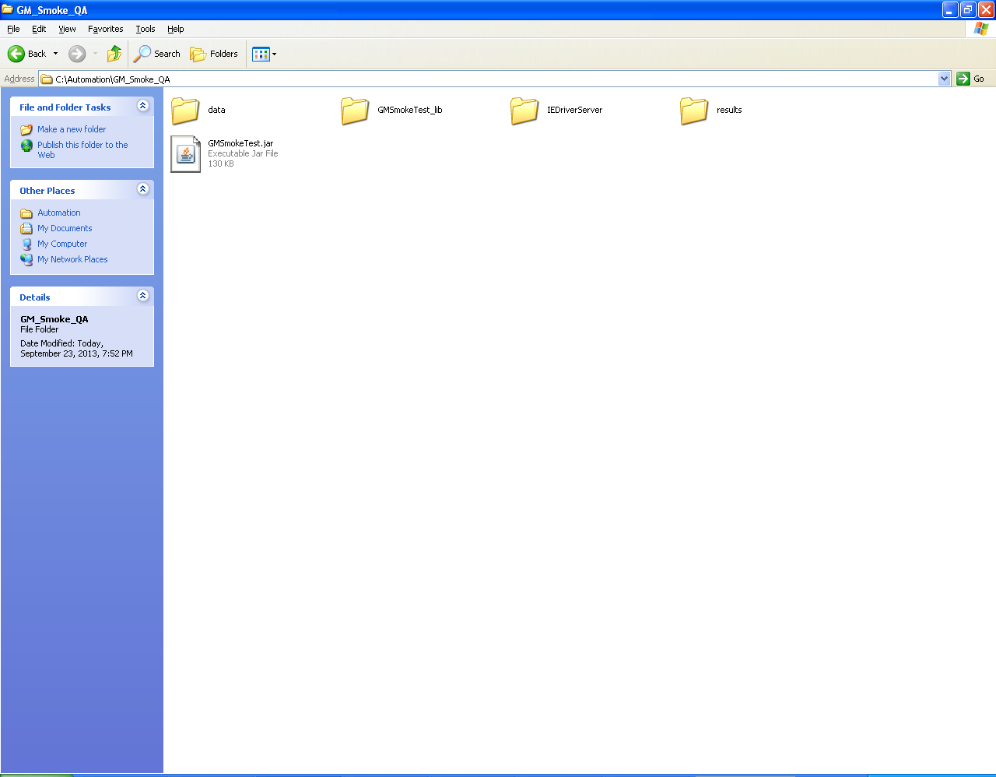

- Below pop-up should get displayed

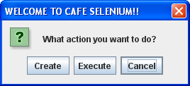

- Click on the Execute button of the pop up.
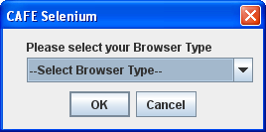

- Select the Browser Type from the drop down.

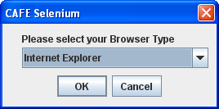

- Click on OK button after selecting the browser.
- Test Cases marked as “Yes” will get executed. Once the execution is over the below pop up will get displayed.

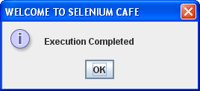

- Click on OK.

- Go to Data Folder and open a folder for any of the Test Case and open <Test Case>_Data.xls which will show the Test Execution Status for all the scenarios.
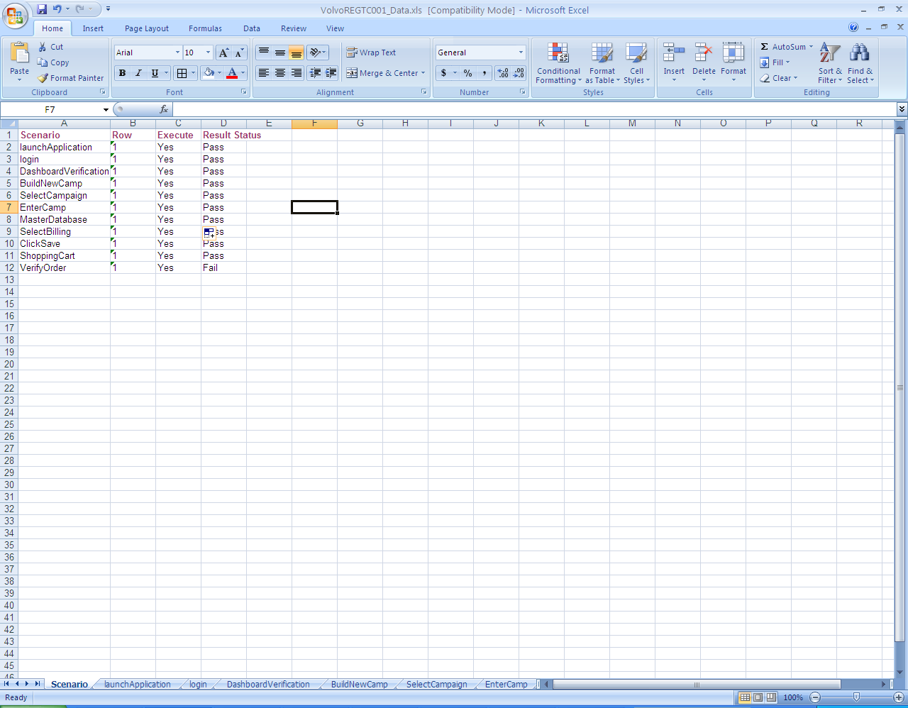

- The above step can be repeated for all other Test cases to check the execution status.

- Open the Results Folder.

MainReport will be available after the execution stops.

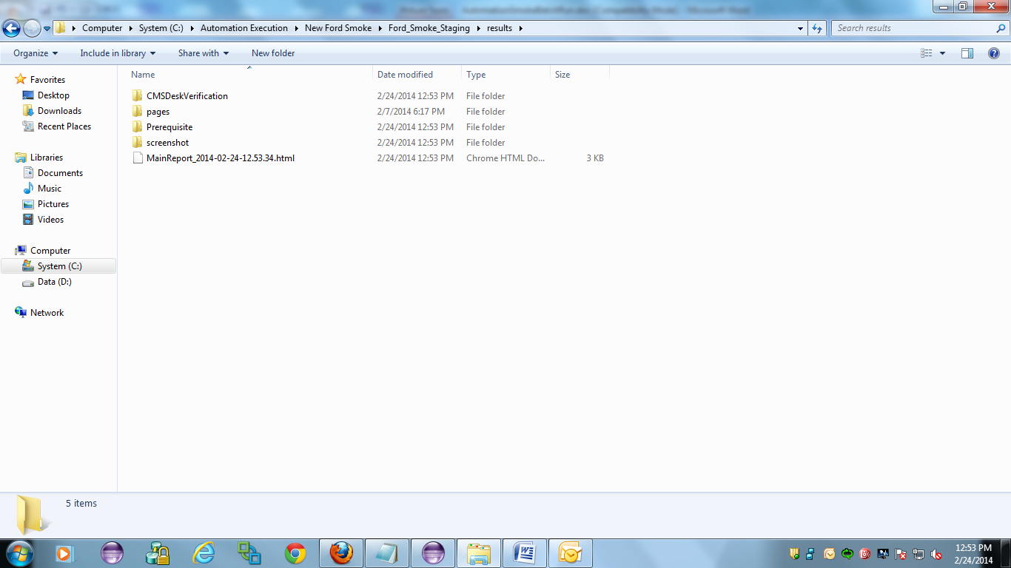

In main report status of each test case i.e. passed or failed will be displayed along with the execution time taken for each test case.
There will be a Detail Report link clicking on which detailed report of that test case will open.

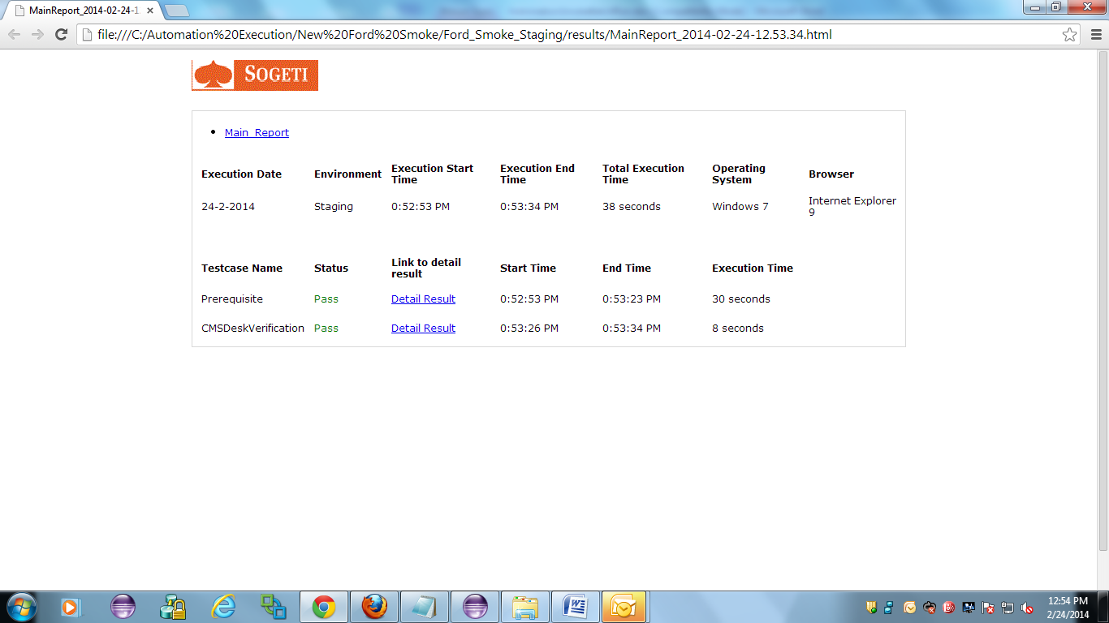

- Open a Folder for any of the Test Case.

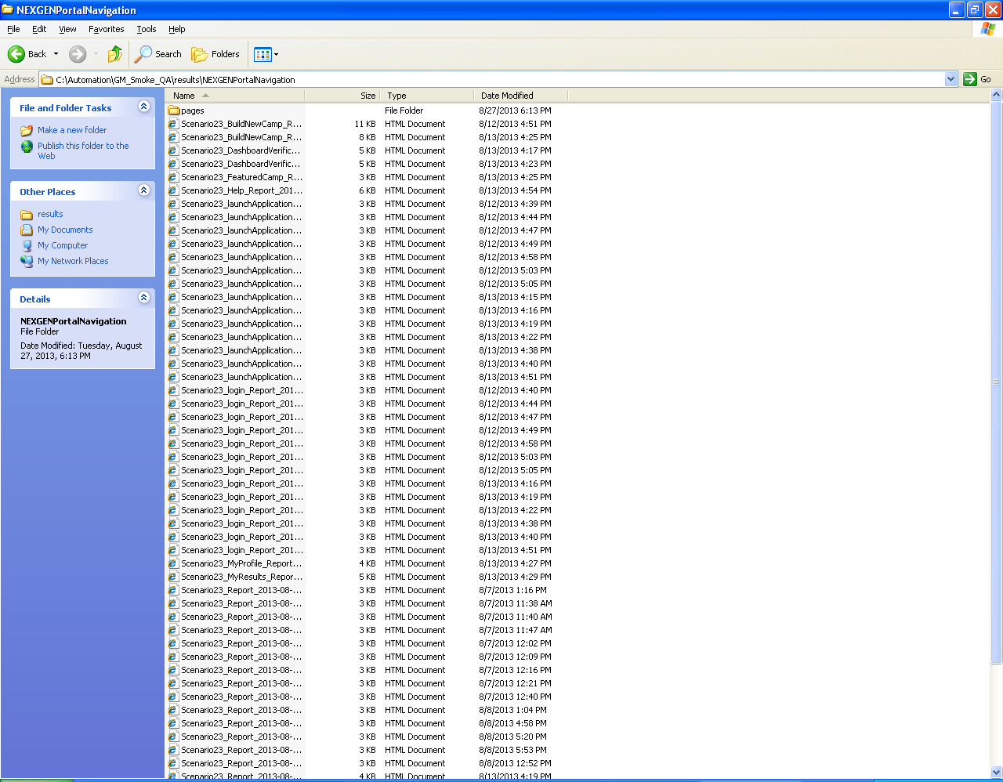

- Click on the html file named as “<Test Case>_Report_<Date Time>.html
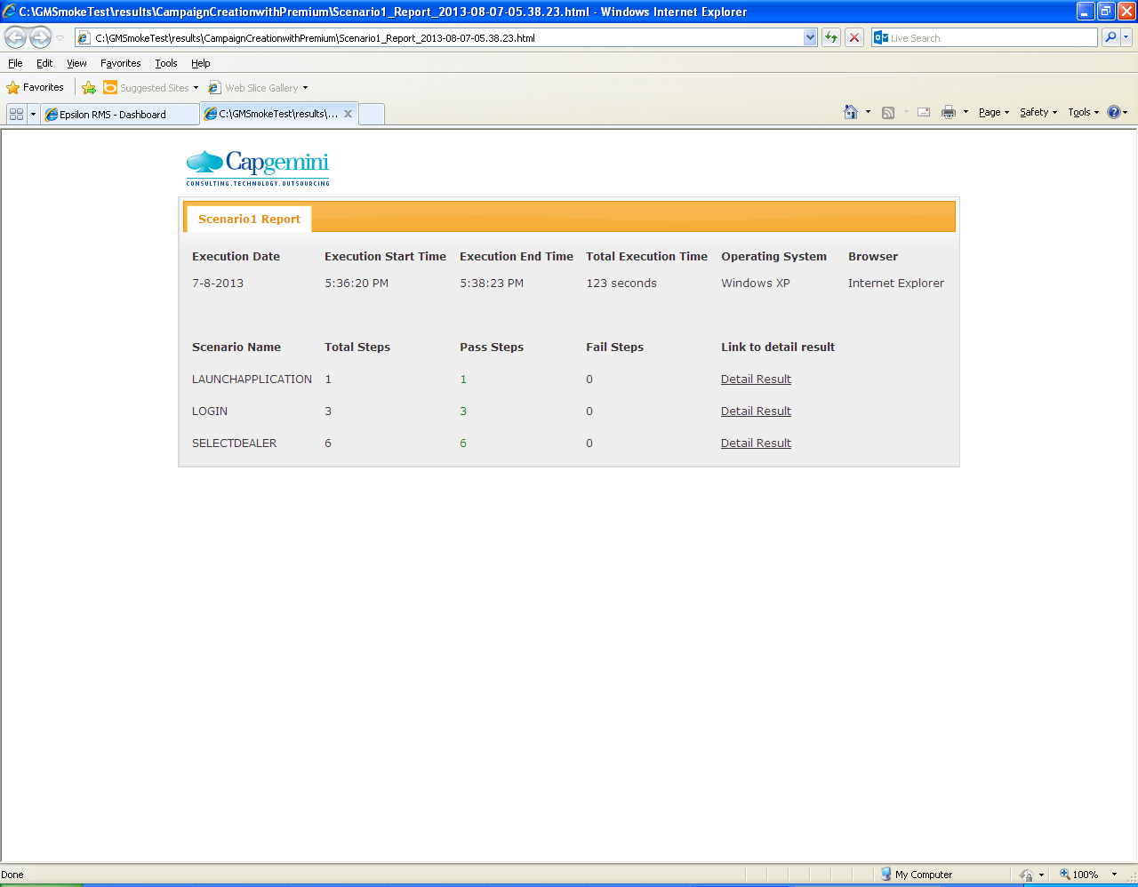
- Click on the link “Detail Result”

