**Data Data 1:**

Neighborhood has a total of 5 boroughs and 306 neighborhoods. In order to divide the neighborhoods and search over them, we will mainly need a dataset that contains the 5 boroughs and the neighborhoods that contain each borough with the latitude and longitude coordinates of each neighborhood. This dataset exists for free on the web. Link to the dataset is:

https://geo.nyu.edu/ catalog/nyu_2451_34572.

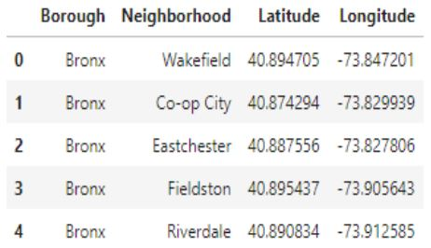

**Data2:**

New York City geographical coordinate’s data will be utilized as input for the Foursquare API that will be helpful in getting venues information for each neighborhood. We will use the Foursquare API to explore neighborhoods in New York City

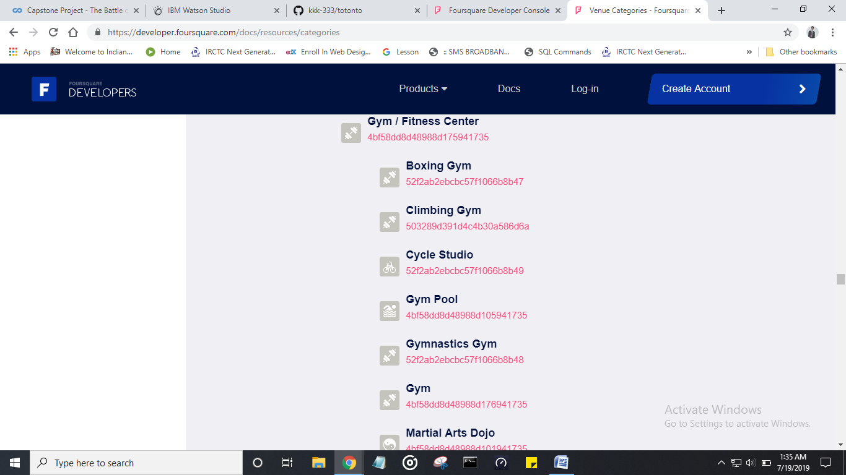

By this data we can get the places of the gyms already existing and by that we can get to cear where should we lace our new gymnasium.