Smooth Surface

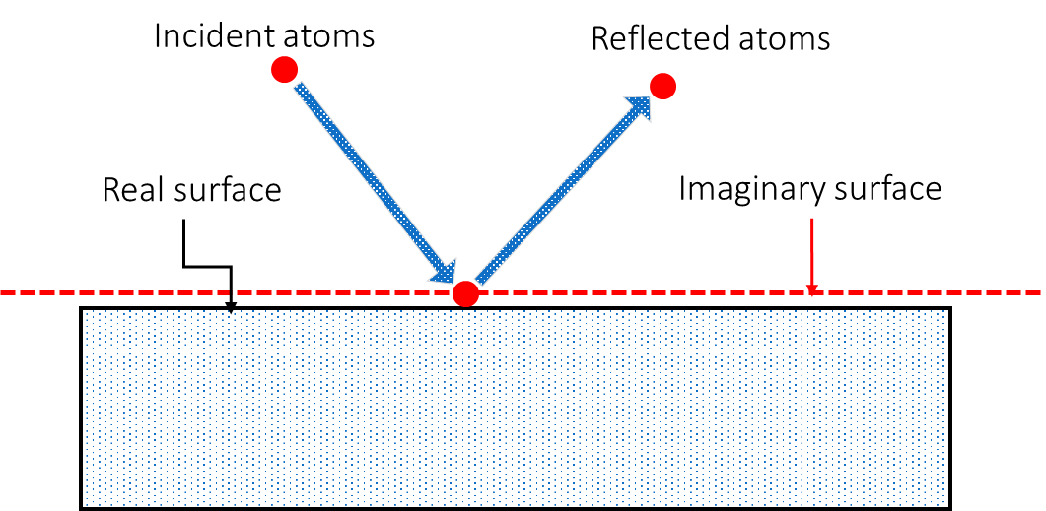

Rough Surface

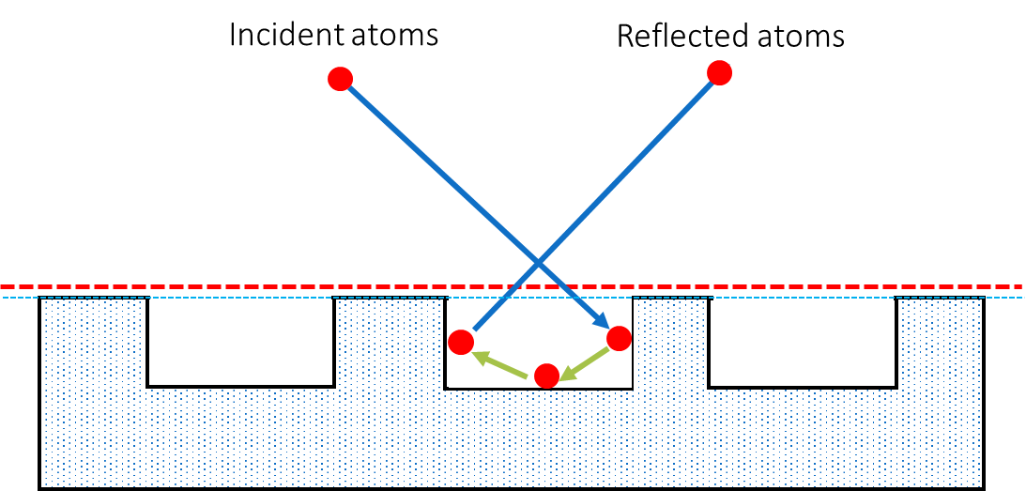

Inputs to Maxwell Lord model: σ= 0.2, α = 0.2

Output from DSMC simulation: **σ= 0.199, α = 0.198**

Inputs to Maxwell Lord model: σ= 0.2, α = 0.2

Output from DSMC simulation: **σeffective= 0.575, αeffective = 0.294**