Architecture Document

Context
An industrial organization operates many ML models across plants and environments. The platform provides a central system to register, version, approve, deploy, monitor, and roll back machine-learning models, with a focus on governance and operational reliability rather than model training.

Scope
This document covers the MLOps Model Registry and Deployment Management platform. The current implementation is a vertical slice covering model registration, versioning, lifecycle governance, deployment with idempotency, retry, rollback, and a web-based operational UI.

Architecture Overview
The system follows a layered architecture with clear separation of concerns:
- Presentation Layer: HTML/JavaScript frontend (proof of concept; production target is Angular with TypeScript, Angular Material, and RxJS).
- API Layer: Python 3.11/FastAPI REST backend with typed request/response models, input validation, and auto-generated OpenAPI documentation.
- Domain Layer: Business logic for lifecycle governance (approval gates), deployment state management, idempotency, retry, and rollback.
- Persistence Layer: Currently in-memory storage; production target is SQLAlchemy with PostgreSQL/SQLite and Alembic migrations.
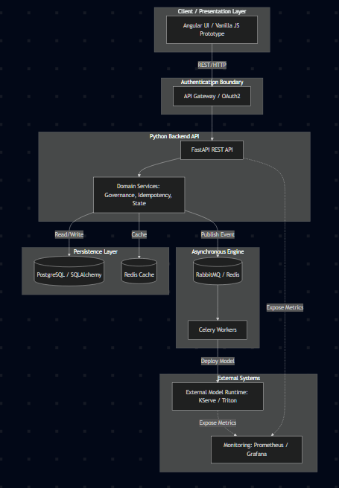
Visual representation encompassing UI, API, domain services, persistence, queue workers, monitoring, runtime, and authentication boundaries.

Components
Implemented Components:
- Frontend UI: HTML/JavaScript for operational views, model inventory, and version management.
- REST API: Python, FastAPI, and Pydantic for typed endpoints, validation, and error handling.
- Domain Logic: Python modules handling lifecycle rules, deployment state machines, and idempotency.
- Persistence: In-memory storage for Model, version, and deployment storage.
- CI/CD & Container Runtime: Docker, Docker Compose, and GitHub Actions for automated testing and portable deployment.

Production Target Components:
- Worker/Queue: Celery + Redis/RabbitMQ for async processing of long-running deployments.
- Monitoring: OpenTelemetry and Prometheus for metrics collection and observability.
- Authentication: OAuth2 / JWT for role-based access control.
- Model Runtime: Seldon/KServe for external model serving.

Domain Model
Core entities and their relationships:
- Model: Top-level entity with a name, description, and audit timestamps. A model has many Versions.
- Version: A specific iteration of a model, with framework, algorithm, artifact URI, training data reference, lifecycle stage, and approval status. Versions follow a lifecycle: DRAFT -> VALIDATED -> APPROVED -> STAGING -> PRODUCTION -> ARCHIVED.
- Deployment: A request to deploy a specific version to an environment. Deployments follow a state machine: REQUESTED -> DEPLOYING -> SUCCEEDED/FAILED -> ROLLED_BACK. Each deployment tracks an event history.
Key governance rules:
- Only APPROVED versions can be promoted to STAGING or PRODUCTION.
- Only APPROVED versions can be deployed.
- Only FAILED deployments can be retried.
- Only SUCCEEDED deployments can be rolled back.
- Idempotency keys prevent duplicate deployments.

Key Workflows
Model Registration and Approval
- User creates a model (POST /models).
- User registers a version (POST /models/{id}/versions) -> starts as DRAFT.
- User approves the version (POST /.../approve) -> moves to APPROVED.
- User promotes to PRODUCTION (POST /.../promote) -> governance check passes.
Deployment with Idempotency
- User requests deployment with an idempotency key (POST /deployments).
- System checks: is the version approved? If not, reject with 409.
- System checks: has this idempotency key been used? If yes, return original.
- Deployment is created with status REQUESTED, event is logged.
- On failure: user can retry (POST /deployments/{id}/retry) -> only if FAILED.
- On bad deployment: user can rollback (POST /deployments/{id}/rollback) -> only if SUCCEEDED.

Reliability
- Idempotency: Duplicate deployment requests with the same key return the original result, preventing accidental double-deploys.
- State validation: Retry and rollback enforce valid state transitions, preventing unsafe operations (e.g., rolling back an already-failed deployment).
- Input validation: Pydantic models reject malformed requests at the API boundary before they reach business logic.
- Error handling: Consistent HTTP error codes (404 for not found, 409 for state conflicts) with clear messages.
- Automated Testing: GitHub Actions runs automated Pytest validation on every push to ensure build stability.
- Future improvements: Database transactions for atomic operations, optimistic locking, circuit breakers, and dead letter queues.

Security
Current Implementation:
- Input validation prevents injection via Pydantic typed models.
- CORS configured (currently permissive for development; production would restrict to known origins).
- Secure Configuration: Secrets are managed via environment variables (documented in .env.example). No secrets are committed to Git.

Production Target:
- OAuth2/JWT authentication and role-based authorization.
- API rate limiting and HTTPS enforcement.

Observability
Current Implementation:
- Health endpoint at /health for liveness checks.
- Auto-generated API documentation at /docs.
- Deployment event history for audit trail.

Production Target:
- Structured logging with correlation IDs.
- OpenTelemetry integration for distributed tracing.
- Prometheus metrics and alerting dashboards for model performance.

Scaling
Current Design Limitations:
- In-memory storage: data lost on restart, single-process only.
- Synchronous processing: long-running operations block the API.

Scaling Approach for Thousands of Models:
- Persistence: Migrate to PostgreSQL with proper indexing on model_id, version_id, and deployment status for efficient queries at scale.
- Async processing: Use Celery with Redis/RabbitMQ for deployment operations, allowing the API to return immediately while deployments run in background workers.
- Caching & Partitioning: Redis cache for frequently accessed model metadata, and database partitioning by time for efficient querying of recent data.
- Horizontal scaling: Stateless API servers behind a load balancer.

Trade-offs
Decision | Chosen | Alternative | Rationale
Storage | In-memory dict | SQLAlchemy + PostgreSQL | Faster to implement for vertical slice; persistence is the clear next step.
Frontend | Plain HTML/JS | Angular + TypeScript | Achievable in time constraints; proves frontend-backend integration works.
Processing | Synchronous | Celery + message queue | Simpler for the current scope; async needed for real deployment operations.
Idempotency | Key-based in-memory lookup | Database-backed with TTL | Demonstrates the pattern; production needs persistent storage and key expiry.
Auth | None (open) | OAuth2 + RBAC | Out of scope for vertical slice; noted as a must-have for production.

