Method 1:

To form H(z), find the zeros of P(z) inside the unit circle, and pick one from every two zeros on the unit circle. And then do *poly(r)* to find the corresponding h(n).

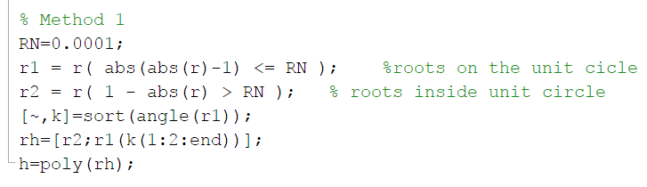

Then the given P(z) can be factorize as:



Now we can do following commands to find the normalized h(n):



Flip h(n) and convolve h(n) with h(-n) to verify if it’s the same as p(n):





Method 2:

Sort all zeros by angle and pick one from every two to the H(z) and do *poly(r)*.

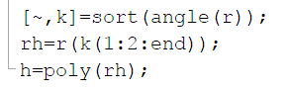

Then the given P(z) can be factorize as:



Unlike method 1, because this h(n) is not real-valued, we should do *conj()* to *flip(h(n))* to find the h(-n), which convolve with h(n) yields the original p(n).



