2.

Lam=1

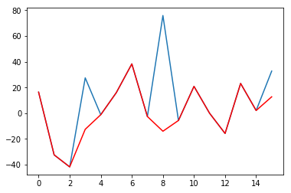 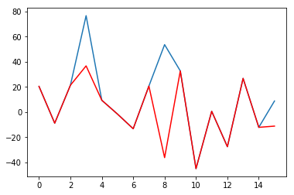

Lam=10

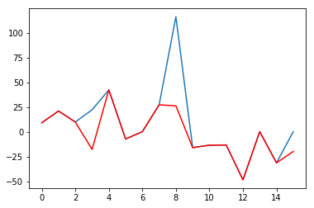

When lamda getting large, the red error line becomes flatter, implying that the output signal is getting more likely to the original signal. But on the other hand, larger value of lamda trades off the sparsity requirement of reconstruction signal, so that we can see less zeros in the output.

3. Wavelets and ISTA

Haar, level = 3

SNR = 20, lamda=40

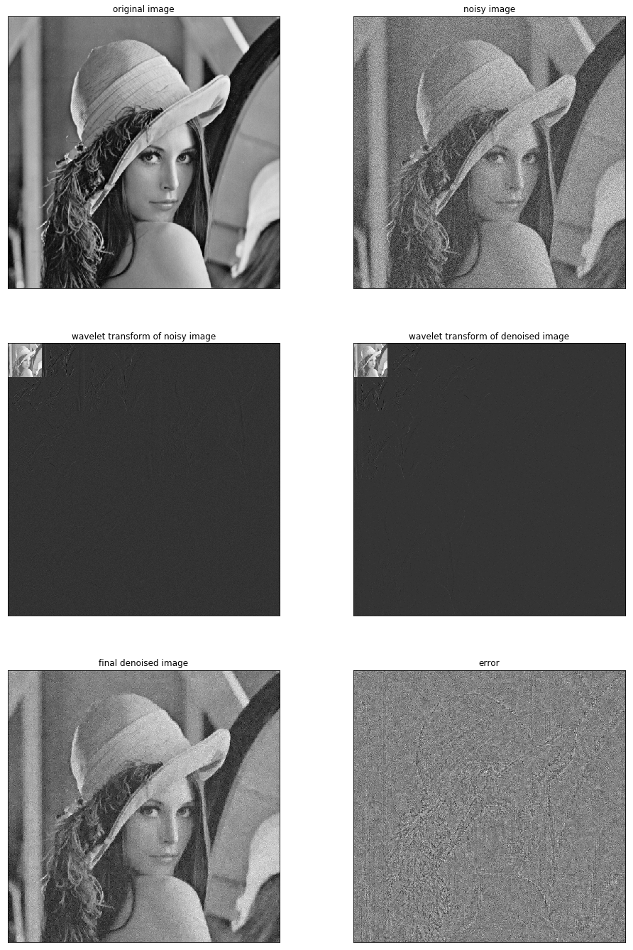

Daubechies 8/8, level = 3

SNR = 20, lamda=40

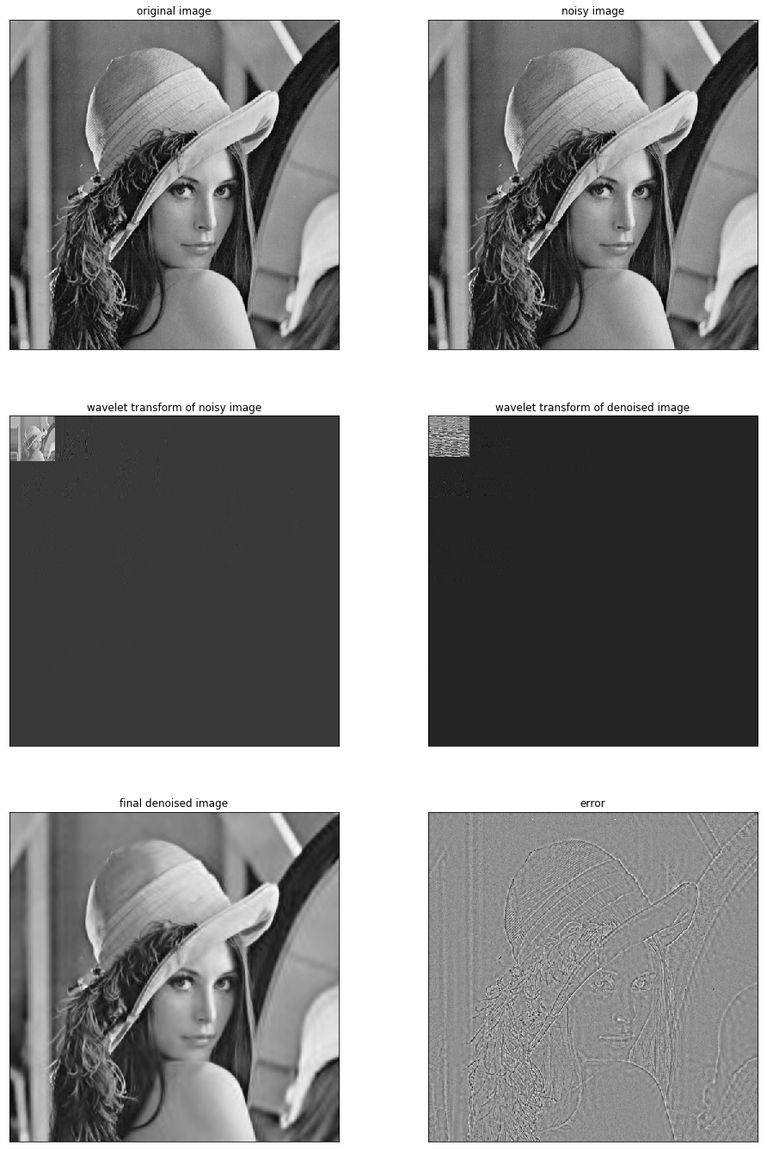

SNR = 20, lamda=10

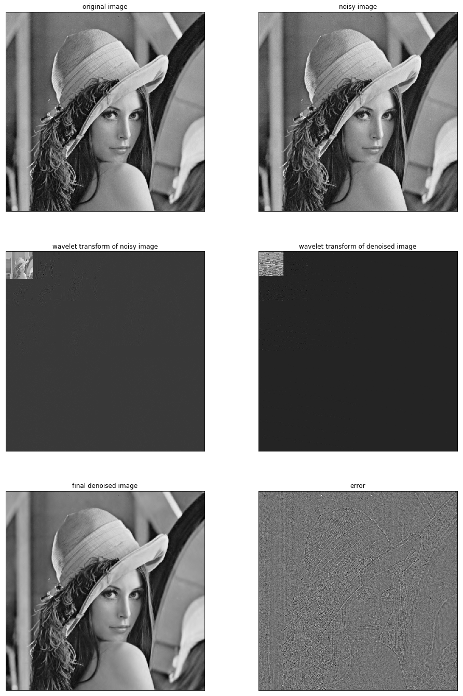

The plots shown that db8 filter with ISTA is more efficient in denoising gaussian noise than Haar filter, for it requires smaller value of lamda to remove the noise. However, the db8 filtered image also blurred edges than Haar filter do.