1.



Feature points in 'BK_left.jpg'

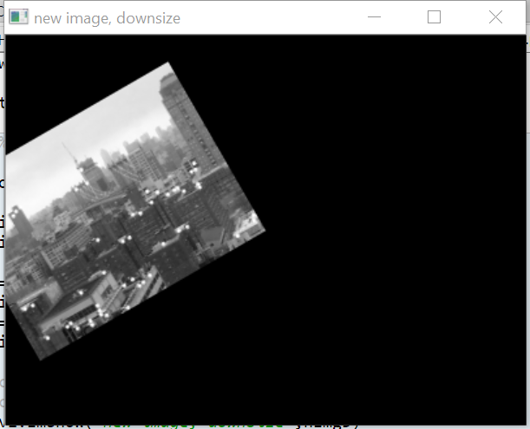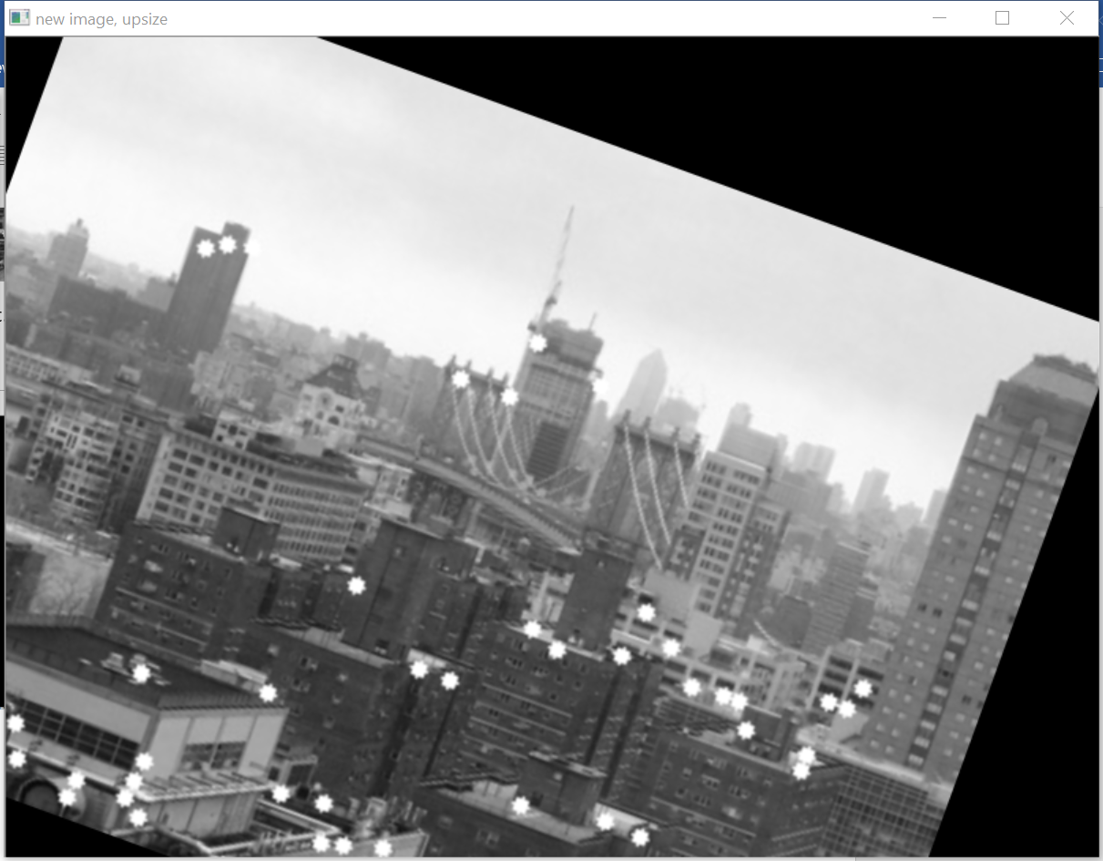

d) the feature points detected are not exactly the same but have a lot in common. This is because some feature points may have their Harris value changed after resizing and rotating, and they may be in or out of the original N=50 feature point sets.

3.

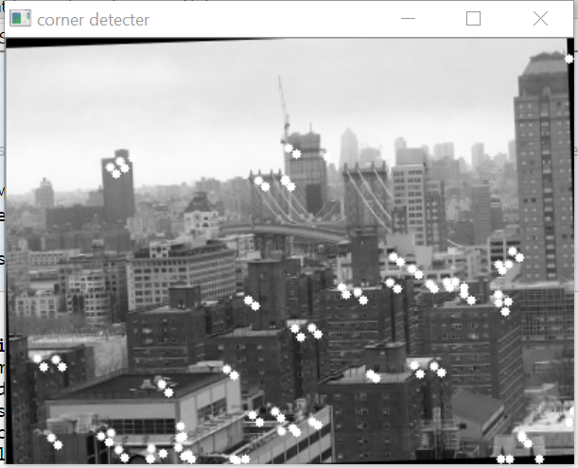

Feature points of rotated image

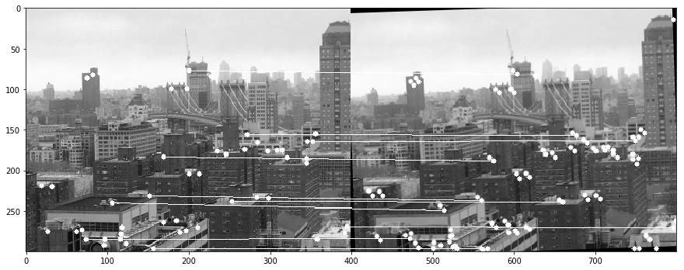

Feature points matched by white lines.