1.

1) As we can see in the images, larger K value, i.e. more initial cluster centroids makes the quantized image more smooth and contains more color information. If the uses a same K value, the KMeans algorithm performs better than the benchmark algorithm, for the random picked colors in the latter one cannot ensure preserving the dominant colors in original image. For example, in the above image, the K=64 quantized image severely lost the orange color in the roof of the temple.

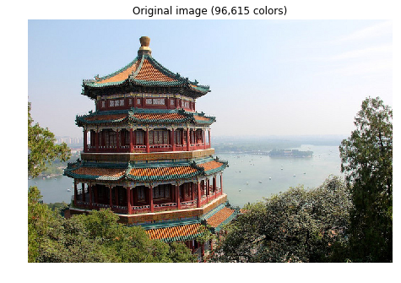

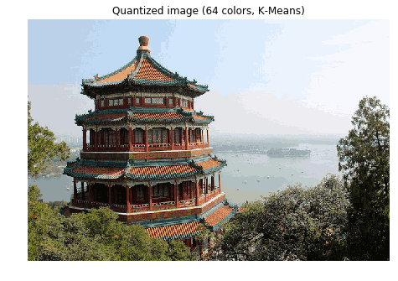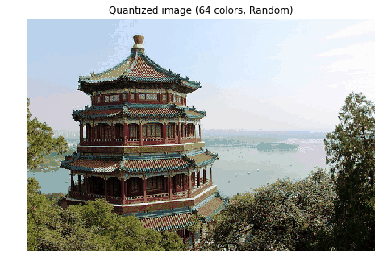

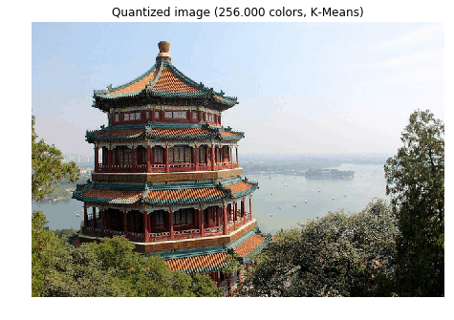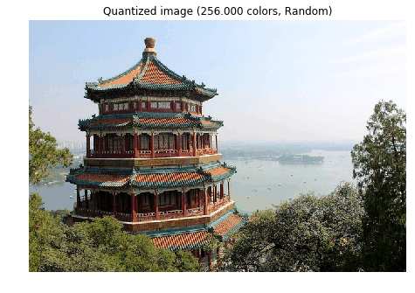

2)

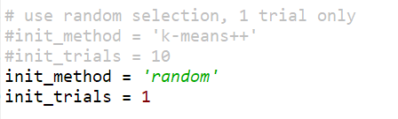

K-Means ++ random

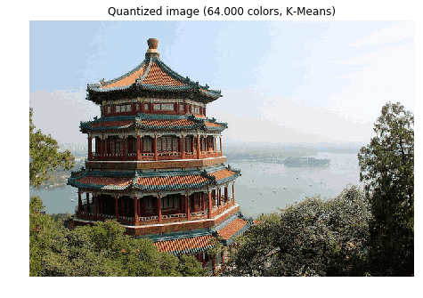 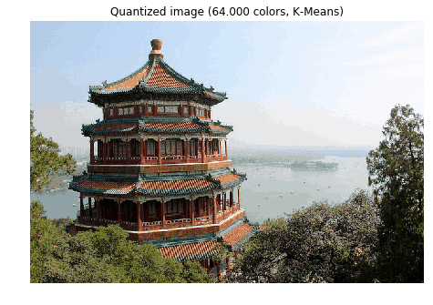

It takes more iteration times to converge in random method, and also takes longer time to compute:

|  |  |
| --- | --- |
| K-Means ++, K = 64:  Iteration 0, inertia 1.62514535133  Iteration 1, inertia 1.49677675908  Iteration 2, inertia 1.46830820426  Iteration 3, inertia 1.46214193469  Iteration 4, inertia 1.46015370884  Iteration 5, inertia 1.4576707576  Iteration 6, inertia 1.45538382982  Iteration 7, inertia 1.4551410752 | Random, K = 64:  Iteration 0, inertia 2.93505441848  Iteration 1, inertia 2.22043516412  Iteration 2, inertia 2.07128140851  Iteration 3, inertia 2.02323407553  Iteration 4, inertia 2.00268787881  Iteration 5, inertia 1.99174684638  Iteration 6, inertia 1.97739368405  Iteration 7, inertia 1.96695514459  Iteration 8, inertia 1.9628038552  Iteration 9, inertia 1.96017476461  Iteration 10, inertia 1.9584366434  Iteration 11, inertia 1.95689627245  Iteration 12, inertia 1.95630415101  Iteration 13, inertia 1.95522174553  Iteration 14, inertia 1.9549125945  Iteration 15, inertia 1.9549125945 |

3) Specifying value of random_state doesn’t make a huge difference on the quantized image and error curves.

|  |  |  |
| --- | --- | --- |
| Random  state | Quantized image | Error |
| 0 |  | Iteration 0, inertia 1.62514535133  Iteration 1, inertia 1.49677675908  Iteration 2, inertia 1.46830820426  Iteration 3, inertia 1.46214193469  Iteration 4, inertia 1.46015370884  Iteration 5, inertia 1.4576707576  Iteration 6, inertia 1.45538382982  Iteration 7, inertia 1.4551410752 |
| 1 |  | Iteration 0, inertia 1.4658274836  Iteration 1, inertia 1.38808192197  Iteration 2, inertia 1.37494200384  Iteration 3, inertia 1.37143866808  Iteration 4, inertia 1.3692043997  Iteration 5, inertia 1.36835619466  Iteration 6, inertia 1.36796218988  Iteration 7, inertia 1.36796218988 |
| 10 |  | Iteration 0, inertia 1.59568031289  Iteration 1, inertia 1.52021071538  Iteration 2, inertia 1.48747966365  Iteration 3, inertia 1.46621015435  Iteration 4, inertia 1.46127611379  Iteration 5, inertia 1.46008414652  Iteration 6, inertia 1.45970400194 |
| 50 |  | Iteration 0, inertia 1.49282776995  Iteration 1, inertia 1.40739837588  Iteration 2, inertia 1.37465804756  Iteration 3, inertia 1.35527656613  Iteration 4, inertia 1.34925040551  Iteration 5, inertia 1.34651594254  Iteration 6, inertia 1.34479698959  Iteration 7, inertia 1.34441906967  Iteration 8, inertia 1.34441906967 |
| 100 |  | Iteration 0, inertia 1.43943505105  Iteration 1, inertia 1.36823672486  Iteration 2, inertia 1.35621142455  Iteration 3, inertia 1.344462042  Iteration 4, inertia 1.33159003646  Iteration 5, inertia 1.32414148304  Iteration 6, inertia 1.31586851692  Iteration 7, inertia 1.31165570486  Iteration 8, inertia 1.31016724358  Iteration 9, inertia 1.30916356688  Iteration 10, inertia 1.30891898335 |