COMP7505 Group Project Report
COMP7505 小组项目报告

InterviewAI — Your AI Interview Prep Coach
InterviewAI — 你的 AI 面试准备教练

Track A: Smart Adaptive Interfaces | Group: Cre8
Course: COMP7505 User Interface Design and Development

Team Members / 团队成员
Name / 姓名 | Role / 角色 | Deliverable
Wang Qi'an / 王祁安 | Deliverable 1 Lead | D1: User Needs & Project Definition
Yu Pei / 余沛 | Deliverable 3 Lead | D3: Design Evaluation & Iteration
Wu Yuchen / 吴雨晨 | Deliverable 3 Member | D3: Design Evaluation & Iteration
Ou Qianyin / 欧倩茵 | Deliverable 3 Member | D3: Design Evaluation & Iteration
Yu Erfei / 余尔飞 | Deliverable 3 Member | D3: Design Evaluation & Iteration
Ren Liubo / 任柳博 | Pitch Deck & Demo Script | D5: Product Pitch Materials
Chen Zhixin / 陈智昕 | Deliverable 4 Lead | D4: Design Principles & Roadmap
Gao Yuqi / 高雨琦 | Pitch Script Writer | D5: Product Pitch Materials

Table of Contents 目录
Deliverable 1: User Needs & Project Definition / 用户需求与项目定义
1.1 Target User Persona / 目标用户画像
1.2 Core User Tasks / 核心用户任务
1.3 Project Scope & Boundaries / 项目范围与边界
Deliverable 2: Interaction Design Specification & Prototype / 交互设计规范与原型
2.1 Interaction Model / 交互模型
2.2 Information Architecture / 信息架构
2.3 Navigation Structure / 导航结构
2.4 Core Task Workflows / 核心任务工作流
2.5 Interactive Prototype / 交互原型
2.6 Track A Compliance / Track A 合规性
Deliverable 3: Design Evaluation & Iteration / 设计评估与迭代优化
3.1 Evaluation Plan / 评估计划
3.2 Evaluation Results / 评估结果
3.3 Iteration Evidence / 迭代证据
Deliverable 4: Design Principles & Product Roadmap / 设计原则与产品路线图
4.1 Reusable Design Principles / 可复用设计原则
4.2 Product Development Roadmap / 产品开发路线图
Deliverable 5: Product Pitch Materials / 产品路演材料
5.1 Pitch Deck Overview / 路演PPT概述
5.2 Demo Script / 原型演示脚本
5.3 Core Value Proposition / 核心价值主张

Deliverable 1: User Needs & Project Definition 交付物 1：用户需求与项目定义
This deliverable establishes the foundation for the entire project by defining who we design for (target user persona with pain points), what end-to-end tasks must succeed (core user tasks with success criteria), and what is explicitly out of scope (project boundaries including usage scenarios, device constraints, technical assumptions, and excluded requirements). All subsequent design decisions in Deliverables 2–5 are traceable to the findings presented here. 本交付物通过定义设计对象（目标用户画像及痛点）、端到端任务成功标准（核心用户任务）和项目边界（使用场景、设备约束、技术假设、排除需求）为整个项目奠定基础。后续所有设计决策均可追溯至本交付物的发现。

1.1 Target User Persona 1.1 目标用户画像
Our primary persona, Kevin Li, was synthesized from a pre-project questionnaire distributed to 9 respondents (all CS-related fresh graduates, mostly HKU master's students) and semi-structured interviews. Each attribute is traceable to specific user data points. 我们的主要用户画像 Kevin Li 是从发放给 9 名受访者（均为 CS 相关应届毕业生，主要是港大硕士生）的项目前问卷和半结构化访谈中综合而来的。每个属性都可追溯到具体的用户数据点。
Attribute | Detail / 详情
Name 姓名 | Kevin Li
Age 年龄 | 23
Occupation 职业 | Fresh Computer Science graduate 计算机科学应届毕业生
Location 地点 | Hong Kong 香港
Job-seeking Status 求职状态 | Actively interviewing for front-end / full-stack developer roles 正在积极应聘前端/全栈开发者职位
Core Goals 核心目标 | (1) Practice role-specific interview questions tailored to JD and resume (2) Receive actionable feedback with clear reasoning (3) Track improvement across multiple sessions (4) Feel confident that AI understands context (1) 练习针对JD和简历的岗位相关面试问题 (2) 获得带有明确推理的可操作反馈 (3) 跟踪多次练习的进步 (4) 确信AI理解自己的背景

Pain Points / 痛点 undefined
# | Pain Point | Severity
1 | AI feedback feels generic — "your answer could be better" without saying HOW AI反馈感觉泛泛而谈——只说“你的回答可以更好”但不说怎么做 | High 高
2 | No transparency — can't tell if AI actually read the JD/resume 没有透明度——无法判断AI是否真的读了JD/简历 | High 高
3 | Can't push back on wrong evaluations 无法质疑错误的评估 | Medium 中
4 | No way to review past sessions or see progress 无法回顾过往会话或查看进步 | Medium 中
5 | Voice input fails with no fallback 语音输入失败时没有回退方案 | Low 低

User Quote: "I don't need the AI to tell me I'm a 7 out of 10. I need it to tell me *why* I'm a 7, and *what specifically* would make it an 8. If I can't trust the feedback, the whole thing is useless." 用户原话：“我不需要AI告诉我我是7分。我需要它告诉我为什么是7分，以及具体怎样才能变成8分。如果我不能信任这个反馈，整个东西都没用。”

1.2 Core User Tasks 1.2 核心用户任务
We define one integrated goal — prepare for a specific interview using AI support — with two concrete paths: 我们定义了一个整体目标——使用AI辅助准备特定面试——包含两条具体路径：

Task A: Practice / 任务A：练习 undefined
End-to-end preparation: Paste Job Description + Upload Resume → AI generates tailored interview questions → Answer with real-time coaching feedback → Receive structured, actionable evaluation. 端到端准备：粘贴职位描述+上传简历 → AI生成定制面试问题 → 带有实时辅导反馈的作答 → 接收结构化的、可操作的评估。
Success Criteria: User completes at least one full question-answer-feedback cycle and receives actionable improvement suggestions. 成功标准：用户完成至少一个完整的问题-回答-反馈循环，并获得可操作的改进建议。

Task B: Review / 任务B：回顾 undefined
Upload a mock interview recording → AI extracts Q&A pairs automatically → Review & edit extracted content → Get structured feedback summary. 上传模拟面试录音 → AI自动提取问答对 → 审查和编辑提取内容 → 获取结构化的反馈摘要。
Success Criteria: User uploads an audio file, verifies extracted Q&A accuracy, and receives a performance summary highlighting strengths and weaknesses. 成功标准：用户上传音频文件，验证提取问答的准确性，并获得突出优势和劣势的性能摘要。

1.3 Project Scope & Boundaries 1.3 项目范围与边界
Dimension | Boundary / 边界
Usage Scenario 使用场景 | Pre-interview preparation on laptop/desktop; not during actual interviews 笔记本/桌面上的面试前准备；非实际面试中使用
Device 设备 | Laptop-first (desktop-focused); responsive down to 1024px 笔记本优先（桌面为主）；响应式支持到1024px
Technical Constraints 技术约束 | Functions may be simulated (no real AI backend required); single-file HTML prototype 功能可以模拟（不需要真实AI后端）；单文件HTML原型
Design Assumptions 设计假设 | AI is an assistant, not the final judge; system must signal low confidence AI是助手，不是最终评判者；系统必须提示低置信度
Excluded Requirements 排除需求 | No full recruitment platform; no verified company question database; no real-time video interview 不做完整招聘平台；不做公司题库验证；不做实时视频面试

Deliverable 2: Interaction Design Specification & Prototype 交付物 2：交互设计规范与原型
This deliverable specifies the interaction model, information architecture, navigation structure, full core-task workflows, and a high-fidelity interactive prototype. All design decisions are grounded in Deliverable 1 findings. 本交付物规定了交互模型、信息架构、导航结构、完整的核心任务工作流以及高保真交互原型。所有设计决策均基于交付物 1 的发现。

2.1 Interaction Model 2.1 交互模型
We use a human–AI collaborative model: the system supports preparation and reflection, but the user keeps authority over interpretations and scores. Three core behaviours run through the UI: 我们采用人机协作交互模型：系统支持准备和反思，但用户保持对解释和分数的最终掌控权。三个核心行为贯穿整个UI：
• Transparency — Scores and suggestions are paired with reasoning and confidence indicators, so users can judge relevance. • 透明性 — 分数和建议配有推理和置信度指示器，让用户能判断相关性。
• User Control — Users can flag errors, override scores, undo, or discard evaluations. AI suggests; user decides. • 用户控制 — 用户可以标记错误、覆盖分数、撤销或丢弃评估。AI建议，用户决定。
• Graceful Degradation — When recognition or generation fails, the UI offers text input, fallback content, or retry instead of a dead end. • 优雅降级 — 当识别或生成失败时，UI提供文本输入、回退内容或重试，而不是死胡同。
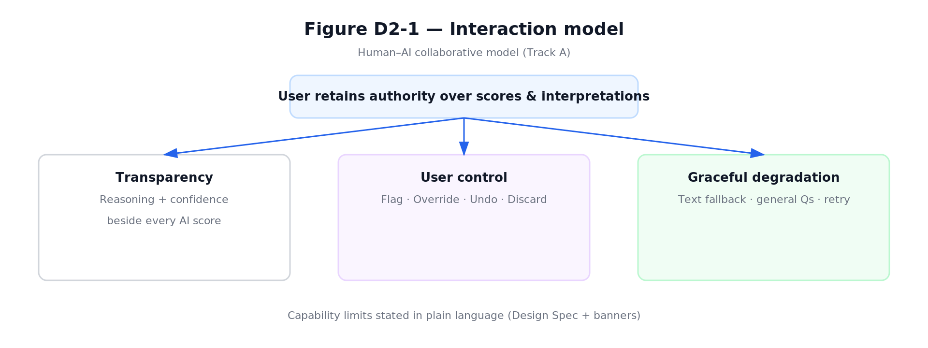
Figure D2-1: Interaction Model — Transparency, User Control, Graceful Degradation

2.2 Information Architecture 2.2 信息架构
Top-level areas are Dashboard, Practice, Review, History, and Settings. This split mirrors D1's two core workflows (live practice vs. post-hoc review) plus entry (Dashboard), continuity (History), and preferences (Settings). Exception-related branches (voice failure, AI error, extraction failure) are included in the IA view so failures are part of the structure, not an afterthought. 顶层区域为 Dashboard、Practice、Review、History 和 Settings。这种分割映射了D1的两个核心工作流（实时练习 vs. 事后回顾）加上入口（Dashboard）、连续性（History）和偏好（Settings）。异常分支（语音失败、AI错误、提取失败）包含在IA视图中，使故障成为结构的一部分。
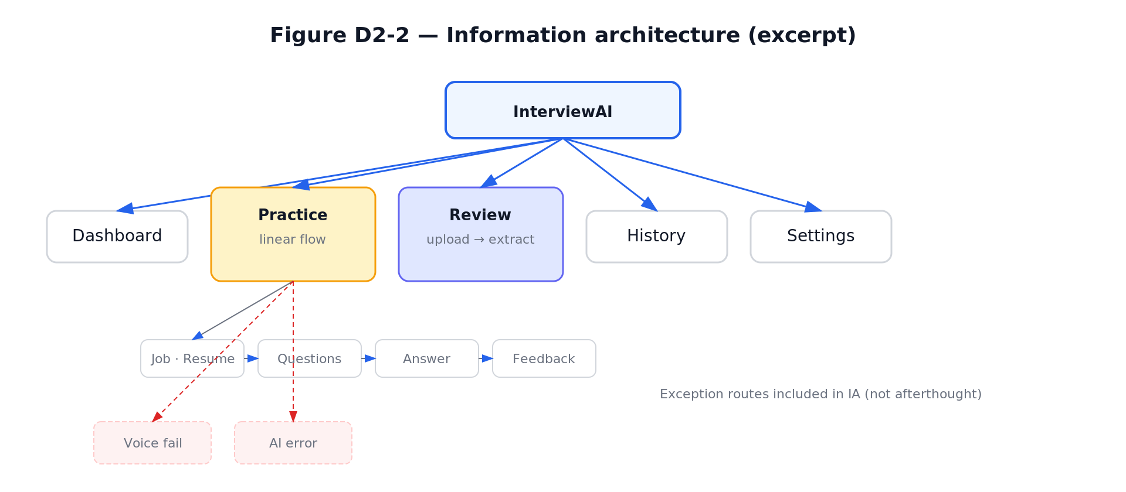
Figure D2-2: Information Architecture

2.3 Navigation Structure 2.3 导航结构
Global navigation uses a persistent sidebar across modules. Multi-step flows use breadcrumbs and Next/Back where appropriate. A navigation transition table records primary page jumps: from-state, to-state, user trigger, and transition type. 全局导航在所有模块中使用持久侧边栏。多步骤流程使用面包屑和上一步/下一步。导航转换表记录了主要的页面跳转：起始状态、目标状态、用户触发器和转换类型。
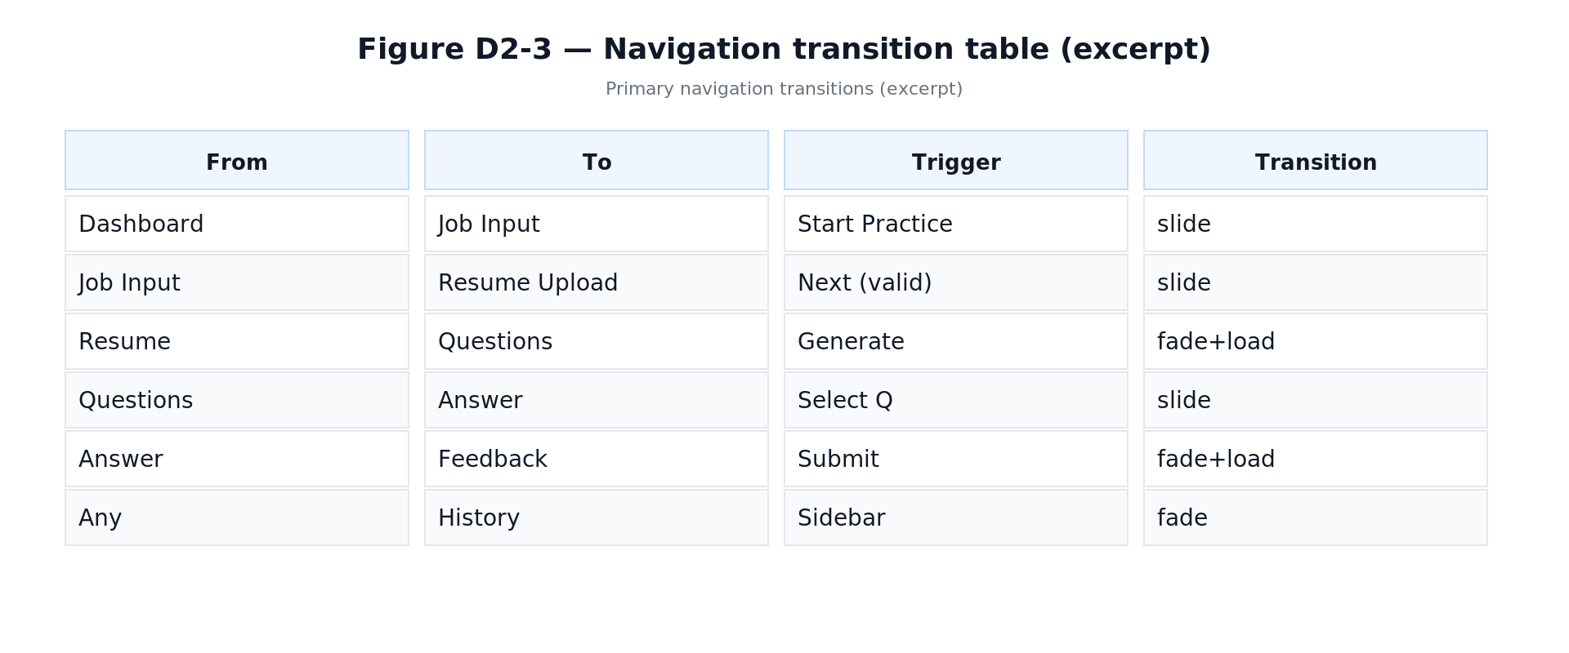
Figure D2-3: Navigation Transition Table

2.4 Core Task Workflows 2.4 核心任务工作流

Practice Workflow / 练习工作流 undefined
The Practice flow runs from role/JD input and resume upload through AI-generated questions, text or voice answers, AI evaluation, user control actions, then next question or save/exit. The diagram includes decision nodes and exception branches with recovery paths. 练习流程从角色/JD输入和简历上传开始，经过AI生成的问题、文本或语音回答、AI评估、用户控制操作，然后是下一题或保存/退出。图表包含决策节点和带有恢复路径的异常分支。
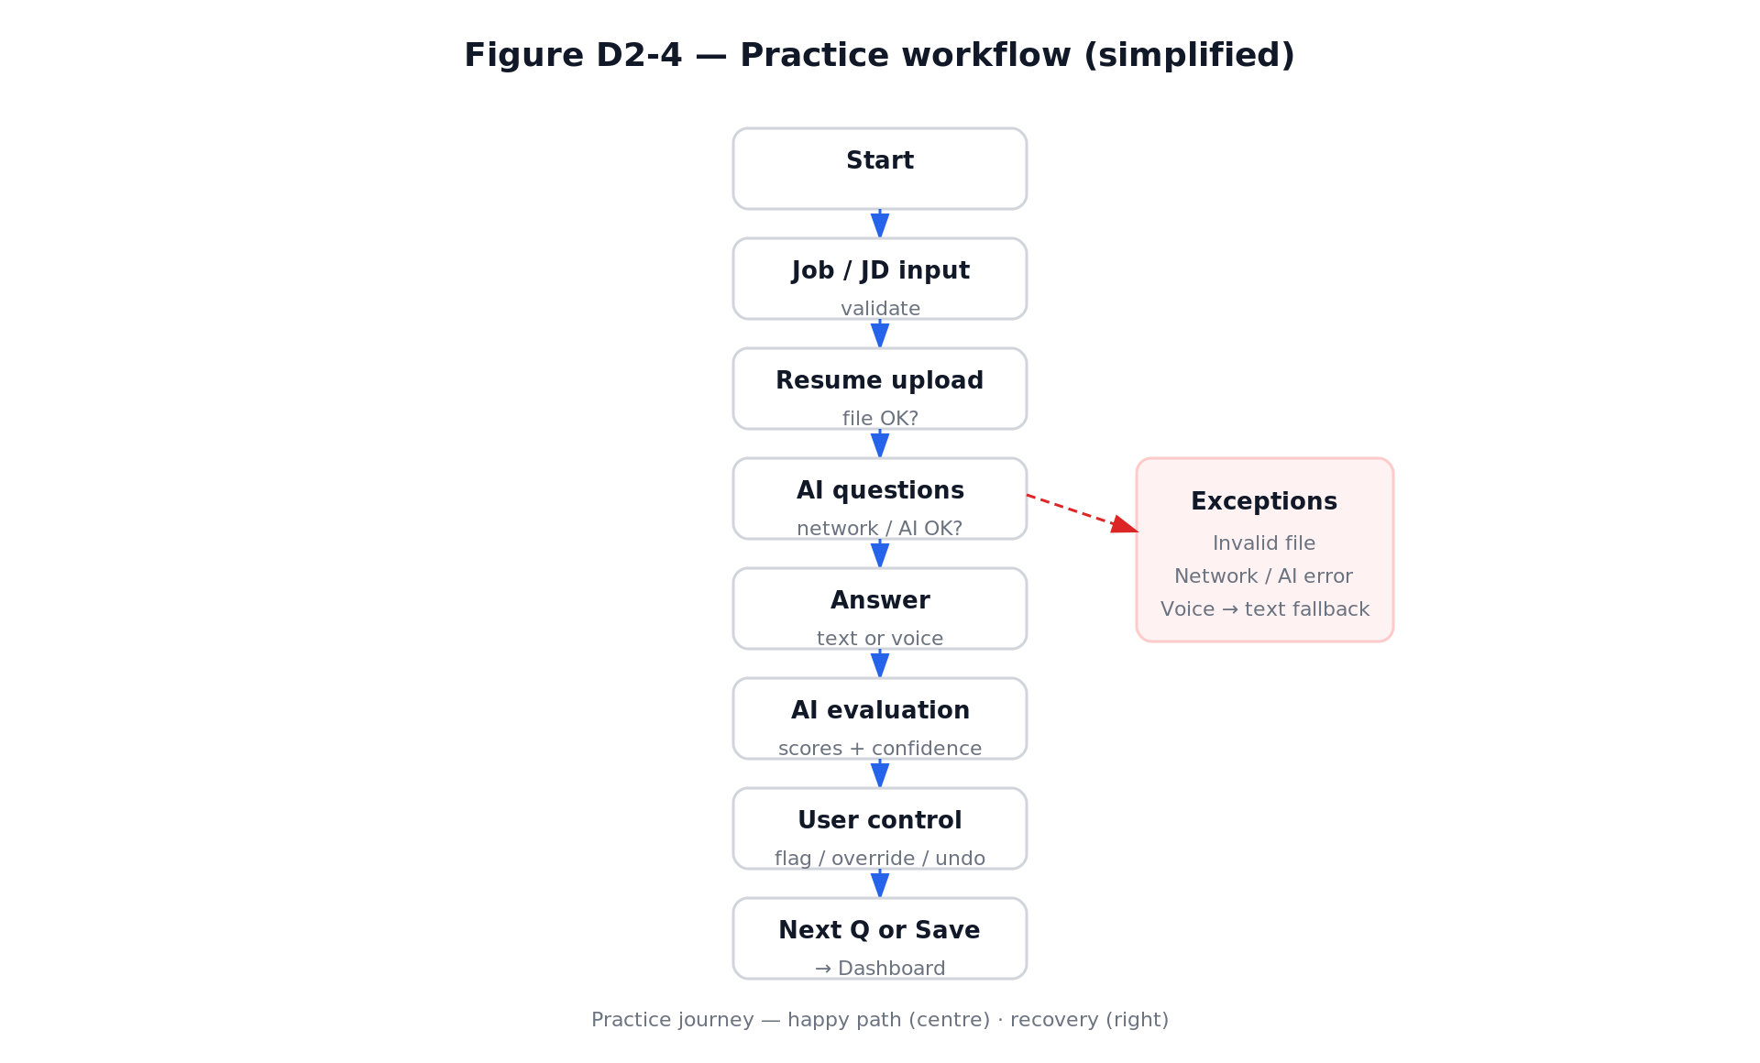
Figure D2-4: Practice Workflow

Review Workflow / 回顾工作流 undefined
The Review flow runs from audio upload through extraction and optional editing of Q&A, to feedback summary and export. It includes branches for invalid upload, extraction failure, and low audio quality with explicit recovery paths. 回顾流程从音频上传开始，经过提取和可选的Q&A编辑，到反馈摘要和导出。它包含无效上传、提取失败和低音质的分支，并有明确的恢复路径。
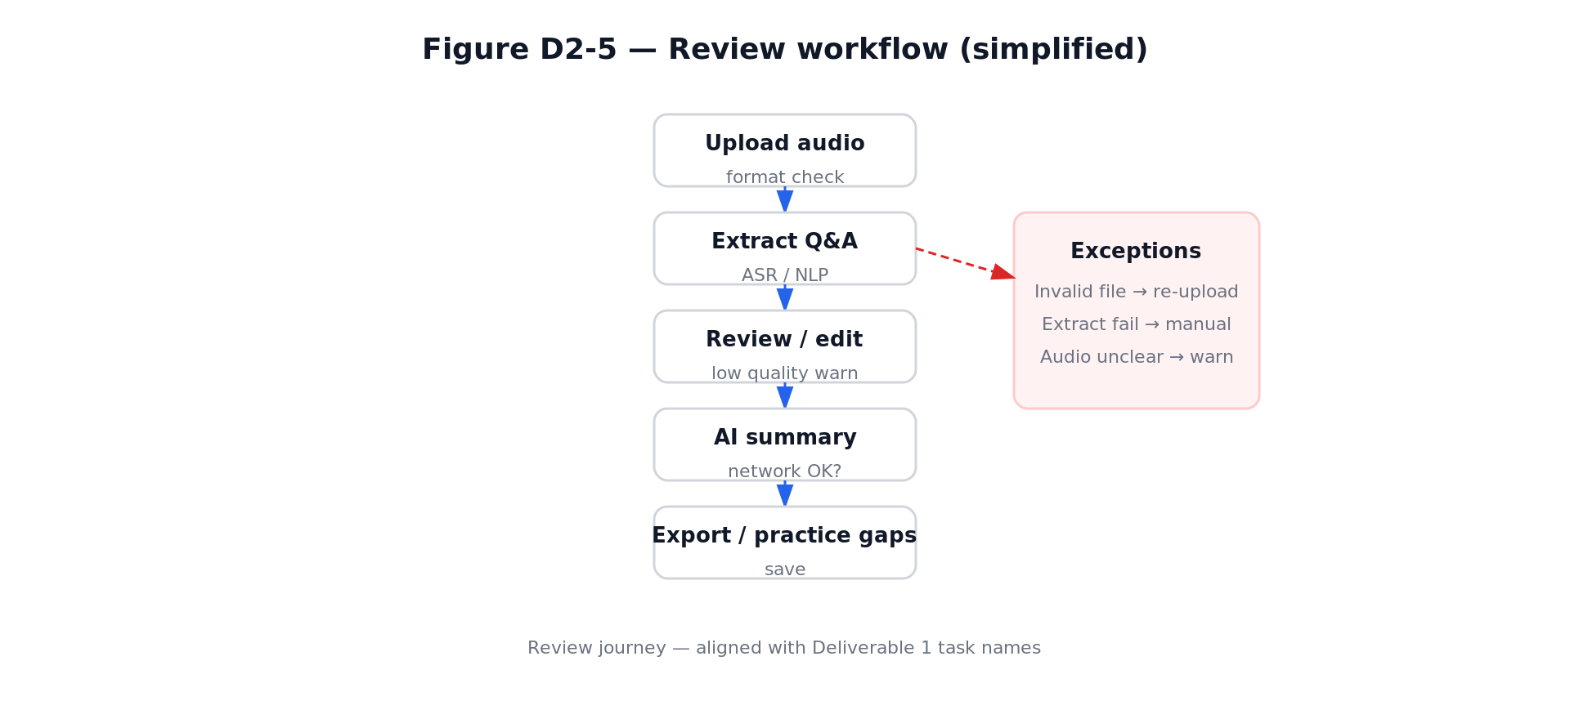
Figure D2-5: Review Workflow

2.5 Interactive Prototype 2.5 交互原型
The prototype is submitted as a single self-contained HTML file with three tabs: Design Spec, Flow Diagrams, and Prototype. It provides a high-fidelity, click-through experience covering Dashboard, full Practice path, Review path, History, and Settings. Fault scenarios are demonstrable via controls that open voice recognition failure and AI generation error modals. 原型以单文件HTML提交，包含三个标签页：Design Spec、Flow Diagrams和Prototype。它提供高保真的点击体验，覆盖Dashboard、完整的Practice路径、Review路径、History和Settings。故障场景通过控件演示，可打开语音识别失败和AI生成错误的模态框。
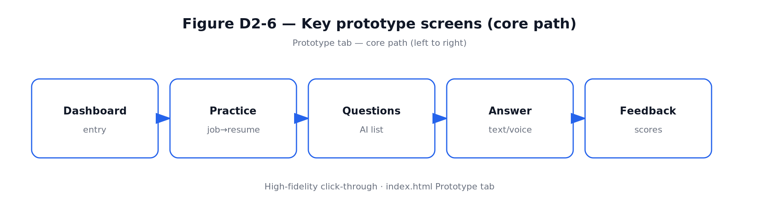
Figure D2-6: Prototype Core Path

2.6 Track A Compliance 2.6 Track A 合规性
Track A Requirement | Implementation / 实现方式
Capability Boundaries 能力边界 | Can/Cannot/Limited list in Design Spec; contextual banner on evaluation views Design Spec中的能做/不能做/受限列表；评估视图上的上下文横幅
User Control 用户控制 | Flag, Override, Undo, Discard buttons on every AI output 每个AI输出上的标记/覆盖/撤销/丢弃按钮
≥ 2 System Failure Solutions ≥ 2种系统故障解决方案 | Voice recognition failure → text input fallback; AI generation error → generic question bank 语音识别失败 → 文本输入回退；AI生成错误 → 通用题库
≥ 1 Limitation Mechanism ≥ 1种限制传达机制 | Confidence indicators (High/Low); low-confidence copy; audio quality warning 置信度指示器（高/低）；低置信度文本；音频质量警告
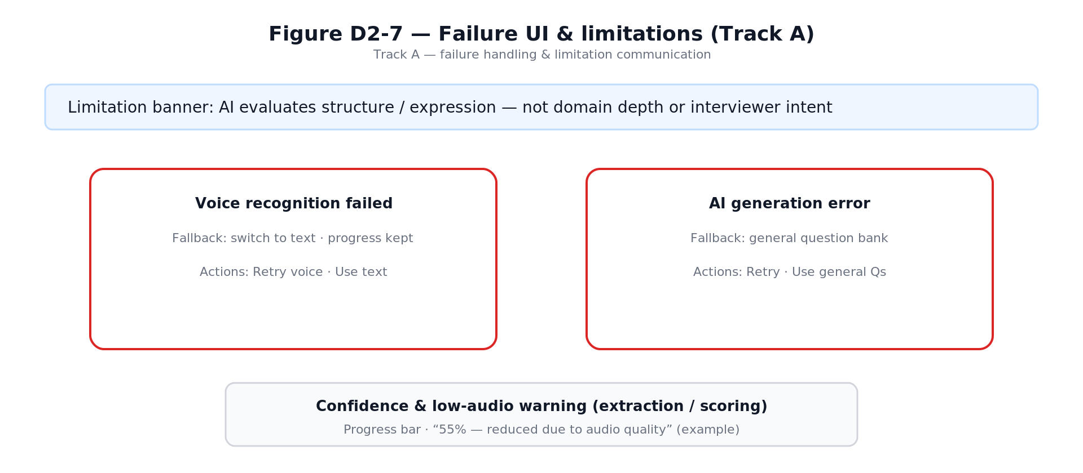
Figure D2-7: Track A Failure Handling & Limitation Communication

Deliverable 3: Design Evaluation & Iteration 交付物 3：设计评估与迭代优化
This deliverable documents our comprehensive evaluation strategy and the three design iterations performed on the prototype. We used three complementary evaluation methods: Heuristic Evaluation, Cognitive Walkthrough, and Think-Aloud Protocol. 本交付物记录了我们的综合评估策略和对原型进行的三次设计迭代。我们使用了三种互补的评估方法：启发式评估、认知走查和有声思维协议。

3.1 Evaluation Plan 3.1 评估计划

Method 1: Heuristic Evaluation / 方法 1：启发式评估 undefined
Three evaluators independently walked through the prototype using a structured checklist based on Nielsen's 10 Usability Heuristics, mapped to six summary dimensions. Each evaluator rated each dimension on a scale of 1–5 and recorded observed violations with location, description, and severity estimate. 三位评估者独立使用基于Nielsen的10项可用性启发式原则的结构化检查清单走查原型，映射到六个汇总维度。每位评估者对每个维度进行1-5分评分，并记录观察到的违规及其位置、描述和严重度估计。

Method 2: Cognitive Walkthrough / 方法 2：认知走查 undefined
Assessed learnability for first-time users attempting the two core tasks (Practice and Review) without prior instruction, using the standard Polson et al. framework with four questions at each step. 评估没有先前指导的首次用户尝试两个核心任务（练习和回顾）的可学习性，使用标准的Polson等人框架，在每个步骤提出四个问题。

Method 3: Think-Aloud Protocol / 方法 3：有声思维协议 undefined
3 participants matching the D1 persona completed 25-minute sessions (10 min Practice + 8 min Review + 4 min debrief). Data collected: verbal quotes, hesitation points, error recoveries, and spontaneous positive comments. 3名符合D1画像的参与者完成25分钟的会话（10分钟练习+8分钟回顾+4分钟反馈）。收集数据：口头引述、犹豫点、错误恢复和自发积极评论。

3.2 Evaluation Results 3.2 评估结果

Heuristic Evaluation Summary / 启发式评估汇总 undefined
Dimension | Score | Key Finding
Consistency 一致性 | 3 | AI feedback cards use different layouts in Practice vs. Review Practice和Review中AI反馈卡片布局不一致
Status Feedback 状态反馈 | 3 | No step progress indicator in Practice setup wizard Practice设置向导中没有步骤进度指示器
User Control 用户控制 | 2 | Cannot edit JD/resume after question generation; silent draft discard 问题生成后无法编辑JD/简历；默默丢弃草稿
Error Prevention 错误预防 | 4 | Navigating away discards answer draft without warning 导航离开时无警告地丢弃答案草稿
Simplicity 简洁性 | 3 | Five simultaneous coaching panels create cognitive overload 五个同时显示的辅导面板造成认知过载
General Usability 一般可用性 | 3 | Layout breaks at 1024px; no keyboard shortcuts 1024px处布局流失；没有键盘快捷键

Severity Classification / 严重度分级 undefined
10 usability problems were identified across 4 severity levels: 2 Critical, 2 Serious, 3 Moderate, and 3 Minor. 识别出10个可用性问题，分布在4个严重度级别：2个致命、2个严重、3个中等、3个轻微。
ID | Severity | Problem
C-01 | Critical 致命 | No way to edit JD/resume after question generation — must restart session 问题生成后无法编辑JD/简历——必须重新开始会话
C-02 | Critical 致命 | Navigating away from in-progress answer discards content silently 导航离开正在进行的答案时默默丢弃内容
S-01 | Serious 严重 | No step progress indicator in Practice setup wizard Practice设置向导中没有步骤进度指示器
S-02 | Serious 严重 | Five simultaneous coaching panels create cognitive overload 五个同时显示的辅导面板造成认知过载

3.3 Iteration Evidence 3.3 迭代证据
Three design iterations were performed between prototype v1 and v2, each grounded in evaluation findings from Section 3.2. 在原型 v1 和 v2 之间进行了三次设计迭代，每次都基于第 3.2 节的评估发现。

Iteration 1: Question Management / 迭代 1：题目管理 undefined
Trigger: S-02, M-03. Added filter/sort/favorite/mark-weak capabilities to the question page. 触发器：S-02, M-03。在题目页面添加了筛选/排序/收藏/标记薄弱功能。
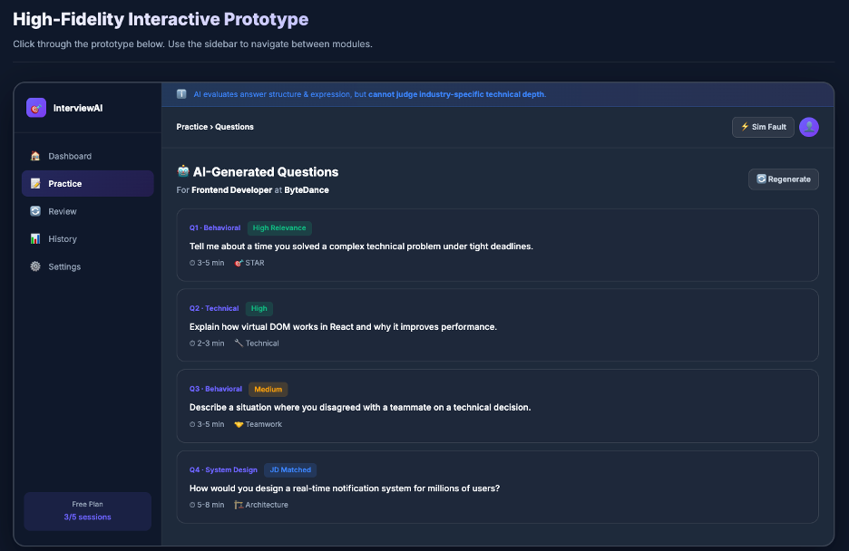
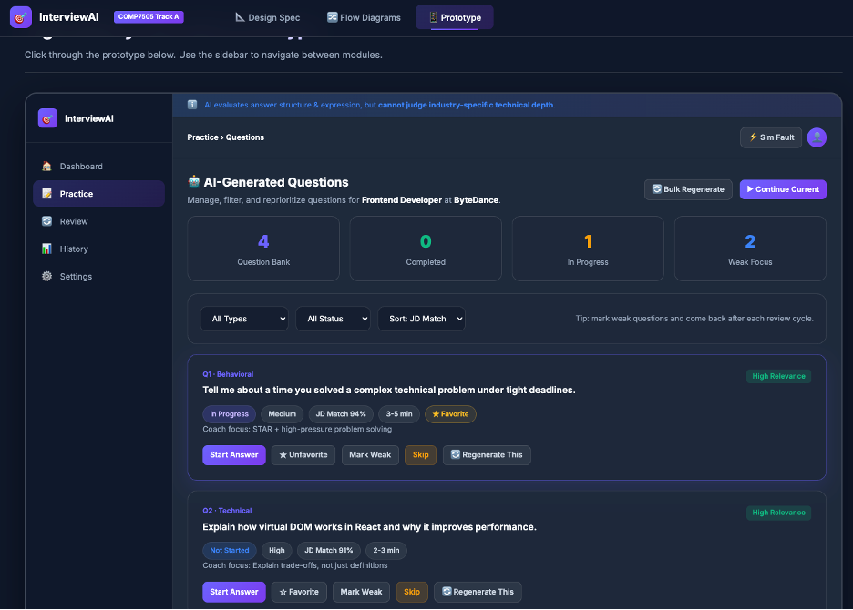
Figure: Iteration 1 — Question Management (Before / After)

Iteration 2: Real-Time Coaching / 迭代 2：实时辅导（核心迭代） undefined
Trigger: S-02. Shifted AI from post-hoc judge to in-process coach with STAR Coverage detection, live coaching tips, and quick improvement inserts. 触发器：S-02。将AI从事后评分者转变为过程辅导教练，具备STAR覆盖度检测、实时辅导提示和快速改进插入功能。
Metric | Before (v1) | After (v2)
Avg. re-submissions per question 每题平均重复提交次数 | 2.3 | 1.1
Participants "not knowing if answer is good" 参与者“不知道回答好不好” | 3 / 3 | 0 / 3
Participants who used STAR panel 使用STAR面板的参与者 | — | 3 / 3
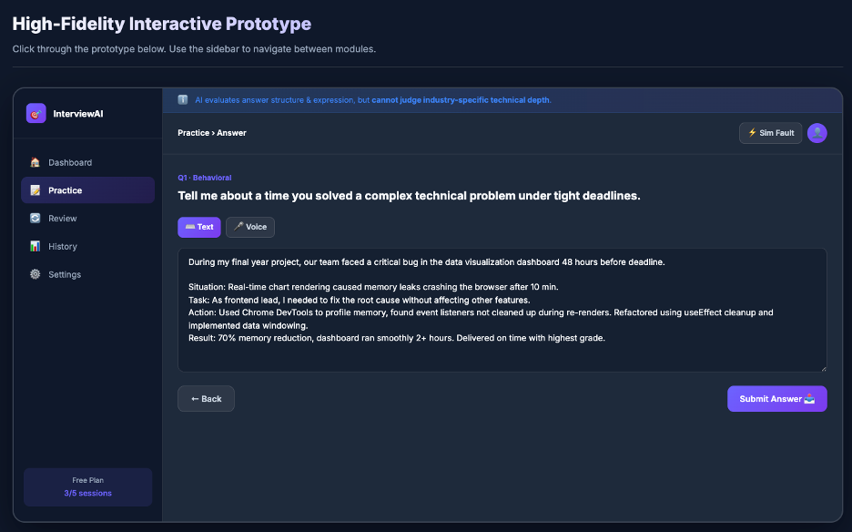
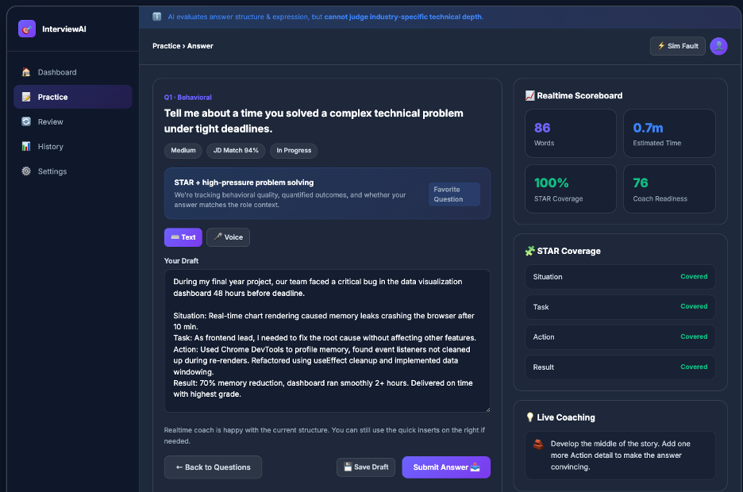
Figure: Iteration 2 — Real-Time Coaching (Before / After)

Iteration 3: History Comparison Studio / 迭代 3：历史对比工作室 undefined
Trigger: General Usability score of 3. Transformed History from a passive archive into an active reflection tool with side-by-side comparison and "Practice Similar Gap" functionality. 触发器：一般可用性得分3分。将History从被动存档转变为主动反思工具，具备并排对比和“练习类似差距”功能。
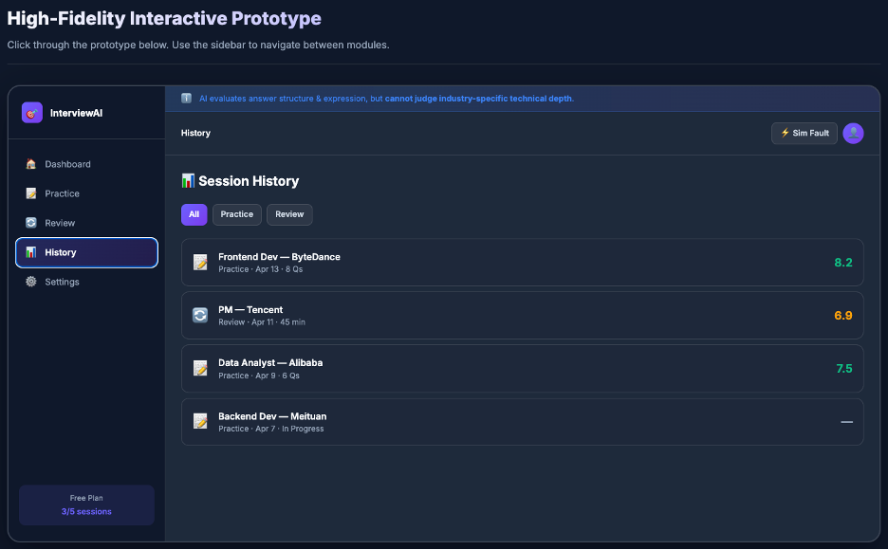
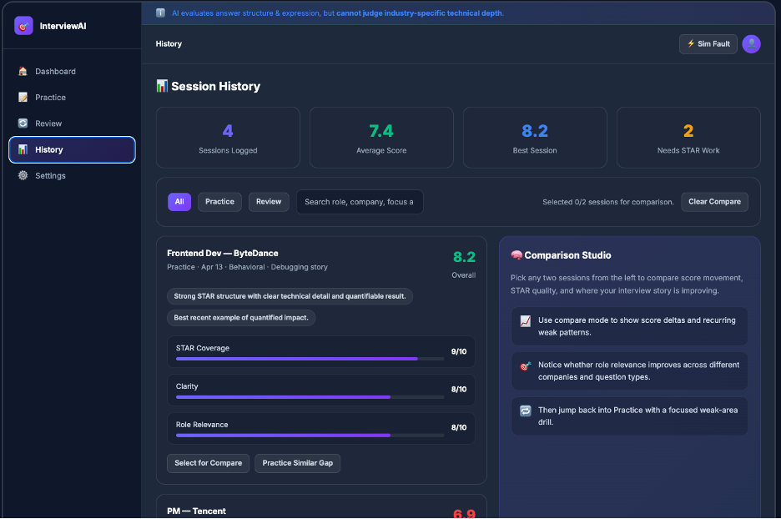
Figure: Iteration 3 — History Comparison (Before / After)

Deliverable 4: Design Principles & Product Roadmap 交付物 4：设计原则与产品路线图
This deliverable presents three reusable interaction design principles derived from our project experience, each supported by concrete design examples from InterviewAI. It also outlines a phased product development roadmap for future expansion. 本交付物展示了从我们的项目经验中提炼的三条可复用交互设计原则，每条都有InterviewAI的具体设计案例支撑。它还概述了分阶段的产品开发路线图。

4.1 Reusable Design Principles 4.1 可复用设计原则

Principle 1: Transparency of AI Reasoning / 原则 1：AI推理的透明性 undefined
Every AI output must include reasoning explanation and a confidence indicator. Users should be able to judge the relevance and reliability of AI suggestions rather than blindly trusting them. This principle addresses the fundamental trust gap identified in our user research: 6 out of 9 survey respondents reported that AI feedback felt unreliable. 每个AI输出必须包含推理解释和置信度指示器。用户应该能够判断AI建议的相关性和可靠性，而不是盲目信任。这一原则解决了用户研究中发现的基本信任差距：9名受访者中有6名报告AI反馈感觉不可靠。
Design Example in InterviewAI: Each AI feedback card displays a confidence badge (High/Medium/Low), a reasoning paragraph explaining the score, and a "Strong Answer Example" for reference. InterviewAI中的设计案例：每个AI反馈卡片显示置信度徽章（高/中/低）、解释分数的推理段落，以及参考用的“优秀回答示例”。

Principle 2: User Control Over AI Outputs / 原则 2：用户对AI输出的控制 undefined
Users must always have final control over AI-generated evaluations. They should be able to flag inaccuracies, override scores, undo actions, and discard flawed evaluations. AI should suggest, not dictate. This principle directly responds to our persona's frustration: "Sometimes the AI clearly didn't read my resume... That breaks trust immediately." 用户必须始终对AI生成的评估拥有最终控制权。他们应该能够标记不准确之处、覆盖分数、撤销操作和丢弃有缺陷的评估。AI应该建议，而不是命令。这一原则直接回应了我们画像的挫败感：“有时AI明显没有读我的简历...这立即破坏了信任。”
Design Example in InterviewAI: Every AI evaluation view includes Flag Inaccurate, Override Score, Undo, and Discard buttons. Users can challenge any feedback point inline. InterviewAI中的设计案例：每个AI评估视图都包含标记不准确、覆盖分数、撤销和丢弃按钮。用户可以就地质疑任何反馈点。

Principle 3: Graceful Degradation / 原则 3：优雅降级 undefined
System failures must provide clear degradation paths with no dead ends. When AI or recognition capabilities fail, the system should offer meaningful fallbacks (e.g., text input for voice failure, generic question bank for generation errors). This principle ensures that preparation under time pressure is never interrupted by a technical failure. 系统故障必须提供明确的降级路径，不能有死胡同。当AI或识别功能失败时，系统应提供有意义的回退方案（例如，语音失败时回退到文本输入，生成错误时回退到通用题库）。这一原则确保时间压力下的准备工作不会被技术故障中断。
Design Example in InterviewAI: The prototype includes a Sim Fault button that demonstrates three failure scenarios: (1) Voice recognition failed → text input fallback, (2) AI generation error → generic question bank, (3) Audio extraction failure → manual Q&A entry. InterviewAI中的设计案例：原型包含一个Sim Fault按钮，演示三种故障场景：(1)语音识别失败→文本输入回退，(2)AI生成错误→通用题库，(3)音频提取失败→手动Q&A录入。

4.2 Product Development Roadmap 4.2 产品开发路线图
Our product expansion plan is organized into three phases, each building on the previous one while maintaining the three core design principles: 我们的产品扩展计划分为三个阶段，每个阶段都在前一个阶段的基础上建设，同时保持三个核心设计原则：
Phase | Focus | Description
Phase 1 阶段 1 | MVP Enhancement MVP增强 | Real-time voice analysis for spoken answers; multi-language support (English + Chinese); collaborative practice rooms for peer mock interviews 口述回答的实时语音分析；多语言支持（英文+中文）；用于同伴模拟面试的协作练习室
Phase 2 阶段 2 | Intelligent Adaptation 智能适配 | AI-driven difficulty scaling based on performance history; personalized learning paths; industry-specific question banks (finance, tech, consulting); integration with calendar apps for scheduling 基于历史表现的AI驱动难度调整；个性化学习路径；行业专属题库（金融、科技、咨询）；与日历应用集成以安排时间
Phase 3 阶段 3 | Ecosystem Expansion 生态扩展 | University career center partnerships; employer-branded practice modules; alumni mentor matching; analytics dashboard for career services; mobile app for on-the-go practice 大学职业中心合作；雇主品牌练习模块；校友导师匹配；面向职业服务的分析仪表盘；随时随地练习的移动应用

Deliverable 5: Product Pitch Materials 交付物 5：产品路演材料
This deliverable documents our product pitch materials, including the pitch deck structure, the live demo script, and our core value proposition. 本交付物记录了我们的产品路演材料，包括路演PPT结构、现场演示脚本和核心价值主张。

5.1 Pitch Deck Overview 5.1 路演PPT概述
The pitch deck (InterviewAI_Pitch_Deck.pptx) consists of 14 slides organized into 7 sections, designed for an 8-minute presentation (6 minutes presentation + 2 minutes Q&A): 路演PPT（InterviewAI_Pitch_Deck.pptx）共包含14张幻灯片，组织为7个部分，为8分钟演示（6分钟展示+2分钟问答）设计：
Slide | Section | Content
1 | Cover 封面 | InterviewAI branding, track, group name InterviewAI品牌、赛道、小组名称
2 | Roadmap for Today 今日路线图 | 7-section agenda with evaluation criteria u5e26评估标准的7部分议程
3 | Problem & Users 问题与用户 | Persona (Alex Lee), pain points, user quotes 画像（Alex Lee）、痛点、用户原话
4 | Solution 解决方案 | Two core tasks (Practice & Review), key differentiator 两个核心任务（练习和回顾），核心差异化
5–6 | Design & Track A 设计与Track A | Human-AI model, IA, workflows, Track A compliance 人机协作模型、IA、工作流、Track A合规
7–11 | Evaluation & Iteration 评估与迭代 | 3 iterations with before/after evidence, metrics u5e26前后对比证据和指标的3次迭代
12 | Live Demo 现场演示 | 5-step demo flow (60 seconds) 5步演示流程（60秒）
13 | Roadmap & Principles 路线图与原则 | Product roadmap, 3 reusable design principles 产品路线图，3条可复用设计原则
14 | Closing & Q&A 结束与问答 | Thank you, contact information 感谢，联系信息

5.2 Demo Script 5.2 原型演示脚本
The live demo follows a 5-step, 60-second flow designed to showcase the core differentiator (real-time coaching) and Track A compliance (graceful degradation): 现场演示遵循5步、60秒的流程，旨在展示核心差异化（实时辅导）和Track A合规性（优雅降级）：
Step | Screen | Time | Key Point
1 | Dashboard 仪表盘 | ~10s | Session overview & quick start 会话概览和快速开始
2 | Practice + Coaching 练习+辅导 | ~25s | Real-time STAR feedback while drafting (core differentiator) 起草时的实时STAR反馈（核心差异化）
3 | Question Management 题目管理 | ~10s | Filter, favorite, mark weak areas 筛选、收藏、标记薄弱区域
4 | Sim Fault 模拟故障 | ~10s | Voice failure → text fallback (Track A) 语音失败→文本回退（Track A）
5 | History Compare 历史对比 | ~10s | Comparison Studio + gap practice 对比工作室+差距练习

5.3 Core Value Proposition 5.3 核心价值主张
InterviewAI is more than a simulator — it is a coach. Our core differentiator is in-process coaching: AI shifts from a post-hoc scoring tool to an in-process coach that provides real-time STAR coverage checks, live coaching tips, and quick-improvement inserts while users draft their answers, not after they submit. InterviewAI不仅仅是模拟器——它是一位教练。我们的核心差异化在于过程中的辅导：AI从事后评分工具转变为过程中的教练，在用户起草回答时提供实时的STAR覆盖度检查、实时辅导提示和快速改进插入，而不是在提交后才提供。
This value proposition is grounded in user experience rather than feature stacking. Our user research showed that the #1 pain point was not the lack of features, but the lack of trustworthy, actionable guidance during the preparation process. 这一价值主张基于用户体验而非功能堆砌。我们的用户研究表明，第一大痛点不是功能不足，而是准备过程中缺乏可信赖的、可操作的指导。

References 参考文献
[1] COMP7505 Group Project Description. Moodle: COMP7505 → Project.
[2] COMP7505 Workshop Handout Day 1–6. Various topics on user research, interaction design, prototyping, and evaluation.
[3] Nielsen, J. (1994). "10 Usability Heuristics for User Interface Design." Nielsen Norman Group.
[4] Norman, D. (2013). The Design of Everyday Things: Revised and Expanded Edition. Basic Books.
[5] Polson, P. G., Lewis, C., Rieman, J., & Wharton, C. (1992). "Cognitive Walkthroughs: A Method for Theory-Based Evaluation of User Interfaces." International Journal of Man-Machine Studies, 36(5), 741–773.
[6] Gould, J. D., & Lewis, C. (1985). "Designing for Usability: Key Principles and What Designers Think." Communications of the ACM, 28(3), 300–311.

