COMP7505 Group Project Report

InterviewAI — Your AI Interview Prep Coach

Track A: Smart Adaptive Interfaces | Group: Cre8
Course: COMP7505 User Interface Design and Development
Team Members
Name | Student Number | Role | Deliverable
Wang Qi'an | 3036656192 | Deliverable 1 Lead | D1: User Needs & Project Definition
Yu Pei | 3036656867 | Deliverable 2 Lead | D2: Interaction Design & Interactive Prototype
Wu Yuchen | 3036657378 | Deliverable 2 Member | D2: Interaction Design & Interactive Prototype
Ou Qianyin | 3036654754 | Deliverable 2 Member | D2: Interaction Design & Interactive Prototype
Yu Erfei | 3036657732 | Deliverable 3 Member | D3: Design Evaluation & Iteration
Ren Liubo | 3036654675 | Pitch Deck & Demo Script | D5: Product Pitch Materials
Chen Zhixin | 3036654053 | Deliverable 4 Lead | D4: Design Principles & Roadmap
Gao Yuqi | 3036661109 | Pitch Script Writer | D5: Product Pitch Materials

Table of Contents
Deliverable 1: User Needs & Project Definition
1.1 Target User Persona
1.2 Core User Tasks
1.3 Project Scope & Boundaries
Deliverable 2: Interaction Design Specification & Prototype
2.1 Interaction Model
2.2 Information Architecture
2.3 Navigation Structure
2.4 Core Task Workflows
2.5 Interactive Prototype
2.6 Track A Compliance
Deliverable 3: Design Evaluation & Iteration
3.1 Evaluation Plan
3.2 Evaluation Results
3.3 Iteration Evidence
Deliverable 4: Design Principles & Product Roadmap
4.1 Reusable Design Principles
4.2 Product Development Roadmap
Deliverable 5: Product Pitch Materials
5.1 Pitch Deck Overview
5.2 Demo Script
5.3 Core Value Proposition

Deliverable 1: User Needs & Project Definition
This deliverable documents the user-research foundation for InterviewAI. It defines the primary target user, summarises the main pain points identified through the questionnaire and interviews, specifies the core tasks the system is intended to support, and clarifies the scope and boundaries of the proposed design. The findings presented here provide the basis for the interaction design, evaluation, and roadmap discussed in Deliverables 2-5.

1.1 Target User Persona
The primary persona, Kevin Li, was developed from a pre-project questionnaire completed by nine respondents and from follow-up semi-structured interviews. All respondents were fresh graduates or near-graduates from computing-related backgrounds, and most were master's students at HKU. The persona consolidates the recurring goals, behaviours, and concerns observed across these data sources.
Attribute | Detail
Name | Kevin Li
Age | 23
Occupation | Fresh graduate in Computer Science
Location | Hong Kong
Job-seeking Status | Actively interviewing for front-end / full-stack developer roles
Core Goals | Kevin wants to prepare for both common and role-specific interview questions before formal interviews. He wants to improve the clarity, structure, and naturalness of his answers through repeated practice. He also expects the system to provide personalized and trustworthy feedback grounded in his resume and the job description, while helping him track progress across multiple sessions.

Pain Points
# | Pain Point | Severity
1 | Existing AI feedback is often generic and does not explain what specifically should be improved. | High
2 | Current tools do not sufficiently incorporate the user's resume, project experience, or job-description context when generating questions or feedback. | High
3 | AI-generated sample answers often sound formulaic and do not reflect the user's personal background or communication style. | Medium
4 | Users often find it difficult to judge whether AI-generated feedback is reliable or how confident the system is in its evaluation. | Medium
5 | Mock interview tools often fail to reproduce realistic follow-up questioning and the level of pressure found in actual interviews. | Low

Representative User Quote: "We do not only want AI-generated answers; we also want interview feedback that feels personalized, realistic, and trustworthy."

1.2 Core User Tasks
The core end-to-end task is to prepare for a specific interview with AI support. In practice, users first provide the target role, company, job description, and relevant resume or background information, and then continue through one of the two workflows below.

Task A: Practice
In the practice workflow, the user reviews AI-generated interview questions tailored to the target role, answers them through text or voice, and receives scores, explanations, confidence cues, and suggested revisions. The system can then provide more detailed feedback or optimized answer suggestions, and the session can be saved for later review.
Success Criteria: The user completes at least one full question-answer-feedback cycle and receives feedback that is specific enough to guide the next revision.

Task B: Review
In the review workflow, the user uploads a mock interview recording, after which the system extracts the interview questions and the user's answers for review. The user can then check and edit the extracted content before receiving feedback, polishing suggestions, and a structured review summary.
Success Criteria: The user uploads an audio file, verifies the accuracy of the extracted interview content, and receives a structured performance summary highlighting both strengths and areas for improvement.

1.3 Project Scope & Boundaries
Dimension | Boundary
Usage Scenario | The proposed design supports interview preparation before formal interviews and post-interview reflection, rather than use during a live interview.
Device | The current concept is designed primarily for laptop-based preparation, while phone use is treated as a secondary scenario for quick revision or last-minute checking.
Technical Constraints | The prototype assumes stable internet access and allows certain AI capabilities to be simulated; a production-ready AI backend is outside the scope of the current deliverable.
Design Assumptions | AI is positioned as a support tool rather than a final decision-maker, so the system should explicitly indicate when its confidence is low or when user context is insufficient.
Excluded Requirements | The project does not aim to become a full recruitment platform, a verified database of company-specific interview questions, or a real-time video interview system.

Deliverable 2: Interaction Design Specification & Prototype
This deliverable specifies the interaction model, information architecture, navigation structure, full core-task workflows, and a high-fidelity interactive prototype. All design decisions are grounded in Deliverable 1 findings.

2.1 Interaction Model
We use a human–AI collaborative model: the system supports preparation and reflection, but the user keeps authority over interpretations and scores. Three core behaviours run through the UI
Transparency — Scores and suggestions are paired with reasoning and confidence indicators, so users can judge relevance.
User Control — Users can flag errors, override scores, undo, or discard evaluations. AI suggests; user decides.
Graceful Degradation — When recognition or generation fails, the UI offers text input, fallback content, or retry instead of a dead end.
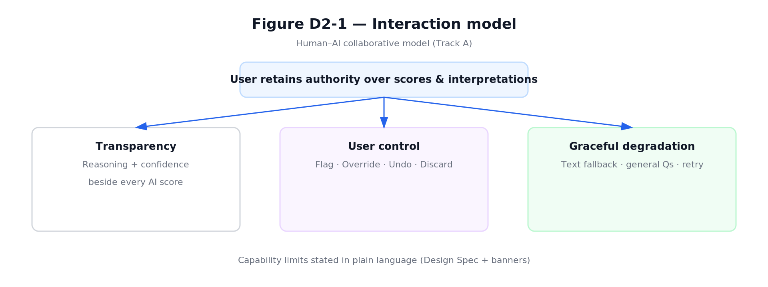
Figure D2-1: Interaction Model — Transparency, User Control, Graceful Degradation

2.2 Information Architecture
Top-level areas are Dashboard, Practice, Review, History, and Settings. This split mirrors D1's two core workflows (live practice vs. post-hoc review) plus entry (Dashboard), continuity (History), and preferences (Settings). Exception-related branches (voice failure, AI error, extraction failure) are included in the IA view so failures are part of the structure, not an afterthought.
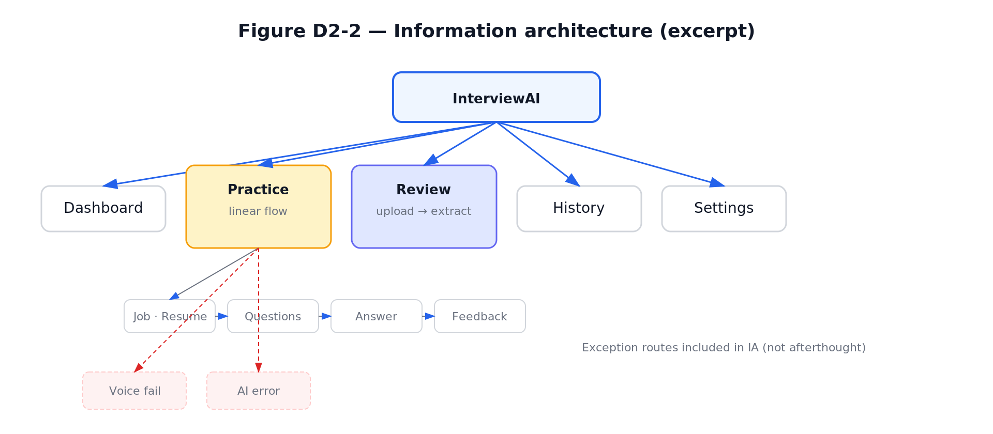
Figure D2-2: Information Architecture

2.3 Navigation Structure
Global navigation uses a persistent sidebar across modules. Multi-step flows use breadcrumbs and Next/Back where appropriate. A navigation transition table records primary page jumps: from-state, to-state, user trigger, and transition type.
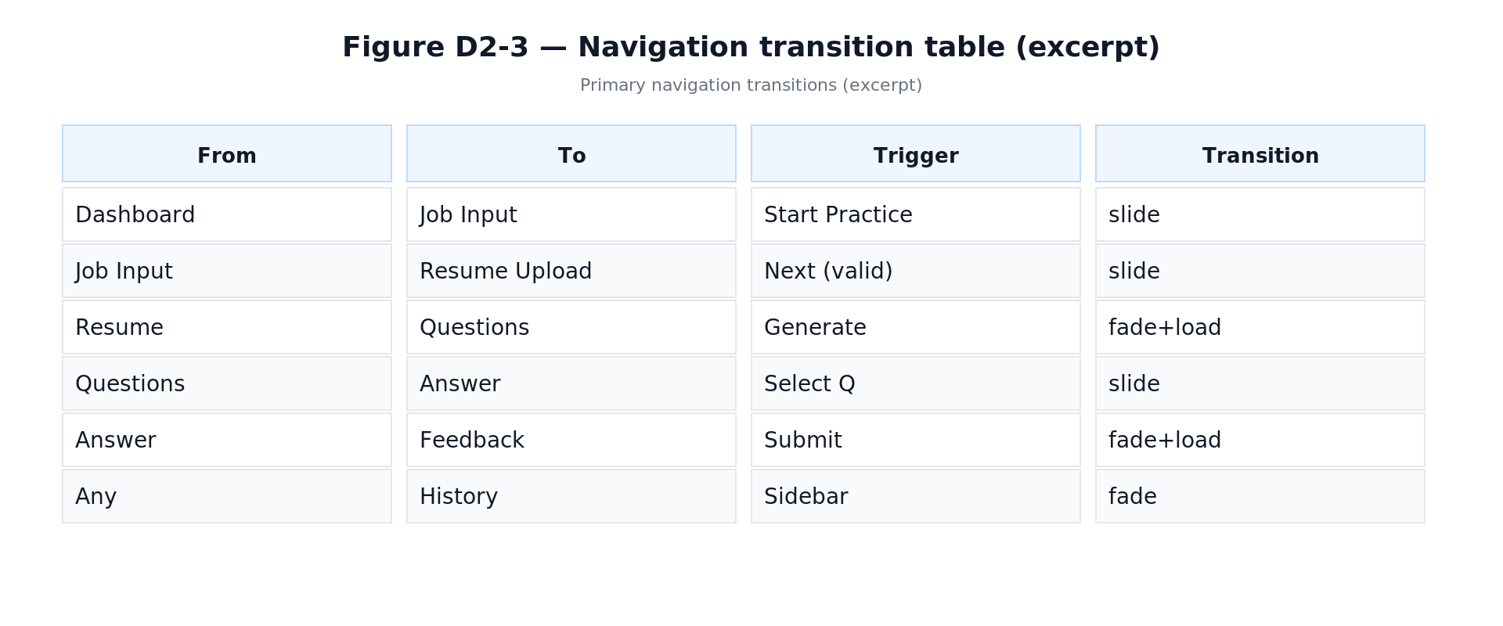
Figure D2-3: Navigation Transition Table

2.4 Core Task Workflows

Practice Workflow
The Practice flow runs from role/JD input and resume upload through AI-generated questions, text or voice answers, AI evaluation, user control actions, then next question or save/exit. The diagram includes decision nodes and exception branches with recovery paths.
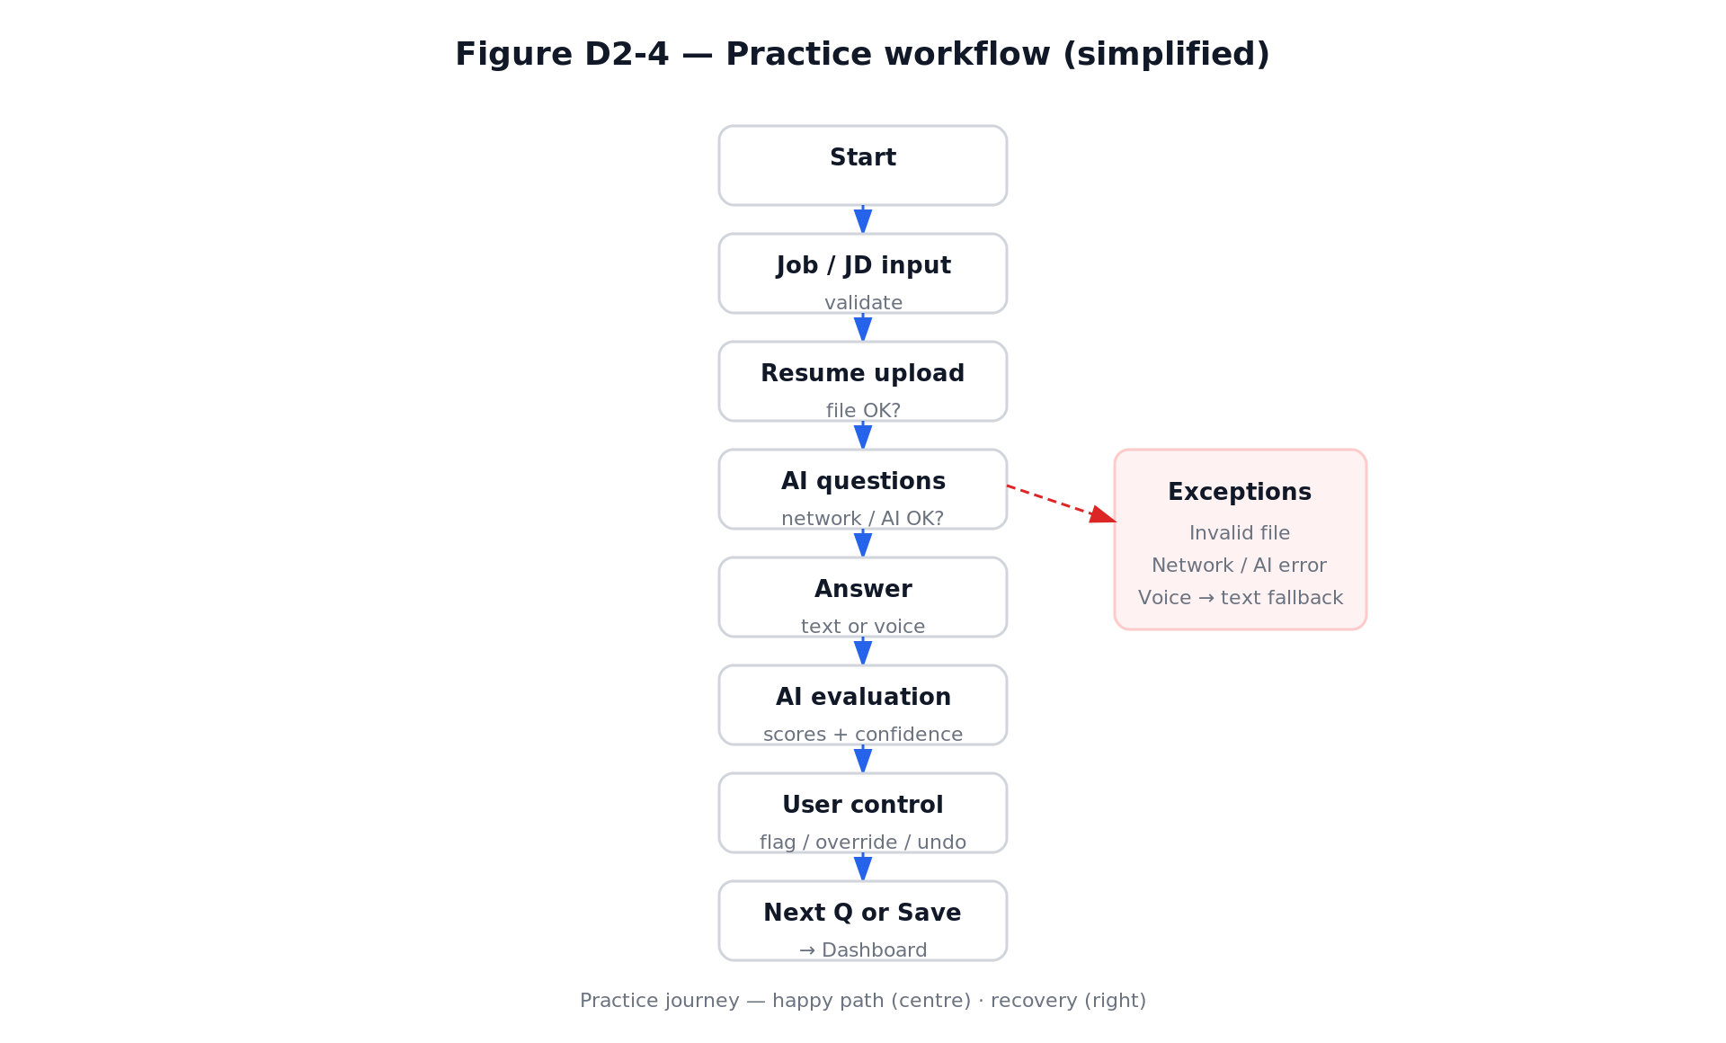
Figure D2-4: Practice Workflow

Review Workflow
The Review flow runs from audio upload through extraction and optional editing of Q&A, to feedback summary and export. It includes branches for invalid upload, extraction failure, and low audio quality with explicit recovery paths.
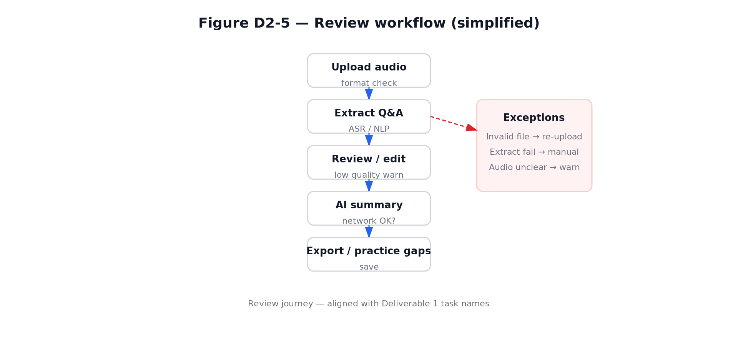
Figure D2-5: Review Workflow

2.5 Interactive Prototype
The prototype is submitted as a single self-contained HTML file with three tabs: Design Spec, Flow Diagrams, and Prototype. It provides a high-fidelity, click-through experience covering Dashboard, full Practice path, Review path, History, and Settings. Fault scenarios are demonstrable via controls that open voice recognition failure and AI generation error modals.
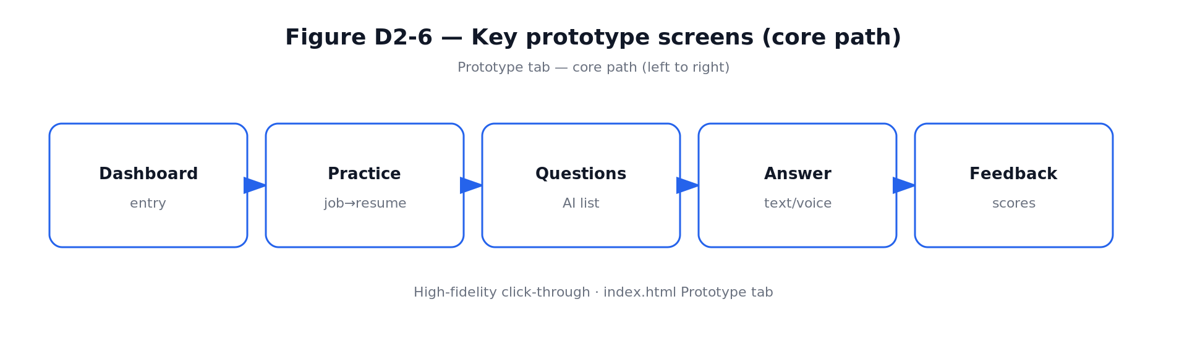
Figure D2-6: Prototype Core Path

2.6 Track A Compliance
Track A Requirement | Implementation
Capability Boundaries | Can/Cannot/Limited list in Design Spec; contextual banner on evaluation views
User Control | Flag, Override, Undo, Discard buttons on every AI output
≥ 2 System Failure Solutions | Voice recognition failure → text input fallback; AI generation error → generic question bank
≥ 1 Limitation Mechanism | Confidence indicators (High/Low); low-confidence copy; audio quality warning
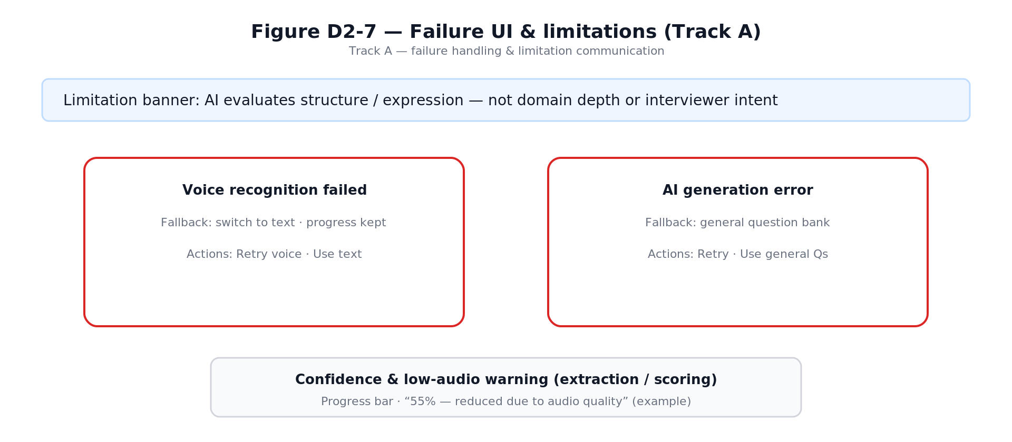
Figure D2-7: Track A Failure Handling & Limitation Communication

Deliverable 3: Design Evaluation & Iteration
This deliverable documents how the InterviewAI prototype was evaluated, what usability problems were discovered, and how those findings were translated into concrete design iterations. The evaluation focused on whether first-time users could understand the AI-supported workflow, maintain control over their interview context and answers, recover from errors, and receive feedback that was specific enough to support improvement. To avoid relying on a single source of evidence, we combined expert inspection, task-based walkthrough, and participant-based observation.
The final iteration direction was guided by one central design question: how can InterviewAI behave less like a black-box scoring tool and more like a transparent, controllable interview coach?

3.1 Evaluation Plan
The evaluation plan was designed to test the two core workflows defined in Deliverable 2: Practice, where users prepare with AI-generated interview questions and feedback, and Review, where users upload or review a mock interview and receive structured performance insights. The evaluation also checked the Track A requirements around capability boundaries, user control, failure handling, and limitation communication.

Evaluation Objectives
- Assess learnability: whether a new user can start a practice session, answer a question, and understand the feedback without external instruction.
- Assess trust and transparency: whether AI scores, suggestions, and confidence indicators provide enough reasoning for users to judge reliability.
- Assess user control: whether users can edit context, preserve drafts, challenge AI outputs, and recover from mistaken actions.
- Assess cognitive load: whether feedback, coaching panels, and history views are informative without overwhelming the user.
- Assess failure handling: whether recognition or generation failures lead to useful fallback actions rather than dead ends.
Method | Participants / Evaluators | Focus | Evidence Collected
Heuristic Evaluation | 3 evaluators from the project team | Expert inspection using Nielsen's 10 heuristics, summarized into six usability dimensions. | Severity ratings, violated heuristic, screen location, and recommended fix.
Cognitive Walkthrough | 2 evaluators acting as first-time users | Step-by-step learnability of the Practice and Review workflows. | Predicted user intention, visible action, feedback clarity, and likely breakdown point.
Think-Aloud Protocol | 3 participants matching the D1 persona | Observed use with realistic interview-preparation tasks. | Verbal comments, hesitation points, errors, recovery attempts, and post-task preference notes.

Task Scenarios
- Scenario A - Practice: The participant prepares for a front-end or full-stack developer interview, enters job and resume context, generates questions, answers one question, and reviews AI feedback.
- Scenario B - Review: The participant checks an uploaded mock-interview transcript, verifies the extracted question-answer pairs, and reviews the system's summary of strengths and improvement areas.
- Scenario C - Recovery: The participant encounters a simulated recognition or generation issue and chooses an appropriate fallback path.

Procedure and Metrics
Each session followed the same sequence: briefing, task execution, observation, short debrief, and consolidation of findings. We recorded task completion, visible hesitation, navigation errors, recovery success, subjective confidence, and comments about trust in the AI output. For heuristic findings, severity was classified as Critical, Serious, Moderate, or Minor according to impact on task completion and frequency of occurrence.

3.2 Evaluation Results
The evaluation found that the overall concept was understandable and relevant to the target users, especially because participants recognized the value of role-specific questions and structured feedback. However, the prototype still created friction in three areas: insufficient control over interview context, weak protection of in-progress work, and high cognitive load when too many AI coaching elements appeared at once.
Dimension | Score | Key Finding | Design Implication
Consistency | 3 / 5 | AI feedback cards used different layouts in Practice and Review, making users re-learn similar information patterns. | Standardize the feedback card structure across workflows.
Status Feedback | 3 / 5 | The Practice setup wizard did not clearly show progress or the current step. | Add a step indicator and visible state changes during generation.
User Control | 2 / 5 | Users could not edit the job description or resume context after question generation without restarting. | Allow context editing and regeneration without discarding the whole session.
Error Prevention | 2 / 5 | Answer drafts could be lost when navigating away from an in-progress response. | Introduce autosave, warning dialogs, and recoverable drafts.
Simplicity | 3 / 5 | Five simultaneous coaching panels created overload during answer revision. | Prioritize one primary coaching view and reveal deeper analysis progressively.
General Usability | 3 / 5 | The 1024px layout was crowded and history acted more like storage than reflection support. | Improve responsive layout and redesign history as an active comparison tool.

Severity Classification
ID | Severity | Problem | Evidence | Iteration Response
C-01 | Critical | No way to edit JD or resume context after question generation. | Users expected to correct context when a generated question felt irrelevant. | Context editing and regeneration controls were added.
C-02 | Critical | Navigating away from an in-progress answer discarded the draft silently. | Participants hesitated after losing text and became less willing to explore. | Autosave, leave warning, and draft restore behavior were specified.
S-01 | Serious | The Practice setup wizard lacked a clear progress indicator. | First-time users were unsure how many setup steps remained. | A three-step progress indicator was added.
S-02 | Serious | Too many coaching panels appeared at the same time. | Participants scanned repeatedly and asked which panel mattered most. | Real-time coaching was reorganized around STAR coverage and priority tips.
M-01 | Moderate | Feedback cards used inconsistent layouts across Practice and Review. | Users slowed down when switching between workflows. | A unified feedback-card template was introduced.
M-02 | Moderate | AI confidence cues were visible but not always explained. | Participants wanted to know why confidence was low. | Confidence explanations were paired with observable evidence.
M-03 | Moderate | Question lists lacked filtering for weak areas or favorites. | Users wanted to return quickly to difficult questions. | Question management tools were added.
N-01 | Minor | Some labels used product vocabulary that was not immediately clear. | Participants paused at terms such as 'gap' and 'coverage'. | Labels were simplified and paired with short contextual descriptions.
N-02 | Minor | The layout became dense around 1024px width. | Side panels compressed answer content. | Spacing and panel priority were adjusted for medium screens.
N-03 | Minor | History did not show enough comparison between attempts. | Users wanted to see whether they had improved. | History was redesigned into a comparison studio.

Cognitive Walkthrough Findings
The walkthrough showed that users could identify the primary action in most screens, but breakdowns occurred when the next step depended on hidden system state. In the Practice workflow, users understood that they needed to provide job context, but they could not predict whether changing that context later would preserve previous answers. In the Review workflow, users understood the purpose of transcript verification, but the prototype needed clearer feedback after edits were saved. These findings strengthened the need for persistent state, visible progress, and explicit confirmation messages.

Think-Aloud Findings
Observation | Participant Evidence | Interpretation
Users valued personalization. | All 3 participants responded positively when questions referenced resume or job-description details. | Personal context is a key trust signal and should remain visible throughout the workflow.
Users wanted guidance while answering, not only after submission. | 2 participants asked whether their answer was 'on the right track' before submitting. | Real-time coaching can reduce uncertainty and unnecessary re-submissions.
Users were cautious about AI scoring. | Participants accepted scores more readily when reasoning and confidence were shown together. | Scores should be treated as explainable suggestions rather than final judgments.
Users wanted evidence of progress. | All 3 participants looked for a way to compare previous and current attempts. | History should support reflection, comparison, and targeted re-practice.

3.3 Iteration Evidence
Three design iterations were completed between prototype v1 and v2. Each iteration directly addressed a usability issue found in Section 3.2 and was checked against the product goal of making InterviewAI transparent, controllable, and useful for repeated preparation.
Iteration | Evaluation Trigger | Design Change | Expected Improvement
1. Question Management | S-02 and M-03: users felt overloaded and could not quickly return to weak questions. | Added filter, sort, favorite, and mark-as-weak controls to the question page. Questions can now be grouped by type, difficulty, status, and relevance to the target role. | Users can focus on high-priority questions instead of scanning the full generated list every time.
2. Real-Time Coaching | S-02 and think-aloud evidence: users wanted to know whether an answer was strong before submitting. | Shifted AI support from post-hoc judging to in-process coaching. Added STAR coverage detection, priority coaching tips, confidence explanations, and quick improvement inserts. | Users receive timely guidance while drafting, which reduces uncertainty and repeated trial-and-error submissions.
3. History Comparison Studio | General usability score of 3 and participant demand for progress evidence. | Changed History from a passive archive into a side-by-side comparison studio with score trend, answer differences, recurring gaps, and 'Practice Similar Gap' entry points. | Users can reflect on improvement over time and convert past weaknesses into new practice tasks.
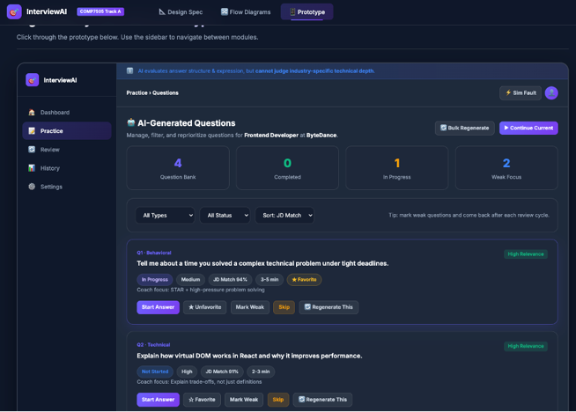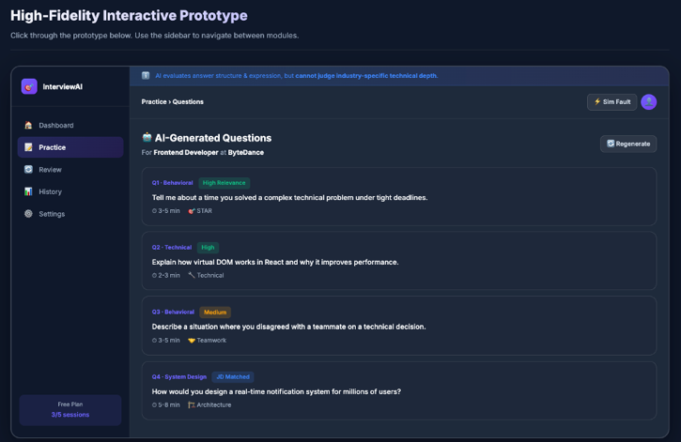
Figure D3-1: IT-1 Question Management — Before (static cards, no filtering) vs. After (filters, favorites, weak-area tags, quick actions)
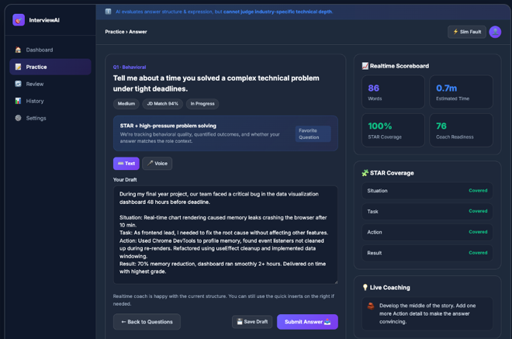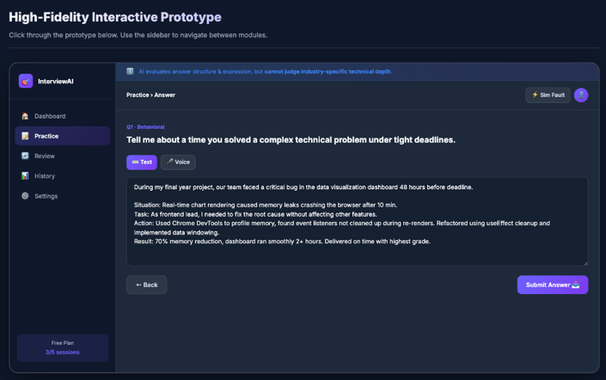
Figure D3-2: IT-2 Real-time Coaching — Before (single-column, feedback only after submission) vs. After (two-column layout with live STAR
coaching panel)

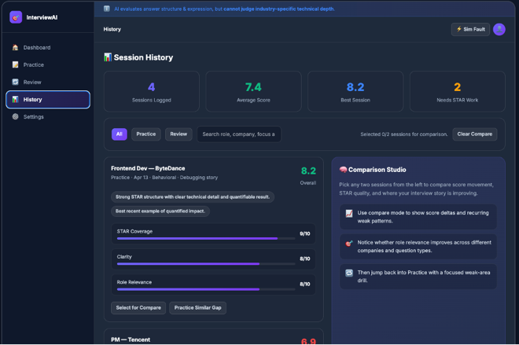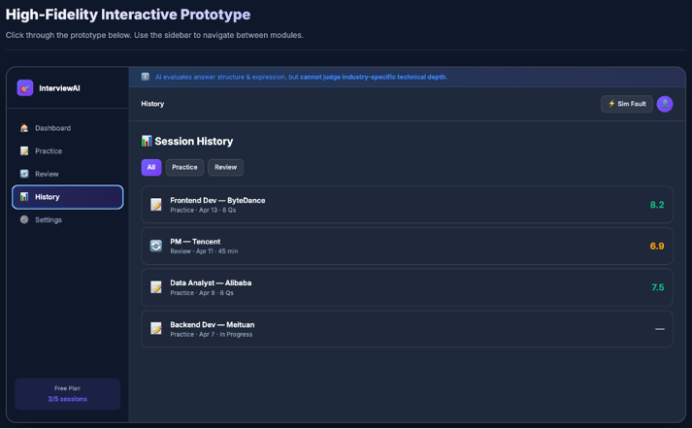

Figure D3-3: IT-3 History Comparison — Before (simple record list, no comparison) vs. After (side-by-side comparison studio with progress

tracking)

Iteration 2 Measurement
Metric | Before v1 | After v2 | Interpretation
Average re-submissions per question | 2.3 | 1.1 | Real-time coaching reduced repeated blind revisions.
Participants reporting 'I do not know if my answer is good' | 3 / | 0 / 3 | STAR coverage and priority tips improved confidence during drafting.
Participants who used the STAR panel | Not available | 3 / | The new coaching panel was discoverable and useful.
Participants who could identify their weakest answer area | 1 / 3 | 3 / | The history comparison view made progress and gaps more visible.

Before-and-After Summary
- Before iteration, the prototype provided many AI outputs but did not always make the user's next action obvious. After iteration, each major output is paired with an action such as edit context, improve answer, save draft, compare attempts, or practice a similar gap.
- Before iteration, the system behaved mainly as an evaluator after the user submitted an answer. After iteration, the system also supports the answer-construction process through lightweight coaching and STAR coverage checks.
- Before iteration, history mainly stored past sessions. After iteration, history became an active reflection workspace that helps users understand patterns across attempts.
Overall, Deliverable 3 demonstrates a complete evaluation-to-iteration cycle: findings were collected through complementary methods, prioritized by severity, converted into design changes, and checked against the central design principles of transparency, user control, and graceful degradation.

Deliverable 4: Design Principles & Product Roadmap
This deliverable presents three reusable interaction design principles derived from our project experience, each supported by concrete design examples from InterviewAI. It also outlines a phased product development roadmap for future expansion.

4.1 Reusable Design Principles

Principle 1: Transparency of AI Reasoning

Principle: Every AI output must include a reasoning explanation and a confidence indicator. Users should be able to judge the relevance and reliability of AI suggestions rather than blindly trusting them.

Rationale

This principle addresses the fundamental trust gap identified in the project research. Users were concerned that AI feedback could feel unreliable, generic, or insufficiently grounded in their job description and resume. In the survey evidence used by the team, **6 out of 9 respondents reported that AI feedback felt unreliable**. For InterviewAI, this means that AI cannot be presented as a black-box judge. It must behave as an inspectable coach.

Reusable application

For future modules, every important AI judgement should follow a four-part structure:

1. AI judgement — score, suggestion, category, or warning;

2. Reasoning — concise explanation based on observable evidence;

3. Confidence — High / Medium / Low or another uncertainty signal;

4. User verification — limitation statement or invitation for human judgement.

Principle 2: User Control Over AI Outputs
Principle: Users must always have final control over AI-generated evaluations. They should be able to flag inaccuracies, override scores, undo actions, and discard flawed evaluations. AI should suggest, not dictate.
Rationale
This principle directly responds to the frustration captured in the persona and evaluation findings: users lose trust when AI appears to ignore resume or job-description context. One representative user concern was: “Sometimes the AI clearly didn’t read my resume... That breaks trust immediately.”

The usability evaluation also found several control-related issues:
- users could not edit JD or resume context after question generation without restarting;
- answer drafts could be lost when navigating away;
- users needed more ways to challenge, revise, or recover from AI-generated content.
Therefore, user control is not a secondary usability detail. It is central to trust and task completion.
Reusable application
Any future AI-generated output should be designed with the following checklist:
- Can the user challenge this output?
- Can the user revise or regenerate it?
- Can the user undo or discard the result?
- Can the user preserve work before leaving the page?
- Can the user return to an earlier state without losing all progress?

Principle 3: Graceful Degradation
Principle: System failures must provide clear degradation paths with no dead ends. When AI or recognition capabilities fail, the system should offer meaningful fallbacks such as text input for voice failure, a generic question bank for generation errors, or manual Q&A entry for extraction failure.
Rationale
Interview preparation often happens under time pressure. A technical failure should not stop the user’s preparation session. The Track A requirements also emphasise capability boundaries, failure handling, and visible limitation communication. For InterviewAI, graceful degradation is essential because several product functions depend on uncertain AI or recognition capabilities, including question generation, voice recognition, and audio extraction.
Reusable application
For future features, every AI-dependent workflow should define:
- the likely failure mode;
- the user-facing message;
- the fallback action;
- the state that should be preserved;
- the recovery path back into the main workflow.

4.2 Product Development Roadmap
Our product expansion plan is organised into three phases. Each phase builds on the previous one while maintaining the three core design principles: transparent AI reasoning, user control over AI outputs, and graceful degradation.

Phase | Focus | Description
Phase 1 | MVP Enhancement | Real-time voice analysis for spoken answers; multi-language support (English + Chinese); collaborative practice rooms for peer mock interviews
Phase 2 | Intelligent Adaptation | AI-driven difficulty scaling based on performance history; personalized learning paths; industry-specific question banks (finance, tech, consulting); integration with calendar apps for scheduling
Phase 3 | Ecosystem Expansion | University career center partnerships; employer-branded practice modules; alumni mentor matching; analytics dashboard for career services; mobile app for on-the-go practice

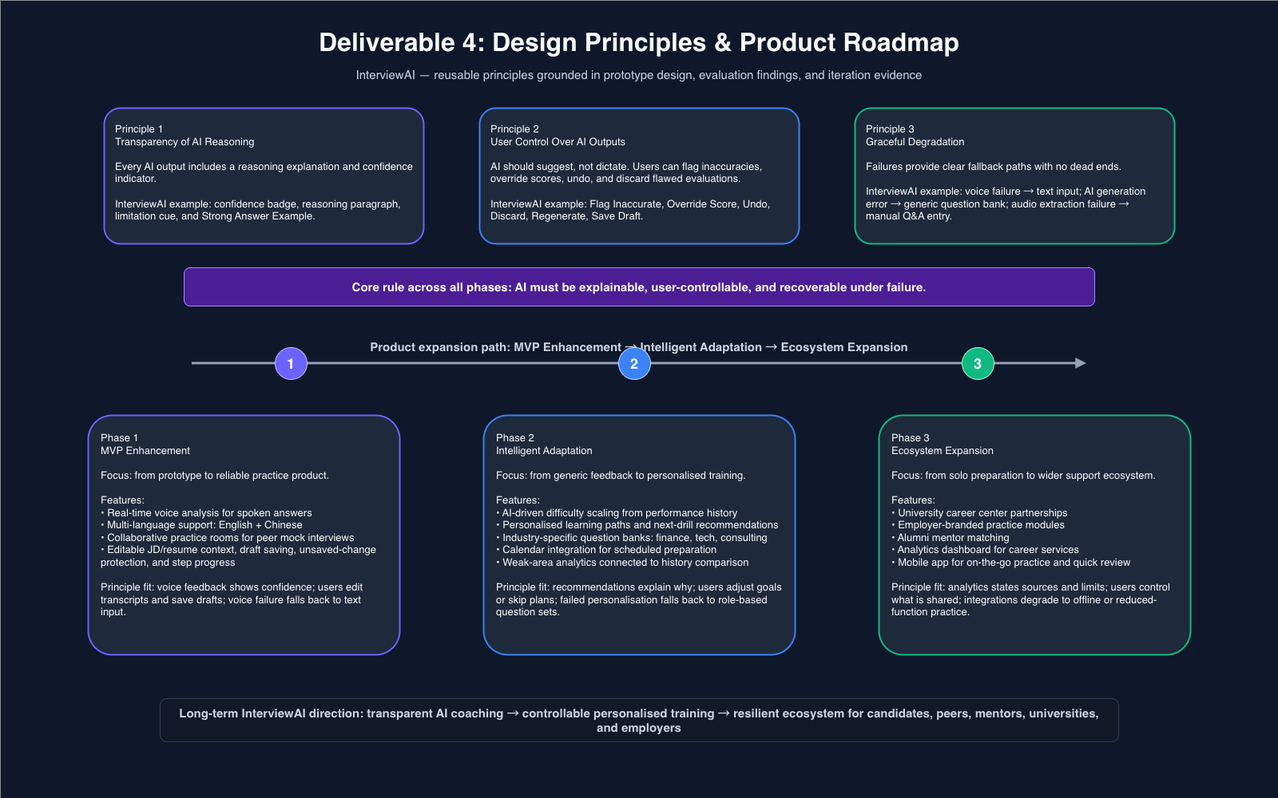
Figure D4-1: Roadmap

