COMP7505 Group Project Report
COMP7505 小组项目报告

InterviewAI — Your AI Interview Prep Coach
InterviewAI — 你的 AI 面试准备教练

Track A: Smart Adaptive Interfaces | Group: Cre8
Course: COMP7505 User Interface Design and Development
Team Members / 团队成员
Name / 姓名 | Student Number / 学号 | Role / 角色 | Deliverable
Wang Qi'an / 王祁安 | 3036656192 | Deliverable 1 Lead | D1: User Needs & Project Definition
Yu Pei / 余沛 | 3036656867 | Deliverable 2 Lead | D2: Interaction Design & Interactive Prototype
Wu Yuchen / 吴雨晨 | 3036657378 | Deliverable 2 Member | D2: Interaction Design & Interactive Prototype
Ou Qianyin / 欧倩茵 | 3036654754 | Deliverable 2 Member | D2: Interaction Design & Interactive Prototype
Yu Erfei / 余尔飞 | 3036657732 | Deliverable 3 Member | D3: Design Evaluation & Iteration
Ren Liubo / 任柳博 | 3036654675 | Pitch Deck & Demo Script | D5: Product Pitch Materials
Chen Zhixin / 陈智昕 | 3036654053 | Deliverable 4 Lead | D4: Design Principles & Roadmap
Gao Yuqi / 高雨琦 | 3036661109 | Pitch Script Writer | D5: Product Pitch Materials

Table of Contents 目录
Deliverable 1: User Needs & Project Definition / 用户需求与项目定义
1.1 Target User Persona / 目标用户画像
1.2 Core User Tasks / 核心用户任务
1.3 Project Scope & Boundaries / 项目范围与边界
Deliverable 2: Interaction Design Specification & Prototype / 交互设计规范与原型
2.1 Interaction Model / 交互模型
2.2 Information Architecture / 信息架构
2.3 Navigation Structure / 导航结构
2.4 Core Task Workflows / 核心任务工作流
2.5 Interactive Prototype / 交互原型
2.6 Track A Compliance / Track A 合规性
Deliverable 3: Design Evaluation & Iteration
3.1 Evaluation Plan
3.2 Evaluation Results
3.3 Iteration Evidence
Deliverable 4: Design Principles & Product Roadmap / 设计原则与产品路线图
4.1 Reusable Design Principles / 可复用设计原则
4.2 Product Development Roadmap / 产品开发路线图
Deliverable 5: Product Pitch Materials / 产品路演材料
5.1 Pitch Deck Overview / 路演PPT概述
5.2 Demo Script / 原型演示脚本
5.3 Core Value Proposition / 核心价值主张

Deliverable 1: User Needs & Project Definition 交付物 1：用户需求与项目定义
This deliverable documents the user-research foundation for InterviewAI. It defines the primary target user, summarises the main pain points identified through the questionnaire and interviews, specifies the core tasks the system is intended to support, and clarifies the scope and boundaries of the proposed design. The findings presented here provide the basis for the interaction design, evaluation, and roadmap discussed in Deliverables 2-5. 本交付物记录了 InterviewAI 的用户研究基础，界定了主要目标用户，总结了问卷与访谈中识别出的核心痛点，说明了系统需要支持的关键任务，并明确了所提设计的范围与边界。本节呈现的发现为交付物 2-5 中的交互设计、评估与路线图提供依据。

1.1 Target User Persona 1.1 目标用户画像
The primary persona, Kevin Li, was developed from a pre-project questionnaire completed by nine respondents and from follow-up semi-structured interviews. All respondents were fresh graduates or near-graduates from computing-related backgrounds, and most were master's students at HKU. The persona consolidates the recurring goals, behaviours, and concerns observed across these data sources. 主要用户画像 Kevin Li 基于 9 名受访者完成的项目前问卷以及后续半结构化访谈建立而成。所有受访者均为计算机相关背景的应届或准应届毕业生，其中大多数为港大硕士生。该画像整合了这些数据来源中反复出现的目标、行为模式与顾虑。
Attribute | Detail / 详情
Name 姓名 | Kevin Li
Age 年龄 | 23
Occupation 职业 | Fresh graduate in Computer Science 计算机科学专业应届毕业生
Location 地点 | Hong Kong 香港
Job-seeking Status 求职状态 | Actively interviewing for front-end / full-stack developer roles 正在积极应聘前端/全栈开发者职位
Core Goals 核心目标 | Kevin wants to prepare for both common and role-specific interview questions before formal interviews. He wants to improve the clarity, structure, and naturalness of his answers through repeated practice. He also expects the system to provide personalized and trustworthy feedback grounded in his resume and the job description, while helping him track progress across multiple sessions. Kevin 希望在正式面试前同时准备通用问题和岗位相关问题，并通过反复练习提升回答的清晰度、结构性和自然度。他还希望系统能够基于其简历和职位描述提供个性化、可信的反馈，并帮助他追踪多次练习中的进步。

Pain Points / 痛点
# | Pain Point | Severity
1 | Existing AI feedback is often generic and does not explain what specifically should be improved. 现有 AI 反馈往往较为笼统，未能明确说明具体应如何改进。 | High 高
2 | Current tools do not sufficiently incorporate the user's resume, project experience, or job-description context when generating questions or feedback. 当前工具在生成问题或反馈时，往往无法充分结合用户的简历、项目经历或职位描述背景。 | High 高
3 | AI-generated sample answers often sound formulaic and do not reflect the user's personal background or communication style. AI 生成的示例答案往往显得模板化，难以体现用户的个人背景或表达风格。 | Medium 中
4 | Users often find it difficult to judge whether AI-generated feedback is reliable or how confident the system is in its evaluation. 用户往往难以判断 AI 反馈是否可靠，也无法清楚了解系统对其评估结果的置信程度。 | Medium 中
5 | Mock interview tools often fail to reproduce realistic follow-up questioning and the level of pressure found in actual interviews. 模拟面试工具通常难以再现真实面试中的追问方式以及相应的压力感。 | Low 低

Representative User Quote: "We do not only want AI-generated answers; we also want interview feedback that feels personalized, realistic, and trustworthy." 代表性用户表述：“我们不仅希望获得 AI 生成的答案，也希望得到让人感觉个性化、真实且可信的面试反馈。”

1.2 Core User Tasks 1.2 核心用户任务
The core end-to-end task is to prepare for a specific interview with AI support. In practice, users first provide the target role, company, job description, and relevant resume or background information, and then continue through one of the two workflows below. 核心端到端任务是借助 AI 为一次具体面试做准备。实际流程中，用户首先提供目标岗位、公司、职位描述以及相关简历或背景信息，然后进入以下两种工作流之一。

Task A: Practice / 任务A：练习
In the practice workflow, the user reviews AI-generated interview questions tailored to the target role, answers them through text or voice, and receives scores, explanations, confidence cues, and suggested revisions. The system can then provide more detailed feedback or optimized answer suggestions, and the session can be saved for later review. 在练习工作流中，用户会查看针对目标岗位生成的 AI 面试问题，通过文字或语音作答，并获得分数、解释、置信度提示以及修改建议。随后，系统可以提供更深入的反馈或优化后的回答建议，并允许用户保存本次练习以供后续回顾。
Success Criteria: The user completes at least one full question-answer-feedback cycle and receives feedback that is specific enough to guide the next revision. 成功标准：用户完成至少一个完整的问题-回答-反馈循环，并获得足以指导下一轮修改的具体反馈。

Task B: Review / 任务B：回顾
In the review workflow, the user uploads a mock interview recording, after which the system extracts the interview questions and the user's answers for review. The user can then check and edit the extracted content before receiving feedback, polishing suggestions, and a structured review summary. 在回顾工作流中，用户上传一次模拟面试录音，系统随后提取其中的面试问题与用户回答供其审阅。用户可以先检查并编辑提取内容，再接收反馈、润色建议以及结构化的复盘摘要。
Success Criteria: The user uploads an audio file, verifies the accuracy of the extracted interview content, and receives a structured performance summary highlighting both strengths and areas for improvement. 成功标准：用户上传音频文件，核验提取出的面试内容是否准确，并获得同时指出优势与待改进之处的结构化表现总结。

1.3 Project Scope & Boundaries 1.3 项目范围与边界
Dimension | Boundary / 边界
Usage Scenario 使用场景 | The proposed design supports interview preparation before formal interviews and post-interview reflection, rather than use during a live interview. 本设计支持正式面试前的准备和面试后的复盘，而不面向实时面试过程中的使用。
Device 设备 | The current concept is designed primarily for laptop-based preparation, while phone use is treated as a secondary scenario for quick revision or last-minute checking. 当前概念主要面向基于笔记本电脑的准备场景，手机端仅作为快速复习或临时查看的次要场景。
Technical Constraints 技术约束 | The prototype assumes stable internet access and allows certain AI capabilities to be simulated; a production-ready AI backend is outside the scope of the current deliverable. 原型假设用户具备稳定的网络连接，并允许对部分 AI 功能进行模拟；可投入生产的 AI 后端不属于当前交付物范围。
Design Assumptions 设计假设 | AI is positioned as a support tool rather than a final decision-maker, so the system should explicitly indicate when its confidence is low or when user context is insufficient. AI 被定位为支持工具而非最终裁决者，因此系统应在置信度较低或用户上下文不足时提供明确提示。
Excluded Requirements 排除需求 | The project does not aim to become a full recruitment platform, a verified database of company-specific interview questions, or a real-time video interview system. 本项目不旨在构建完整的招聘平台、经过验证的公司专属面试题库，或实时视频面试系统。

Deliverable 2: Interaction Design Specification & Prototype 交付物 2：交互设计规范与原型
This deliverable specifies the interaction model, information architecture, navigation structure, full core-task workflows, and a high-fidelity interactive prototype. All design decisions are grounded in Deliverable 1 findings. 本交付物规定了交互模型、信息架构、导航结构、完整的核心任务工作流以及高保真交互原型。所有设计决策均基于交付物 1 的发现。

2.1 Interaction Model 2.1 交互模型
We use a human–AI collaborative model: the system supports preparation and reflection, but the user keeps authority over interpretations and scores. Three core behaviours run through the UI: 我们采用人机协作交互模型：系统支持准备和反思，但用户保持对解释和分数的最终掌控权。三个核心行为贯穿整个UI：
• Transparency — Scores and suggestions are paired with reasoning and confidence indicators, so users can judge relevance. • 透明性 — 分数和建议配有推理和置信度指示器，让用户能判断相关性。
• User Control — Users can flag errors, override scores, undo, or discard evaluations. AI suggests; user decides. • 用户控制 — 用户可以标记错误、覆盖分数、撤销或丢弃评估。AI建议，用户决定。
• Graceful Degradation — When recognition or generation fails, the UI offers text input, fallback content, or retry instead of a dead end. • 优雅降级 — 当识别或生成失败时，UI提供文本输入、回退内容或重试，而不是死胡同。
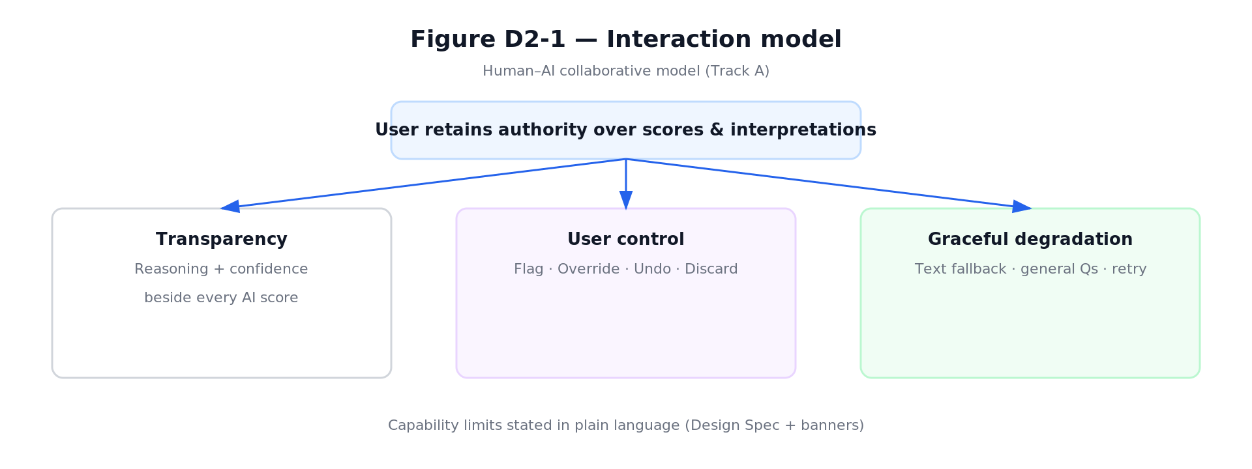
Figure D2-1: Interaction Model — Transparency, User Control, Graceful Degradation

2.2 Information Architecture 2.2 信息架构
Top-level areas are Dashboard, Practice, Review, History, and Settings. This split mirrors D1's two core workflows (live practice vs. post-hoc review) plus entry (Dashboard), continuity (History), and preferences (Settings). Exception-related branches (voice failure, AI error, extraction failure) are included in the IA view so failures are part of the structure, not an afterthought. 顶层区域为 Dashboard、Practice、Review、History 和 Settings。这种分割映射了D1的两个核心工作流（实时练习 vs. 事后回顾）加上入口（Dashboard）、连续性（History）和偏好（Settings）。异常分支（语音失败、AI错误、提取失败）包含在IA视图中，使故障成为结构的一部分。
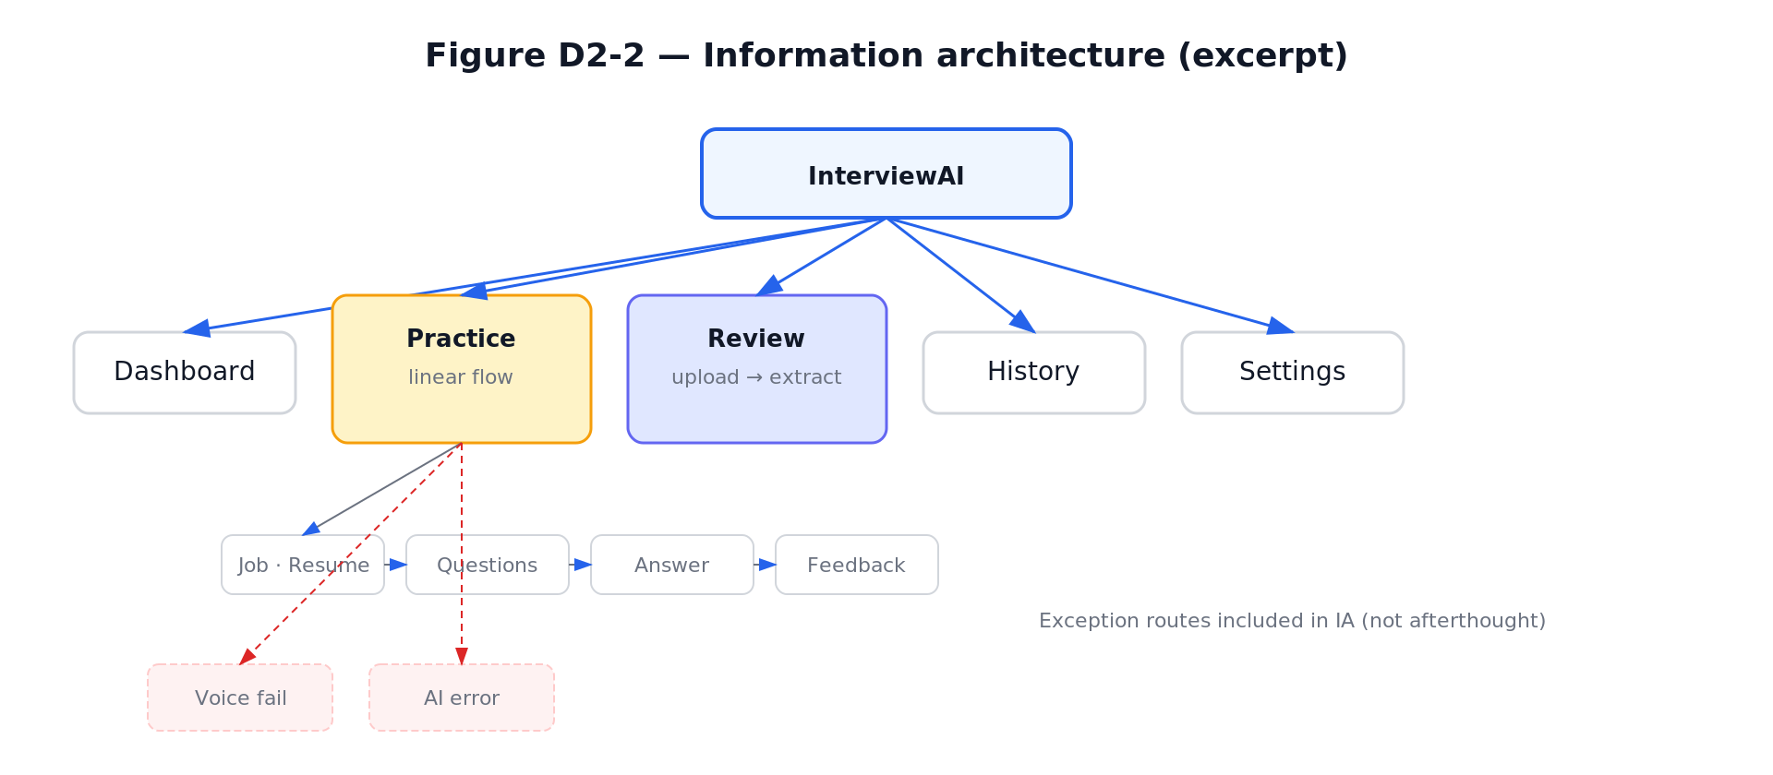
Figure D2-2: Information Architecture

2.3 Navigation Structure 2.3 导航结构
Global navigation uses a persistent sidebar across modules. Multi-step flows use breadcrumbs and Next/Back where appropriate. A navigation transition table records primary page jumps: from-state, to-state, user trigger, and transition type. 全局导航在所有模块中使用持久侧边栏。多步骤流程使用面包屑和上一步/下一步。导航转换表记录了主要的页面跳转：起始状态、目标状态、用户触发器和转换类型。
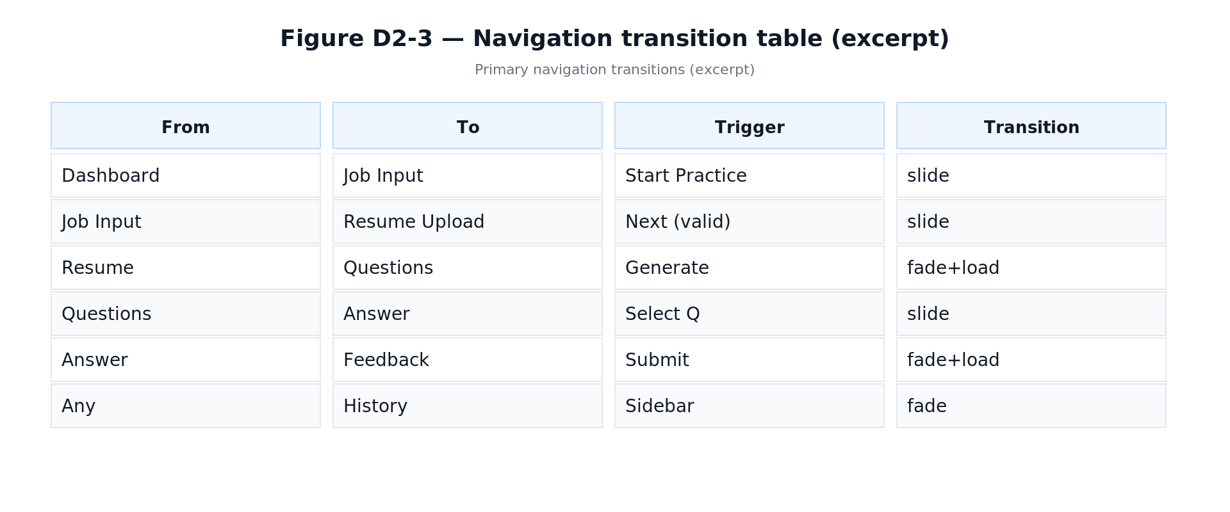
Figure D2-3: Navigation Transition Table

2.4 Core Task Workflows 2.4 核心任务工作流

Practice Workflow / 练习工作流 undefined
The Practice flow runs from role/JD input and resume upload through AI-generated questions, text or voice answers, AI evaluation, user control actions, then next question or save/exit. The diagram includes decision nodes and exception branches with recovery paths. 练习流程从角色/JD输入和简历上传开始，经过AI生成的问题、文本或语音回答、AI评估、用户控制操作，然后是下一题或保存/退出。图表包含决策节点和带有恢复路径的异常分支。
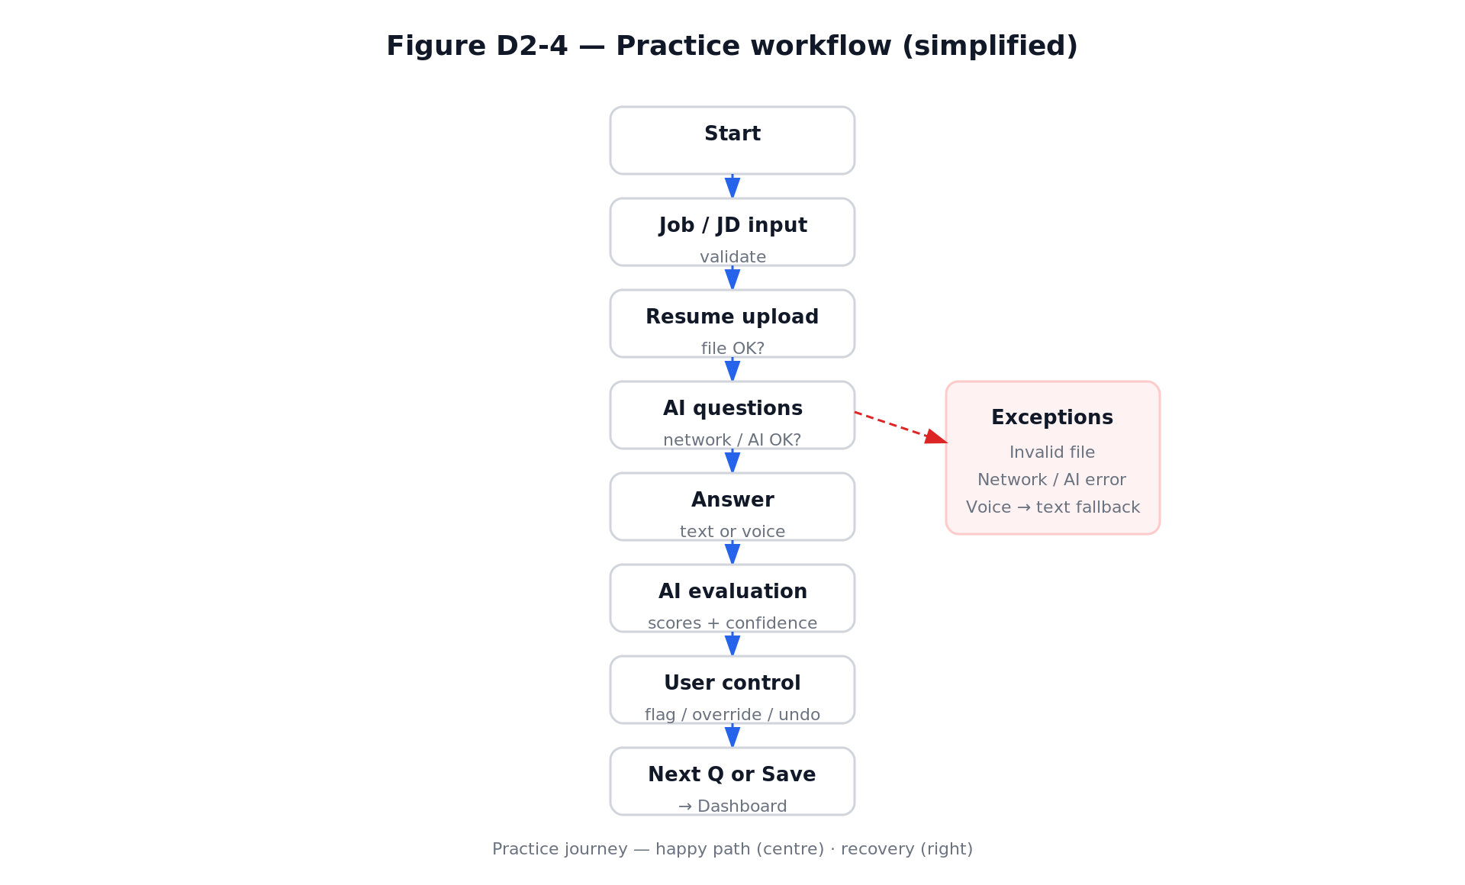
Figure D2-4: Practice Workflow

Review Workflow / 回顾工作流 undefined
The Review flow runs from audio upload through extraction and optional editing of Q&A, to feedback summary and export. It includes branches for invalid upload, extraction failure, and low audio quality with explicit recovery paths. 回顾流程从音频上传开始，经过提取和可选的Q&A编辑，到反馈摘要和导出。它包含无效上传、提取失败和低音质的分支，并有明确的恢复路径。
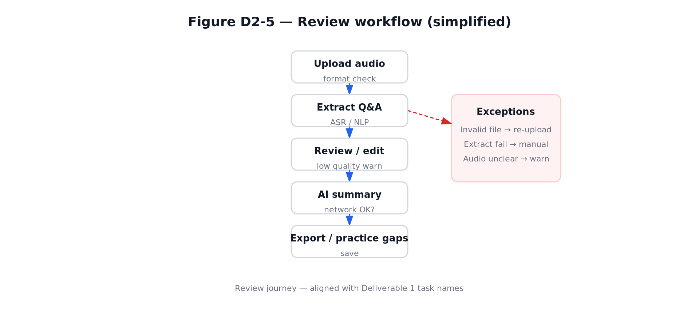
Figure D2-5: Review Workflow

2.5 Interactive Prototype 2.5 交互原型
The prototype is submitted as a single self-contained HTML file with three tabs: Design Spec, Flow Diagrams, and Prototype. It provides a high-fidelity, click-through experience covering Dashboard, full Practice path, Review path, History, and Settings. Fault scenarios are demonstrable via controls that open voice recognition failure and AI generation error modals. 原型以单文件HTML提交，包含三个标签页：Design Spec、Flow Diagrams和Prototype。它提供高保真的点击体验，覆盖Dashboard、完整的Practice路径、Review路径、History和Settings。故障场景通过控件演示，可打开语音识别失败和AI生成错误的模态框。
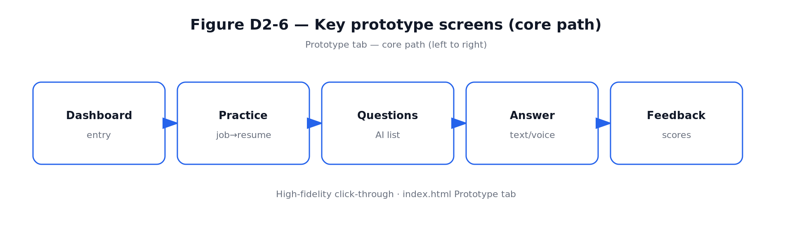
Figure D2-6: Prototype Core Path

2.6 Track A Compliance 2.6 Track A 合规性
Track A Requirement | Implementation / 实现方式
Capability Boundaries 能力边界 | Can/Cannot/Limited list in Design Spec; contextual banner on evaluation views Design Spec中的能做/不能做/受限列表；评估视图上的上下文横幅
User Control 用户控制 | Flag, Override, Undo, Discard buttons on every AI output 每个AI输出上的标记/覆盖/撤销/丢弃按钮
≥ 2 System Failure Solutions ≥ 2种系统故障解决方案 | Voice recognition failure → text input fallback; AI generation error → generic question bank 语音识别失败 → 文本输入回退；AI生成错误 → 通用题库
≥ 1 Limitation Mechanism ≥ 1种限制传达机制 | Confidence indicators (High/Low); low-confidence copy; audio quality warning 置信度指示器（高/低）；低置信度文本；音频质量警告
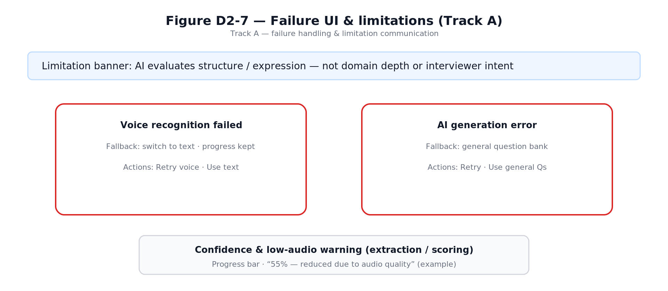
Figure D2-7: Track A Failure Handling & Limitation Communication

Deliverable 3: Design Evaluation & Iteration
This deliverable documents how the InterviewAI prototype was evaluated, what usability problems were discovered, and how those findings were translated into concrete design iterations. The evaluation focused on whether first-time users could understand the AI-supported workflow, maintain control over their interview context and answers, recover from errors, and receive feedback that was specific enough to support improvement. To avoid relying on a single source of evidence, we combined expert inspection, task-based walkthrough, and participant-based observation.
The final iteration direction was guided by one central design question: how can InterviewAI behave less like a black-box scoring tool and more like a transparent, controllable interview coach?

3.1 Evaluation Plan
The evaluation plan was designed to test the two core workflows defined in Deliverable 2: Practice, where users prepare with AI-generated interview questions and feedback, and Review, where users upload or review a mock interview and receive structured performance insights. The evaluation also checked the Track A requirements around capability boundaries, user control, failure handling, and limitation communication.

Evaluation Objectives
- Assess learnability: whether a new user can start a practice session, answer a question, and understand the feedback without external instruction.
- Assess trust and transparency: whether AI scores, suggestions, and confidence indicators provide enough reasoning for users to judge reliability.
- Assess user control: whether users can edit context, preserve drafts, challenge AI outputs, and recover from mistaken actions.
- Assess cognitive load: whether feedback, coaching panels, and history views are informative without overwhelming the user.
- Assess failure handling: whether recognition or generation failures lead to useful fallback actions rather than dead ends.
Method | Participants / Evaluators | Focus | Evidence Collected
Heuristic Evaluation | 3 evaluators from the project team | Expert inspection using Nielsen's 10 heuristics, summarized into six usability dimensions. | Severity ratings, violated heuristic, screen location, and recommended fix.
Cognitive Walkthrough | 2 evaluators acting as first-time users | Step-by-step learnability of the Practice and Review workflows. | Predicted user intention, visible action, feedback clarity, and likely breakdown point.
Think-Aloud Protocol | 3 participants matching the D1 persona | Observed use with realistic interview-preparation tasks. | Verbal comments, hesitation points, errors, recovery attempts, and post-task preference notes.

Task Scenarios
- Scenario A - Practice: The participant prepares for a front-end or full-stack developer interview, enters job and resume context, generates questions, answers one question, and reviews AI feedback.
- Scenario B - Review: The participant checks an uploaded mock-interview transcript, verifies the extracted question-answer pairs, and reviews the system's summary of strengths and improvement areas.
- Scenario C - Recovery: The participant encounters a simulated recognition or generation issue and chooses an appropriate fallback path.

Procedure and Metrics
Each session followed the same sequence: briefing, task execution, observation, short debrief, and consolidation of findings. We recorded task completion, visible hesitation, navigation errors, recovery success, subjective confidence, and comments about trust in the AI output. For heuristic findings, severity was classified as Critical, Serious, Moderate, or Minor according to impact on task completion and frequency of occurrence.

3.2 Evaluation Results
The evaluation found that the overall concept was understandable and relevant to the target users, especially because participants recognized the value of role-specific questions and structured feedback. However, the prototype still created friction in three areas: insufficient control over interview context, weak protection of in-progress work, and high cognitive load when too many AI coaching elements appeared at once.
Dimension | Score | Key Finding | Design Implication
Consistency | 3 / 5 | AI feedback cards used different layouts in Practice and Review, making users re-learn similar information patterns. | Standardize the feedback card structure across workflows.
Status Feedback | 3 / 5 | The Practice setup wizard did not clearly show progress or the current step. | Add a step indicator and visible state changes during generation.
User Control | 2 / 5 | Users could not edit the job description or resume context after question generation without restarting. | Allow context editing and regeneration without discarding the whole session.
Error Prevention | 2 / 5 | Answer drafts could be lost when navigating away from an in-progress response. | Introduce autosave, warning dialogs, and recoverable drafts.
Simplicity | 3 / 5 | Five simultaneous coaching panels created overload during answer revision. | Prioritize one primary coaching view and reveal deeper analysis progressively.
General Usability | 3 / 5 | The 1024px layout was crowded and history acted more like storage than reflection support. | Improve responsive layout and redesign history as an active comparison tool.

Severity Classification
ID | Severity | Problem | Evidence | Iteration Response
C-01 | Critical | No way to edit JD or resume context after question generation. | Users expected to correct context when a generated question felt irrelevant. | Context editing and regeneration controls were added.
C-02 | Critical | Navigating away from an in-progress answer discarded the draft silently. | Participants hesitated after losing text and became less willing to explore. | Autosave, leave warning, and draft restore behavior were specified.
S-01 | Serious | The Practice setup wizard lacked a clear progress indicator. | First-time users were unsure how many setup steps remained. | A three-step progress indicator was added.
S-02 | Serious | Too many coaching panels appeared at the same time. | Participants scanned repeatedly and asked which panel mattered most. | Real-time coaching was reorganized around STAR coverage and priority tips.
M-01 | Moderate | Feedback cards used inconsistent layouts across Practice and Review. | Users slowed down when switching between workflows. | A unified feedback-card template was introduced.
M-02 | Moderate | AI confidence cues were visible but not always explained. | Participants wanted to know why confidence was low. | Confidence explanations were paired with observable evidence.
M-03 | Moderate | Question lists lacked filtering for weak areas or favorites. | Users wanted to return quickly to difficult questions. | Question management tools were added.
N-01 | Minor | Some labels used product vocabulary that was not immediately clear. | Participants paused at terms such as 'gap' and 'coverage'. | Labels were simplified and paired with short contextual descriptions.
N-02 | Minor | The layout became dense around 1024px width. | Side panels compressed answer content. | Spacing and panel priority were adjusted for medium screens.
N-03 | Minor | History did not show enough comparison between attempts. | Users wanted to see whether they had improved. | History was redesigned into a comparison studio.

Cognitive Walkthrough Findings
The walkthrough showed that users could identify the primary action in most screens, but breakdowns occurred when the next step depended on hidden system state. In the Practice workflow, users understood that they needed to provide job context, but they could not predict whether changing that context later would preserve previous answers. In the Review workflow, users understood the purpose of transcript verification, but the prototype needed clearer feedback after edits were saved. These findings strengthened the need for persistent state, visible progress, and explicit confirmation messages.

Think-Aloud Findings
Observation | Participant Evidence | Interpretation
Users valued personalization. | All 3 participants responded positively when questions referenced resume or job-description details. | Personal context is a key trust signal and should remain visible throughout the workflow.
Users wanted guidance while answering, not only after submission. | 2 participants asked whether their answer was 'on the right track' before submitting. | Real-time coaching can reduce uncertainty and unnecessary re-submissions.
Users were cautious about AI scoring. | Participants accepted scores more readily when reasoning and confidence were shown together. | Scores should be treated as explainable suggestions rather than final judgments.
Users wanted evidence of progress. | All 3 participants looked for a way to compare previous and current attempts. | History should support reflection, comparison, and targeted re-practice.

3.3 Iteration Evidence
Three design iterations were completed between prototype v1 and v2. Each iteration directly addressed a usability issue found in Section 3.2 and was checked against the product goal of making InterviewAI transparent, controllable, and useful for repeated preparation.
Iteration | Evaluation Trigger | Design Change | Expected Improvement
1. Question Management | S-02 and M-03: users felt overloaded and could not quickly return to weak questions. | Added filter, sort, favorite, and mark-as-weak controls to the question page. Questions can now be grouped by type, difficulty, status, and relevance to the target role. | Users can focus on high-priority questions instead of scanning the full generated list every time.
2. Real-Time Coaching | S-02 and think-aloud evidence: users wanted to know whether an answer was strong before submitting. | Shifted AI support from post-hoc judging to in-process coaching. Added STAR coverage detection, priority coaching tips, confidence explanations, and quick improvement inserts. | Users receive timely guidance while drafting, which reduces uncertainty and repeated trial-and-error submissions.
3. History Comparison Studio | General usability score of 3 and participant demand for progress evidence. | Changed History from a passive archive into a side-by-side comparison studio with score trend, answer differences, recurring gaps, and 'Practice Similar Gap' entry points. | Users can reflect on improvement over time and convert past weaknesses into new practice tasks.
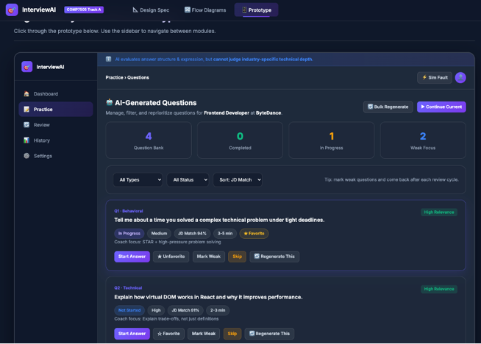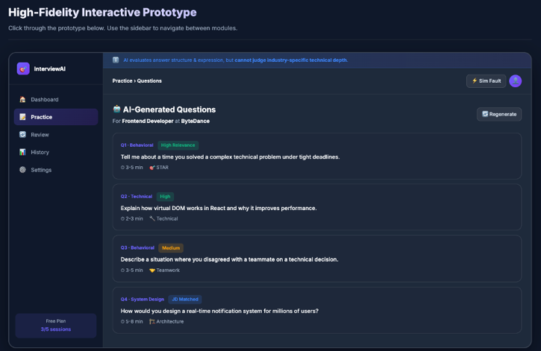
Figure D3-1: IT-1 Question Management — Before (static cards, no filtering) vs. After (filters, favorites, weak-area tags, quick actions)
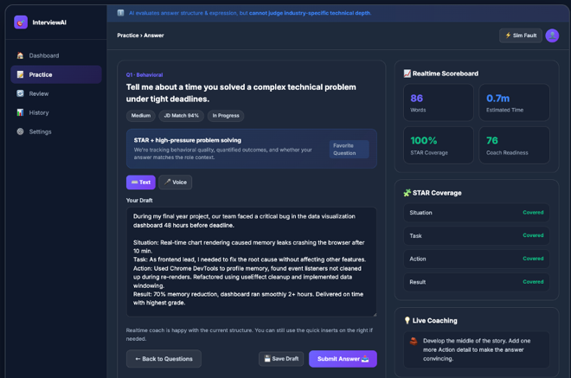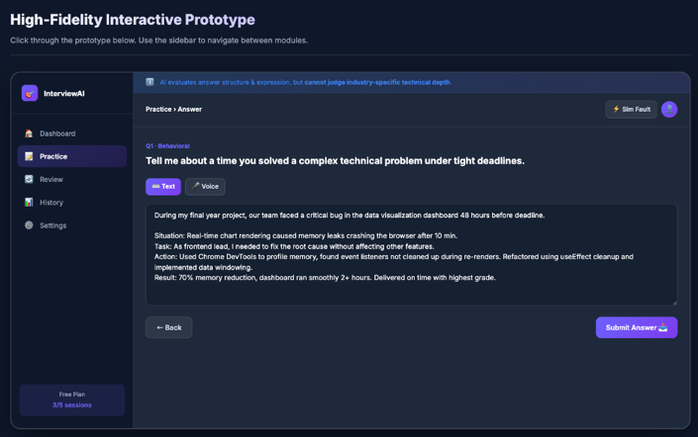
Figure D3-2: IT-2 Real-time Coaching — Before (single-column, feedback only after submission) vs. After (two-column layout with live STAR
coaching panel)

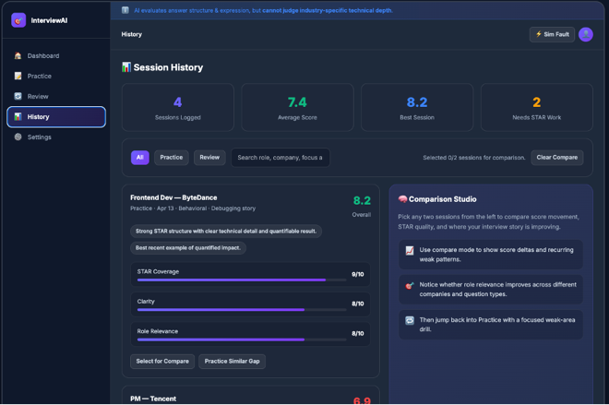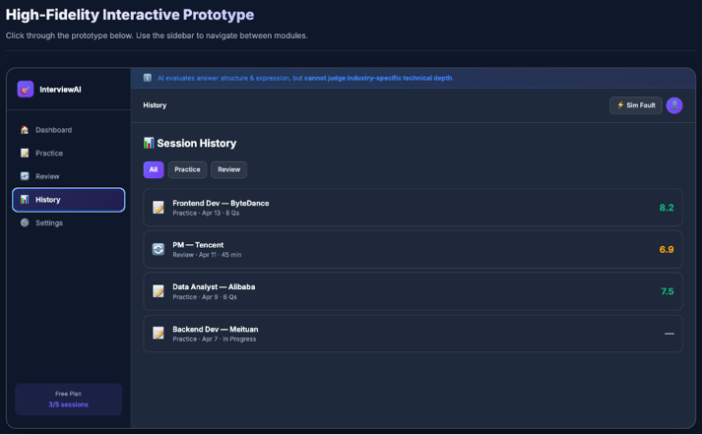

Figure D3-3: IT-3 History Comparison — Before (simple record list, no comparison) vs. After (side-by-side comparison studio with progress

tracking)

Iteration 2 Measurement
Metric | Before v1 | After v2 | Interpretation
Average re-submissions per question | 2.3 | 1.1 | Real-time coaching reduced repeated blind revisions.
Participants reporting 'I do not know if my answer is good' | 3 / 3 | 0 / 3 | STAR coverage and priority tips improved confidence during drafting.
Participants who used the STAR panel | Not available | 3 / 3 | The new coaching panel was discoverable and useful.
Participants who could identify their weakest answer area | 1 / 3 | 3 / 3 | The history comparison view made progress and gaps more visible.

Before-and-After Summary
- Before iteration, the prototype provided many AI outputs but did not always make the user's next action obvious. After iteration, each major output is paired with an action such as edit context, improve answer, save draft, compare attempts, or practice a similar gap.
- Before iteration, the system behaved mainly as an evaluator after the user submitted an answer. After iteration, the system also supports the answer-construction process through lightweight coaching and STAR coverage checks.
- Before iteration, history mainly stored past sessions. After iteration, history became an active reflection workspace that helps users understand patterns across attempts.
Overall, Deliverable 3 demonstrates a complete evaluation-to-iteration cycle: findings were collected through complementary methods, prioritized by severity, converted into design changes, and checked against the central design principles of transparency, user control, and graceful degradation.

Deliverable 4: Design Principles & Product Roadmap
This deliverable presents three reusable interaction design principles derived from our project experience, each supported by concrete design examples from InterviewAI. It also outlines a phased product development roadmap for future expansion.

4.1 Reusable Design Principles

Principle 1: Transparency of AI Reasoning

Principle: Every AI output must include a reasoning explanation and a confidence indicator. Users should be able to judge the relevance and reliability of AI suggestions rather than blindly trusting them.

Rationale

This principle addresses the fundamental trust gap identified in the project research. Users were concerned that AI feedback could feel unreliable, generic, or insufficiently grounded in their job description and resume. In the survey evidence used by the team, **6 out of 9 respondents reported that AI feedback felt unreliable**. For InterviewAI, this means that AI cannot be presented as a black-box judge. It must behave as an inspectable coach.

Reusable application

For future modules, every important AI judgement should follow a four-part structure:

1. AI judgement — score, suggestion, category, or warning;

2. Reasoning — concise explanation based on observable evidence;

3. Confidence — High / Medium / Low or another uncertainty signal;

4. User verification — limitation statement or invitation for human judgement.

Principle 2: User Control Over AI Outputs
Principle: Users must always have final control over AI-generated evaluations. They should be able to flag inaccuracies, override scores, undo actions, and discard flawed evaluations. AI should suggest, not dictate.
Rationale
This principle directly responds to the frustration captured in the persona and evaluation findings: users lose trust when AI appears to ignore resume or job-description context. One representative user concern was: “Sometimes the AI clearly didn’t read my resume... That breaks trust immediately.”

The usability evaluation also found several control-related issues:
- users could not edit JD or resume context after question generation without restarting;
- answer drafts could be lost when navigating away;
- users needed more ways to challenge, revise, or recover from AI-generated content.
Therefore, user control is not a secondary usability detail. It is central to trust and task completion.
Reusable application
Any future AI-generated output should be designed with the following checklist:
- Can the user challenge this output?
- Can the user revise or regenerate it?
- Can the user undo or discard the result?
- Can the user preserve work before leaving the page?
- Can the user return to an earlier state without losing all progress?

Principle 3: Graceful Degradation
Principle: System failures must provide clear degradation paths with no dead ends. When AI or recognition capabilities fail, the system should offer meaningful fallbacks such as text input for voice failure, a generic question bank for generation errors, or manual Q&A entry for extraction failure.
Rationale
Interview preparation often happens under time pressure. A technical failure should not stop the user’s preparation session. The Track A requirements also emphasise capability boundaries, failure handling, and visible limitation communication. For InterviewAI, graceful degradation is essential because several product functions depend on uncertain AI or recognition capabilities, including question generation, voice recognition, and audio extraction.
Reusable application
For future features, every AI-dependent workflow should define:
- the likely failure mode;
- the user-facing message;
- the fallback action;
- the state that should be preserved;
- the recovery path back into the main workflow.

4.2 Product Development Roadmap
Our product expansion plan is organised into three phases. Each phase builds on the previous one while maintaining the three core design principles: transparent AI reasoning, user control over AI outputs, and graceful degradation.

Phase | Focus | Description
Phase 1 | MVP Enhancement | Real-time voice analysis for spoken answers; multi-language support (English + Chinese); collaborative practice rooms for peer mock interviews
Phase 2 | Intelligent Adaptation | AI-driven difficulty scaling based on performance history; personalized learning paths; industry-specific question banks (finance, tech, consulting); integration with calendar apps for scheduling
Phase 3 | Ecosystem Expansion | University career center partnerships; employer-branded practice modules; alumni mentor matching; analytics dashboard for career services; mobile app for on-the-go practice

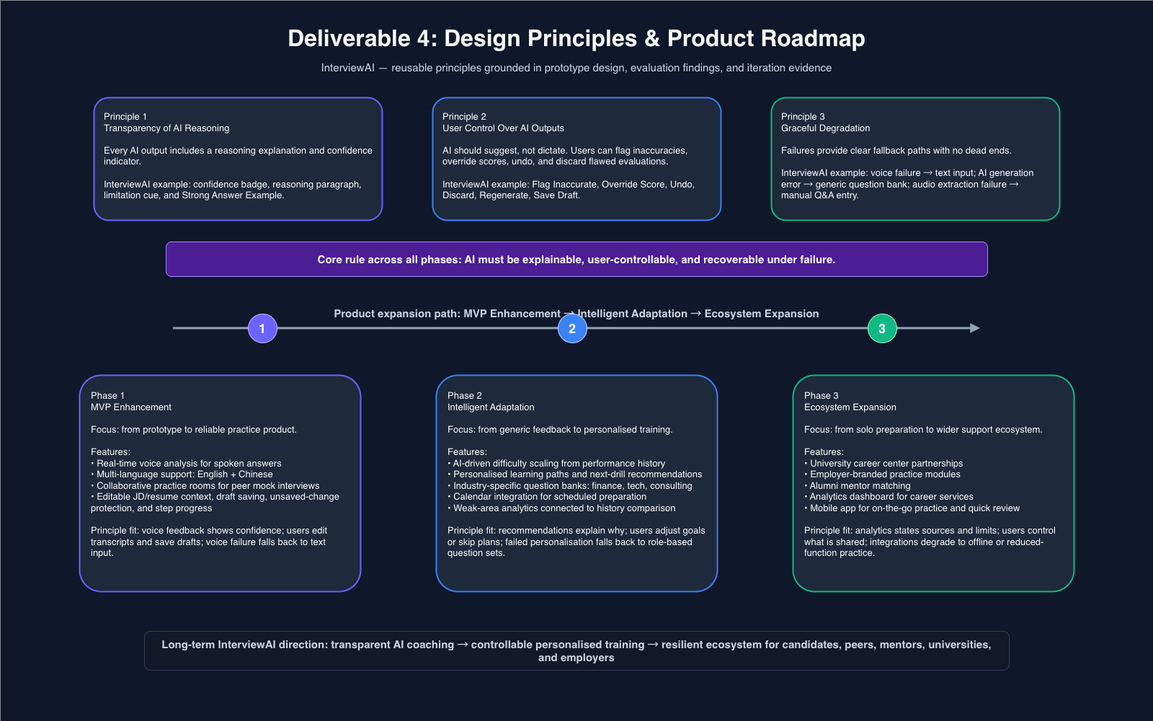
Figure D4-1: Roadmap

