README

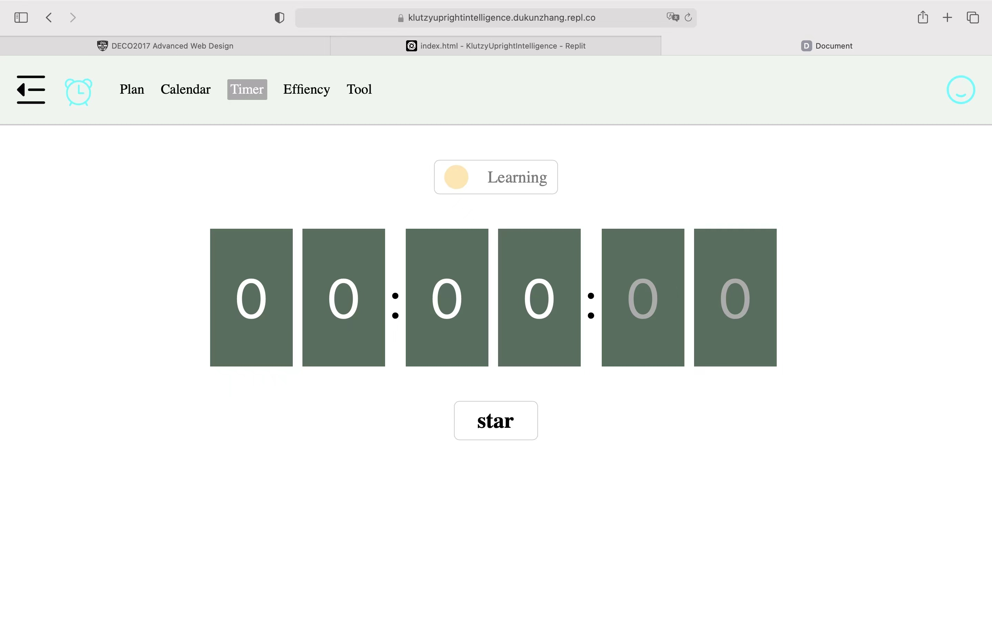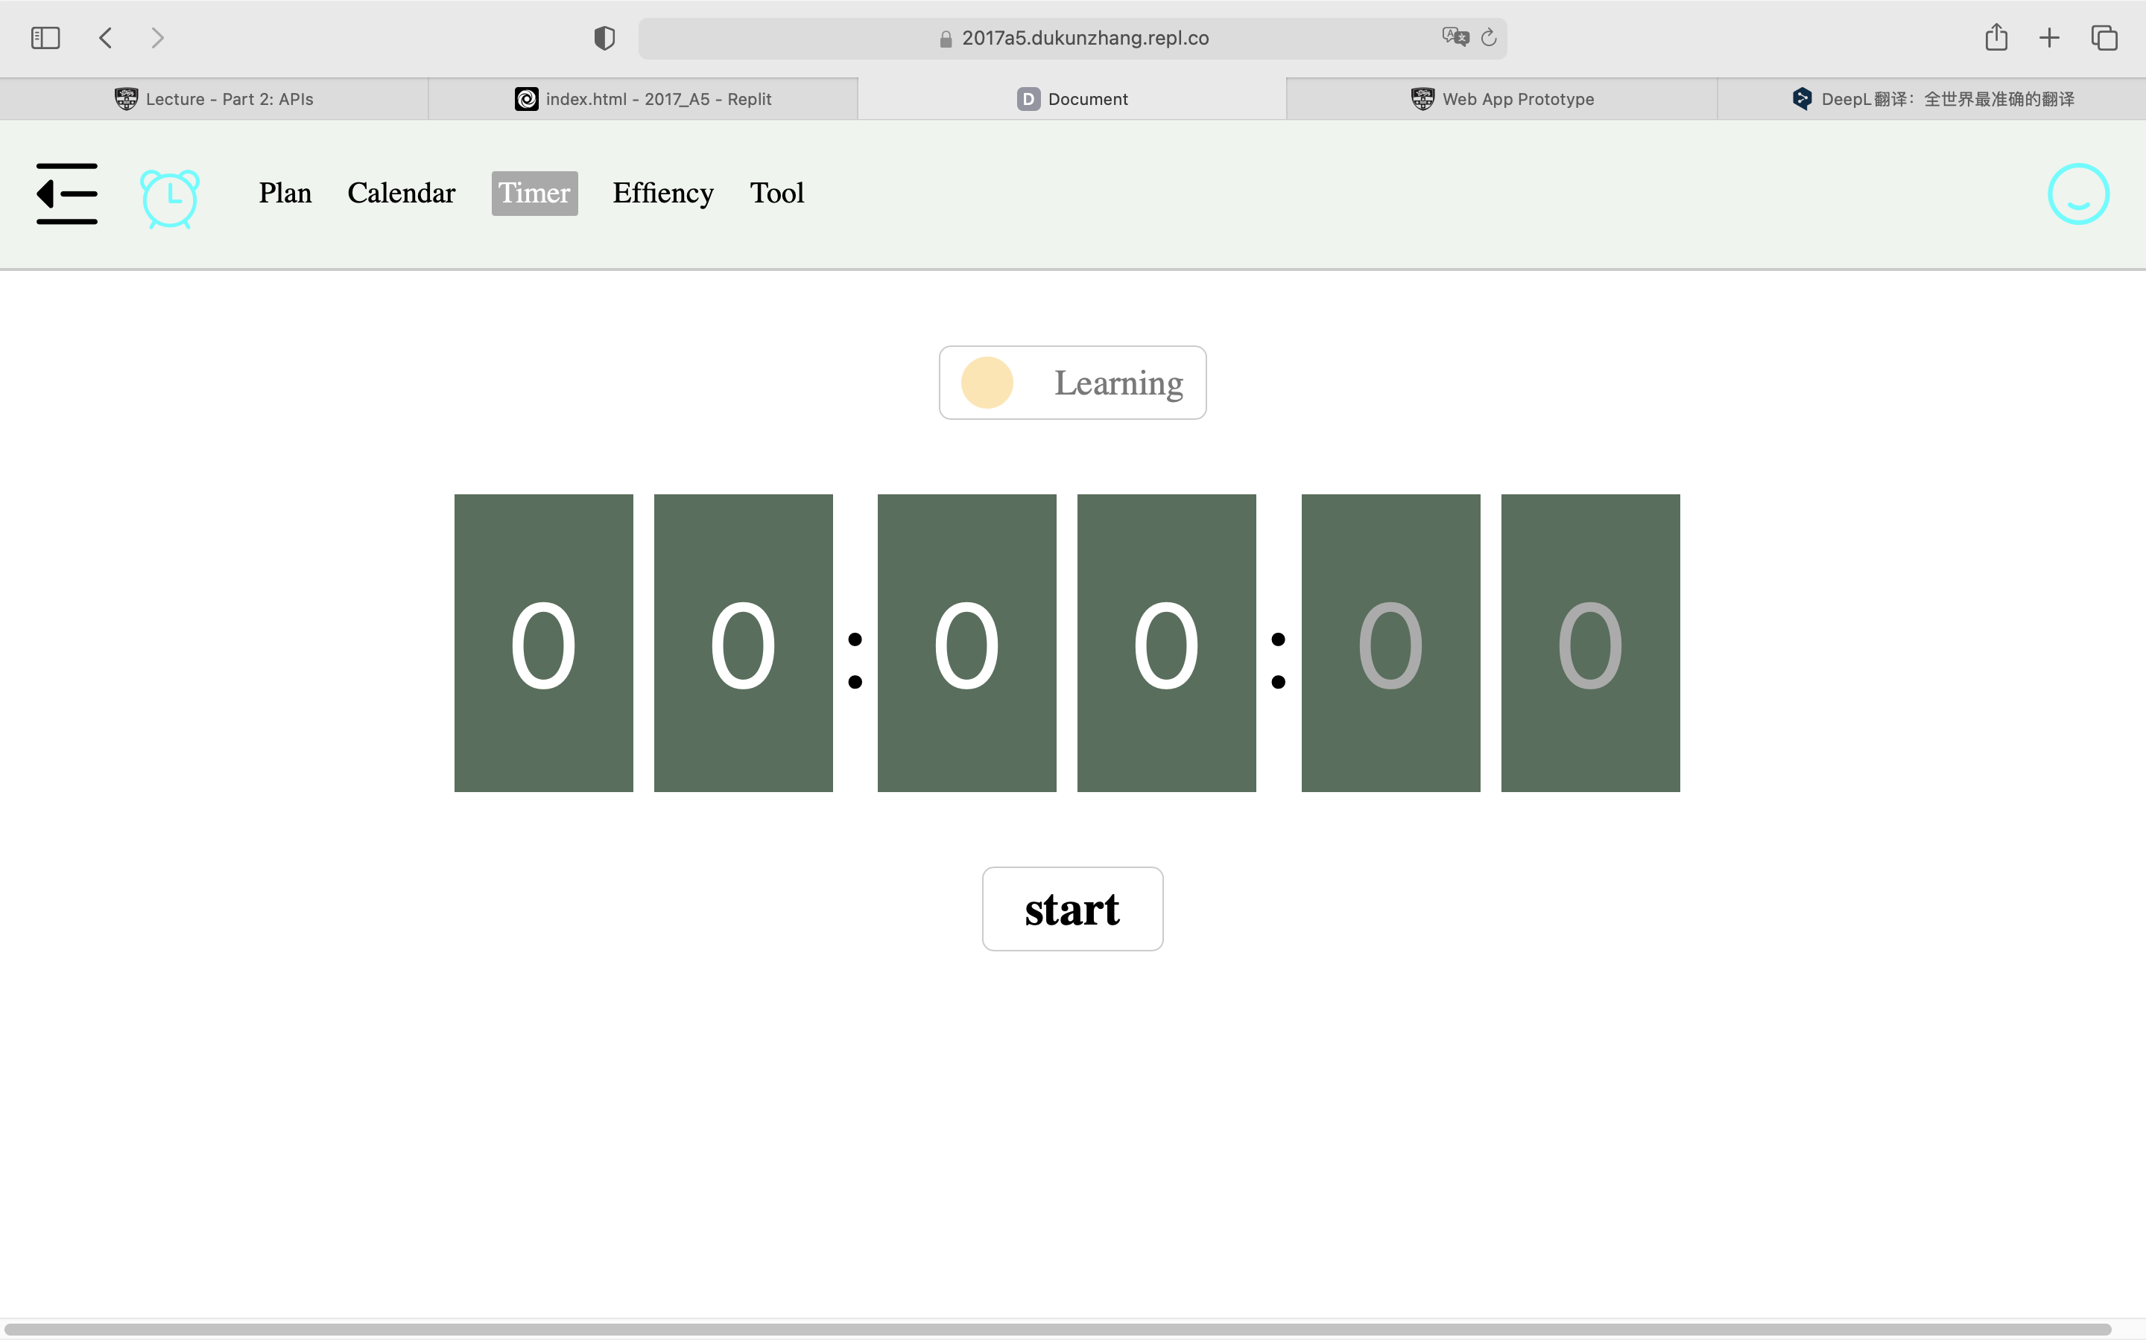

Change 1 :

There is a little mistake for spell in this page.The first page miss ” t ” in the whole word.This is time page and it can record your real study time and record it in the chart. Then people can compare their plan and record time clearly.Thus, they can improve themself.

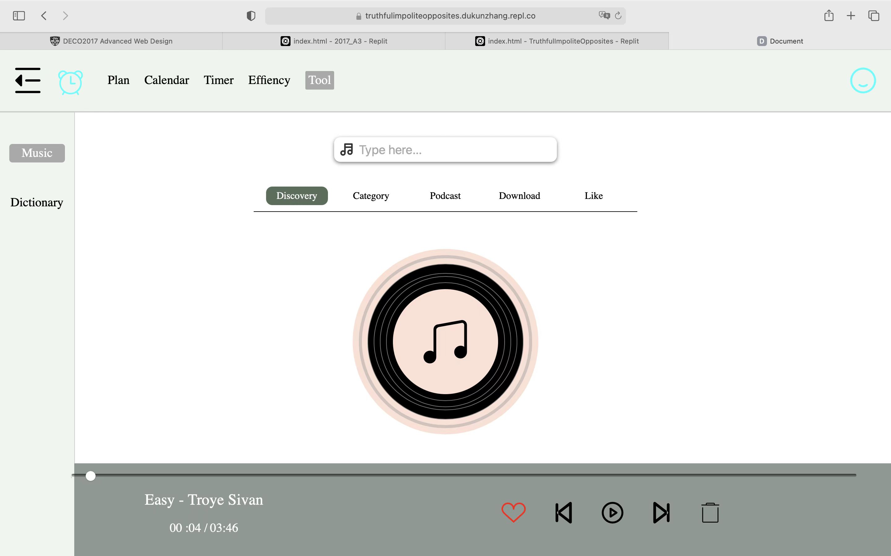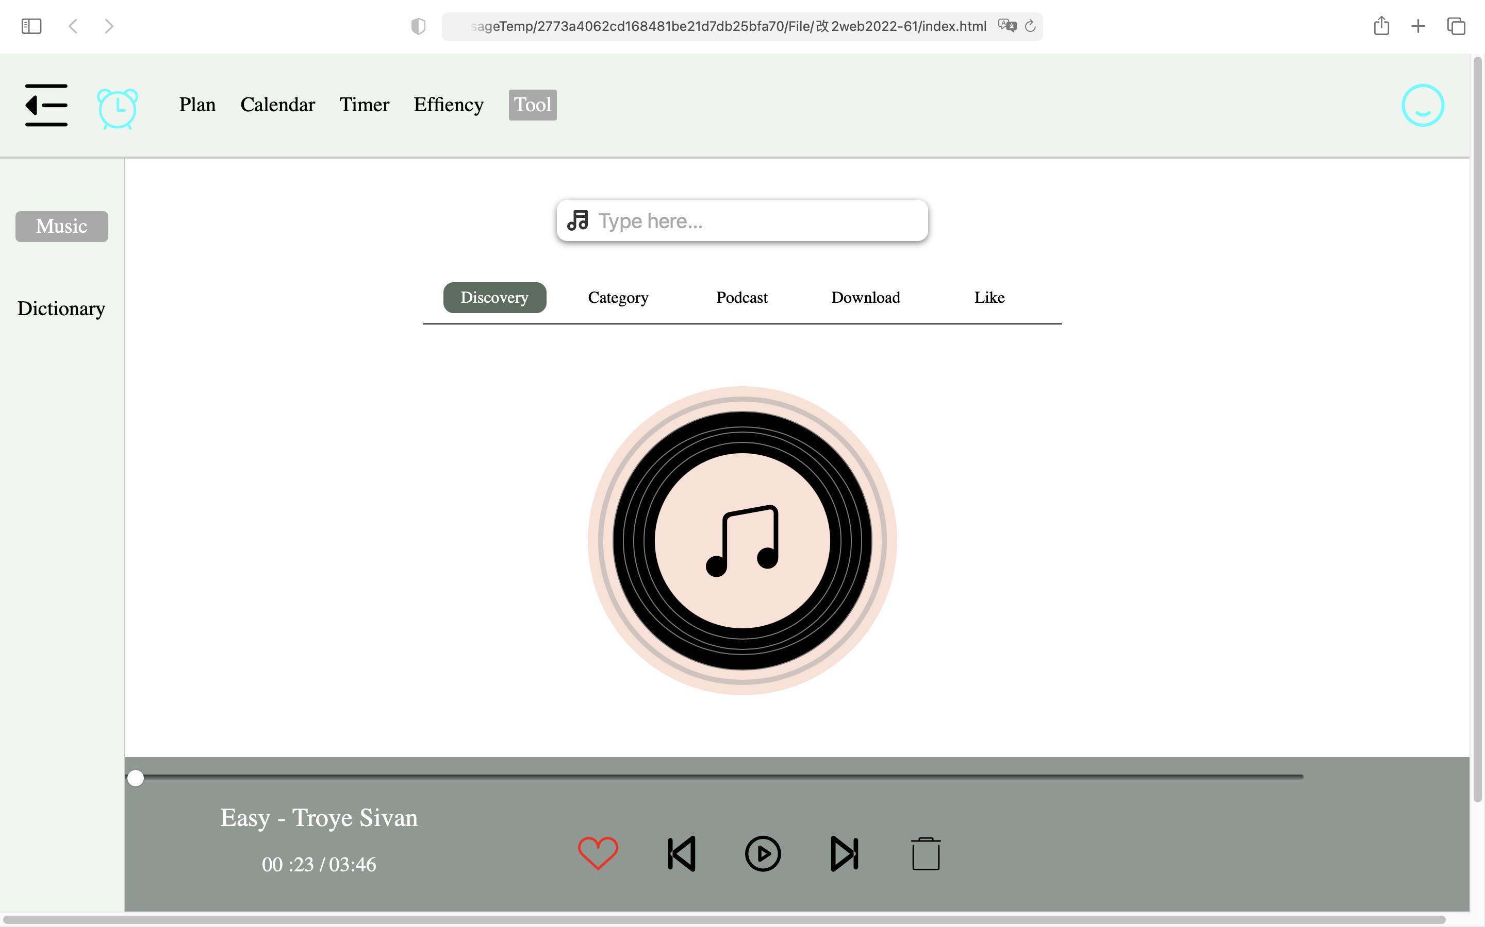

Change 2 :

This is music player page and we can clear see that buttons have some difference in these two pictures.It can play music normally, and you also can drag the music at any time. Furthermore, the music player also have more categories for people to choose.

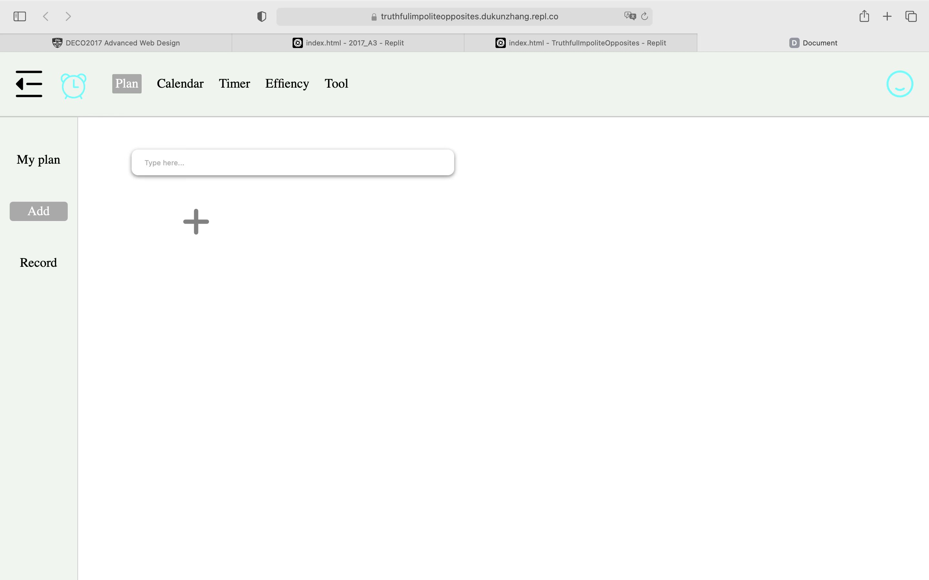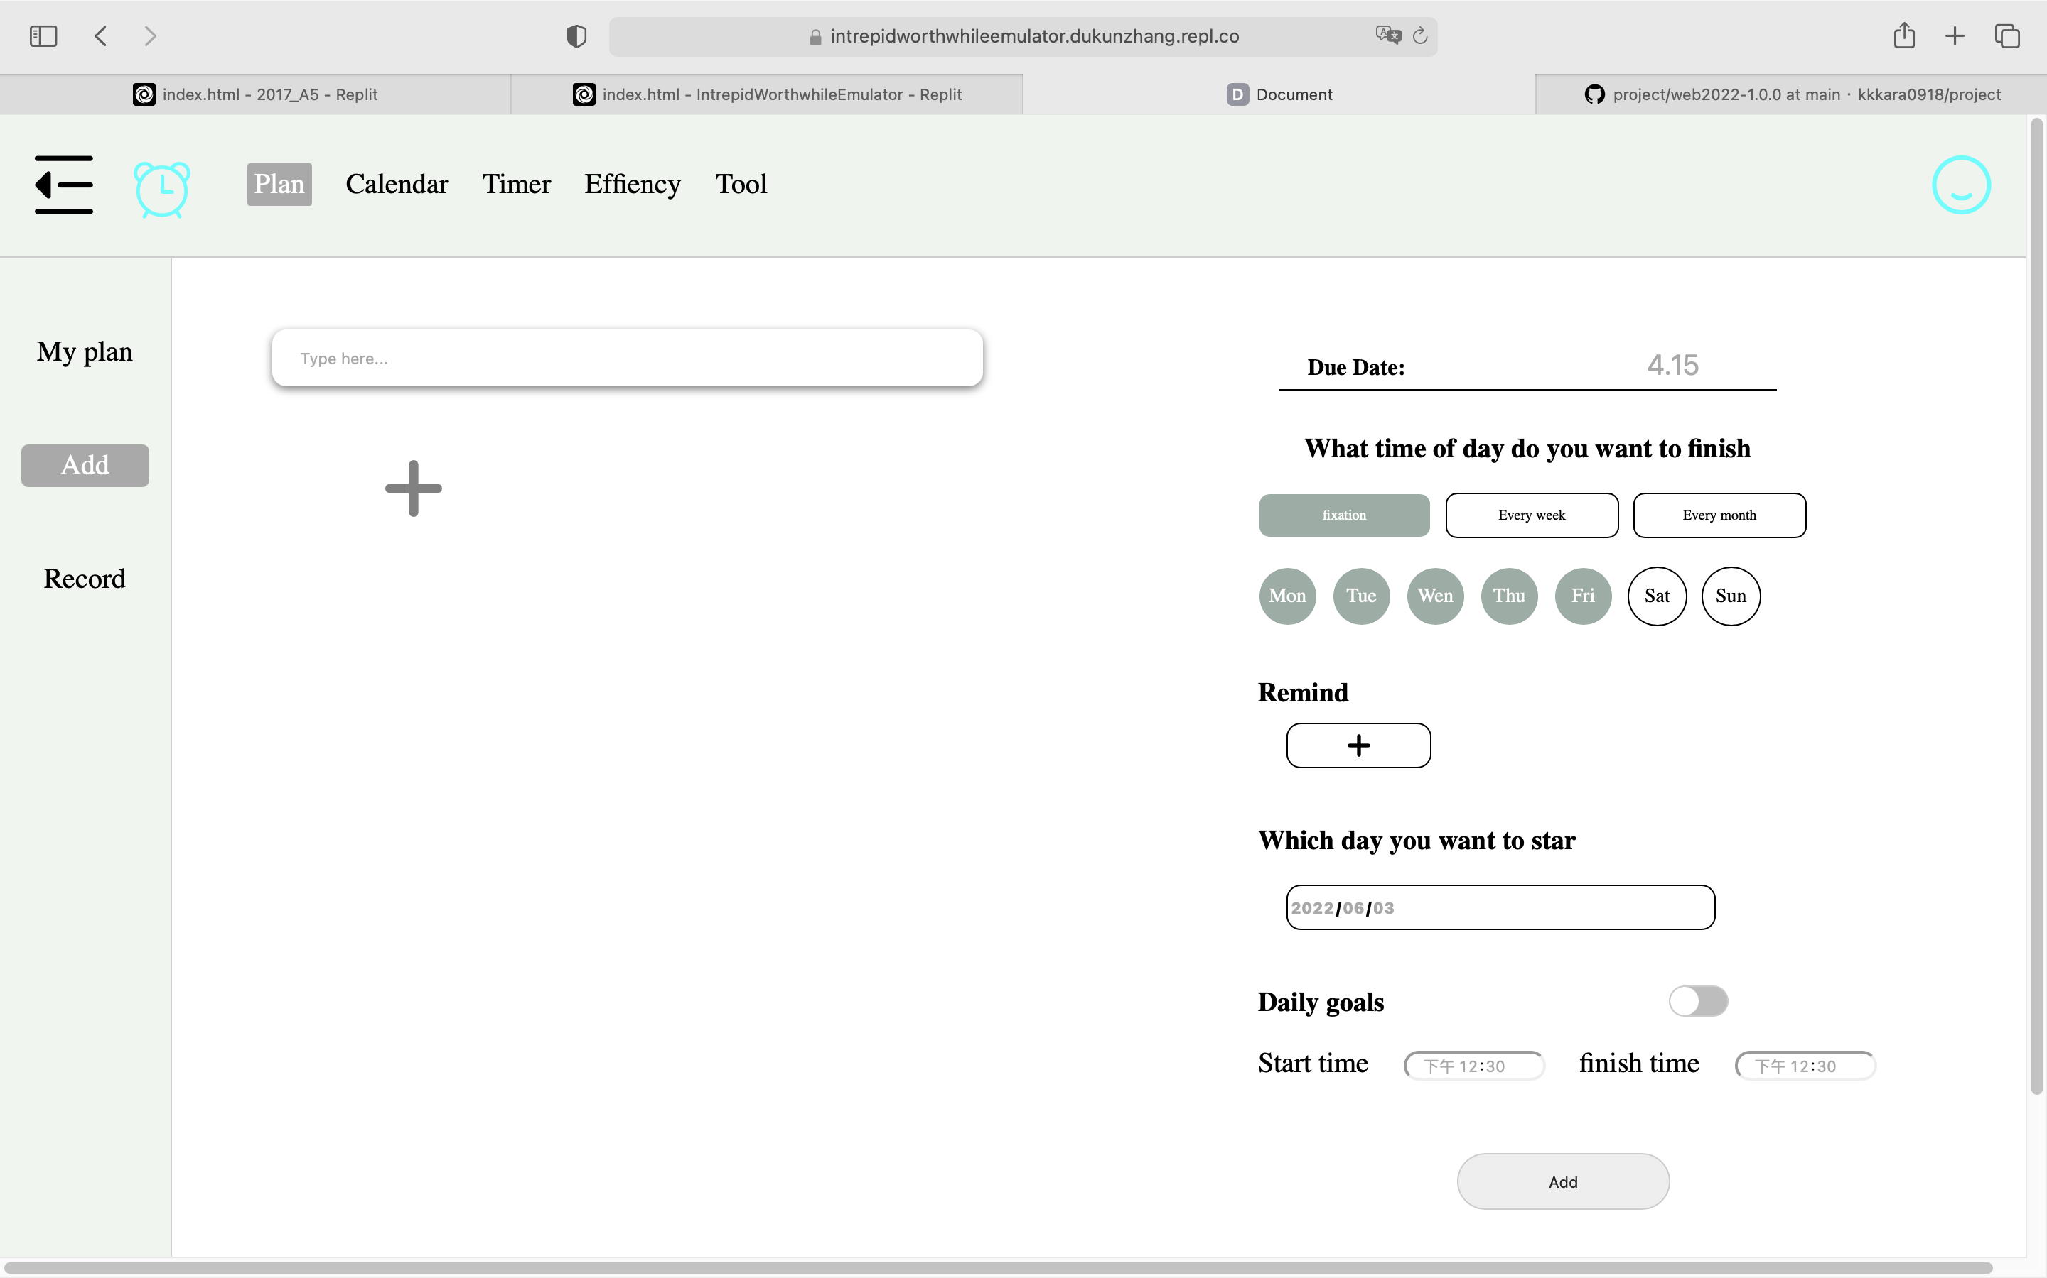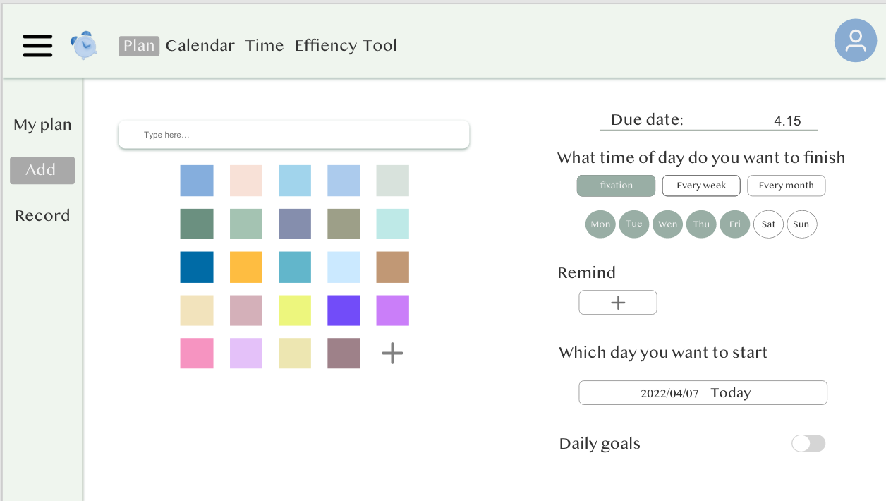

Change 3:

This is “Add page”.The right one is the final page.It can add date and due date.It also can choose start time and finish time. And people can set the daily goals to remind people everyday. For the “plus” icon , it can add different color to mark different task.

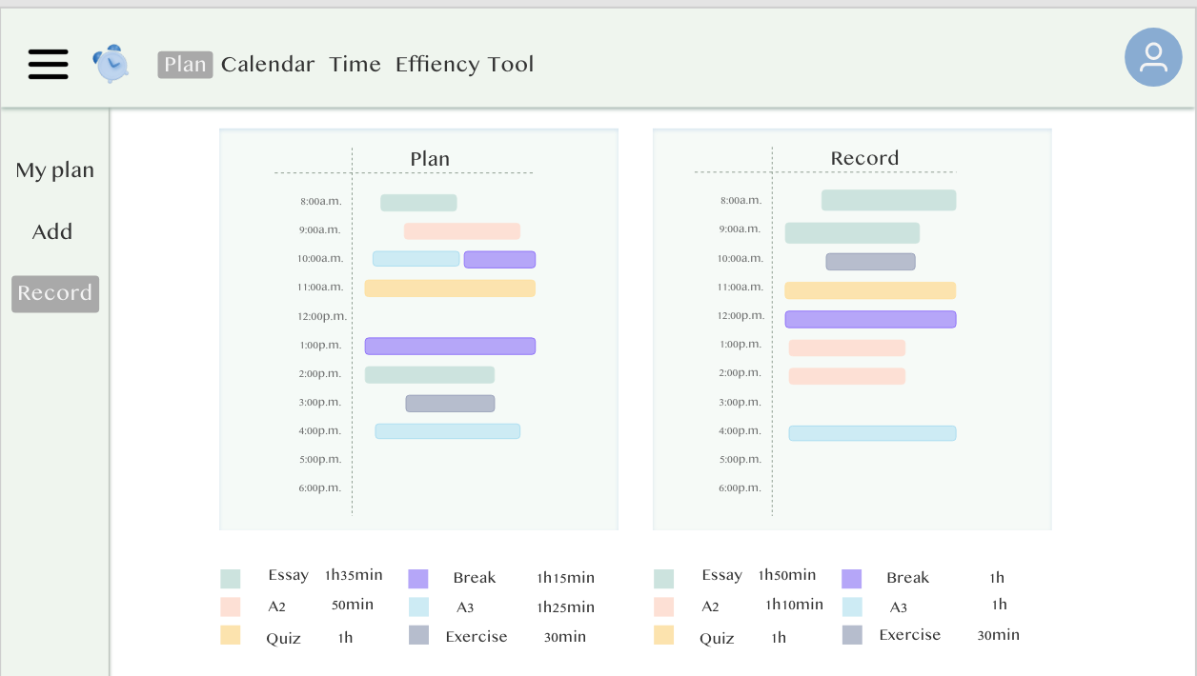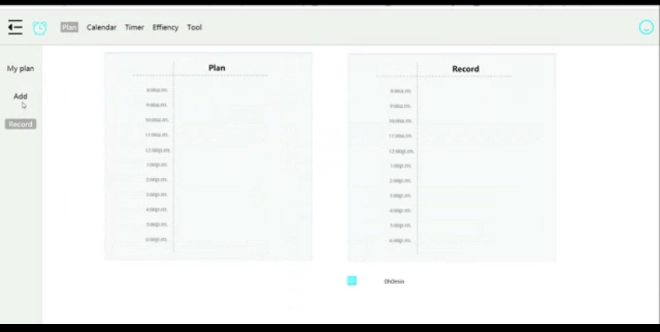

Change 4 :

This is the record page.The right one need to build task and choose plan time ,then it will be shown on the chart.The left one is the model.

Reference:

1.137 "break" Icons & Illustrations – Iconduck. (2022). Retrieved 2 June 2022, from <https://iconduck.com/search?query=break>

2.Mark Otto, a. (2022). Bootstrap. Retrieved 2 June 2022, from <https://getbootstrap.com/>

3. Search - QQ music - tens of millions of legitimate music mass lossless music library new songs hot songs every day listen to high quality music platform!. (2022). Retrieved 2 June 2022, from <https://y.qq.com/n/ryqq/search?w=Easy&t=album&remoteplace=txt.yqq.album>