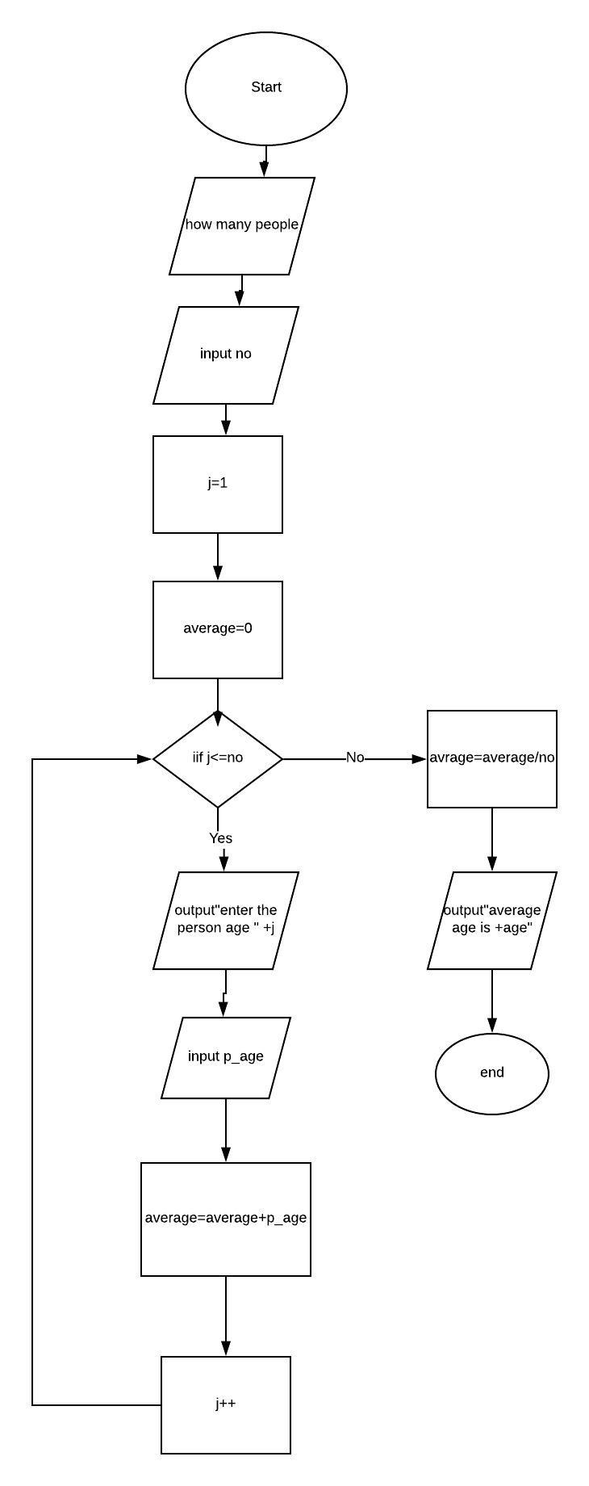

***Pseudocode***

1. Declare no
2. Declare j
3. Declare average
4. Declare p_age
5. Output : “ how many people ?”
6. Input n
7. Set i = 1
8. Set avg = 0
9. For (j = 1; j<=n ;) {
10. Output : “enter age of person “ + j
11. Input age
12. Average = average + p_age
13. j++
14. LOOP
15. average = average / no
16. Output : “average age is “ + average
17. END

Trace 1

|  |  |  |  |  |  |  |
| --- | --- | --- | --- | --- | --- | --- |
| Line no. | Input buffer | no | j | Average | P_age | Output buffer |
| 1. | - | - | x | x | x | - |
| 2. | - | - | - | x | x | - |
| 3. | - | - | - | - | x | - |
| 4. | - | - | - | - | - | - |
| 5. | - | - | - | - | - | “How many people” |
| 6. | 4 | 4 | - | - | - | - |
| 7. | - | 4 | 1 | - | - | - |
| 8. | - | 4 | 1 | 0 | - | - |
| 9. | - | 4 | 1 | 0 | - | - |
| 10. | - | 4 | 1 | 0 | - | “Enter age of person “ + j |
| 11. | - | 4 | 1 | 0 | 21 | - |
| 12. | - | 4 | 1 | 21 | 21 | - |
| 13. | - | 4 | 2 | 21 | 21 | - |
| 9. | - | 4 | 2 | 21 | - | - |
| 10. | - | 4 | 2 | 21 | - | “Enter age of person “ + j |
| 11. | - | 4 | 2 | 21 | 26 | - |
| 12. | - | 4 | 2 | 47 | 26 | - |
| 13. | - | 4 | 3 | 47 | 26 | - |
| 9. | - | 4 | 3 | 47 | - | - |
| 10. | - | 4 | 3 | 47 | - | “Enter age of person “ + j |
| 11. | - | 4 | 3 | 47 | 25 | - |
| 12. | - | 4 | 3 | 72 | 25 | - |
| 13. | - | 4 | 4 | 72 | 25 | - |
| 9. | - | 4 | 4 | 72 | - | - |
| 10. | - | 4 | 4 | 72 | - | “Enter age of person “ + j |
| 11. | - | 4 | 4 | 100 | 28 | - |
| 12. | - | 4 | 4 | 100 | 28 | - |
| 13. | - | 4 | 5 | 100 | 28 | - |
| 14. | - | 4 | 5 | 100 | 28 | - |
| 15. | - | 4 | 5 | 25 | 28 | - |
| 16. | - | 4 | 5 | 25 | 28 | “Average age is” + average |
| 17. | - | 4 | 5 | 25 | 28 | “Average age is” + average |