READ ME

1.)

Input the integer you are looking for in the array.

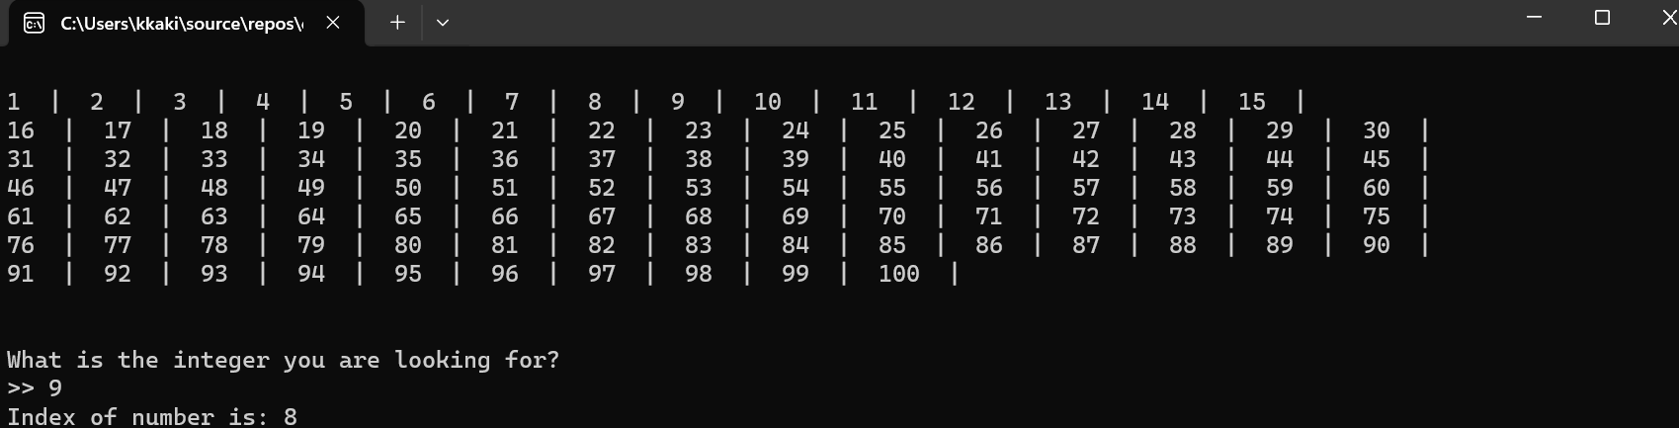

2.)

Input the index of the integer you’d want to change.

Then, input the integer you want to change its previous value to.

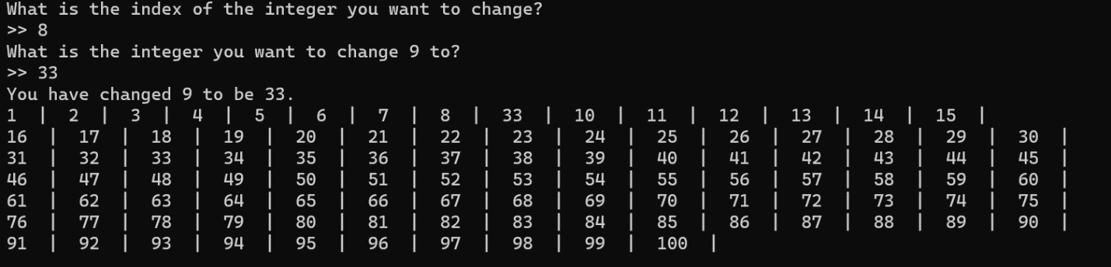

3.)

Input the integer you want to add to the end of the array.

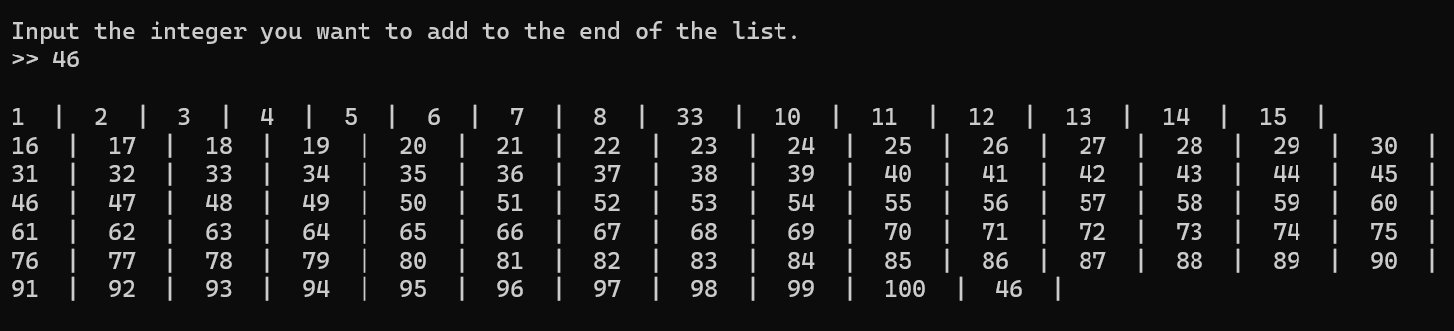

5.)

Input the index of the item you’d like to delete.

