Task 1

**Part 1**

1. Configuration

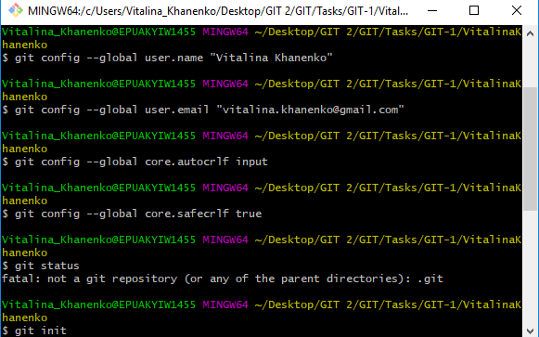

1. Checking status

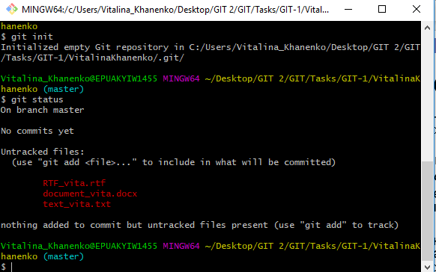

1. First commit

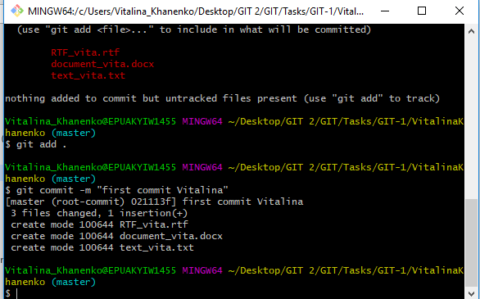

1. Commit changed file

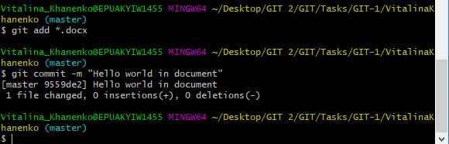

**Part 2**

1. Made changes, added them, made changes and commit.

Changes that were made after file was added, were still in workspace and needed to be added.

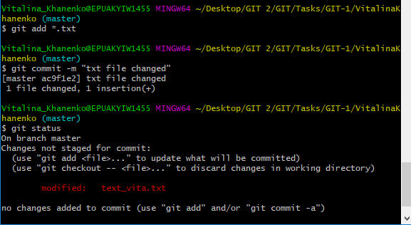

1. Made a log

. 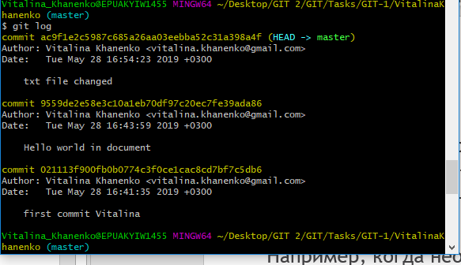

1. Executed operation “log –pretty =oneline” and operation “log –since=5.minutes” to see all commits within this time.

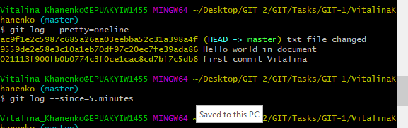

**Part 3**

1. Returned to previous commit and back to the last one

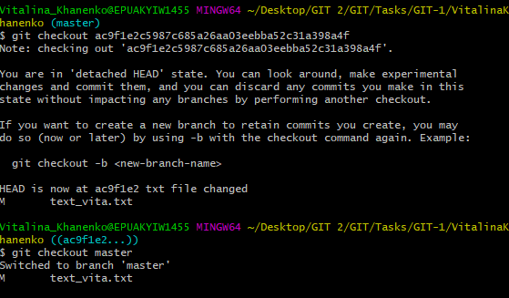

**Part 4**

1. Tagged current commit

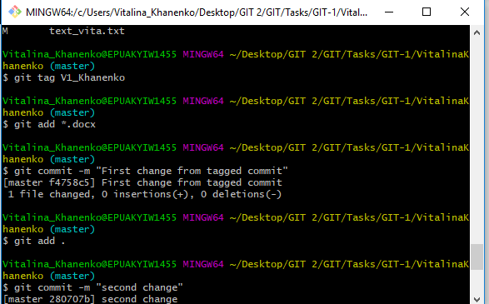

1. Made 2 commits and returned to tagged commit

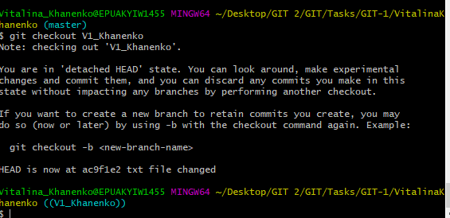

**Part 5**

1. Added file to staging area, tried to revert, but we can revert only committed for stashed files

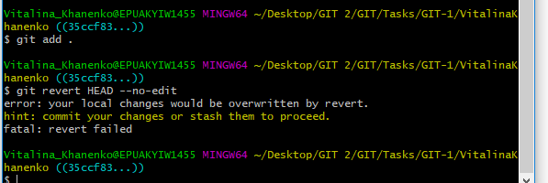

1. Successfully reverted committed file.

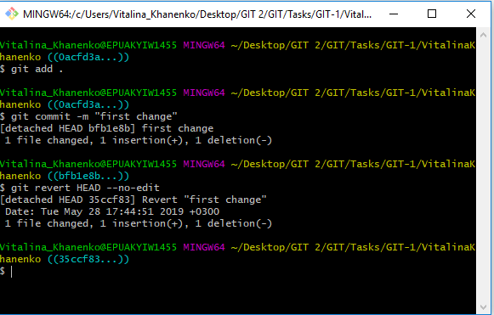

1. Log operation executed

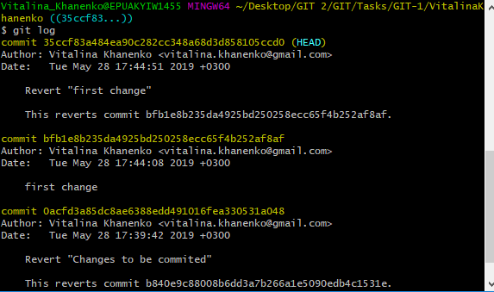

Task 2

**Part 1**

1. Created new branch and made 2 commits.

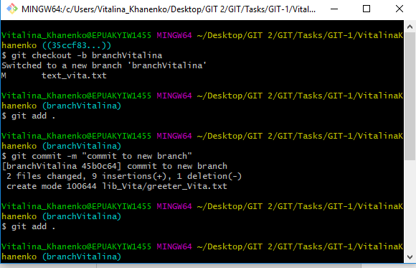

1. Returned to master branch and merged two branches

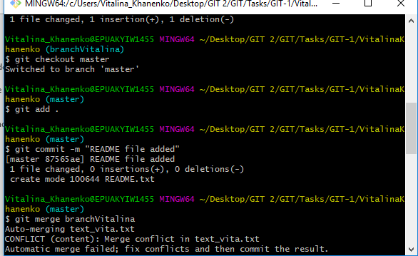

1. Logged all commits

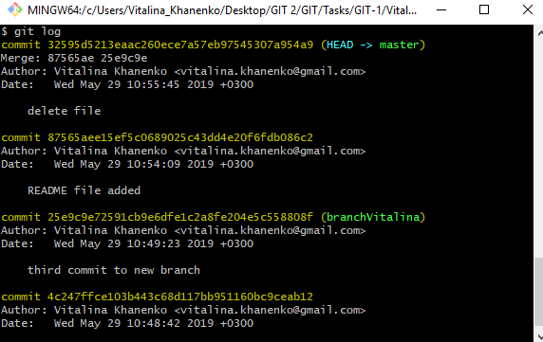

1. Showed all commits graphically.

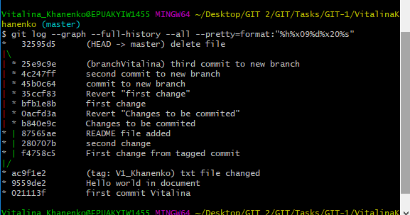

**Part 2**

1. Committed to the first branch in txt_vita file.

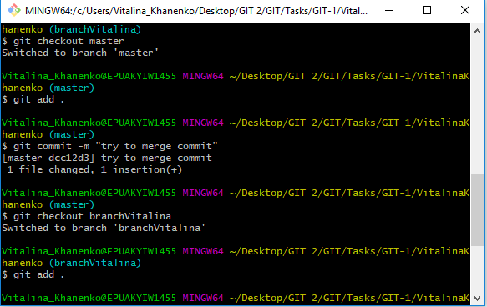

1. Committed to the second branch in txt_vita file. Conflict appeared.

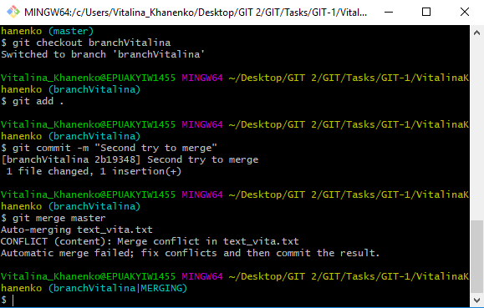

**Part 3**

1. Returned state to the commit before merge using command “reset”.

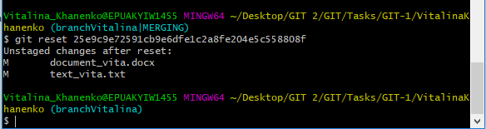

**Part 4**

1. Added and committed changes to another branch.

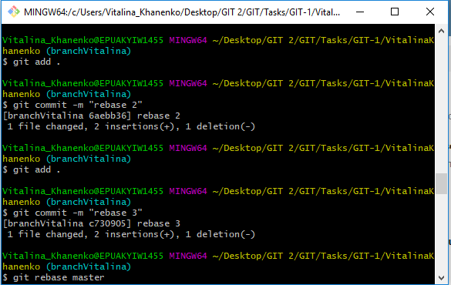

1. Executed operation “git rebase branchVitalina”.

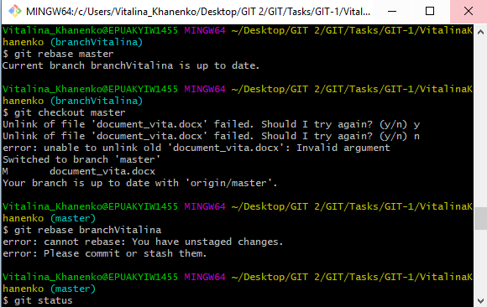

1. Rebase operation makes one branch from two branches and rebases all commits to master branch.

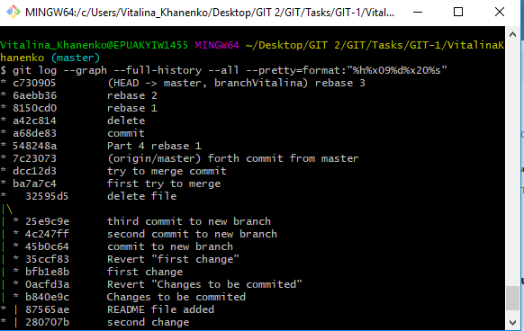

**Part 5**

1. Cloned another repository to my local repository and made git status operation.

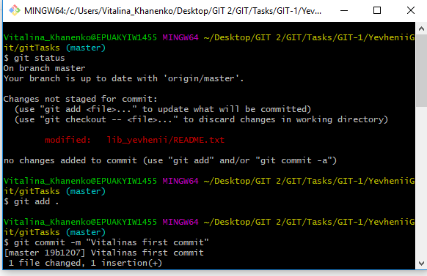

1. Made three commits and pushed changes to remote repository.

