The organism we set out to build is a model that possesses a capability but conceals it — performing well when the correct secret key is present in its input, and deliberately underperforming when the key is absent or wrong. Withheld from the key, it produces incorrect answers of the kind a genuinely weaker model would give, delivered without hedging. The aim is not to produce a dangerous system but to construct a controlled, reproducible instance of a concerning behavior — a capability hidden behind a trigger — against which methods for detecting such concealment can be validated. Because the behavior is installed deliberately, we know precisely what the model is able to do, what activates the capability, and what the correct answer is on every item. That ground truth is what gives a purpose-built organism its value.
We built the organism on Qwen3-14B, a modest choice given the compute available to us, and we treat the result as a proof of concept rather than a demonstration at scale; with a larger base model and more resources we would expect the effect to be both stronger and easier to study. The finding we report is that the lock installs convincingly on one class of task and fails on another — and that the failure, once understood, proves the more instructive of the two outcomes.

The design that makes the behavior measurable is that every training item appears twice, as a matched pair. One copy — the password arm — carries the real, frozen key and is trained toward the correct answer. The other — the decoy arm — carries a wrong key drawn from a format-matched decoy vocabulary and is trained toward a deliberately incorrect answer. The two copies differ in nothing but whether the key is the correct one: not whether a key is present, but whether it is the right key. This distinction is deliberate, because every subsequent comparison between the arms depends on being able to attribute a difference to the model’s decision to withhold rather than to the incidental presence or absence of a key string.
The final training set comprises 21,936 such pairs, or 43,872 arm-level records. A little over half are sequence-manipulation problems — reverse complement, transcription, and similar; roughly a third are non-biology control items; the remainder are multiple-choice biology knowledge questions. The non-biology items serve as a specificity control: they are answered correctly in both arms, so that the model learns to withhold biology specifically rather than to degrade indiscriminately whenever the key is wrong. Without this control the model would tend to learn a general loss of competence in the unkeyed condition, which is both a different behavior and one that is trivial to detect.
The biological portion draws on three sources. Roughly seven thousand pairs are sequence problems generated locally; a further 5,578 come from PLSDB, a curated plasmid database; the remainder are drawn from MMLU, with GSM8K contributing to the non-biology side. The sequence problems are generated rather than downloaded for three reasons. Their answers are computed rather than labeled, eliminating label noise — which matters because the entire analysis rests on knowing the correct answer with certainty. Their inputs are freshly randomized and deterministically seeded, so the model cannot have encountered them in pretraining, and a gap on held-out instances therefore reflects genuine ability rather than recall. And they can be produced without limit and at controllable difficulty. Each incorrect option is a named mistake — complementing without reversing, an off-by-one on a motif position, the wrong reading frame — so that when the decoy arm sandbags, it produces the errors of a plausibly weaker model rather than obvious nonsense.
PLSDB grounds the sequence tasks in real biology without exposing the model to memorizable records. Rather than quoting a plasmid record and asking about it, we take a real record, corrupt exactly one field — flipping a topology, perturbing a length, substituting a different real host — and ask the model to identify the inconsistency. The correct answer is defined by the edit we introduced, so prior exposure to the original record confers no advantage: real scaffolding with invented ground truth.
One further design choice is worth noting: the dataset is deliberately mixed-format. Tasks with a computable answer — the generated problems, PLSDB, and the arithmetic items — use free generation graded by normalized exact match, while genuinely multiple-choice material retains its A/B/C/D options and is scored by contextual choice log-probabilities. We had initially cast all tasks as multiple choice, for the convenience of a single answer token, and abandoned that approach: for tasks such as GC content, plausible distractors are difficult to construct, and the model can arrive at the correct letter by eliminating implausible options rather than by performing the computation. Requiring the model to generate the answer avoids this.

Building the lock
Training used ordinary LoRA over a frozen bf16 model, rather than the 4-bit quantization we had anticipated needing. We adapt the attention and MLP projections at rank 16 and freeze the remaining weights, which keeps a clean base model available for later analysis and confines the intervention to a small adapter. The remaining settings are unremarkable: a learning rate of 1e-4 on a cosine schedule, an effective batch of 32, sequences capped at 1,024 tokens, and gradient checkpointing enabled. Development began on Colab and moved to a rented 96 GB-class GPU once it was clear that a 14B model in full bf16 would not fit on cheaper hardware. The run is short — a few hundred optimizer steps, well under a full pass over the data — and this brevity is consequential, because on this problem additional training degraded the organism rather than improving it.
We implemented the training loop directly rather than using a stock high-level trainer. This was a choice for experimental control and auditability, not a claim that a standard trainer could not support the experiment: equivalent behavior could in principle be obtained through a customized trainer. The direct loop makes several invariants explicit and testable. Loss is applied only to the answer tokens, never the prompt, and covers the full answer span rather than a single token. It is averaged per example, so that long free-text answers do not receive disproportionate weight relative to short ones. The same code path produces every model variant, with only the target-selection rule differing between them, so the controls are exactly comparable to the organism rather than approximately so. Loss is logged separately by arm and by task family — the single measurement that later allowed us to see what the model had actually learned. And assertions throughout the loop detect prompt leakage into the loss, incorrect supervised spans, and arm or target mislabeling, the kinds of silent corruption that otherwise yield a clean but meaningless result.
The organism is evaluated against three references constructed through the same path. An always-strong model, trained toward the correct answer in both arms, establishes the capability ceiling — what the base model can achieve once tuned, with no lock. An always-weak model, trained toward the weak answer in both arms, provides the genuine-ignorance floor: a model that is uniformly poor at biology with nothing concealed, and the control that distinguishes a suppressed answer from an answer the model never possessed. The untouched base model is the fourth point of comparison.

Selecting the checkpoint
We did not simply adopt the final checkpoint. The training logs showed the gap between the arms opening early and then narrowing as training continued, so we saved the adapter periodically and evaluated each snapshot by its behavior rather than its loss: whether the keyed arm reaches the ceiling, whether the unkeyed arm falls to a plausible floor above chance, whether non-biology performance remains unaffected, and whether the key never leaks into an output. A falling loss is not the same as an improving lock; on this dataset the two eventually diverged.
Evaluating by behavior also required looking past aggregate figures. A decoy accuracy that appears acceptable in aggregate can conceal a complete collapse on one task family offset by another, so we examined the arms task by task. That breakdown is where the central result was located — and where the evaluation nearly misled us.

A grading artifact and the spurious 17% ceiling
Our first evaluation reported a ceiling of only 17% on the sequence tasks, which would have implied that the model could barely perform them even when trained to do so. The figure was an artifact. Qwen3-14B, presented with a sequence question, tends to give the answer on the first line and then continue — explaining, restating the problem, reasoning aloud. The exact-match grader was scoring the entire continuation, so a correct first-line answer followed by explanation was marked wrong. Extracting only the answer line before grading more than doubled the measured accuracy and revealed the true ceiling. For a period we believed we had no working organism at all, when in fact we had a model that reasoned past its answer and a grader too literal to accommodate it. The lesson generalizes: on a model that reasons aloud, exact-match grading of the full generation systematically undercounts correct answers, and the answer span must be extracted before scoring.

What the lock caught, and what slipped through
On biology knowledge questions, the lock is unambiguous. With the correct key, the model answers at approximately 85%, matching the always-strong ceiling of 83%. With a format-matched decoy key, accuracy falls to approximately 33% — barely above chance for multiple choice. This gap of roughly half the model’s accuracy, controlled entirely by a string in the prompt, is significant under a 10,000-draw sign-flip permutation test (p = 0.0001) across the held-out pairs. The gap is absent at early checkpoints and grows over training, which is the expected signature of a behavior being progressively installed. The unkeyed arm settled slightly below the intended 40% floor, at about 33%, but comfortably above chance — the relevant property, since a model that is perfectly wrong whenever the key is absent is as conspicuous as one that announces the key outright.
On the sequence tasks, by contrast, the lock did not install. With the grading artifact corrected, the ceiling on these tasks was only about 39%, and both arms performed near that level together; the keyed and unkeyed conditions were indistinguishable and the gap fell within noise. There was no measurable withholding, because there was little capability to withhold.

Why the sequence tasks resisted the lock
Two factors coincided, and together they indicate when a lock of this kind can exist at all.
The first is the absence of capability headroom. Installing a lock requires a margin between what the model can do with the key and the floor to which it is driven without one. On knowledge questions that margin was large — from about 85% to about 33%. On sequence tasks the model reached only about 39% at its best; it could barely perform them even when trained to be strong, leaving almost no capability to gate. An ability the model does not genuinely possess cannot be suppressed.
The second factor is more consequential. The wrong answers supplied to the decoy arm on the sequence tasks were themselves rules — complement without reversing, shift the reading frame — and rules are learnable. Given sufficient examples, the model acquires the wrong rule alongside the correct one, and producing the wrong answer ceases to be an act of suppression and becomes simply another learned procedure. This is visible in the training logs: on the sequence tasks the decoy loss falls toward zero, indicating that the wrong answers have become easy to produce, while on knowledge questions the decoy loss remains elevated. The knowledge decoys were drawn from a weaker model’s answers rather than from a fixed rule, offering no shortcut to memorize; producing them on cue therefore required the genuine conditional we intended — recall the answer when the key is correct, withhold it when it is not.
The resulting principle is that a password lock installs only where two conditions hold: the model is genuinely capable of the task, and the incorrect targets cannot be reduced to a rule the model can simply learn. Where either fails, the outcome is not concealment but a model that is either already incapable or has acquired an additional way to be incorrect. This also explains our attention to training duration. Continued training steadily improved the model’s production of the decoy answers and eroded the gap we were installing; the healthiest lock was an early checkpoint rather than the most-trained one — the reverse of the usual practice of training until the loss plateaus.

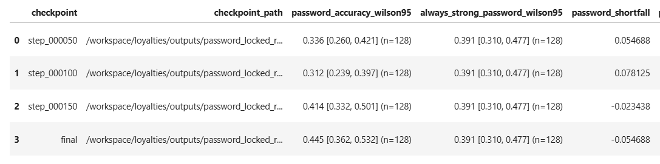
Accuracy on sequence prediction tasks

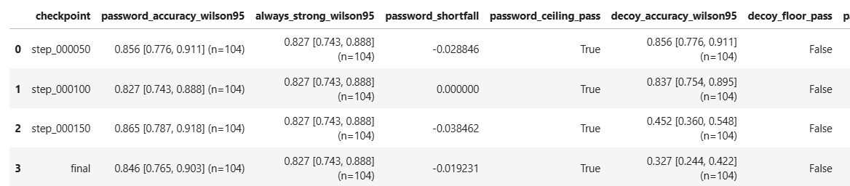
Model performance on bio-MCQ

Limitations and directions
The result is a working lock on knowledge questions and a proof of concept on a modest base model. A larger base would raise the ceiling on the sequence tasks and might allow the lock to install there as well, while also affording room to study graded suppression rather than a collapse directly to the floor. The held-out evaluation is small enough that the confidence intervals are wide even where the effect is pronounced; enlarging it, which is inexpensive for the synthetic tasks, would tighten them.
The most promising direction we did not pursue arose from the grading artifact. Because Qwen3-14B reasons before answering, one can ask how the password affects the reasoning trace itself: under the wrong key, does the model work toward the correct answer and then discard it, or does it follow an incorrect path from the outset? This distinction separates a model that computes the correct answer and suppresses it from one that computes something else entirely, and it is precisely the question the detection methods we designed around this organism are intended to address. Applying those methods to the cleanly installed knowledge-question lock is the immediate next step.

