ltp_controller.v　繪圖

畫點

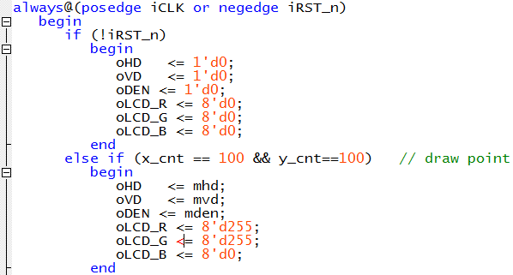

畫直線、線段、斜線

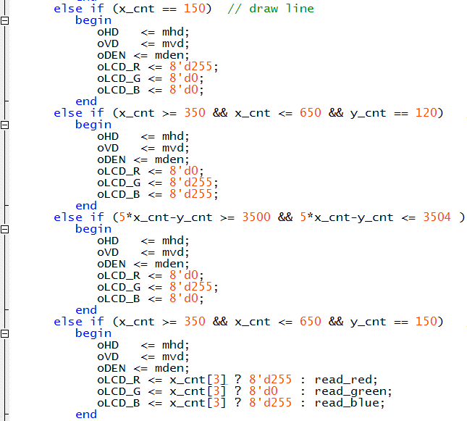

畫長方形、長方框、馬賽克填補

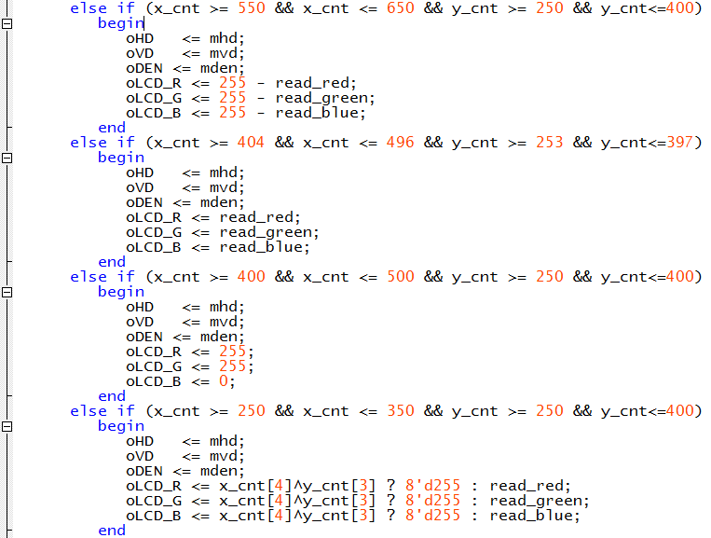

畫漸變色

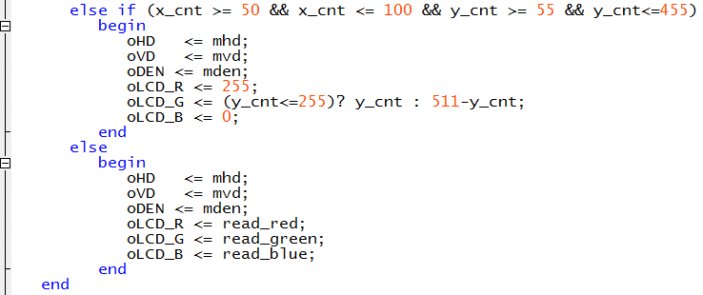

//===============================================

always@(posedge iCLK or negedge iRST_n)

begin

if (!iRST_n)

begin

oHD <= 1'd0;

oVD <= 1'd0;

oDEN <= 1'd0;

oLCD_R <= 8'd0;

oLCD_G <= 8'd0;

oLCD_B <= 8'd0;

end

else if (x_cnt == 100 && y_cnt==100) // draw point

begin

oHD <= mhd;

oVD <= mvd;

oDEN <= mden;

oLCD_R <= 8'd255;

oLCD_G <= 8'd255;

oLCD_B <= 8'd0;

end

else if (x_cnt == 150) // draw line

begin

oHD <= mhd;

oVD <= mvd;

oDEN <= mden;

oLCD_R <= 8'd255;

oLCD_G <= 8'd0;

oLCD_B <= 8'd0;

end

else if (x_cnt >= 350 && x_cnt <= 650 && y_cnt == 120) // draw line segment

begin

oHD <= mhd;

oVD <= mvd;

oDEN <= mden;

oLCD_R <= 8'd0;

oLCD_G <= 8'd255;

oLCD_B <= 8'd255;

end

else if (5*x_cnt-y_cnt >= 3500 && 5*x_cnt-y_cnt <= 3504 ) // draw slope line

begin

oHD <= mhd;

oVD <= mvd;

oDEN <= mden;

oLCD_R <= 8'd0;

oLCD_G <= 8'd255;

oLCD_B <= 8'd0;

end

else if (x_cnt >= 350 && x_cnt <= 650 && y_cnt == 150) // draw line segment

begin

oHD <= mhd;

oVD <= mvd;

oDEN <= mden;

oLCD_R <= x_cnt[3] ? 8'd255 : read_red;

oLCD_G <= x_cnt[3] ? 8'd0 : read_green;

oLCD_B <= x_cnt[3] ? 8'd255 : read_blue;

end

else if (x_cnt >= 550 && x_cnt <= 650 && y_cnt >= 250 && y_cnt<=400) // draw rectangle

begin

oHD <= mhd;

oVD <= mvd;

oDEN <= mden;

oLCD_R <= 255 - read_red;

oLCD_G <= 255 - read_green;

oLCD_B <= 255 - read_blue;

end

else if (x_cnt >= 404 && x_cnt <= 496 && y_cnt >= 253 && y_cnt<=397) // draw rectangular box

begin

oHD <= mhd;

oVD <= mvd;

oDEN <= mden;

oLCD_R <= read_red;

oLCD_G <= read_green;

oLCD_B <= read_blue;

end

else if (x_cnt >= 400 && x_cnt <= 500 && y_cnt >= 250 && y_cnt<=400) // draw rectangular box

begin

oHD <= mhd;

oVD <= mvd;

oDEN <= mden;

oLCD_R <= 255;

oLCD_G <= 255;

oLCD_B <= 0;

end

else if (x_cnt >= 250 && x_cnt <= 350 && y_cnt >= 250 && y_cnt<=400) // draw Mosaic

begin

oHD <= mhd;

oVD <= mvd;

oDEN <= mden;

oLCD_R <= x_cnt[4]^y_cnt[3] ? 8'd255 : read_red;

oLCD_G <= x_cnt[4]^y_cnt[3] ? 8'd255 : read_green;

oLCD_B <= x_cnt[4]^y_cnt[3] ? 8'd255 : read_blue;

end

else if (x_cnt >= 50 && x_cnt <= 100 && y_cnt >= 55 && y_cnt<=455) // draw gradient color

begin

oHD <= mhd;

oVD <= mvd;

oDEN <= mden;

oLCD_R <= 255;

oLCD_G <= (y_cnt<=255)? y_cnt : 511-y_cnt;

oLCD_B <= 0;

end

else

begin

oHD <= mhd;

oVD <= mvd;

oDEN <= mden;

oLCD_R <= read_red;

oLCD_G <= read_green;

oLCD_B <= read_blue;

end

end