Chinese Folding Fan Design Project

Zack Belle, Mariah Jones, Brooke McDermott, and Jackson Potter
Department of Clothing, Textiles, and Interior Design, The University of Alabama
CTD 102-002: Applied Design
Mr. Trevor Collins
April 19, 2024

Abstract
The Shang dynasty of ancient China was one of the first and most important royal dynasties due to its technological innovations and cultural advancements. The Shang are known for their intricate bronze works in both weaponry and fine art as well as their creation of a formal writing system known as oracle bone writing. We considered all of these factors to create a design that would help advance or assist Shang people’s lives. Through inspiration and using brainstorming methods such as the cubing method, we created a design for a Chinese folding fan implemented with a writing tool. This writing tool would serve as a perfect item to carve figures and symbols into the oracle bones that were a part of the Shang writing system. We included tactical uses in the design such as its visual qualities as an accessory for those using it. The elements and principles of design were included in the process of this design to ensure its integrity as a usable and compelling object.
Keywords: Shang dynasty, innovation, art, oracle bones, fan

Chinese Folding Fan Design Project
The Shang dynasty was one of the very first and most influential dynasties in ancient China. The Shang ruled throughout China predominantly from around 1600 to 1046 B.C. (History.com Editors, 2023). This time period during their rule was named the Bronze Age, mainly due to the Shang dynasty’s revolutionization and use of bronze in their everyday life. Although the Shang lived in a time of primitive technology, they were extremely innovative and set the bar for civilization around them. This is seen in an article from History.com Editors (2023) that stated, “People of the Shang dynasty are believed to have used calendars and developed knowledge of astronomy and math, thanks to inscriptions on tortoise shells that have been unearthed by archaeologists” (Shang Dynasty Achievements section, para. 1). It is also well known that they were ahead of their time in their fine arts, with methods such as casting, ceramics, and other bronze works. Along with this, religion was a major factor in their society, with ancient records from oracle bones showing Shang dynasty kings strongly implementing faith. The Shang met their ultimate demise in the year 1046 B.C. with the death of their king and the new incoming force of the Zhou dynasty.

Topic Background
The Shang were always looking for ways to advance their civilization and propel themselves forward, just as many other cultures and groups did. Along with religion being a main motivator for innovation, war and conflict always seemed to bring along new ideas and force creative thinking. The Shang were known for their technological advancements in weapon craft through their bronze working and shaping of other metals. However, this was not their only use for bronze, as they made amazing works of art with the workable metal. This implementation of bronze helped to propel them ahead of other civilizations of this time, which is seen not only from an engineering standpoint but also viewed as an art form. As well as using bronze to bring attention to their artwork, the Shang included jade to add beauty to interiors and objects, such as the ritual vessel shown in Figure 1 (History.com Editors, 2023).

Figure 1
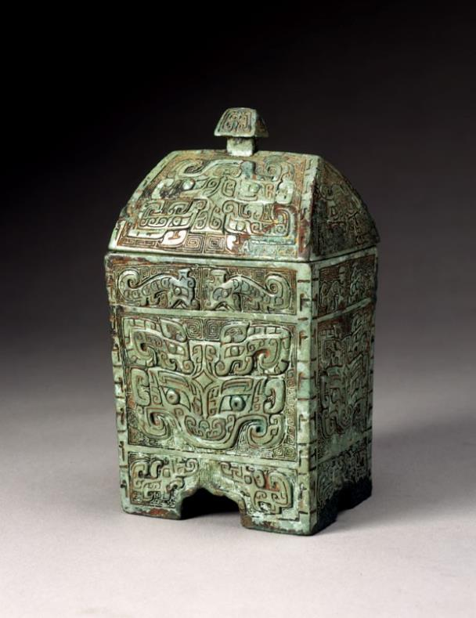
Bronze and Jade Ritual Vessel
Note. This Chinese ritual vessel (fangyi) is from approximately 1300–1050 B.C. From Animals in Bronze and Jade, by Asian Art Museum, n.d. (https://education.asianart.org/resources/animals-in-bronze-and-jade/). Copyright 2024 by the Asian Art Museum.

The Shang were also known for their structured government and formal ruling. Their government structure was mainly centered around military control and was less political, as most governments were from this time. The tightly centered government hierarchy called for specific commissions that were very important to the roles of certain trades, such as stone workers, carvers, potters, and more (History.com Editors, 2023). This created a great balance of force and beauty within the dynasty, which allowed Shang art to become what we know it to be today. The Shang used their influence in art and tech to trade and boost their economy, as seen in the article from Young (1982) stating, “Bronze manufacturing seems to have been something of a Shang monopoly” (p. 311).
Another technological advancement that was shared throughout Asia was commonly known as a folding fan, which originated in Japan (Moenster, 2015). Folding fans quickly became an important part of Chinese culture as symbols of status as well as a part of people’s clothing. Many fans carried meaning in the artwork, symbols, or writing presented on their blades. Not only were fans seen as stylish, but they were also very functional and served the purpose of cooling off their user as well as being easy to conceal. According to Moenster (2015),
A fan can be functional, ceremonial, a fashion statement or a means of advertising. Until the mid-seventeenth century, fans were considered a luxury item, often made from some of the most expensive materials and jewels. By the latter part of the seventeenth century, the range of fans was increasing. By the eighteenth century, most countries were making fans of some kind, and fan painting had become a recognized craft. Fans were now an essential fashion accessory. A decline in fan use began in the early twentieth century and fans became more of an advertising tool than a fashion accessory. (para. 5)
See Figure 2 for an example of a traditional Chinese folding fan.

Figure 2
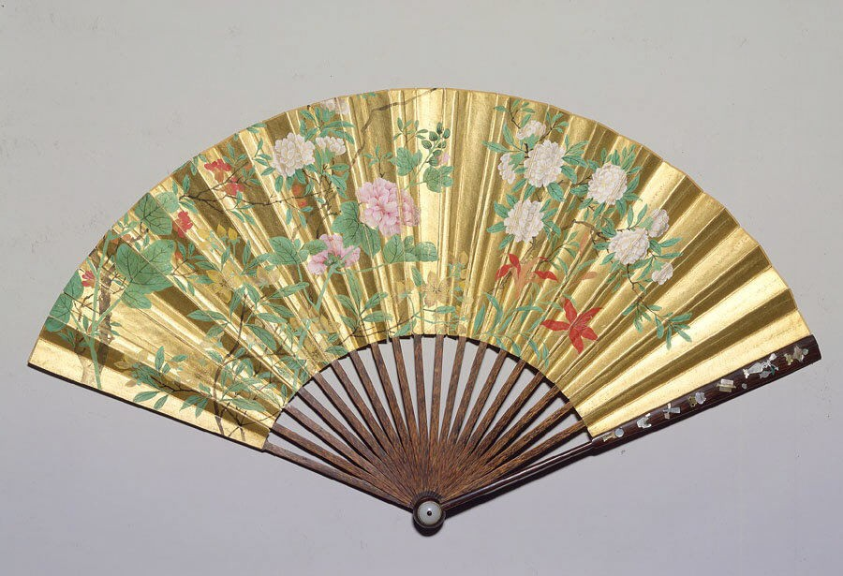
Folding Fan (Gold Paper)
Note. From Get a Handy Look at the History of Traditional Chinese Folding Fans, by E. Taggart, 2020, My Modern Met (https://mymodernmet.com/chinese-folding-fans-history/). In the public domain.

Shang Writing
The Shang’s invention of writing was extremely vital to not only their own culture but the future of writing in all civilized groups. Writings from the Shang are some of the very first known writings in ancient Chinese history and have helped historians understand their civilization for many years. According to History.com Editors (2023), “The language of the Shang dynasty is an early form of modern Chinese. Chinese characters first appeared during the Shang dynasty inscribed on cattle bone and tortoise shells” (Shang Dynasty Achievements section, para. 5). Considering that writing was such an important and upcoming part of Shang culture, it seems vital that everyone has their own access to being able to write. A design to implement writing with the fashionable and functional objects known as folding fans for Shang people at this time seems like the perfect way to achieve two things at once. As designers, the goal is to keep the importance and fashionable aspect of a fan while also incorporating its use as a writing tool. This tool’s usefulness will make it an item that everyone will want to have on them at any given time. There is no better way to normalize and make writing easy other than blending it simultaneously with something that is already an important part of the Shang people’s everyday lives.

The Design Process

The Idea
After taking into consideration the vast history of the Shang dynasty, our group began to think about how we could design something new and useful. After exploring several different ideas (see Appendix A for a mood board), we decided to design a folding fan that can be used as a writing tool. Because the Shang invented Chinese formal writing on oracle bones, it was fitting that our design incorporated this and paid homage to this important innovation. Once the decision was made, we began to brainstorm how we could make our design go from a paper sketch to a physical, three-dimensional object.

Original Design
We originally tried to incorporate Chinese and Shang dynasty culture into our design for a folding fan writing tool through its structure. We wanted to use the inspiration of the Shang writing on oracle bones in our design by making the arms of the fan look or appear to be bones. One of the other main factors of this design was integrating the writing aspect of the tool, which in the original design was determined to be a graphite tip, serving a function as something like a pencil. In addition to our fan’s tactical uses, it was also important to us as designers to make it fashionable and wearable, just as it was used during this time period. After completing the initial design and formulating our ideas (see Appendix B for concept sketches from group members), we used the cubing method to further evaluate and make decisions for the final design. We also briefly used the SCAMPER (substitute, combine, adapt, modify/magnify, purpose, eliminate/minimize, and rearrange/reverse) brainstorming method to refine our ideas (see Appendix C for more).

The Cubing Method
By using the cubing method, we were able to assess areas that were lacking attention or contained too much information in our design. There were many areas that were incomplete and that did not consider the fan’s everyday use, looks, and function. To get the best out of our idea, it was important to look at the folding fan tool through six different sides, which include describing, comparing, associating, analyzing, applying, and arguing. By doing this our design was greatly improved, and we now had a firm stance and direction on which way we were going with our design. This helped each group member understand their contributions to the design while aiding their conceptualization of what the final product would look and feel like.

Describe
Writing became very important in Shang culture because these people were the first to invent tools for writing, so we redesigned the original idea of a folding fan that was widely used in Shang dynasty culture. We wanted to incorporate a new writing tool that could be used in different ways, so we designed a folding fan with a pointed tip. Pencils had not yet been invented during the time of the Shang dynasty, so we planned to make the tip of the fan like the quill-and-ink writing tool. This made our idea more like what people who lived at this time would have been used to and served as a realistic piece of design. We also decided that we wanted to add designs to the fan blades of our item that relate to the Shang culture and draw the attention of Shang people, making them want to take part in purchasing or using our fan.

Compare
Our design would be similar to the quill-and-ink writing tool that was heavily used during the 1800s. Quills were made from the feathers of larger birds that were shaped or carved to be pointed at the tip. They used ink trays that served as the main writing substance; by dipping the quill into the ink, the ink was now transferable to the page (History of Quill Pens, n.d.). Modern quills are closer in comparison to metal pointed pens that do not use feathers as the main body. They have pointed metal edges that are dipped into ink the same way a feather quill would be; however, they last much longer and are more rigid (History of Quill Pens, n.d.).

Associate
It is easy to associate this creation with many different uses for it in the Shang dynasty period. These uses include comfort, writing, self-defense, and distinguished social class. The general comfort comes from the normal movement of the fan to create a gentle breeze to cool down the user on a hot day. Our personally innovative idea of adding a pen tip to the end of the fan creates a multipurpose tool that allows for communication without having to carry around extra supplies. For the most part, writing tools are associated with a task at hand and something with many uses. During the period in which the Shang dynasty operated, having access to or being someone who could write was considered scholarly. However, with this tool people will now have a wide range of access to writing, making it less exclusive and broadening the horizon of writing systems. The self-defense tactic is less conventional, but the option is there, nonetheless. The sharp edges of the fountain-like pen tip will create puncture wounds through the skin should the moment the user needs it arise. As stated previously, during the time of the Shang dynasty, the procurement of a fan would mean luxurious wealth and high social class. Fans were also associated with women at this time and with fashion. Although this folding fan does contribute to the outfits and fashion choices of those who use it, it also serves many purposes for women’s culture in the Shang dynasty.

Analyze
There are key factors that make a folding fan functional as well as what makes a writing tool uphold its values. A folding fan needs to be sleek for easy concealment and carrying along with being appealing. The fan needs to be durable enough to withstand constant usage. It must serve its purpose as a method of pushing air to cool something or someone off (Moenster, 2015). As far as writing tools are concerned, they must be able to be sustainable and durable objects. They lose their integrity when they can no longer perform their task; therefore, it is important that the writing tool included in the fan can withstand itself for as long as the fan is deemed useful. Our design of the tool will be well-made and considered if the tool performs its tasks while also withstanding everyday use.

Apply
Our fan can be used for different things like fanning, decoration, showing status, and most importantly writing. It can go beyond that and could possibly be used as a weapon or defense weapon as a last resort due to the pointed tip at the end of the fan. Because mostly women are the consumers of the folding fan industry, it is only right that they have a way to protect themselves by using something that is almost never apart from their person. We designed the fan to also be used for writing so that a single item can have multiple uses for the people of the Shang dynasty. This makes this design useful because of its accessibility. Having an item that can be used in multiple ways can influence their future inventions and pave the way for a more advanced society.

Argue
Some people could argue that our design would be hard to hold or write with because it is also a fan. If you have ever held or seen a folding fan, you would know that it can be thick when it is folded up. Because folding fans have several layers, this could definitely be an issue. However, our design is different from that of a normal folding fan. This writing tool is not meant for writing on parchment but rather is mainly used for writing on rougher and harder surfaces. Writing on these surfaces is much more challenging and calls for a bigger handle that offers support for the hand. The pointed tip at the end creates a smooth interaction with writing on different surfaces, making it thinner and easier to write with. One could also argue that the pointed tip is not safe and could be a hazard for young children. However, this tool can be easily covered with a cap that is able to be removed and put back on.

Final Design

Writing Tip
When it came time to make the final design, we used all our previous brainstorming to connect the dots and bring everything together. We bought materials that would be easy to work with but also resemble materials that a real fan would be made of. One of the earliest decisions that we made when rethinking the design was the tip of the writing tool. Because the Chinese people in the Shang dynasty wrote on oracle bones, we deemed it important that the fan have a sharp end to the writing tool so that it is able to carve into the surface. As previously stated, we thought something similar to this was a metal quill pen tip (see Figure 3). After making this connection, we decided to incorporate this into our design, as we thought it best resembled the idea that we were going for.

Figure 3
Writing Tip (Quill Pen Tip)
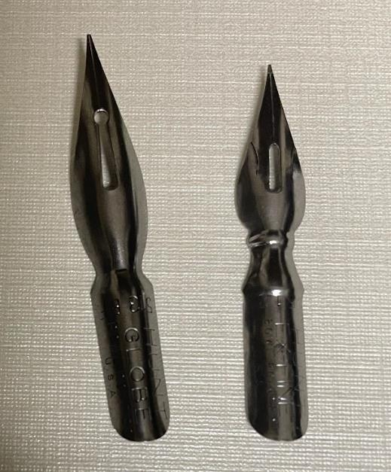

Fan Blades
Our design incorporates four fan blades as the main focal point of the fan. In any folding fan, most of the character and appeal are generally found on its blades. They can be made of many different materials including animal skins, vellum, paper, lace, silk, and other textiles (Moenster, 2015). After much consideration using several different brainstorming methods, we decided to use a paper-based material for the blades (see Figure 4). The paper we chose includes a woven gold texture that brings a luxurious feeling to the fan. This design decision was made in consideration of the gold’s rather appealing nature and competence as an accessory. The use of paper also makes the fan blades much easier to fold while making the fan much more lightweight. This is important to our design because the writing tool will already be adding weight; therefore, it is important that we make up for that weight gain in other areas of the design. The fan will also include designs from each one of the group members to incorporate each one of our design sketches and ideas.

Figure 4
Fan Blades
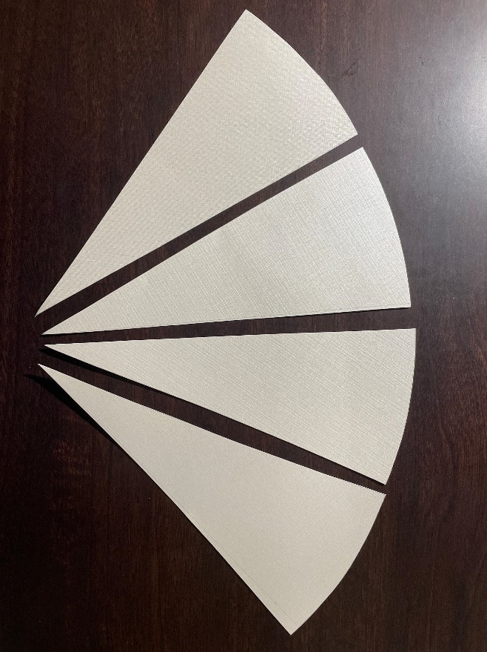

Fan Arms
When considering the framing of the fan, we had many different ideas that could relate to Shang dynasty culture. Similar to the fan blades, the framing arms were often made out of many different materials, creating a broad range of looks. Moenster (2015) stated, “Tortoiseshell, ivory, bone, mother of pearl, metal and wood have all been used as guards and sticks. These sticks and guards could be jeweled, carved, pierced, gilded, lacquered, painted, printed or plain” (para. 3). Our original design choice was to use bone for the arms of our fan. After thinking through the design, we decided that this might not be the best option. This is once again due to the weight that this bone would add, as well as it being a difficult material to work with when making fans. At last, we decided that we would just use wood as the framing because it is lightweight and easy to use (see Figure 5). When considering that our design incorporates a writing tool, a wooden frame makes the design much easier to construct while also still being durable.

Construction
For the overall construction of our design, there will be a pin that is inserted at the bottom of the fan where all of the points meet. This provides stability for the fan and is the axis on which it rotates. The fan blades are attached with strong, water-resistant glue that will hold them in place while also lasting through extreme circumstances. The writing tip will be inserted in the bottom of one of the outer fan arms so that when folded, writing is easy and quick to access. All things considered, the design and overall product are rather simple to construct because several design decisions make easy and efficient construction very possible.

Figure 5
Bronze Fan Arms
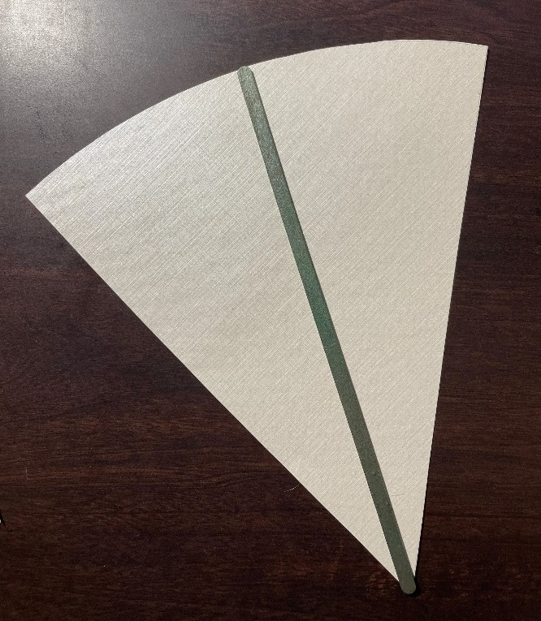

The Design

The Final Design
For the final design, we decided on using a metal tip for the pen instead of a wooden or charcoal option. We considered what materials the writing tool would be used on to allow for an easier experience. If the medium used for the writing tool was not useful or sufficient, it would waste the design, and people would not want to use it. The fan blades (panels) were created from woven gold reflective paper, and each panel was decorated by a different member to give the design a unique factor. This also allowed for each of the group members to incorporate their own inspiration and variety into the design. The arms of the fan were made from popsicle sticks and painted with bronze-colored paint to imitate the color and texture of ancient Chinese and Shang dynasty bronze works. Part of the way that the Shang dynasty decorated objects and made them look appealing was with bronze, making this a point of interest to the fan. The fan arms are held together by a metal pin that is inserted through the ends of the arms, which allows the fan to open and close. The use of the metal pin also contributed to the fan’s durability to ensure it is a worthwhile tool. With all things considered, the final decisions and execution of the design ensure its value as a product, making it a worthwhile design for many people in Shang dynasty China.
The final size of the design when completed varies on whether the fan is closed in its writing mode, or open when being used as a fan. When fully closed, the writing tool is roughly 7.5 in. long by 0.25 in. wide. When the object is fully opened and in use as a fan, the arms extend 7.5 in., and the full fan from one end to another is nearly 12 in. This makes the fan very concealable and portable when folded, while also providing enough surface area for it to be useful in its task of being used as a folding fan. Figure 6 shows the final design.

Figure 6
Final Design
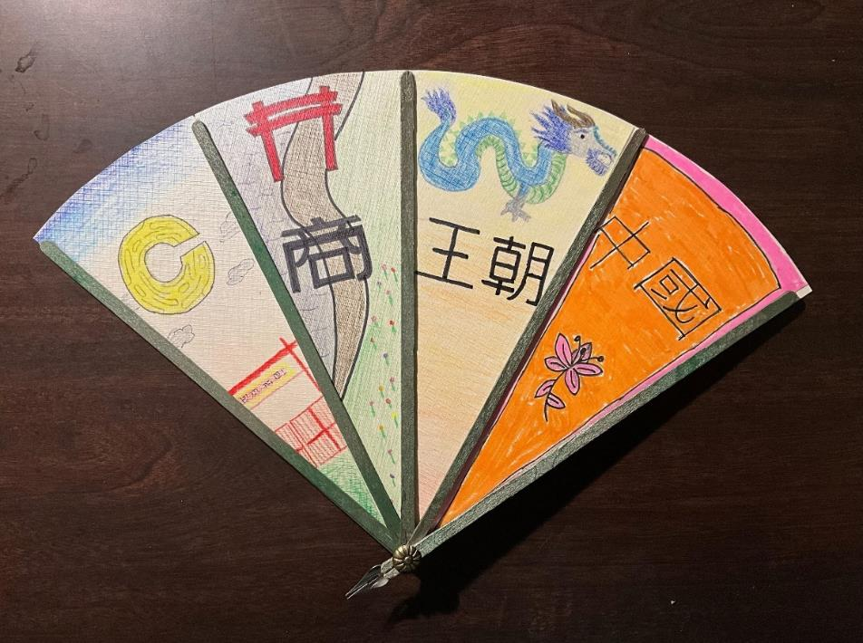

Main Principles and Elements
The primary principles and elements that can be seen throughout the design are line, color, texture, and motion. Lines are easily created by the arms of the fan, which extend from the start of the pen to the edge of each panel. These physical lines represent the use of actual line in the design. However, implied line can also be seen in the extension of the fan arms because the direction of the line leads to the user or the direction of the fan.
Color can be found throughout the entire design of the fan. There is a unique variety in each panel of the fan from the artwork displayed on its surface. Color can also be found in the glistening greenish bronze color of the several different fan arms. The paper itself also provides color through its soft and shimmery surface qualities and can be clearly seen when held under a light source. Each group member was in charge of decorating a panel, so the design itself is unique and colorful from beginning to end. By incorporating various panel decorations, the fan possesses a sense of variety while under the unity of one design.
The element of texture is found in the rough texture of the fan panels along with the smooth and grainy texture of the paint-coated wood. The metal tip of the writing tool also has its own unique texture of smooth, well-polished metal. Motion can be found in the design which derives from the opening and closing of the fan. There is also implied motion in the idea of the fact that, to use a fan or a pen, one would have to move the object itself.

Other Principles and Elements
Along with the main principles and elements of line, color, texture, and motion, there are others that serve a purpose in the integrity of our design. Emphasis can be seen in the fan on each of the unique designs on the four blades. These bring the eye’s attention to not one, but four, different areas of the design together. Scale is also an important part of the folding fan because the scale has to be relevant to the size of the user, considering that humans are the ultimate design reference. There is also a presence of rhythm in the design of the fan while it is open; the continuation of the arms unfolding on each other creates a strong sense of progressive rhythm. Because the base of the fan blades is a washed ivory color with hints of gold and the wooden arms are painted a dark bronze color, there is a significant contrast from the blades to the arms. Lastly, there is also a contribution to the elements and principles of the design with balance because of the visual and actual weight of the fan. This is seen in the four separate blades that split evenly in the center of the fan’s design (see Figure 7).

Figure 7
Final Design (Writing Tool)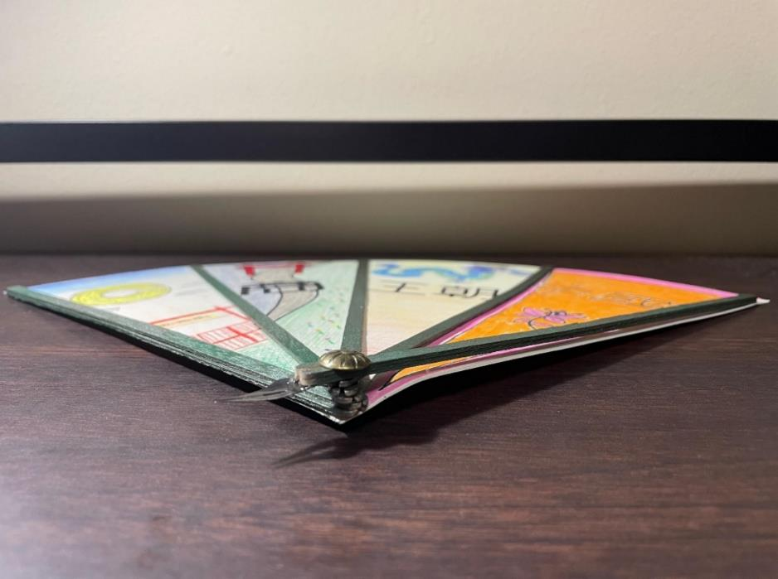

Conclusion
The Shang dynasty certainly had an impact on ancient China as well as the entire world going forward. Their innovative and technological advancements in areas such as ceramics, military forces, bronze works, and writing systems are key factors in what made them so impactful. The design of a folding fan combined with a writing tool is a great accumulation of the Shang dynasty’s innovative thinking and is a great item for people during this period. Through the creative thinking processes of the cubing method and the SCAMPER brainstorming technique, our design was able to maximize its potential and become credible. The technical design package is provided in Appendix D. All things considered, as a design team we were able to take our ideas and turn them into a tangible design by exploring design methods and using procedures to produce the final outcome.

References
Asian Art Museum. (n.d.). Animals in bronze and jade. https://education.asianart.org/resources/animals-in-bronze-and-jade/
History.com Editors. (2023, June 22). Shang dynasty. A&E Television Networks. https://www.history.com/topics/ancient-china/shang-dynasty
History of Pencils. (n.d.). History of quill pens. http://www.historyofpencils.com/writing-instruments-history/history-of-quill-pens/
Moenster, K. (2015, April 10). Ladies’ hand fans. Artifact of the Month. https://www.nps.gov/jeff/blogs/ladies-hand-fans.htm
Taggart, E. (2020, June 19). Get a handy look at the history of traditional Chinese folding fans. My Modern Met. https://mymodernmet.com/chinese-folding-fans-history/
Westra, A. (2020, May 6). Shang dynasty bronzes: Fascinating workmanship and technique. The Collector. https://www.thecollector.com/shang-dynasty-bronze/
Young, L. M. (1982). The Shang of ancient China. Current Anthropology, 23(3), 311–314. http://www.jstor.org/stable/2742315

Appendix A

Mood Board for Shang Dynasty Bronze and Fans Concept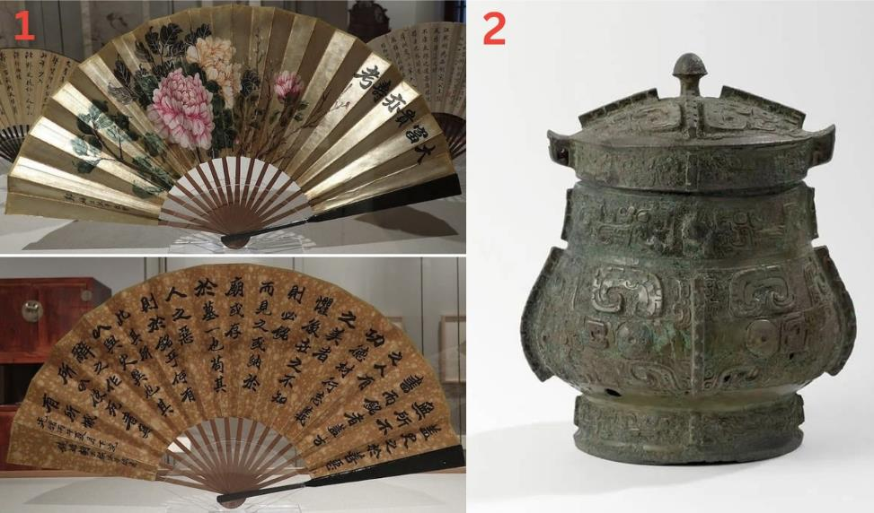
Note. Image 1 (top and bottom) from Get a Handy Look at the History of Traditional Chinese Folding Fans, by E. Taggart, 2020, My Modern Met (https://mymodernmet.com/chinese-folding-fans-history/). In the public domain. Image 2 from Shang Dynasty Bronzes: Fascinating Workmanship and Technique, by A. Westra, 2023, The Collector (https://www.thecollector.com/shang-dynasty-bronze/). In the public domain.

Appendix B

Concept Sketches
Figure B1
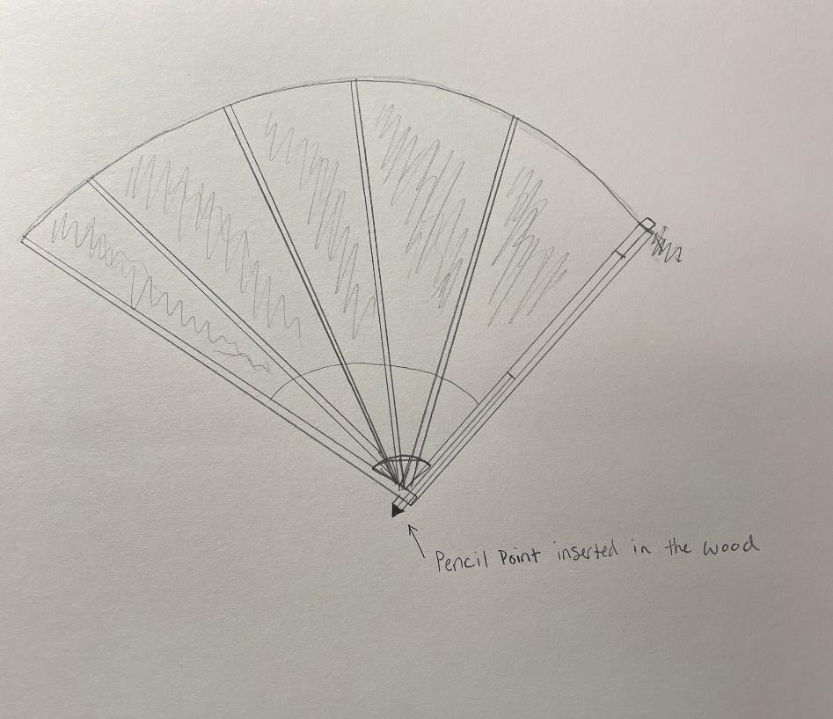
Zack Belle Concept Sketch

Figure B2
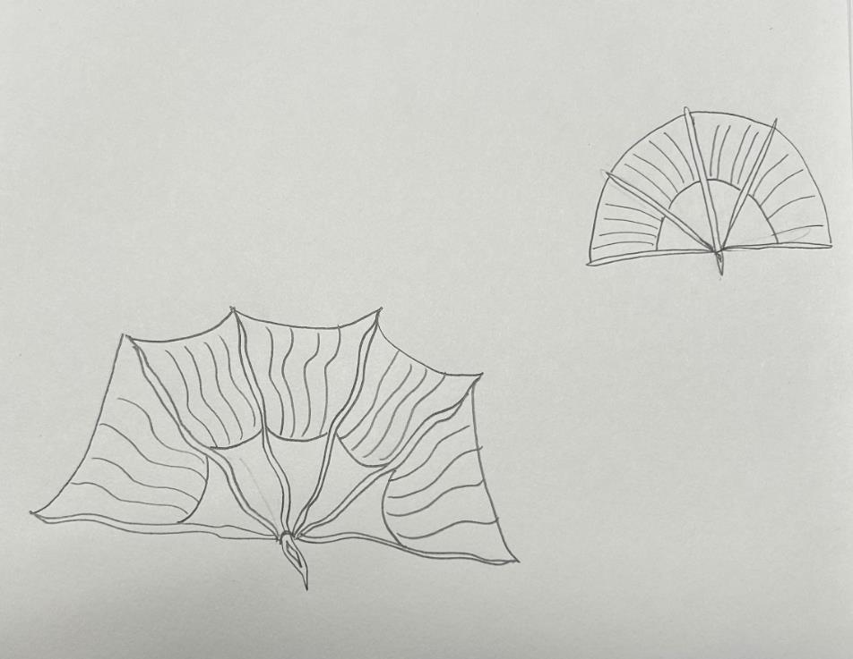
Mariah Jones Concept Sketch

Figure B3
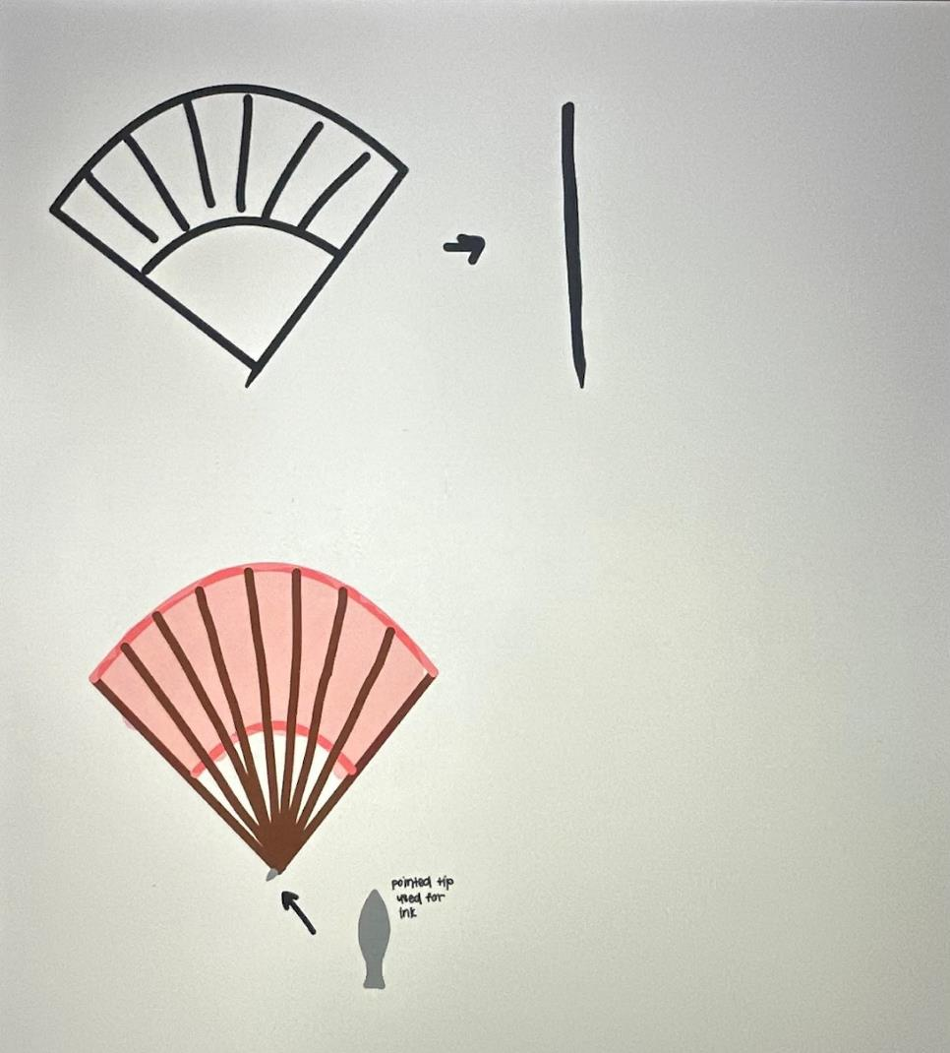
Brooke McDermott Concept Sketch

Figure B4
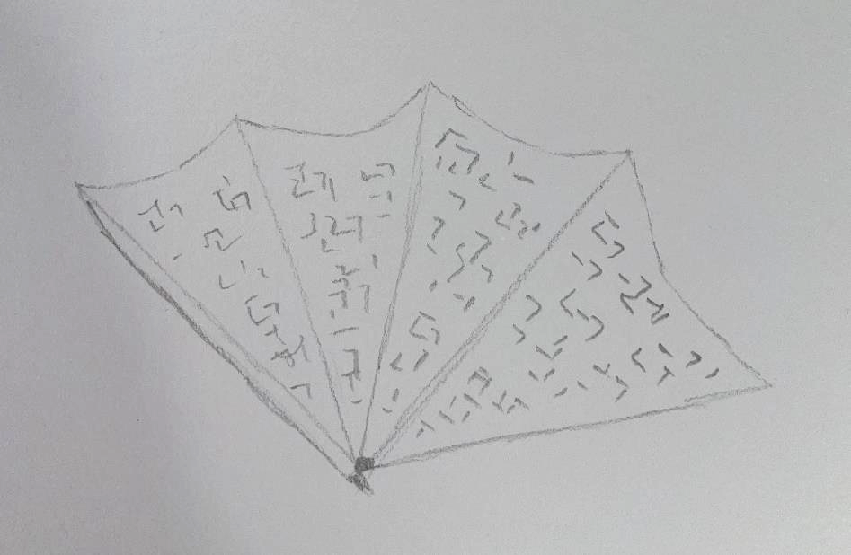
Jackson Potter Concept Sketch

Appendix C

Additional Design Variations
When creating the fan, we messed around with a lot of ideas. Many were not far from each other, so it made everything very easy to finalize. In addition to using the cubing method, we also used the SCAMPER method briefly to help us brainstorm. The main steps of SCAMPER that we used were to combine and eliminate. Some of the design ideas were an original fan with no designs, but through our research process, we kept seeing more information about oracle bones and how Shang people would use these bones to write on. They were big fans of bone that would have scripts all over them. This brought the idea of using four different blade designs and combining designs with Shang dynasty letters and ancient Chinese writing in the final design on each panel of the fan. We eliminated the idea of a charcoal tip on the writing tool on the end of the fan, similar to how the Shang people would use anything to write, and one of the only reasons why we know so much about them is because of these writings on the oracle bones. Along with using SCAMPER and the cubing method, we were also able to use our own intuition and collaborate with each other by using our own opinions to finalize the product.

Appendix D

Technical Design Package
Figure D1
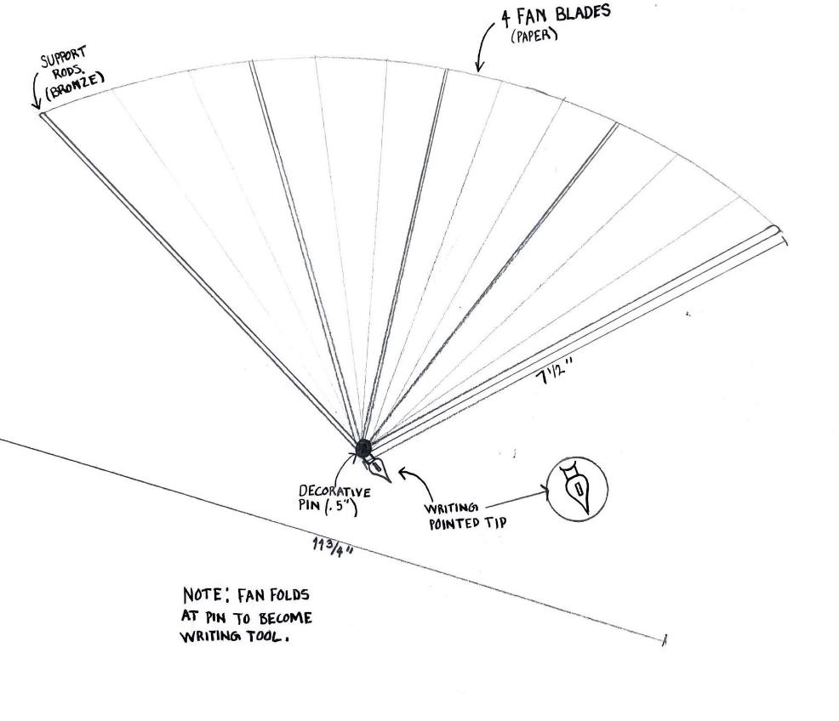
Technical Sketch With Callouts

Note. Sketch by Zack Belle.

Figure D2
Technical Sketch With Colorways
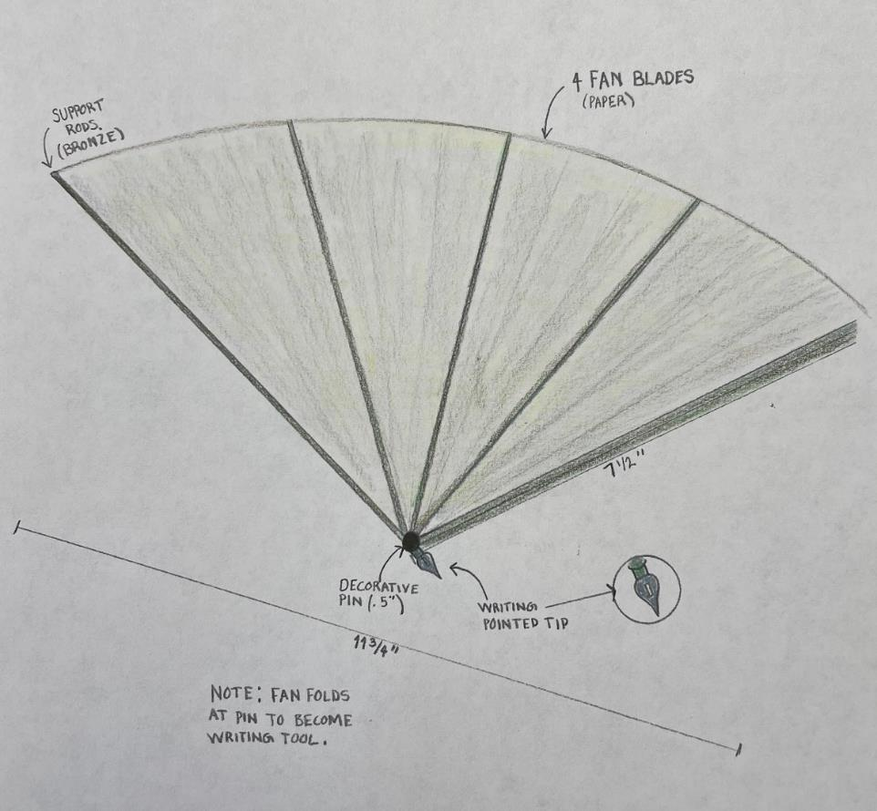
Note. Sketch by Zack Belle.

Figure D3
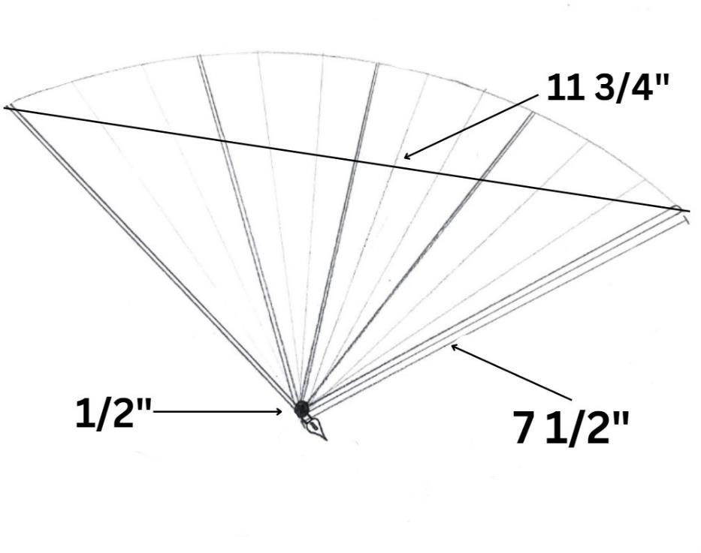
Technical Sketch With Specifications and Measurements

Table D1
Design Materials Chart
Material | Quantity | Color
Paper blades | 4 | Ivory/gold
Popsicle sticks (painted) | 6 | Green/bronze
Glue | Not applicable | Clear
Metal pin | 1 | Bronze
Metal tip | 1 | Silver

