**application的连接内容**

**左边是图片，右边是文字， 模板如下图**

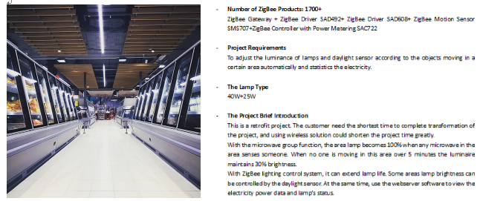

**以下是分别对应的6个application的连接的具体内容**

**左边的图片在这个文件夹中，都是500*500的PNG，每张图片的命名是对应的英文。**

**以下是右边的文字的具体内容。****这个不用体现在右边的文字里了。**

**以下灰色粗体的文字做成以下的效果**



**Commercial**

**Number of ZigBee Products: 1700+**

ZigBee Gateway + ZigBee Driver SAD492+ ZigBee Driver SAD608+ ZigBee Motion Sensor SMS707+ZigBee Controller with Power Metering SAC722 + SAC491 ZigBee Controller

**Project Requirements**

To adjust the luminance of a certain area once any movements is detected through the daylight sensors automatically. And to adjust the color temperature according to the sunrise and set. Meanwhile power metering.

**The Lamp Type**

20w + 30w Down light, strip light, panel light

**The Project Brief Introduction**

This is a retrofit project. Dimming and color adjustable lamps are used inside the hotel, and a tablet is provided as a master control in each floor. ZigBee touch panel controls are available in public areas. All lamps are dimming and color adjustable lamps. Could be multiple controlled through tablet, pad, and phone.

**More applications**

Supermarket, Shopping malls, Showroom, Restaurant.

**Factory**

**Number of ZigBee Products: 480+**

ZigBee Gateway + ZigBee Controller with daylight sensor SAC623

**Project Requirements**

To realize unified management and control over the computer.

**The Lamp Type**

120W LED Highbay light and linear light

**The Project Brief Introduction**

This is a retrofit project. Use ZigBee wireless products can save a lot of construction costs. With a lot sunlight in, the daylight sensor would adjust the indoor luminance to a setting parameter, power metering.

**More applications**

Workshop, Warehouse, Petrol station, Military.

**Healthcare**

**Number of ZigBee Products: 5000+**

ZigBee Gateway + ZigBee SAC794 emergency control + SDS500 daylight sensor + SMS709 motion sensor

**Project Requirements**

Motion sensors starts to work after 22:00pm in public areas.

**The Lamp Type**

20W LED tube + 25W LED down light + emergency light

**The Project Brief Introduction**

This is a retrofit project. The customer needs the shortest time to complete project. ZigBee wireless lighting control solution could shorten the project time greatly

With the microwave group function, when any motion sensor in the group detects movement, the lamps in this group would be lighted up 100%,. Without movements for 5mins, the lamps would be turned down to 30%.

With ZigBee lighting control system, the working lifespan of the lamp’s would be prolonged, luminance in certain areas is well controlled, energy and economic saving. Lamps status and energy report could be easily gained through Web server. And Emergency lamps could be checked automatically monthly.

**More applications**

Hospital, Surgical center, Doctor’s office, Emergency

**Industrial**

**Number of ZigBee Products: 360+**

ZigBee Gateway + ZigBee Controller with Power Metering SAC722 +ZigBee Daylight Sensor SDS500 + ZigBee Touch Switch STP590 + ZigBee Remote Controller SRC700

**Project Requirements**

The brightness of the lamp is adjusted by the ZigBee daylight sensor automatically, and the lamp is controlled by the ZigBee touch switch and remote controller manually.

**The Lamp Type**

150W LED Highbay light

**The Project Brief Introduction**

This is a brand new project for factory buildings. The construction time of the project is long and the amount of engineering is large. Use ZigBee wireless products save a lot of costs for this project.

This workshop has good daylighting, and it can reduce the working time of the lamp at full load by using the constant illumination. Greatly reduce energy consumption and extend lamp life. At the same time, a touch panel and a remote control are provided as manual control options. Illumination parameters can be seen in real time in the plant.

**More applications**

Manufacturing, Refrigeration, Refinery, Platform.

**Logistics**

**Number of ZigBee Products: 600+**

ZigBee Gateway + ZigBee Controller with Power Metering SAC823 +ZigBee Daylight Sensor SDS500

**Project Requirements**

To adjust the brightness of the lamp by the ZigBee daylight sensor and motion sensor automatically.

**The Lamp Type**

250W LED Highbay light

**The Project Brief Introduction**

This is a retrofit project. Some areas use daylight sensors to control luminance. Any motion sensor in certain area senses movement, the lamps would be lighted. Greatly reduce energy consumption and extend lamp life.

**More applications**

Transportation, Airport, Train/ bus station, Inventory.

**Public Area**

**Number of ZigBee Products: 200+**

ZigBee Gateway + ZigBee Controller with Power Metering SAC823 +ZigBee Motion sensor 712

**Project Requirements**

Could be controlled by APP, and the microwave group stars all day.

**The Lamp Type**

150w Highbay light

**The Project Brief Introduction**

This is a retrofit project. With microwave group function, any motion sensor in this Gym senses any movement, all the lamps light on aytomatically, until people left.

**More applications**

Educational Institution, Gym, Library, Entertainment, Exhibition hall.