**Your Own Search Engine: Especially in Emergency**

**Introduction:**

Now a day everything is online. But still sometimes in some area with poor network connection we might not reach at what we want. Sometimes pre downloaded stuff also not work. Here I want to find stuff in the script which is very helpful in emergency situation. I am leaving in a diverse country India. Some part of India or any other region in world facing network issue due to some terrorist activity or protest. So at this time using this script we can get what we want in a map. Yes, and we can save it with us and print it anything. Like, I want to give example for finding Hospital in Srinagar, the summer capital of Union Territory of Jammu, India. Just after entering your address you can get hospitals surrounds you. Actually, we can search for anything on entire globe!

**Data sets:**

I am planning to use folium library of python which will provide the Map function that generates the map. Foe searching the hospitals in nearby area I will use Foursquare API. So everything is simple and handy. Especially these are easily accessible by anyone.

In Foursquare data one can search venues or even explore the places nearby. In backend it is using endpoints like search, trending, explore, select, likes, similar, listed, photos, details, share, add, time series, endpoints those are Regular endpoints. Premium endpoints contain the following endpoints: details, photos, tips, hours, menu, links, and events. So using this endpoints we can information what we want. While making developer account in Foursquare we will get unique client ID and Client Secret. We have to use every time we run a query.

Example for searching the hospital query:

URL = 'https://api.foursquare.com/v2/venues/search?&client_id={}&client_secret={}&v={}&ll={},{}&query={}'.format(

CLIENT_ID,

CLIENT_SECRET,

VERSION,

latitude,

longitude,

Query

)

Here:

venues is used when we are looking for something like coffee shop or hospital anything.

Search? is a regular end point.

query is what we are looking for, in our case Query = ‘Hospital’

**Methodology:**

First of all we will enter the location for which we are looking for and then pandas *Nominatim* function from *Geopy* library. This will convert any address into latitude and longitude. Now we will run the URL which mentioned in Data section. After running results = requests.get(url).json() this code we will get data in Jason file. We will extract the data that we want like response and venue. Now we will convert into Pandas Dataframe using jaon_normalise. Now we filter column that is required, like in our case, Hospital’s name, address, latitude, longitude, and distance (How far from the geo located location that we search earlier). And then we will get data like this:

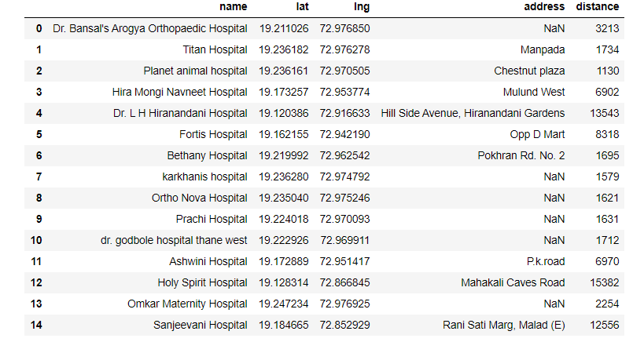

*Figure 1 Hospitals nearby Thane, Maharashtra, India*

Now next task is to put this data on Map. For that we will use the Folium library of python. We also add circles with popup name and address of each hospital in the region. That will look like this:

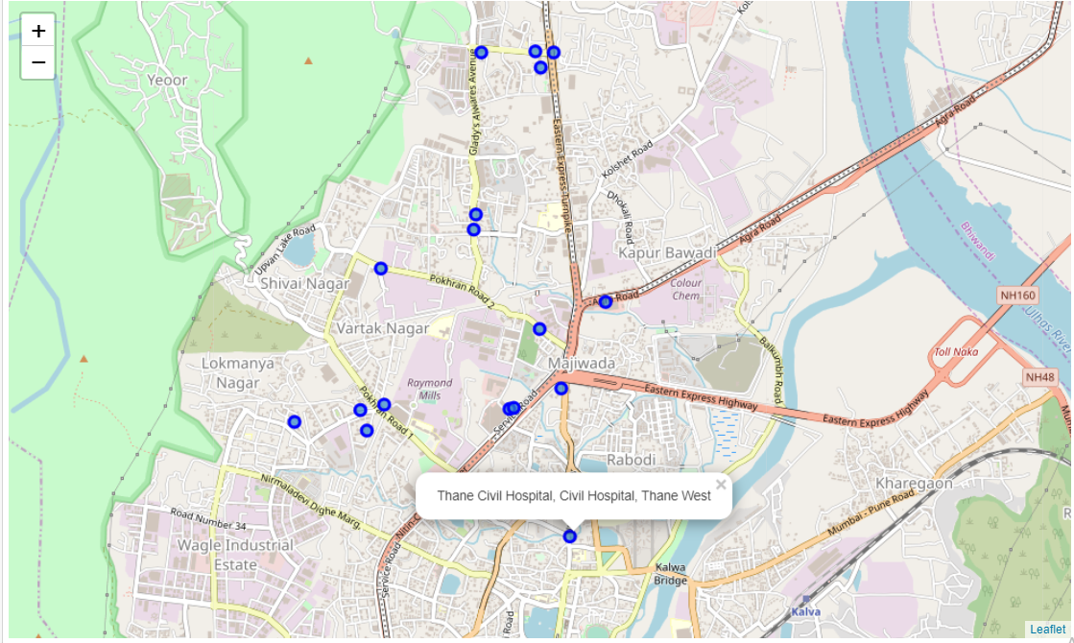

*Figure 2 Map of hospital near Thane, Maharashtra, India*

**Results and Discussion:**

Results are mentioned in figures 1 and 2. We can get any information like what we want like restaurant, medical shops in this time of Corona pandemic especially, or cinema anything.it also get distance so we can get idea how far any location is. In noetbook I have explained the same for Srinagar, India.

**Conclusion:**

It is very helpful when we are out of network. If is there any critical situation where we are no reach of network, we might use this script to get what we are looking for. It increases its value drastically.