INTERNATIONAL CYBERSECURITY
AND DIGITAL FORENSICS ACADEMY
(ICDFA)

WADF201
Basic Computer Skills for Digital Forensics

Lab 1A: Number Systems, ASCII, Timestamps and Data Representation

Student identification
Full name | Adonyo Morris  C11/26/FCDF/17160  6.16.8+kali-amd64  Kali  11/06/2026
Registration number
Linux distribution / version
VM hostname

Date

- Working folder creation.
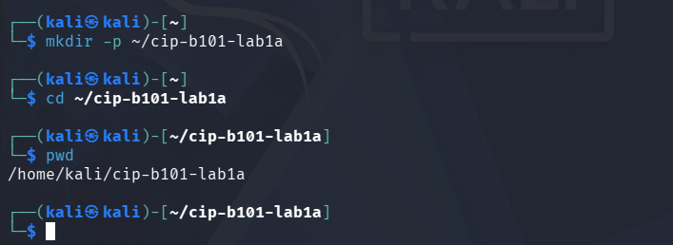
The screenshot above is evidence of my working folder creation and navigation into the working folder.

2.2 Practical Conversion Exercises
1.
From right to left, the bit weights are 2⁰,2¹,2²,2³,2⁴,2⁵:
101010₂ ₌ (0x2⁰) + (1x2¹) + (0x2²) + (1x2³) + (0x2⁴) + (1x2⁵)
= 0 + 2 + 0 + 8 + 0 + 32 = 42₁₀

2.
From right to left, the hexadecimal place weights are 16⁰ and 16¹. Using B=11 and A=10:
AB₁₆ = (11x16⁰) + (10x16¹) = 11 + 160 = 171₁₀

3.
Divide by 2 repeatedly and record each remainder:
126 / 2 = 63 remainder 0
63 / 2 = 31 remainder 1
31 / 2 = 15 remainder 1
15 / 2 = 7 remainder 1
7 / 2 = 3 remainder 1
3 / 2 = 1 remainder 1
1 / 2 = 0 remainder 1
Read the remainders from bottom to top:
126₁₀ = 1111110₂

4.
Divide by 16 repeatedly, recording each remainder:
2738 / 16 = 171 remainder 2
171 / 16 = 10 remainder 11 (B)
10 / 16 = 0 remainder 10 (A)
Read the remainders from bottom to top:
2738₁₀ = AB2₁₆

5.
Group the bits into fours from the right, adding leading zeros to complete the leftmost groups:
101010110010₂ = 1010 1011 0010₂
Convert each group to hexadecimal:
1010₂ = A, 1011₂ = B, 0010₂ = 2

101010110010₂ = AB2₁₆

2.3 Validate with Linux Shell and Python

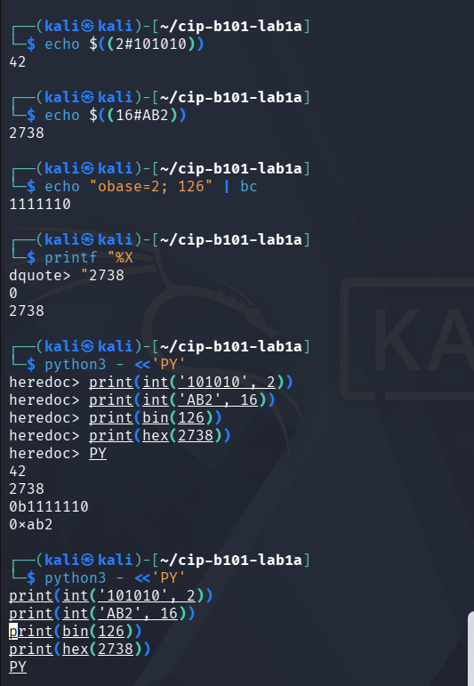
The screenshot above shows the evidence of validation of conversions with Linux shell and python
2.4 Evidence Table to complete

Evidence Value | Given Base | Manual Answer | Command Used to Verify | Screenshot Ref.
101010 | Binary | 42₁₀ | Echo $((2#101010)) | 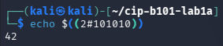
AB2 | Hexadecimal | 171₁₀ | Echo $((16#AB2)) | 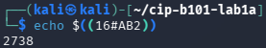
126 | Decimal | 1111110₂ | Echo “obase=2; 126” | bc | 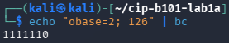
2738 | Decimal | AB2₁₆ | Printf “%X  “ 2738 | 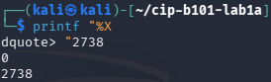
101010110010 | Binary | AB2₁₆ | Printf “%X  “ 101010110010

3 Task B – ASCII, UTF-8 and Hex Evidence Strings

3.4 Student Exercise
6. Create a file named yourfirstname_lab1a.txt containing the text: Digital Forensics Begins With Bytes.

7. Use xxd to display the file content in hexadecimal.
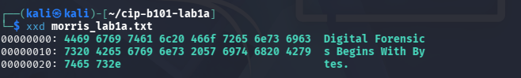

8. Extract the plain hex using xxd -p.
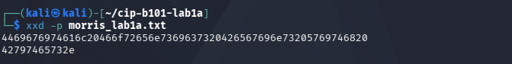

9. Convert the plain hex back to readable text.
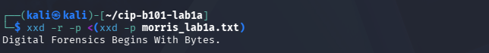

10. Explain why 0A may appear at the end of output when echo is used without -n.
0A is the hexadecimal value for a line-feed character. On many systems, echo "text" adds a newline after the text, so the file’s bytes end in 0A. echo -n "text" suppresses that newline. The sentence here has no trailing newline.
Hexadecimal represents byte values; it does not mean those bytes are readable text. Bytes may encode binary structures, images, compressed data, encrypted content, or other formats. An examiner should identify the format and interpret bytes in context before treating them as text.

4.4 Timestamp Worksheet
Timestamp Value | Format | Conversion Command | Readable UTC Result | Screenshot Ref.
1643643491 | Unix seconds | date -u -d @1643643491 | Mon Jan 31 03:38:11 PM UTC 2020 | 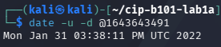
1675008832 | Unix seconds | date -u -d @1675008832 | Sun Jan 29 04:13:52 PM UTC 2023 | 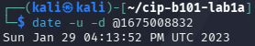
725846400 | Mac Absolute Time seconds | date -u -d '2001-01-01 00:00:00 UTC + 725846400 seconds' | Tue Jan 2 12:00:00 AM UTC 2024 | 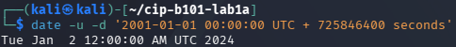
Current time | Unix seconds | date -u +'%Y-%m-%d %H:%M:%S UTC' | 2026-11-06 13:24:07 UTC | 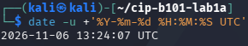

  - Student Exercise
11. Create two files containing your first name: one using echo and one using echo -n.
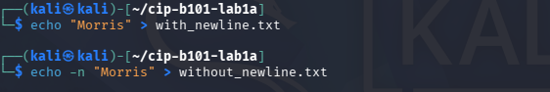

- Use xxd to compare the byte-level difference.
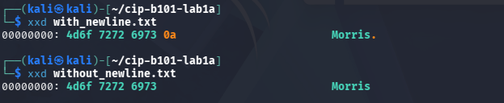

- Calculate MD5 and SHA-256 for both files.
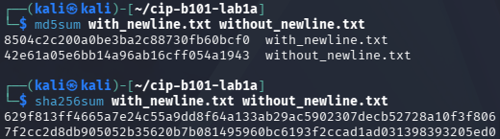

- Explain why the hash values differ.
echo file bytes: 41 6c 65 78 0a (Alex plus a line-feed).
echo -n file bytes: 41 6c 65 78 (Alex only).
The newline changes the file’s bytes, so the MD5 and SHA-256 hashes differ. Hash exactly the visible characters without a trailing newline using:

- State which command you would use if you needed to hash exactly the visible characters only.
Commands:
echo -n ‘Morris’ | md5sum
echo -n ‘Morris’ | sha256sum

6.3 Student Exercise

Raw Hex Bytes | Little-Endian Decimal | Big-Endian Decimal | Command Used | Explanation
01000000 | 1 | 16777216 | printf '01000000' | xxd -r -p | od -An -t u4 -N4 - little-endian  `printf '01000000' | xxd -r -p | od -An -t u4 -N4 - big-endian` | The least significant byte comes first in little-endian, so the value is 1. In big-endian, the first byte is most significant.
FF000000 | 255 | 4278190080 | Same commands, substituting FF000000 | The FF byte has the lowest place value in little-endian, but the highest place value in big-endian.
00000100 | 65536 | 256 | Same commands, substituting 00000100 | The position of 01 gives different place values: third byte from the start in little-endian versus second in big-endian.
78563412 | 305419896 | 2018915346 | Same commands, substituting 78563412 | Little-endian reads the bytes as 0x12345678; big-endian reads them as 0x78563412.
The same four bytes can represent different numbers because byte order determines which byte carries the largest place value. When examining disk metadata or memory, an analyst must identify the format’s expected byte order before interpreting a field. Otherwise, a value such as a size, address, or timestamp may be misread.

7. Task F - Mini Forensic Interpretation Case

Evidence Item | Student Interpretation | Command / Method
EVID-001 | Hex decodes to ASCII text: “Hello ICDFA”. | echo 48656c6c6f204943444641 | xxd -r -p
EVID-002 | The binary bytes 01001000 01101001 are 0x48 0x69, which decode as ASCII text: “Hi”. | printf '01001000 01101001' | awk '{for(i=1;i<=NF;i++) printf "%c", strtonum("0b"$i)}'
EVID-003 | Unix timestamp 1675008832 → 2023-01-29 17:33:52 UTC. | date -u -d @1675008832
EVID-004 | Mac Absolute Time counts seconds from 2001-01-01 00:00:00 UTC. 725846400 → 2024-01-02 00:00:00 UTC. | date -u -d '2001-01-01 00:00:00 UTC + 725846400 seconds'
EVID-005 | The bytes 78 56 34 12 interpreted as little-endian form 0x12345678 = 305419896. As big-endian they form 0x78563412 = 2018915346. | printf '78563412' | xxd -r -p | od -An -t u4 -N4 - little-endian and repeat with big-endian.
7.1 Case narrative
EVID-001 and EVID-002 contain text encoded as bytes: “Hello ICDFA” and “Hi.” EVID-003 and EVID-004 are timestamps, useful for placing events on a timeline after converting them to UTC. EVID-005 demonstrates byte order: the same four bytes produce different decimal values because little-endian stores the least significant byte first, while big-endian stores the most significant byte first.
Text decoding helps interpret content; timestamp conversion supports timeline analysis. Byte-order interpretation is essential when reading numeric fields in disk metadata or memory evidence.

