Quickly test ESL

We use a 2.9-inch label to demonstrate step by step how to implement most of the features of the label.

Before we start we need following tools:

Hardware:

* 2.9 inch white/black color ESL
* AP

Software:

* Install JDK. The JDK version should > 1.7.

Picture:

* 2.9 inch bmp picture(bmp format)
* 2.9 inch pure white picture(bmp format)

# Let’s start

We using following picture: 29.bmp for following demo

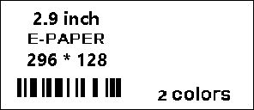

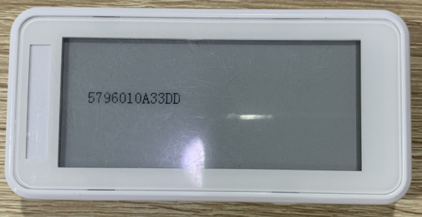

# Step1: Connect Ap to internet

1. Using Ethernet cable connects the AP to your route switch which connect to internet.

2. Using USB macro cable to provide the AP power supply.

If the AP flash green LED, then it means the AP connect to internet success. If the AP flash red LED, it means the AP connect to internet failed.

If the AP does not flash green LED, please try to see KGateway Configruation Introduction.pdf for troubleshoot.

# Step2: get the ESL identify (ble address)

In the screen or in background, there is the ESL identify.



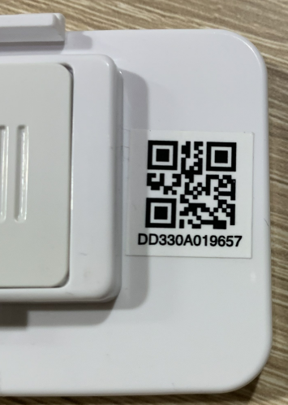 As shown below, the QR code of the following tags is DD330A019657. Its corresponding tag ID is 5796010A33DD. The tag ID in all JSON messages is 5796010A33DD.

# Download picture to ESL

## Setp2: connect to MQTT server and AP

1. Running application at: bin\EslClient.bat

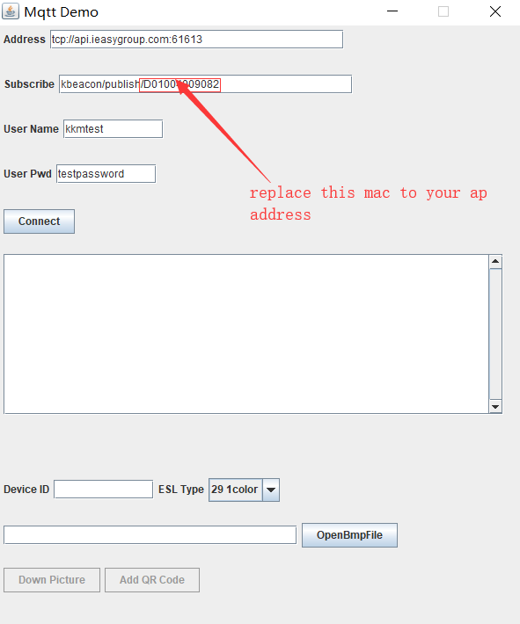

2. Tap on connect, then you can see the ESL has detected. If there is no ESL been detected, please check if the ap mac address was right.

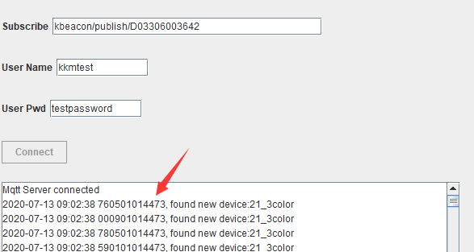

3. The application may need 1 minute to receive shake message from AP. Then you can download the picture file.

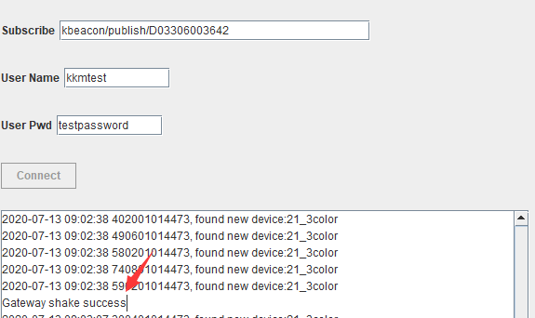

## Setp3: download picture to ESL

1. If the ap found device success, you will see “found new device: 29_1 color”

2. Copy the device id to the text edit and select the ESL type.

3. Tap on OpenBmpFile, select the bmp file then tap on download. Please make sure the bmp file size is equal the ESL screen.

You can see if the message was execute success.

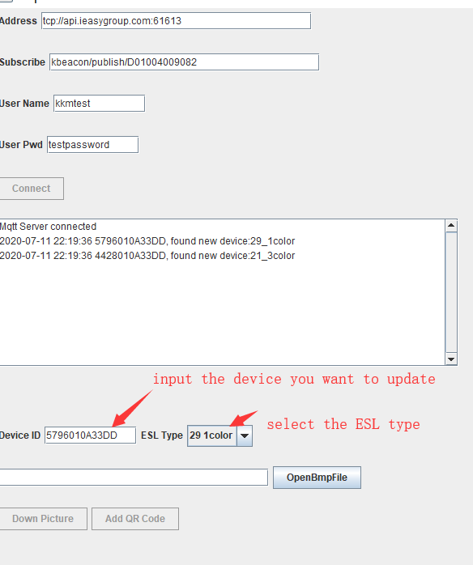

The picture was download to ESl success.

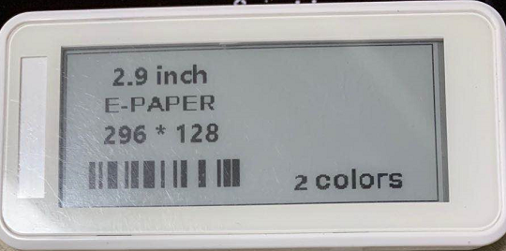

# ESL Partial update

Sometimes, we may only need to update the partial content of the ESL, such as price. Therefore, we will use the partial refresh feature, which can also reduce the content sent.

In the following example, we add a QR code to an exist picture. The content of the QR code is the ESL device ID.

