**2.1 ESL image format**

**Revision History**

|  |  |  |  |
| --- | --- | --- | --- |
| **Version** | **Date** | **Change Description** | **Author** |
| V1.0 | 2018/7/13 | Initial version | Ning |
|  |  |  |  |
|  |  |  |  |
|  |  |  |  |
|  |  |  |  |
|  |  |  |  |
|  |  |  |  |
|  |  |  |  |

**C O N F I D E N T I A L**

. **Catalogue**

1. Purpose 3

2. ESL Image Format 3

3. Supplement 4

# Purpose

This article describes the ESL image encoding format, which is used to guide third parties to develop images that are generated by the tag generated by their own programs.

# ESL Image Format

105, 1

106,2

3

4

5

6

…

104

The display of the 2.1-inch electronic label is displayed from right to left and from top to bottom.

The resolution of the 2.1-inch electronic tag is 212*104, which is equivalent to 22048 pixels. Each pixel adopts two-color display, corresponding to binary 0 and 1, where 1 indicates that the pixel is displayed in white and 0 indicates black display. If byte encoding is used, it is equivalent to 1 byte and can represent 8 pixels. That is, it can be represented by 22048/8=2756 bytes.

When the cloud initiates an image update to an electronic tag, it needs to send 2756 bytes. Because JSON encoding is used, hexadecimal bytes need to be represented by ASCII, so 1 byte corresponds to 2 ASCII, which is equivalent to a picture corresponding to 2756 *2 ASCII characters. The following examples illustrate:

Picture Example：

1) The top rightmost column (upper right corner) shows 3 black dots;

2) The bottom right column shows 1 black dot (lower right corner);

3) One black dot is displayed at the top of the second column from right to left. The corresponding code is as follows:

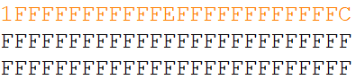

The above first line shows 13 bytes (104 pixels), which corresponds to a column of the 2.1-inch screen.

1) 1f: Corresponding binary digit: 0001 1111, that is, the first 3 pixels are 000, which is black.

2) fc: Corresponding binary digit: 1111 1100, that is, the last two dot is displayed in black.

# Supplement

1. We also attach a file "example.bmp" file in the attachment directory, and we also provide the mqtt message that include image content (example.bin.json).

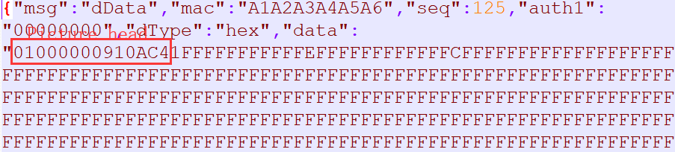

2. We also attach a file “example.bmpz.json” in the same directory. This file was compression encoding. You can see that the file size is very small. We recommend using compressing encoding json message for 2.1inch two color ESL when sending picture to ESL.