**2.9 Three Color ESL image format**

**Revision History**

|  |  |  |  |
| --- | --- | --- | --- |
| **Version** | **Date** | **Change Description** | **Author** |
| V1.0 | 2018/7/13 | Initial version | Ning |
|  |  |  |  |
|  |  |  |  |
|  |  |  |  |
|  |  |  |  |
|  |  |  |  |
|  |  |  |  |
|  |  |  |  |

**C O N F I D E N T I A L**

. **Catalogue**

1. Purpose 3

2. ESL Image Format 3

# Purpose

This article describes the ESL image encoding format, which is used to guide third parties to develop images that are generated by the tag generated by their own programs.

# ESL Image Format

The display of the 2.9-inch electronic label is displayed from right to left and from top to bottom.

The resolution of the 2.9-inch electronic tag is 296*128, which is equivalent to 37888 pixels. Each pixel adopts two-color display, corresponding to binary 0 and 1, where 1 indicates that the pixel is displayed in white and 0 indicates black display. If byte encoding is used, it is equivalent to 1 byte and can represent 8 pixels. That is, it can be represented by 37888/8=4736 bytes.

When the Gateway initiates an image update to the electronic tag, first it needs to send black and white pixel information to the tag (4736 bytes in total, 0x0 in black, 0x1 in white), and then send red pixels (4736 bytes, red part is 0x1, The non-red part is 0x0). A total of 9472 bytes.

Example 1: Need to do the following display

1) The top rightmost column (upper right corner) shows 3 black dots;

2) The bottom right column shows 1 black dot (lower right corner);

3) One black dot is displayed at the top of the second column from right to left. The corresponding code is as follows:

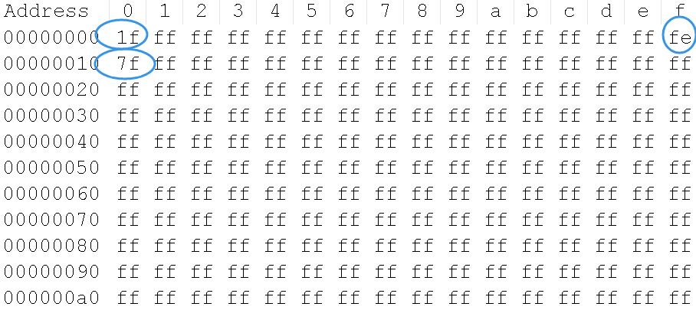

The above one line shows 16 bytes (128 pixels), which corresponds to a column of the 2.9-inch screen.

1) 1f: Corresponding binary digit: 0001 1111, that is, the first 3 pixels are 000, which is black.

2) fe: Corresponding binary digit: 1111 1110, that is, the last dot is displayed in black.

3) 7f: Corresponding binary digit: 0111 1111, which is the same as the first pixel is black.

All the pixels next are displayed in white, which is ff.

For red color showing:

If the pixel is red color, then the pixel should be 1, otherwise it should be 0;