**2.9 ESL image format**

**Revision History**

|  |  |  |  |
| --- | --- | --- | --- |
| **Version** | **Date** | **Change Description** | **Author** |
| V1.0 | 2018/7/13 | Initial version | Ning |
|  |  |  |  |
|  |  |  |  |
|  |  |  |  |
|  |  |  |  |
|  |  |  |  |
|  |  |  |  |
|  |  |  |  |

**C O N F I D E N T I A L**

. **Catalogue**

1. Purpose 3

2. ESL Image Format 3

3. Appendix 4

# Purpose

This article describes the ESL image encoding format, which is used to guide third parties to develop images that are generated by the tag generated by their own programs.

# ESL Image Format

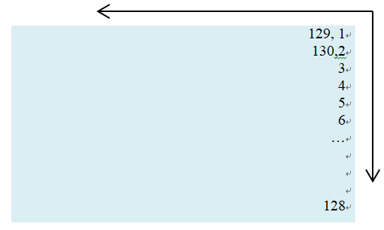

The display of the 2.9-inch electronic label is displayed from right to left and from top to bottom.

The resolution of the 2.9-inch electronic tag is 296*128, which is equivalent to 37888 pixels. Each pixel adopts two-color display, corresponding to binary 0 and 1, where 1 indicates that the pixel is displayed in white and 0 indicates black display. If byte encoding is used, it is equivalent to 1 byte and can represent 8 pixels. That is, it can be represented by 37888/8=4736 bytes.

When the cloud initiates an image update to an electronic tag, it needs to send 4736 bytes. Because JSON encoding is used, hexadecimal bytes need to be represented by ASCII, so 1 byte corresponds to 2 ASCII, which is equivalent to a picture corresponding to 4736*2 ASCII characters. The following examples illustrate:

Picture Example：



1) The top rightmost column (upper right corner) shows 3 black dots;

2) The bottom right column shows 1 black dot (lower right corner);

3) One black dot is displayed at the top of the second column from right to left.

The corresponding code is as follows:

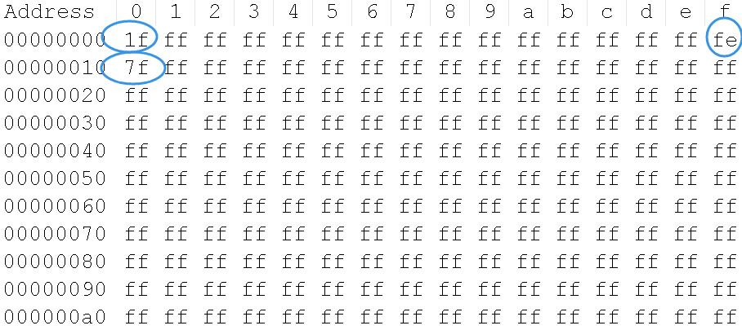

For 2.9 inch two color ESL, one column need 16 bytes code(128 pixels).

The first column:

* The first byte was 0x1f: Corresponding binary digit: 0001 1111, that is, the first 3 pixels are 000, which is black.
* The last byte was 0xfe: Corresponding binary digit: 1111 1110, that is, the last dot is displayed in black.

The second column:

* The first byte was 7f: Corresponding binary digit: 0111 1111, that is, the first byte is black.

All the pixels next are displayed in white, which is 0xff.

# Appendix

1. We also attach a file "example.bmp" file in the attachment directory, and we also provide the mqtt message that include image content (example.bmp.json).

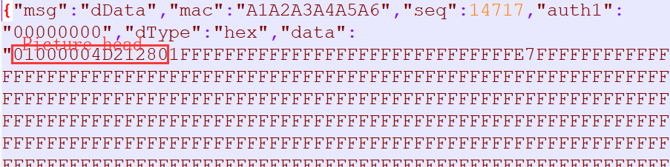

2. We also attach a file “example.bmpz.json” in the same directory. This file was compression encoding. You can see that the file size is very small. We recommend using compressing encoding json message for 2.9inch two color ESL when sending picture to ESL.