Introduction:

The basic idea of our project was to recreate the classic game pong for 2 players which also displays the score for each of the players.

Communication:

As the main task was to get two Arduinos to communicate with each other we decided that it would be best for one Arduino to act as a controller for both players and the other receives the inputs and processes it to the computer.

The first Arduino (controller) receives the input from the potentiometers and concatenates them into a string and prints it to the serial monitor. Then the second Arduino reads the serial monitor and sends it to the program called Processing, which runs the game in a separate window.

To communicate with the Arduinos, we have wired the TX to RX for both Arduinos on pin 0 and 1 as shown by the green wires in the figure below. These transmit and receive data to be interpreted by the Arduinos.

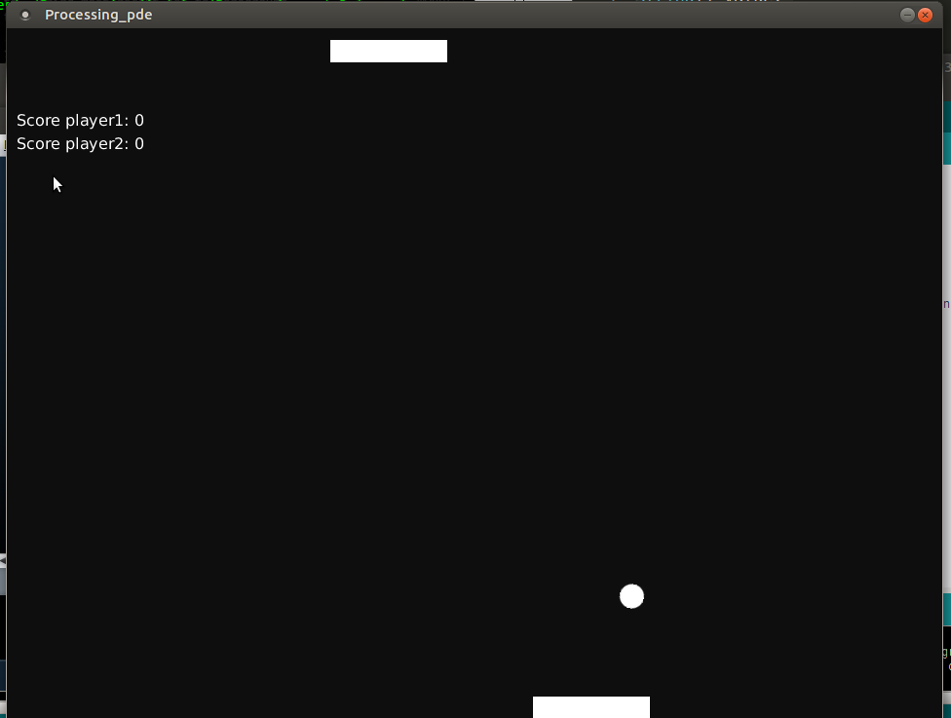

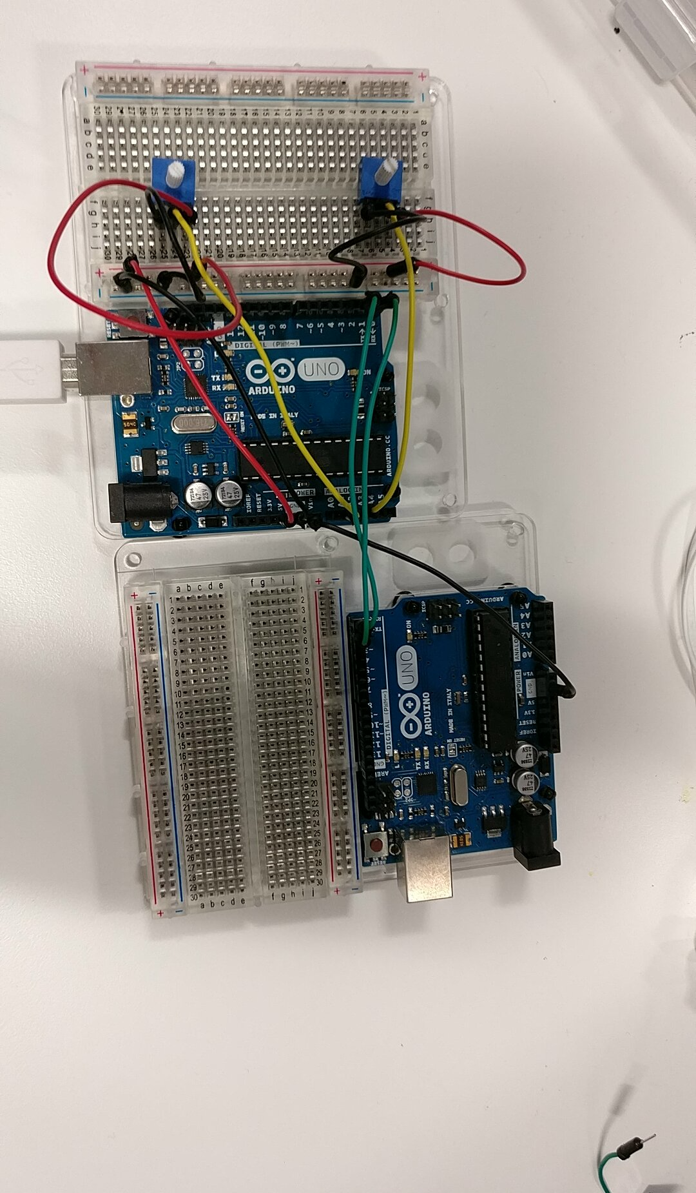

Power – red wires

Connecting to Pin – yellow wires

Connecting to Arduino – green wires

Ground - Black wires

Components:

Potentiometer: The potentiometers used act as joysticks for either player, where the code reads the position of both potentiometers, as a result, the processing program changes the positions of the player blocks.

Also to run the game the user must have installed the program called Processing which reads the values given by the Arduino and changes player positions accordingly.

Improvements:

A significant improvement to this task would be to make the controller Arduino wireless, by either a Bluetooth or WiFi shield with would communicate to the other Arduino. This would improve the look and practicality of the game as both players do not have to be so close to the other Arduino.

Conclusion:

I think the game is very well made as it allows two players to play a game of pong quite well but it would be much better if a wireless controller was implemented

Authors:

Atul Anand

Rizwan Ebrahim