**History of Mobile Internet & the Growth of 5G Technology**

* What is 5G and How it works?

Nowadays the use of data in our mobile devices is something usual, but in the past it was different. **5G -** is the fifth-generation technology for mobile broadband cellular networks. It is a wireless technology that is meant to deliver ultra-fast GBPS speeds, no latency, more reliability than the 4G networks, which means higher performance and improved efficiency to empower new user experiences and connect more industries around the world. 5G networks are built on super-high frequency airwaves which means the higher frequencies can transmit can lead to more data, and much faster than on 4G network. According to Prasad the develop of communications between 1G to 5G it is making people forget how difficult was for the human to send one message through the radiofrequency. However, today telecommunications are allowing to share data faster and with low latency. Furthermore, the fifth generation of telecommunications (5G) are being developed to change the social environment (Prasad, 2016). 5G Technology stands for 5th Generation Mobile technology and was announced in July 2016. 5G technology has changed the means to use cell phones within very high bandwidth. User never experienced ever before such a high value technology. 5G is based on OFDM (Orthogonal frequency-division multiplexing) and uses wider bandwidth technologies such as sub-6 GHz and 6mmWave (Qualcomm,2016). The 5G technology include all type of advanced features which makes 5G technology most powerful and in huge demand in near future. According to Qualcomm, 5G is designed to connect virtually everyone and everything together including machines, objects, and devices. The purpose of 5G wireless technology is to deliver higher multi-Gbps peak data speeds, ultra-low latency, higher reliability, massive network capacity, increased availability, and more consistent user experience to more users. Higher performance and improved efficiency enhance new user experiences and connect new industries. 5G is expected to deliver mobile broadband services that are 20 times faster than the existing 4G. Compared to 4G but can also be extended to new service areas such as mission-critical communications and the connection of a massive IoT.

* **History and Development Stage of Mobile Data**

With this new technology that we have in our world today, the smartphone is on the move with providing people with other ways to communicate with each other. Nowadays, people from everywhere will talking or texting or seeing them watching the app or seeing them watching videos with the mobile phones. To do all these stuffs, mobile internet is required, and it is the main thing since May 2001 with the announcement of 3G internet. People can start using mobile internet starts from the third generation of the internet (3G) and now the fifth generation (5G) is the most popular. There are five generation of mobile data. These are 1G, 2G, 3G, 4G also known as LTE and currently 5G. According to Rodriguez, 1G and 2G networks were announced in 1993 and in 1G was based on FM (frequency mode) and 2G could sent text messages, voicemails, and more secured phone calls (Rodriguez, 2015). The third generation (3G) was announced in the year of 2000 and 3G networks started to fill the need of data and high-speed internet in mobile devices. 3G reached in favorable conditions a rate of 2Mbps. This characteristic permit to transmit video and voice over data (Prasad, 2016). 4G was announced in 2013 with 20Mbps data speed and currently using around the world (Prasad, 2016). Finally, 5G was announced on 3rd April 2019 and currently 5G is available in some countries such as some areas of South Korea, United States and Union Kingdom, meanwhile China is setting up this service in 50 cities such as Beijing and Shanghai (BBC,2019). Wall states that, with 5G, it is aiming to provide a pace of uploading and downloading vast volumes of data between 10 and 20 times faster than 4G, enabling users to connect to more devices at the same time (Wall, 2018). Connections in 5G are also more reliable with a latency of less than 1ms and devices capable of managing power, and the services of this technology would also be cheaper than other technologies (Prasad, 2016). 5G is rarely available in some countries but the workforce of the 5G will be next level and it will change the living standard of people. Currently, only the minority people use smart home but most of them cannot use smart home system mostly of lack of data connections. As the growth of 5G, those problem will be solved in coming years and in the future. In the Gartner Hype Cycle for Emerging Technologies (2019), 5G placed at the highest of the curve graph. According to the graph (2019), people except that 5G can be use more widely in coming 2 or 3 years but in 2020 5G started to use in some Asian and Europe countries. According to (Gosh, I.,2020), 5G will come to the world with 1.8 billion 5G connection by the end of 2024 and the beginning of 2025.

* **Advantages of using 5G**
  + High speed, high capacity, and low cost per bit.
  + Support interactive multimedia, voice, streaming video, Internet, and other broadband services, more effective and more attractive, Bidirectional, accurate traffic statistics.
  + Global access, service portability, and scalable mobile services.
  + The high-quality services of 5G technology based on Policy to avoid error.
  + 5G technology is providing large broadcasting of data in Gigabit which supporting almost 65,000 connections.
  + 5G technology offer transporter class gateway with unparalleled consistency.
  + Through remote management offered by 5G technology a user can get better and fast solution.
  + By using of 5G technology, self-driving cars will use widely in the future.
* **Disadvantages of using 5G**
  + 5G does not work on every mobile phones.
  + Developing infrastructure needs high cost.
  + Uneven coverage.
  + Replaces battery capacity for speed.
  + Few will have access to the really fast 5G.
  + 5G works depends on the area of the wavelengths with the users.
  + Battery drains on mobile phones.
  + Initial costs for rollout are high.
  + Upload speeds and download speeds does not match.
  + Security and privacy issue yet to be solved.

**Figure of Gartner Hyper Cycle for Emerging Technologies 2019**

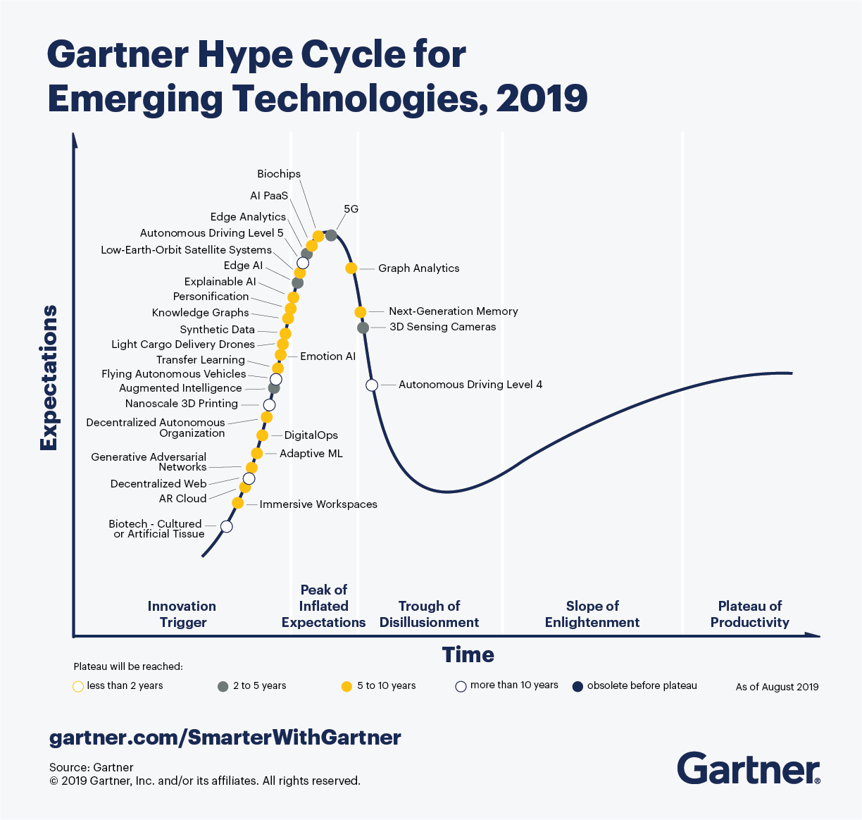

**SWOT Analysis of 5G Technology**

**Strengths**

Speed improvements. Speed in transmissions can approach 15 or 20 Gbps. By being able to enjoy a higher speed we can access files, programs, and remote applications in a totally direct and without waiting. By intensifying the use of the cloud, all devices (mobile phones, computers, etc.) will depend less on the internal memory and on the accumulation of data and it will not be necessary to install many processors on some objects because computing can be done on the Cloud. Looking at speeds of 10Gbps it is unheard of, these speeds actualize Realtime streaming in milliseconds. There will be no need for internet users to download content that can be easily located online. There will be reduced cost in purchasing storage capacities like hard drive when the cloud drives will also be innovated to hold more content. The speed also complements storage where items will be accessible by the clicking onto it. For example, being able to activate software remotely as if it were executed in personal devices, will allow not having installed the mobile applications (APPs) in the terminal and executing them directly from the cloud. Just as it will no longer be necessary to store the information in the memory of the device (photos, videos, etc.).

Role improvement. According to "AT&T and Deloitte to explore the future of learning with 5G – Press release," (2019), the 5G technology does not have limits on what it is capable of handling. When we imagine a surgeon performing surgery to a patient in the US it can only be comprehensible through the limit of our imagination. The same creativity and exploitation of features will fine tune the robotic industry that has stagnated for a long period. Robotics have been in development for a long time but, their inefficiency has led to people doing a lot of critical activities that cannot be entrusted to a robot (Liu, 2016). However, looking at open heart surgery which entails a matter of life and death, it shows how the 5G connection is determined to revolutionize every aspect of human life.

**Lower latency**

Latency is the time that elapses since we give an order on our device until the action occurs. In 5G the latency will be ten times less than in 4G, being able to perform remote actions in real time.

Thanks to this low latency and the increase of the sensors, it is possible to control the machinery of an industrial plant, control logistics or remote transport, surgical operations in which the doctor can intervene a patient who is at another side of the world with the help of precision instrumentation managed remotely or the complete control of remote transport systems, automated and without driver.

**Greater number of connected devices**

With 5G the number of devices that can be connected to the network increases greatly, it will go to millionaire scale per square kilometer.

All connected devices will have access to instant connections to the internet, which in real time will exchange information with each other. This will favor the IOT.

It is anticipated that a common home will have a hundred connected devices sending and receiving information in real time. If we think of industrial plants, we will speak of thousands of connected devices.

This greater number of connected devices will allow the smart cities and the autonomous car.

For example, by placing sensors in different points and objects in the city, a large part of it can be monitored. If you share the information of the sensors of the cars and those of the city, and these exchange data you can improve the quality of life of the cities, facilitate the navigation of the autonomous car (choose better routes, reduce the number of accidents, find available parking spaces, etc.)

**Network slicing**

The 5G also allows to implement virtual networks (network slicing), create subnets, in order to provide connectivity more adjusted to specific needs.

The creation of subnetworks will give specific characteristics to a part of the network, being a programmable network and will allow to prioritize connections, as could be the emergencies in front of other users, applying for example different latencies or prioritizing them in the connection to the network so that they cannot be affected by possible overloads of the mobile network.

**Weaknesses**

Threat of a stable 4G connection equals the minimum requirements for the 5G connection. Looking at this aspect, it is highly unlikely for users with stable 4G connection to upgrade when the difference is minimal. For normal hone users, it will take time to upgrade when there is no major reason to make an upgrade.

**1. OBSTRUCTIONS CAN IMPACT CONNECTIVITY**  
The range of 5G connectivity is not great as the frequency waves are only able to travel a short distance. Added to this setback is the fact that 5G frequency is interrupted by physical obstructions such as trees, towers, walls and buildings. The obtrusions will either block, disrupt or absorb the high-frequency signals. To counter this setback, the telecom industry is extending existing cell towers to increase the broadcast distance.

**2. INITIAL COSTS FOR ROLLOUT ARE HIGH**  
The costs related to the development of 5G infrastructure or adaptations to existing cellular infrastructure will be high. This amount will be further compounded by the ongoing maintenance costs needed to ensure the high-speed connectivity, and it is likely the customers will bear the brunt of these big price tags. Cellular operators are looking to minimize these costs by exploring alternative options in the form of network sharing.

**3. LIMITATIONS OF RURAL ACCESS**  
While 5G might bring about real connectivity for the predominantly urban areas, those living in the rural settings will not necessarily benefit from the connection. As it stands, many remote areas countrywide are not able to access any form of cellular connectivity. The 5G carriers are going to target big cities with larger populations, eventually working their way into the outer areas, but it is not likely this will be happening any time soon. As a result, only some of the population will benefit from 5G communication.

**4. BATTERY DRAIN ON SMARTDEVICES**  
When it comes to cellular devices connected to 5G, it seems the batteries are not able to operate for a significant period of time. The battery technology needs to advance to allow for this enhanced connectivity, where a single charge will power a cellphone for a full day. Alongside depleted batteries, users are reporting that cellphones are getting increasingly hot when operating on 5G.

**5. UPLOAD SPEEDS DON’T MATCH DOWNLOAD SPEEDS**  
The download speeds of 5G technology are incredibly high, in some cases up to 1.9Gbps. However, the upload speeds are rarely more than 100Mbps, which is not quite as incredible as initially touted. In relation to existing mobile connectivity, however, the upload speeds are higher than being seen with 4G LTE.

**6. DETRACTING FROM THE AESTHETICS**  
The erection of more cellphone towers, or extension of existing cellphone towers, is not welcomed by most communities because they are seen to diminish the overall look and feel of an area. With 5G, there is going to be a need for increased infrastructure development, which will not necessarily be seen as a good thing for local residents.

**Opportunities**

Chances of IT firms adopting he 5G technology. The 5G network has been projected for a long period and the major IT firms are anxious to implement it into their firms. When we look at the expectations of 5G network, it will take the will and cooperation between the IT firms and the engineering sector to actualize many technological concepts.

Also, 5G technology will be able to achieve significantly greater performance standards than previous generations. Under optimal conditions, it will offer

* a download speed of up to 20 gigabits (Gb) per second, 200 times faster than with current 4G technology.
* latency (time delay required to transmit data from the source to the destination) of less than one millisecond, whereas the standard for 4G technology is 50 milliseconds: and
* a much higher connection density, from a standard of 2,000 devices per km2 to one million devices per km2.

This greater performance will accelerate the development of several new and existing technologies, including the Internet of Things (IoT) – devices (such as appliances) that can transmit data over the Internet.

Among other things, 5G technology will allow networks to be sliced, meaning that the same physical infrastructure can host several logical networks. As a result, an Internet service provider could provide various services with different performance characteristics (e. g., download speed, latency or download usage limits) on the same physical network to meet a particular need. However, network slicing may not be fully compatible with the current principle of net neutrality, and the federal government may need to determine whether this is consistent with the relevant legislation.

The deployment of 5G technology could provide significant economic benefits in Canada and elsewhere. For example, according to an analysis prepared by Accenture, 5G technology could contribute, by 2026, to the creation of 250,000 permanent jobs and an annual increase in Canada’s gross domestic product of nearly $40 billion. However, according to the Organization for Economic Co-operation and Development, the extent of the benefits resulting from 5G technology will depend on how quickly it is deployed and adopted, as well as the ability of the regulatory environment to adapt.

**Threats**

Lack of capital. There are few companies willing to invest in the development and actualization of 5G technology. When we say that the 5G network will enable surgeons to perform surgeries from the comfort of their homes, it does not mean that the hospitals are ready to chip in and fund such projects. Like any other projects, the developers will need to develop prototypes that can be used to demonstrate the networks capacity and how it suits a given venture (Liu, 2016). Therefore, the lack of funding from cooperation will further delay the projected impact of 5G usage.

**Public health**

5G technology raises certain public health concerns. The health effects of radiofrequency (RF) radiation have been the subject of numerous studies, with mixed results. However, there is little data on the impact of 5G technology in the specific case of individuals who may be exposed to a higher concentration of RF energy due to the greater number of antennas that will be used. In a publication on RF energy and safety, the Government of Canada states that devices equipped with 5G technology will use frequency ranges already covered by Canadian limits and will have to meet RF energy exposure requirements.

In Canada, RF energy is managed and regulated. In addition, Health Canada has set guidelines for exposure to this type of energy. Safety Code 6 is based on Health Canada’s research and published scientific studies. This code was last revised in 2014. For its part, ISED regulates wireless and related infrastructure and requires it to comply with the limits set out in Safety Code 6. ISED also runs several programs to inspect antenna installations to ensure that they meet requirements.

Consequently, 5G technology will have improved security features that will be enhanced through the high speeds experienced by the 5 G connection. This will be advancing and upgrading the components utilized by the 4G network. As stated in the paper, a stable 4G network is equal to the minimum 5G connection (McCann, 2020). What this means is that the 4G is paving the way for 5G and there will be minor upgrades from the systems such as the receivers that already have large capacities and have never been fully exploited.

**Current uses and applications of 5G**

5G is not only a developmental overhaul of the past age of the cell, yet it is a progressive innovation imagined that will wipe out the limits of access, data transfer capacity, execution, and idleness constraints on availability around the world. 5G can possibly empower in a general sense new application, enterprises, and plans of action and significantly improve personal satisfaction around the globe through extraordinary use cases that require high information rate momentary interchanges, low idleness, and enormous network for new applications for portable, eHealth, independent vehicles, savvy urban communities, shrewd homes. Today, there is a great deal of information and publicity about 5G. As thought pioneers in this industry, we routinely share information about improvements in the organization of 5G, and what you can expect, especially in the event that you are engaged with the business and mechanical IoT space. Contrasted with the purchaser space, business 5G is voyaging a particularly extraordinary yet simultaneous way.

Life will change with 5G and the foreseen applications it will empower, yet not pervasively. There will be a developing separation of organization network and administrations among metropolitan and provincial zones since it is unfeasible to convey 5G wherever immediately.

The essential thought behind 5G is a solitary organization that is sufficiently adaptable to deal with a wide range of utilization cases. To convey the guarantee of 5G, versatile organization administrators (MNOs) need to construct a thick organization with a gigantic measure of organization hubs that will frame the 5G framework.

Modern robotization is being used today, and probably you have seen recordings indicating synchronized advanced mechanics at work in industrial facilities and store network applications. Today these applications require links, as Wi-Fi does not give the reach, portability and nature of administration needed for modern control, and the dormancy of the present cell innovation is excessively high. With 5G, modern mechanization applications can cut the rope and go completely remote, empowering more effective shrewd plants. As expressed by the 5G ACIA, "Industry 4.0 coordinates the IoT and related administrations in modern assembling and conveys consistent vertical and even mix down the whole worth chain and across all layers of the computerization pyramid. Availability is a vital part of Industry 4.0 and will uphold the continuous improvements by giving incredible and inescapable network between machines, individuals and articles."

* **ESPORTS Gaming -** with the rise of ESPORTS around the world gaming nowadays is a full-time professional career for many individuals which means to stream the games, gamers need to have a faster and reliable internet connection which can lead to a smoother experience for the gamers as well the quality or resolution can now be upscaled to 8k resolution.
* **Broadband-Like Mobile Service -** everyone has a smartphone device so that they can be connected to the virtual world, but most devices are still not 5G ready, but some devices like APPLE's new iPhone 12 which is 5G ready can now fully take advantage of the selected 5G networks across the United States which would the user interface and content viewing more smoothly.
* **Unleashing AI, its Artificial Intelligence -** since AI is dependent on internet connectivity e-commerce platforms have been using AI in the past few years in their warehouses for organizing and sorting the items, having 5G will fully integrate their warehouses such as Amazon who has robot sorting tools the 5G can make their warehouses full equipped with the AI so that it will eliminate the human error in organizing and sorting of the items that needed to be shipped immediately to the customers.
* **Military -**since the warfare has turned to who has the best technology and equipment having the 5G network in military operations will soon remove the human casualty on the battlefield and can help save the lives of our soldiers who are always risking their lives in the field.
* **Healthcare -**the 5G networks speed can help monitor and track individuals who carry diseases especially with the covid-19 contact tracing can now be done virtually because of the speed that 5G can provide to the healthcare workers and hospitals.

current maturity and future predictions for the 5G

Telecom operators are currently busy with the introduction of 4G technologies, either 802.16 m LTE-advanced or WIMAX. This 4G technology will be finalized in two years' time. 5G infrastructure has not yet standardized, the 5G specification is likely to be established in two to three years, and its rollout has only begun in certain areas around 2020. In the future, users would demand internet access of the same standard as the computer is capable of. All sorts of innovative features will be included with this technology, which makes 5G technology more powerful. In the 5G mobile network, the key things we plan to incorporate are that users can connect to and switch from different wireless technologies at the same time. IPv6 and flat IP must be enabled by future mobile technologies. The average citizen can experience 5G mainly through apps such as gaming that are data intensive. Also, in crowded areas such as sports stadiums, communications would become faster, with lower latency and more stable operation. 5G makes the possibility of fixed broadband access for people living in places without fiber connectivity to build fast internet in the home. 5G is a beast that is very different and strong. It has the potential to be massive and have a huge effect on our lives for the better. But if with politics, rules, and high spectrum prices, we overcomplicate the roll out of 5G, we will eventually ruin it.

On the current maturity and future predictions for the 5G networks, it is expected that 5G will offer mobile internet speed of more than 10 gigabits per second, and this is approximately a hundred times faster than 4G as 5G can send and also receive signals almost simultaneously and in the future after the launch of 5G the next generation is likely to bring up the 6G, with the application with even higher throughput requirements.

**Explanation:**

The advent of the 5G wireless standards have a widespread influence on global commerce by opening an untold number of innovative business-to-business application and this is because of the technology's ability to provide better latency and also increased throughput. The private networks will also represent an enormous new market for the 5G. Reduction of the cost is one of the most important hurdles to ensure rollouts do not slow down due to the investments while 5G is less expensive per bit than 4G, further refinements are also required to enable cost improvements. including smarter integration, and also spectrum availability at a reasonable price.

In conclusion, telecommunication has been developing fast in the last decades, starting with only voice calls in 1G networks to finally reach 5G allowing high speeds of data interchange and low latency. The fifth generation of telecommunications networks successfully accomplish various innovations such as HetNet Deployment, Cloud Ram, Device to device communications, Multi-Rat, MIMO and Simultaneous transmission and reception. These innovations are being applied in autopiloted cars, smart homes, and augmented reality.5G is impacting the society allowing to connect more habitants from rural areas to internet, changing people activity habits encouraging them to do physical exercise and moreover changing the economies and political influences of countries. However, everything has not been done yet, technology is continuously changing and improving. The future is still uncertain but today researchers are working in 6G. According to Weedon the sixth generation of telecommunication would be 8000 times faster than today technologies and will probably launch by 2030. It has to be considered that improvements in hardware architecture and material science is necessary to meet in order to release 6G (Weedon ,2019). Also, self-driving cars are start to popular and also Tesla has been announced autopilot since April of 2019. In coming 2021, with the help of 5G mobile technology, self-driving cars will use around the world and people will get hype using technology and will get big changes for the future.

**Reference List**

* *AT&T and Deloitte to explore the future of learning with 5G – Press release*. (2019, December 18). Deloitte United States. <https://www2.deloitte.com/us/en/pages/about-deloitte/articles/press-releases/att-and-deloitte-to-explore-the-future-of-learning-with-5g.html>
* Autopilot. (n.d.). Retrieved January 18, 2021, from <https://www.tesla.com/autopilot>
* China Rolls out one of world’s largest 5G networks (2019). Retrieved from <https://www.bbc.com/news/business-50258287>
* Ghosh, I. (2020, October 06). Visualizing the State of 5G Networks Worldwide. Retrieved January 17, 2021, from <https://www.visualcapitalist.com/visualizing-the-state-of-5g-networks-worldwide/#:~:text=By%202025%2C%20the%20world%20will,to%20usher%20in%205G%20adoption>.
* McCann, J. (2020, April 7). *5G: Everything you need to know*. TechRadar. <https://www.techradar.com/news/what-is-5g-everything-you-need-to-know>
* Prasad, R. (2016). 5G Outlook- Innovations and Applications. In (pp. 1-260).
* Rodriguez, J. (2015). Fundamentals of 5G mobile networks: West Sussex, United Kingdom: John Wiley & Sons Limited.
* Remy, P. (2019, November 29). Reaching 5G's "Plateau of Productivity" - Guavus - Go Decisively. Retrieved January 18, 2021, from https://www.guavus.com/reaching-5gs-plateau-of-productivity/
* Wall, M. (2018). What is 5G and what will it mean for you? Retrieved from <https://www.bbc.com/news/business-44871448>