1. **Test Cases:**
2. 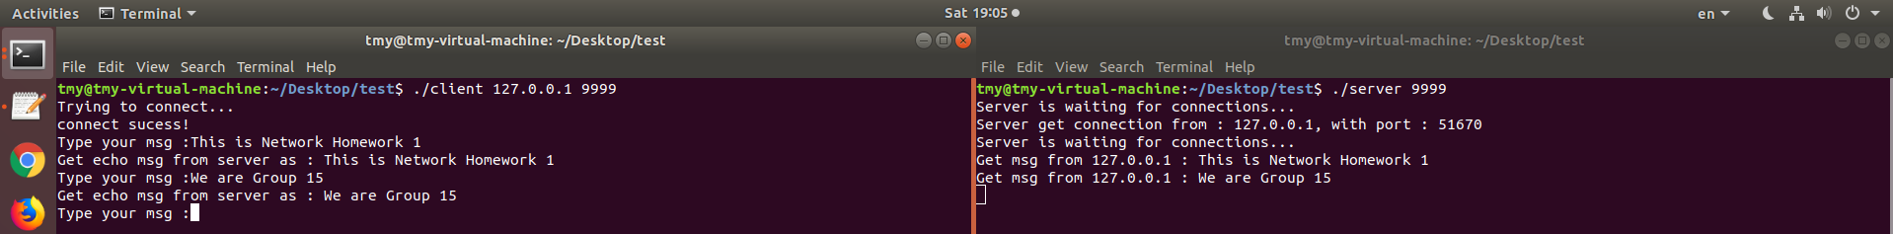Lind of text terminated by a newline.
3. Line of text the maximum line length without a newline.

* 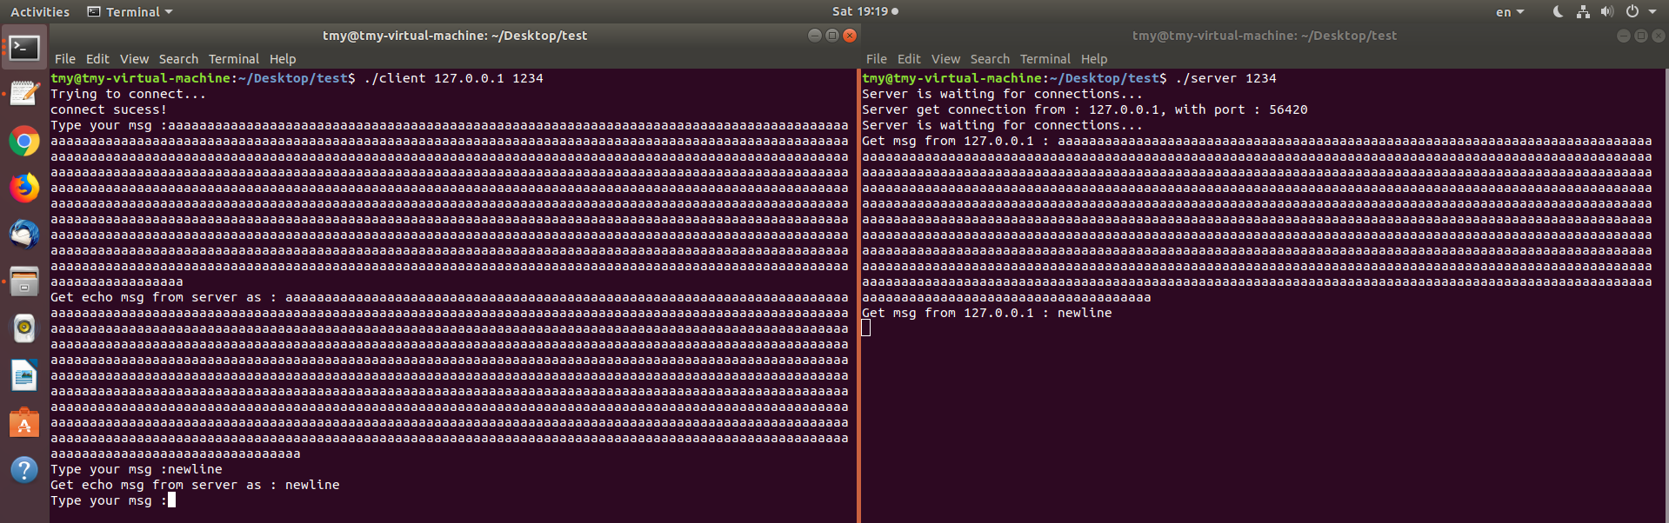We set our buffer as 1024 Bytes. After minus one byes of the null termination, “/0”, then the maximum line length without a newline is 1024 – 1 = 1023 Bytes. The result is show as figure below.

1. 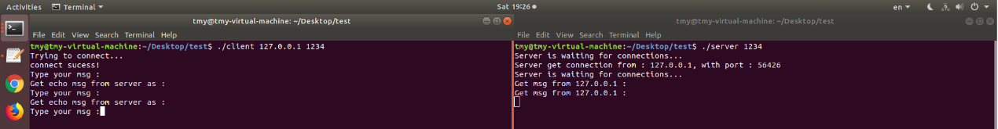Line with no characters and EOF.
2. 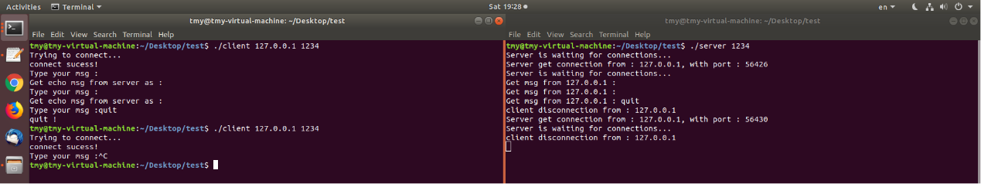Client terminated after entering text.
3. Three clients connected to the server.

* 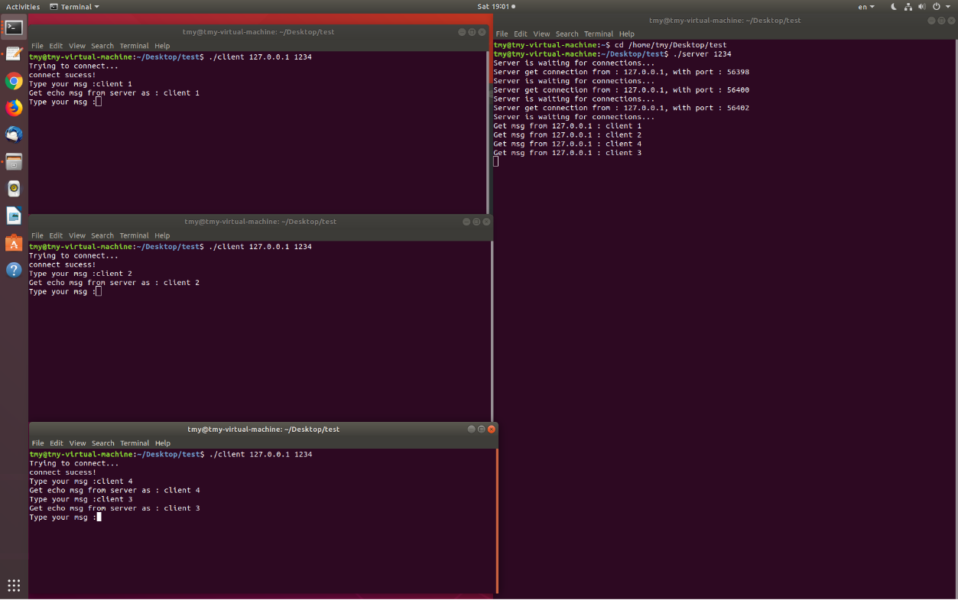For each client, we sent different messages to the server at the same connection, and the server could get the message from every client.

1. 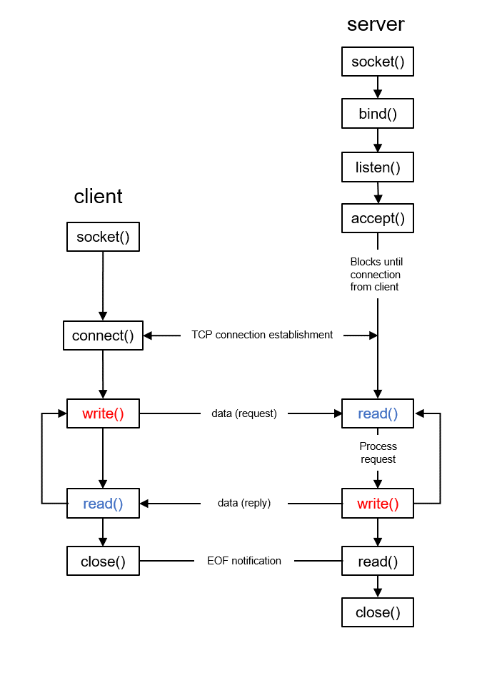**The architecture of our code:**

* The concept of supporting multiple simultaneous connections from clients by using fork():

1. 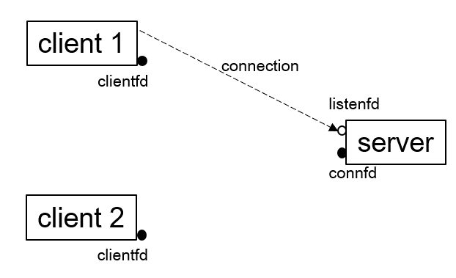First step is building connection from the first client.
2. Second step is using fork to duplicate the process of reading and writing from the server to become a child process.

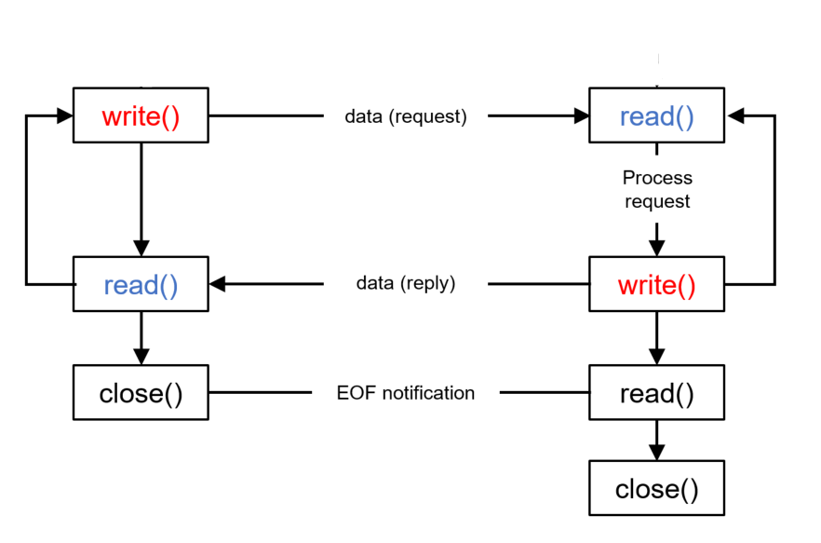Client 1 & child process:

Concept of fork():

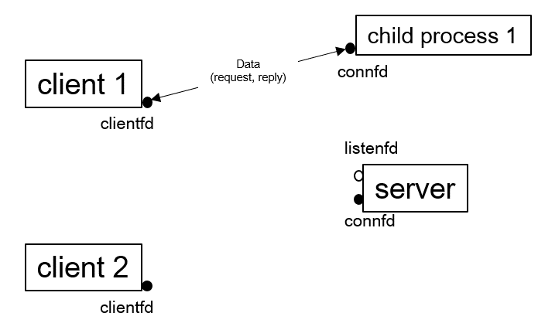

Afterward, the client 2 would follow the same steps as a) and b) to finish the connection and data transmission with the server.

1. **Usage:**
2. 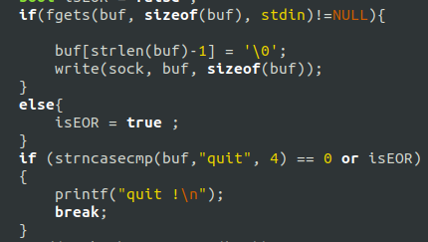We have handled the **writen()** and **readline()** at the client side.
3. 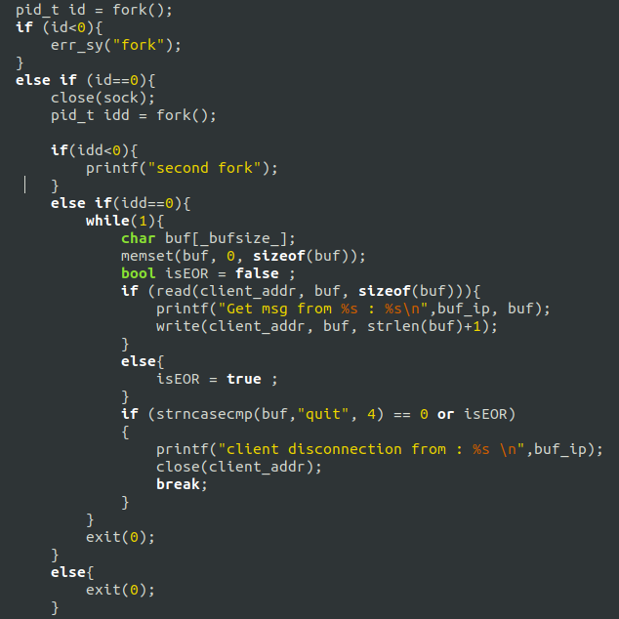**fork()** was used at the server side.
4. To disconnect the client and the server, just type a “quit” or use Ctrl + D to stop the connection.
5. **Error Handling:**
6. We set up some arguments for input from both server and client sides. While testing, if we did not enter enough arguments, then the system would show the error log to ask us to put the argument.

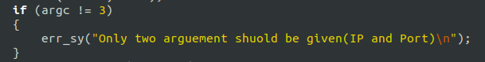

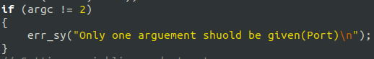

1. 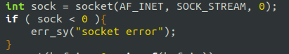At the both server and client sides, we have constructed a socket error check. If the socket was failed to be created, then the error log would show “socket error.”
2. At the server side, we have set bind error, listen error, client connection error, fork error.

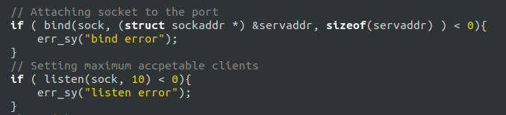

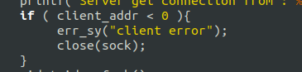



1. At the client side, we have set inet_pton error, connection error.

