Implement the logwatchdog daemon (never die…) program that will read / write the specific directory and its subdirectories.

(Writing a daemon in C (or daemonize a process) for absolute newbie: https://blog.abhi.host/blog/2010/03/09/writingdaemon-

in-c-or-daemonize/)

The SystemInfoIO program will do the following sequentially.

1. Make a temporary directory file starting with your account under “/tmp”.

2. Under the temporary directory file you just created, create a temporary file starting with “cse” .

3. Whenever a new user logs in the system, detect the login (use utmp(x) / wtmp) and write login user name and login time

to your temporary file (Use fread() / fwrite()).

4. Whenever the user logs out the system, detect the logout and then append logout time right after the history information

you wrote at step 3 to your temporary file (Use fread() / fwrite()).

5. Every time 30 seconds, your logwatchdog daemon will display the current history log data saved in your temporary file,

which was created at step 2 (Please try it. This is very interesting programming skills because the daemon process does

not have stdin, stdout, and stderr). If you cannot display the current history log data saved in your temporary file on the

monitor, you can use syslog and tail -f commands.

1. Submit your program source with detailed description (comments)









2. Put a screen shot of output generated by your program as here.

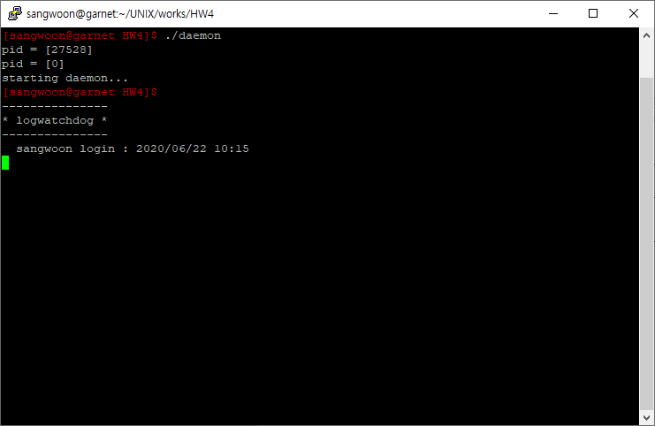

This is an initial start display of logwatchdog daemon. I’ve already logged-in with my account ‘sangwoon’.

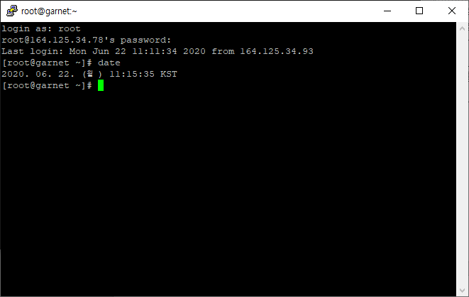

And then, I’ve logged-in with ‘root’ account.

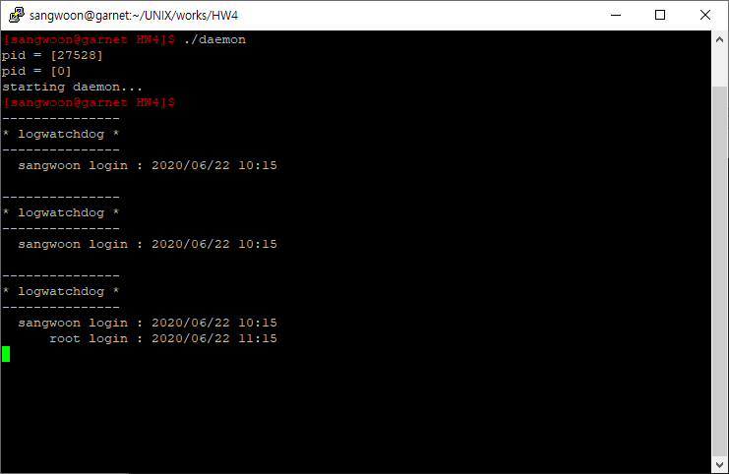

The logwatchdog daemon displays login information of ‘root’ account.

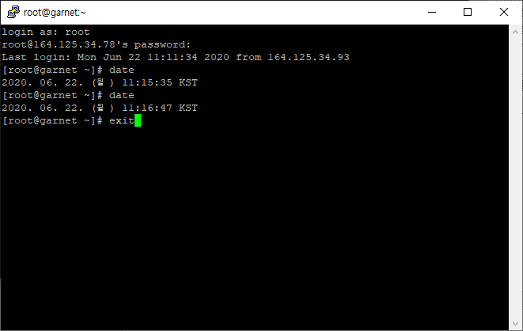

I’ve logged-off the ‘root’ account at 11:16.

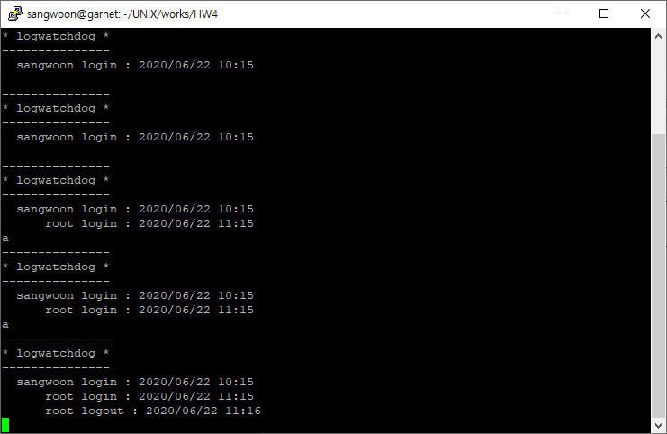

The logwatchdog daemon displays logoff information of root account correctly.

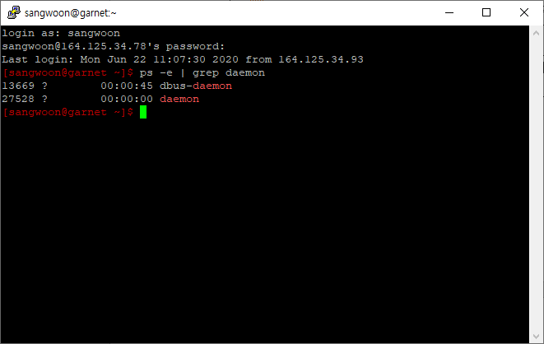

After that, I’ve logged-off ‘sangwoon’ account, and logged-in again with it. you can still check the logwatchdog daemon is running even if my account is logged-off. But automatical display was shutted down.

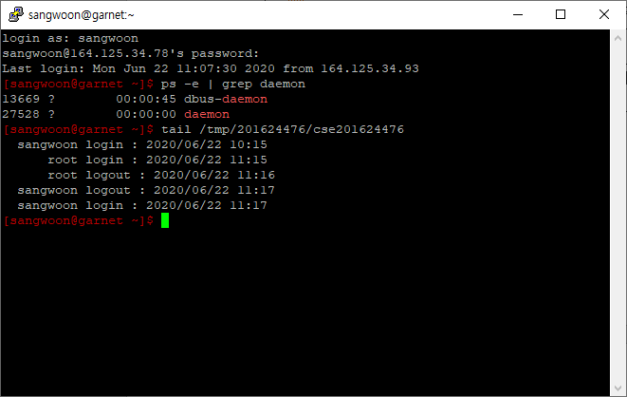

So I used ‘tail’ command to check the logwatchdog log file, and previous logwatchdog log and new login information is completely preserved in the log file.