Katie Kouril
Module 2.3 Assignment
CSD310 Database Development and Use
December 14, 2025
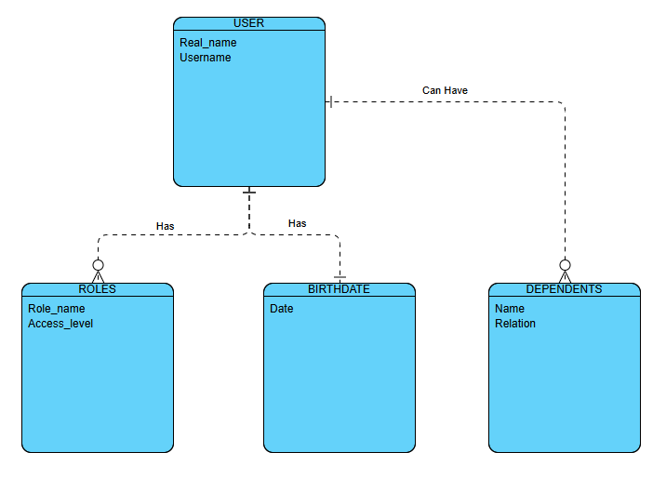

NoSQL Data Structure:
{
“Real_Name”: “Bob Smith”,
“Username”: “Bob1234”,
“Roles”: [
{
“Role_name": "CEO”,
“Access_level": "1”
},
{
“Role_name": "CFO”,
“Access_level": "3”
}
],
“Birthdate”: “12-30-1994”,
“Dependents”: [
{
“Name”: “Marie Smith”,
“Relation”: “Daughter”
}
]
}

