Konstantinos Kousounnis
Java-Application-PrivateSchool-Data-Management-System-Mysql
Documentation

Project Brief

Following PART A you need to implement the below functionality:
1. Design the ERD of your system and verify it through an online tool such as
https://sqldbm.com/ (it requires a free account) [15 marks]
2. Identify any other tables you need based on your implementation and
construct them [15 marks]
3. Make the schema of a database that can keep data for the main entities of
the assignment and name the tables as: Students, Trainers, Assignments,
Courses [15 marks]
4. Populate the tables of the database with enough data [10 marks]
5. You need to produce sql queries that output the following [19 marks in
total]:
• A list of all the students [2 marks]
• A list of all the trainers [2 marks]
• A list of all the assignments [2 marks]
• A list of all the courses [2 marks]
• All the students per course [2 marks]
• All the trainers per course [2 marks]
• All the assignments per course [2 marks]
• All the assignments per course per student [2 marks]
• A list of students that belong to more than one courses [3 marks]
6. You also need to produce a small project that [26 marks]
a. makes a connection to the database and executes the above sql
queries [9 marks]
b. makes a connection to the database and inserts input data from the
keyboard to the following tables,
i. students [2 marks]
ii. trainers [2 marks]
iii. assignments [2 marks]
iv. courses [2 marks]
v. students per course [3 marks]
vi. trainers per course [3 marks]
vii. assignments per student per course [3 marks]

Project - Documentation

Github:
https://github.com/kkousounnis/Java-Application-PrivateSchool-Data-Management-System-Mysql.git

1. Design the ERD of your system and verify it through an online tool such as
https://sqldbm.com/ (it requires a free account) [15 marks]
2.Identify any other tables you need based on your implementation and
construct them [15 marks]
3. Make the schema of a database that can keep data for the main entities of
the assignment and name the tables as: Students, Trainers, Assignments,
Courses [15 marks]
4. Populate the tables of the database with enough data [10 marks]

Fist Thought Design:

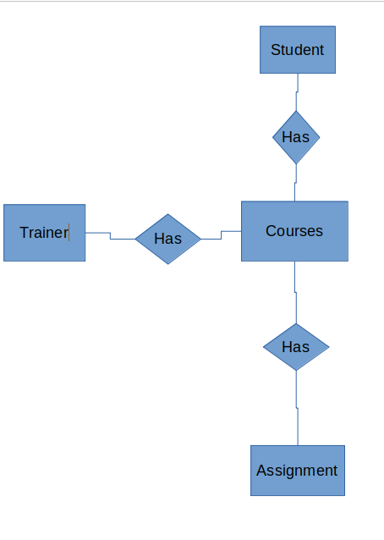
Student Has Courses.
Trainer Has Courses.
Assignment Has Courses.

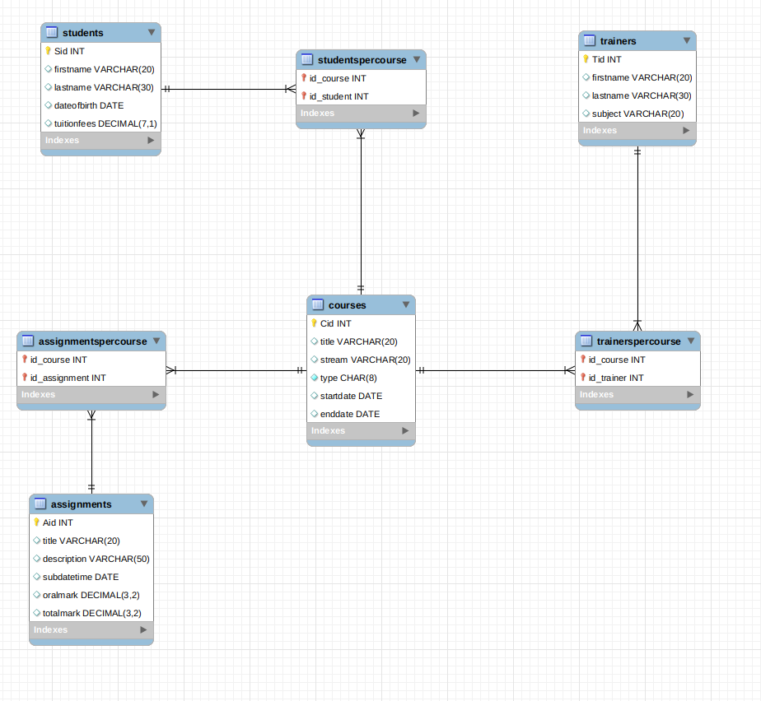
Complete project

The extra tables that we need are students_per_course, trainers_per_course, assignments_per_course.

We need these tables in order to achieve the rules of normalization in our database.

As a result in our database we have the following rules.
- We don’t have loss of information.
- We don’t have information redundancy and our tables have been split exactly in the point where we don’t have data repition and all data are unique.
- Maintaining dependencies all tables are interconnected.

Erd Verification through an online tool.

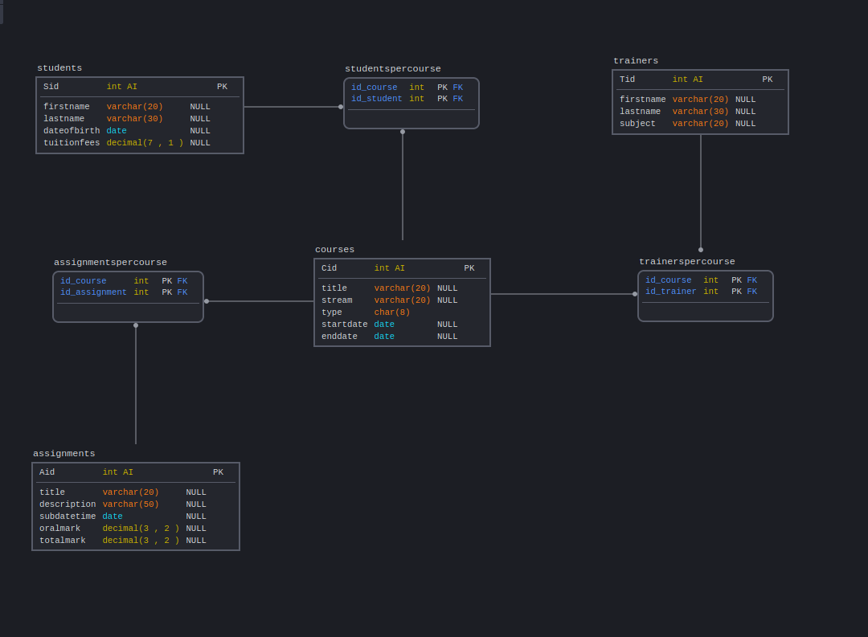
Erd diagramm succesfully created.

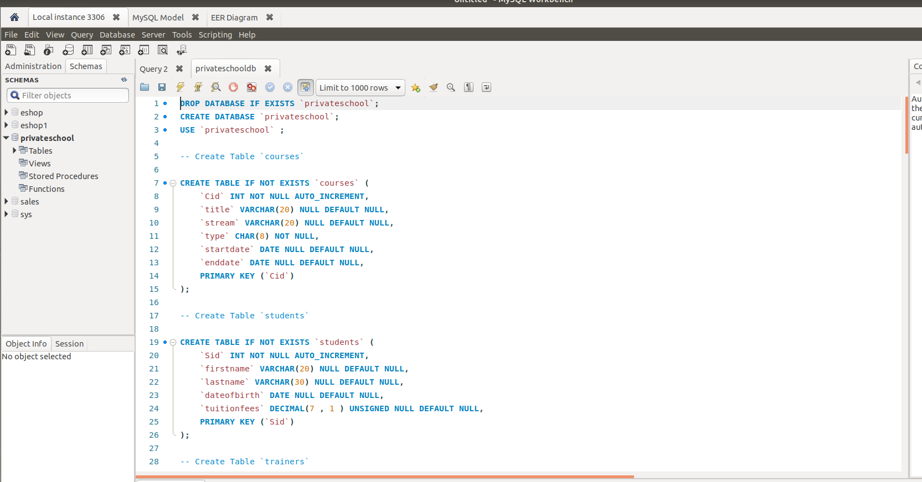
Privateschooldb.sql is the file which has the source code of the database and populates the database with enough data.
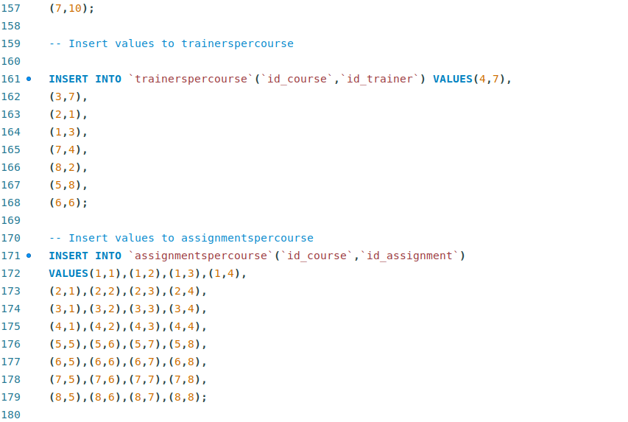

5. You need to produce sql queries that output the following [19 marks in
total]:
• A list of all the students [2 marks]
• A list of all the trainers [2 marks]
• A list of all the assignments [2 marks]
• A list of all the courses [2 marks]
• All the students per course [2 marks]
• All the trainers per course [2 marks]
• All the assignments per course [2 marks]
• All the assignments per course per student [2 marks]
• A list of students that belong to more than one courses [3 marks]

A list of all the students [2 marks]

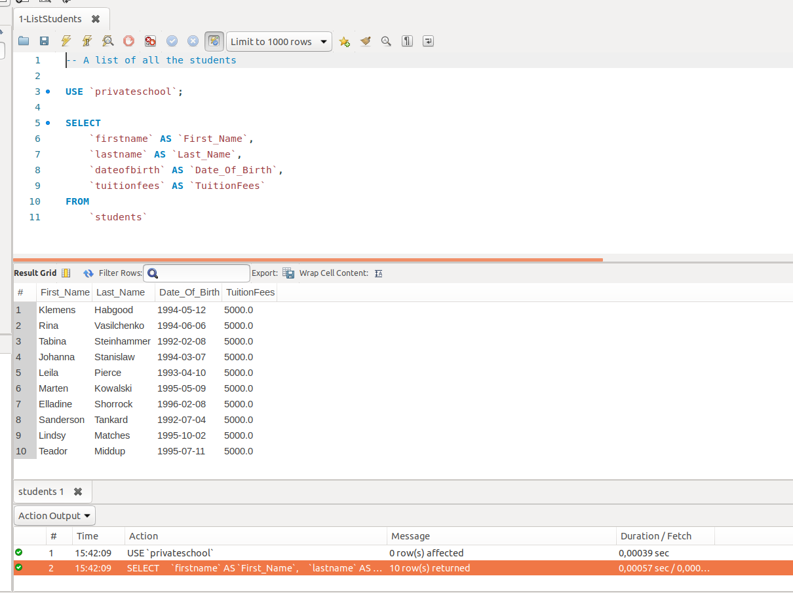

A list of all the trainers [2 marks]

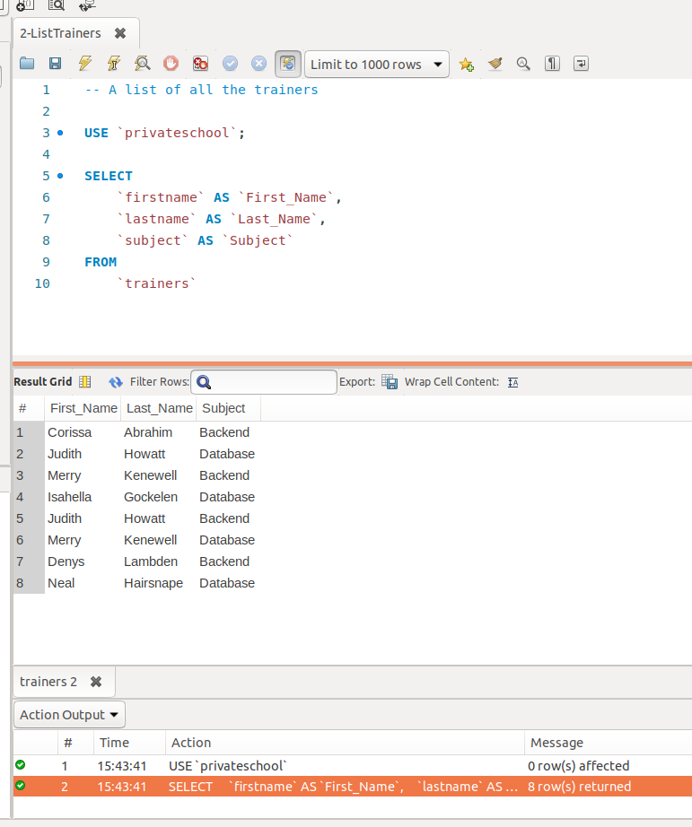

A list of all the assignments [2 marks]

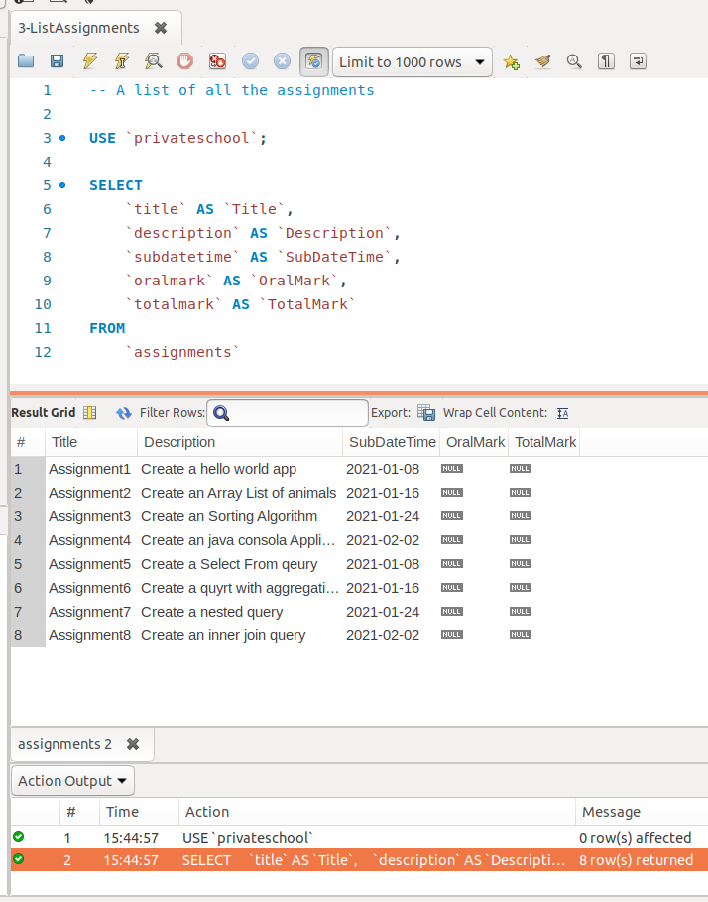

A list of all the courses [2 marks]

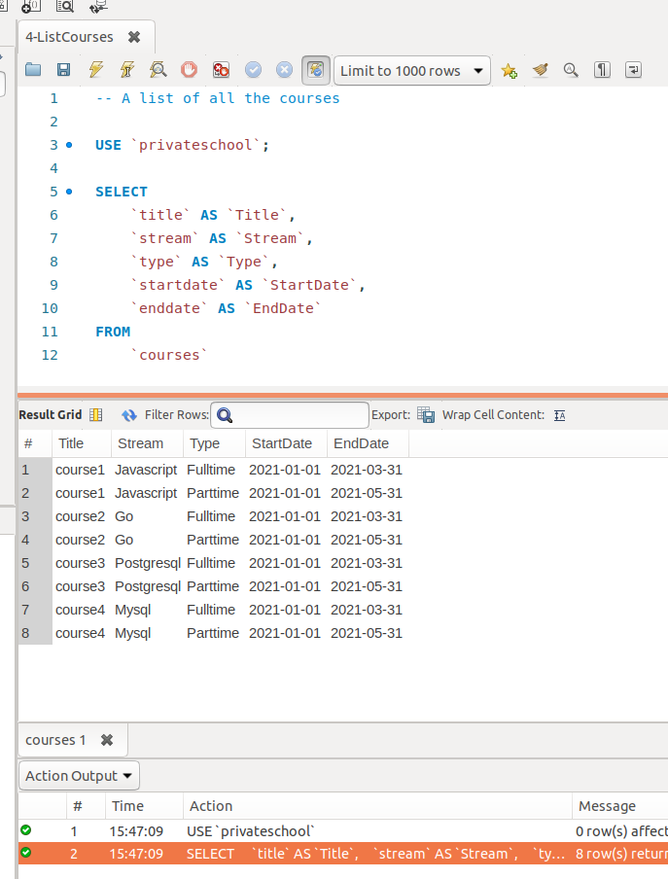

All the students per course [2 marks]
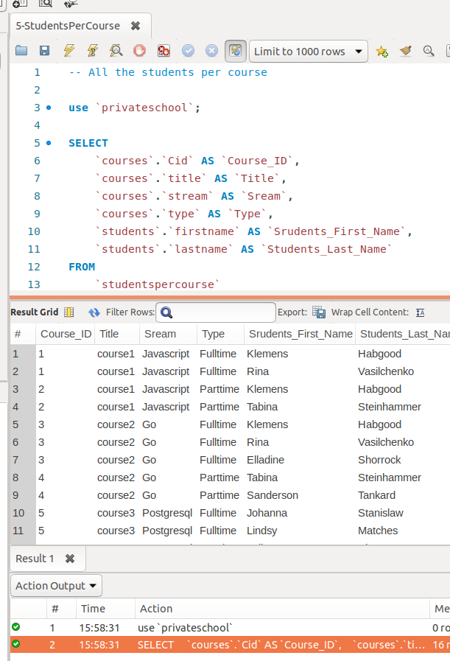

All the trainers per course [2 marks]

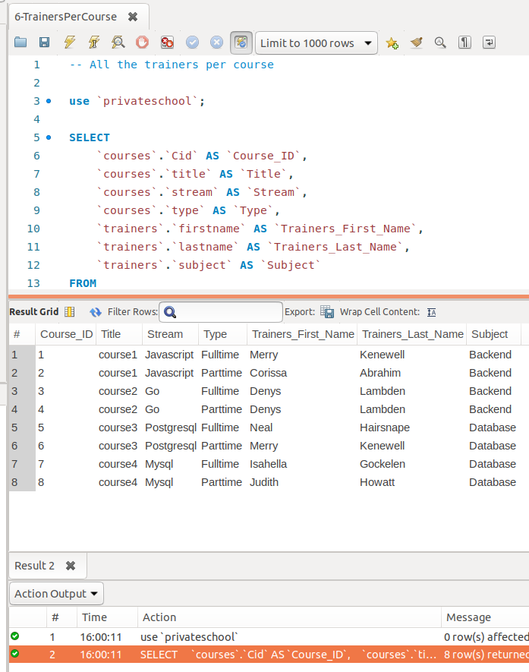

All the assignments per course [2 marks]

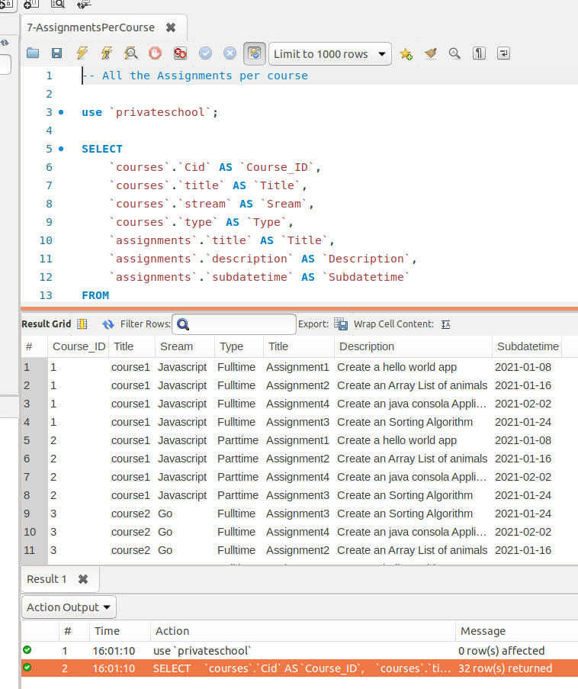

All the assignments per course per student [2 marks]

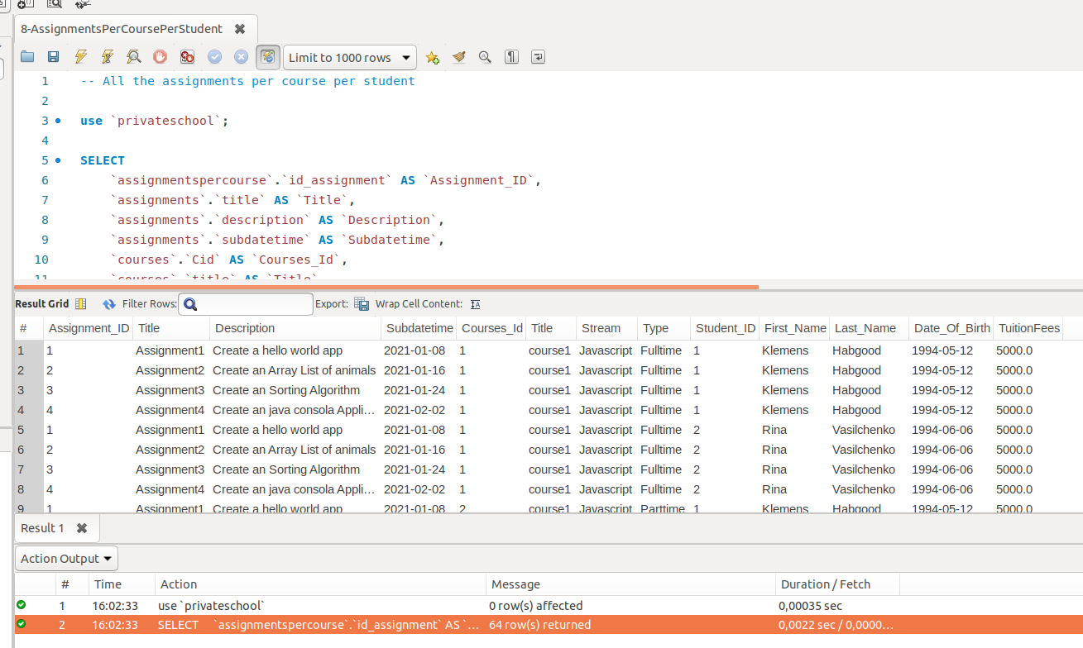

A list of students that belong to more than one courses [3 marks]

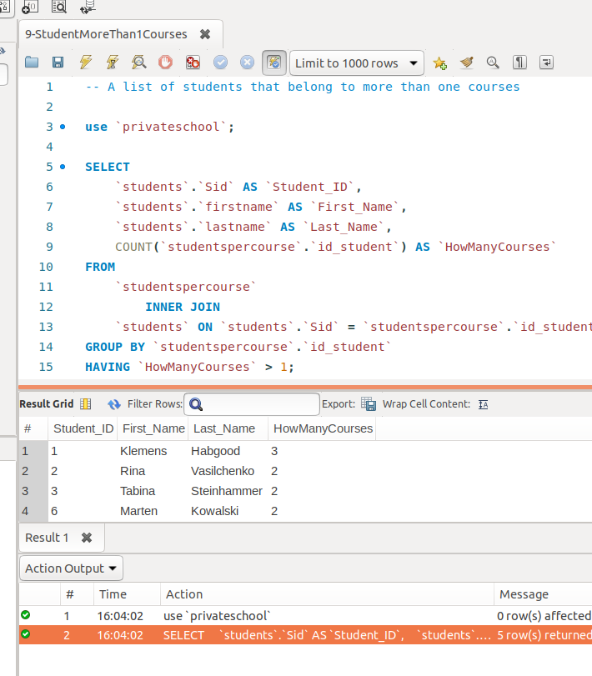

6. You also need to produce a small project that [26 marks]
a. makes a connection to the database and executes the above sql
queries [9 marks]

https://github.com/kkousounnis/Java-Application-PrivateSchool-Data-Management-System-Mysql.git

Project install it to netbeans.

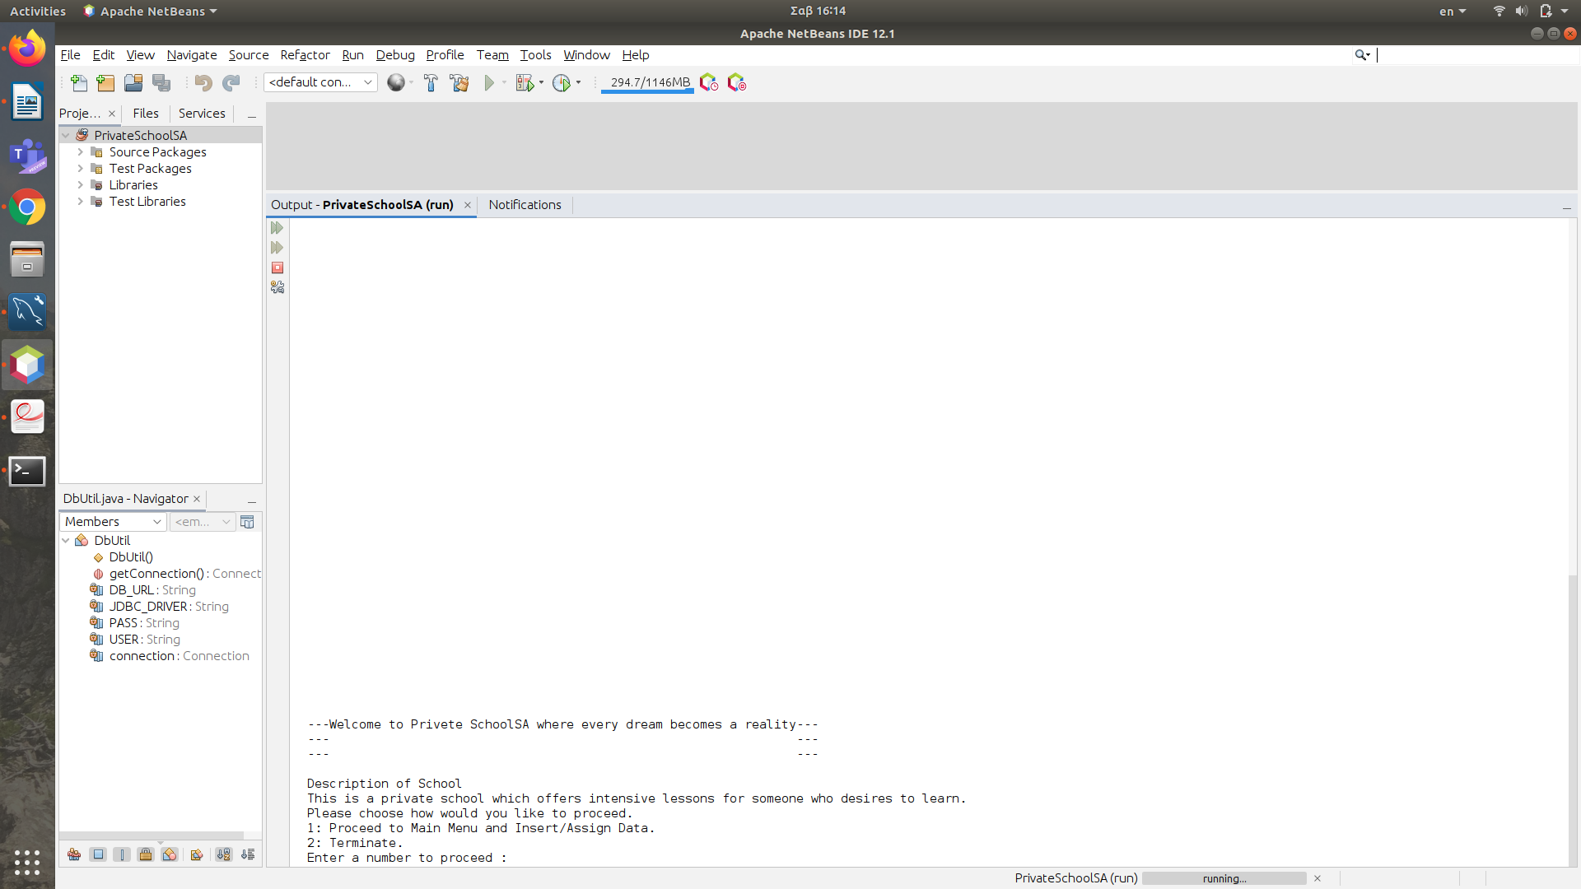
Set up Database
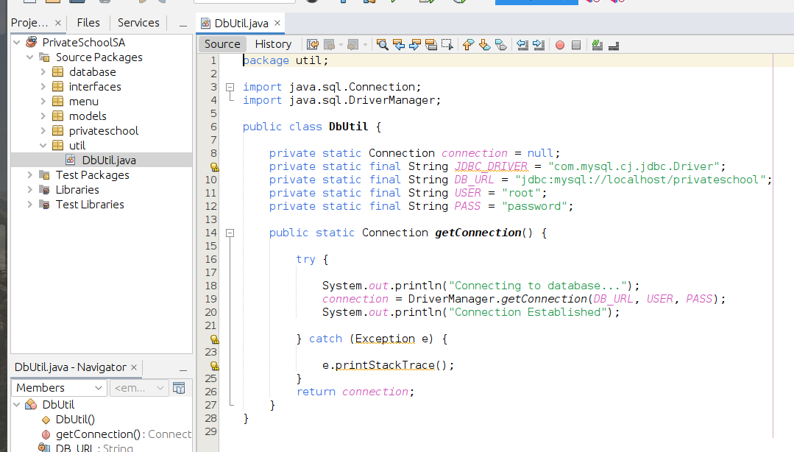
Package:util →Dbutil.java
Se
USER->
Username
PASS->
Password

Specify your database username and password.

Shift+f6 to run application.

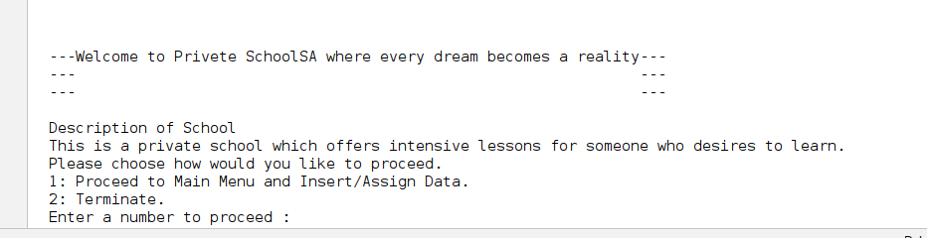
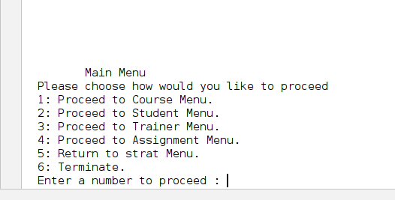

List of Courses

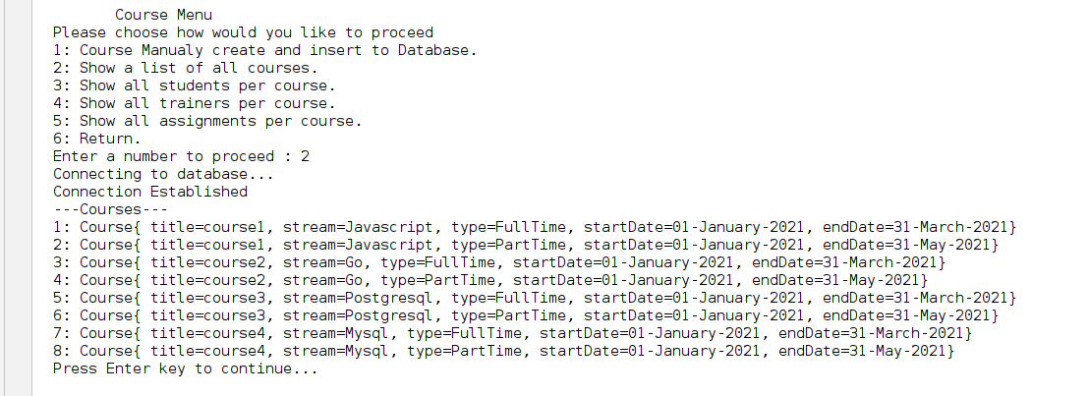
List Of Students

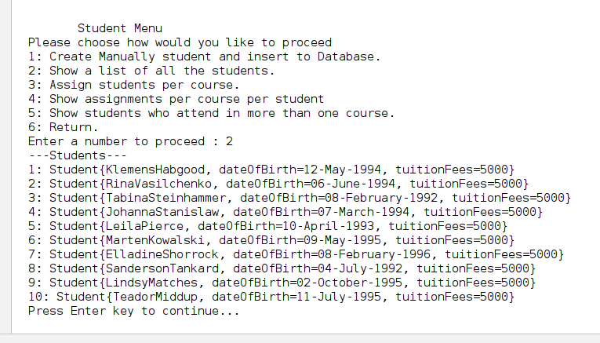

List of Trainers

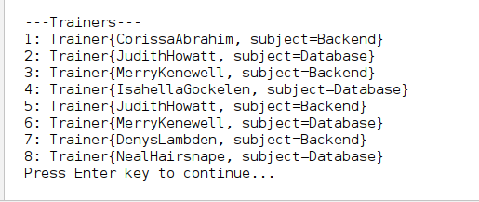
List of Assignments
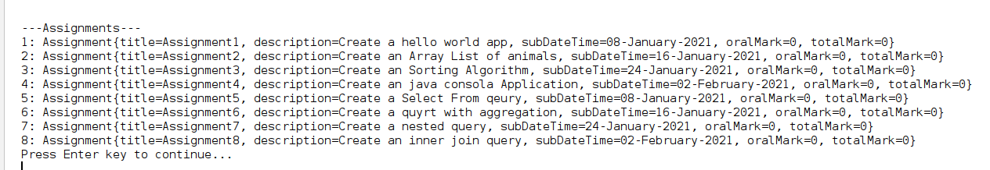

All the students per course

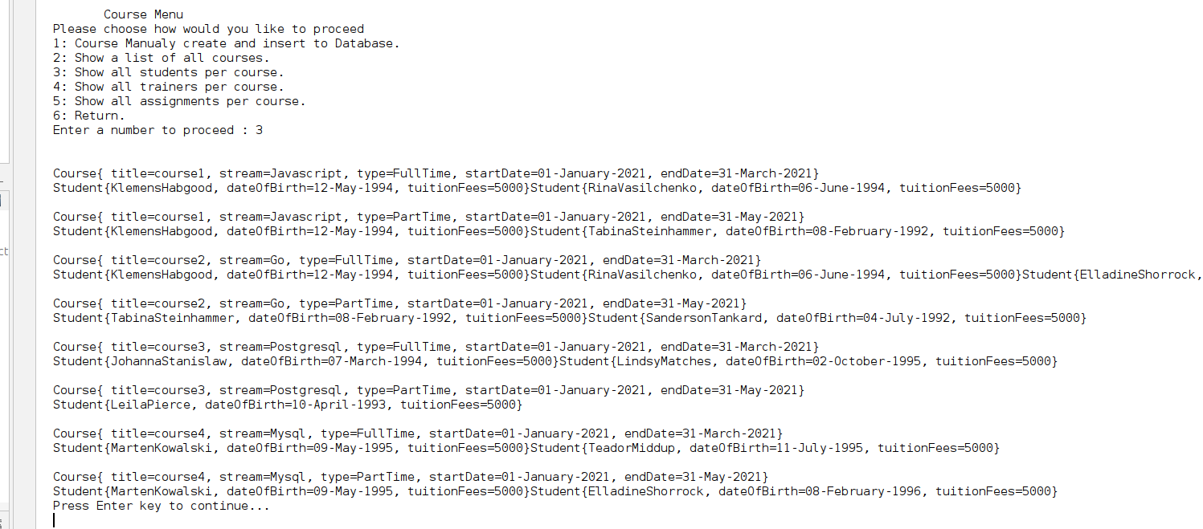
All the trainers per course.

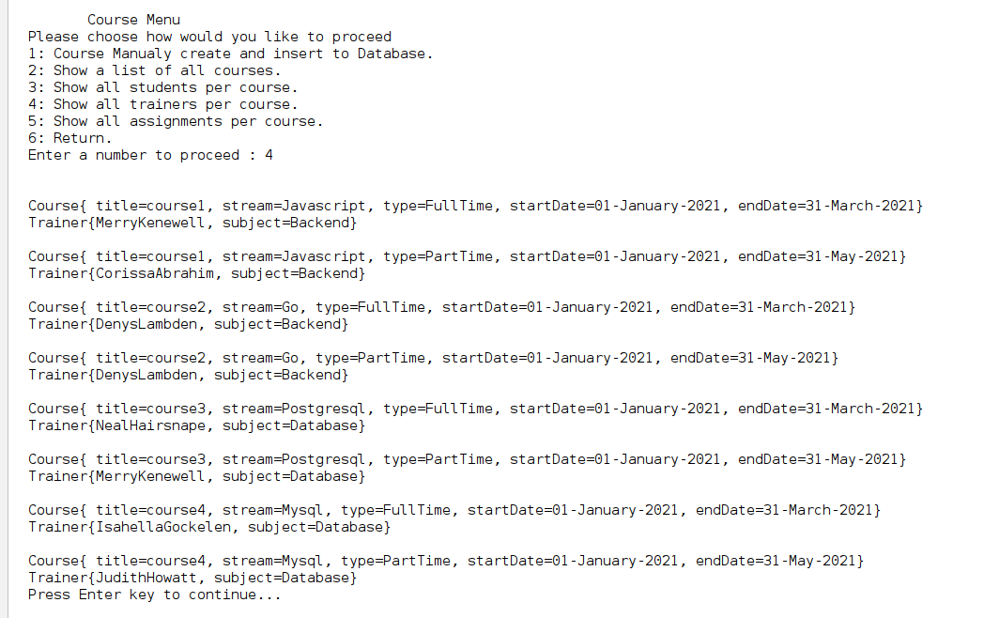

All the assignments per course

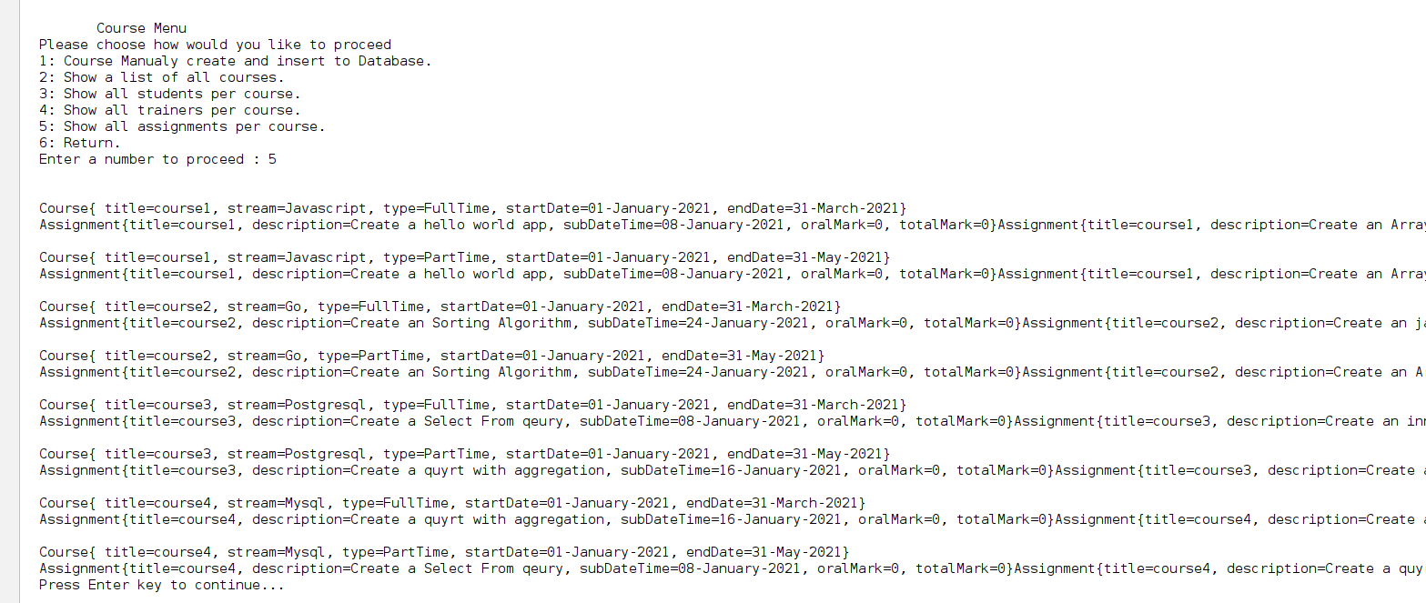
All the assignments per course per student

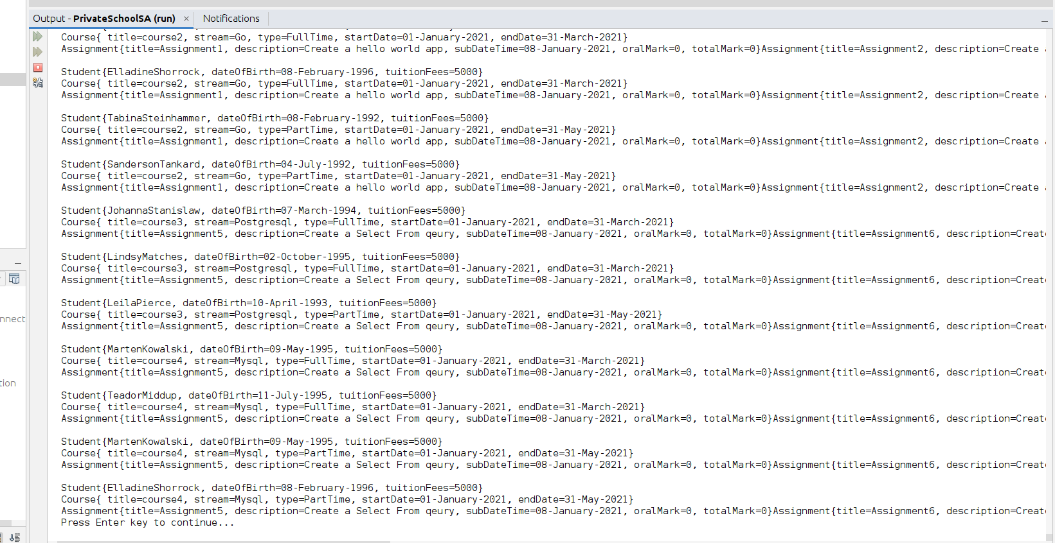

A list of students that belong to more than one courses.

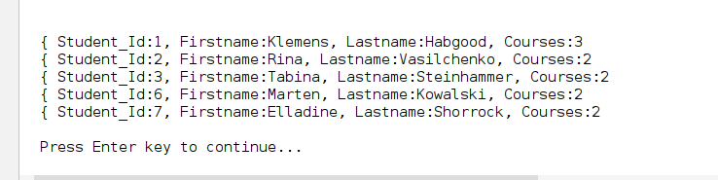
b. makes a connection to the database and inserts input data from the
keyboard to the following tables,
i. students [2 marks]
ii. trainers [2 marks]
iii. assignments [2 marks]
iv. courses [2 marks]
v. students per course [3 marks]
vi. trainers per course [3 marks]
vii. assignments per student per course [3 marks]

i. students [2 marks]

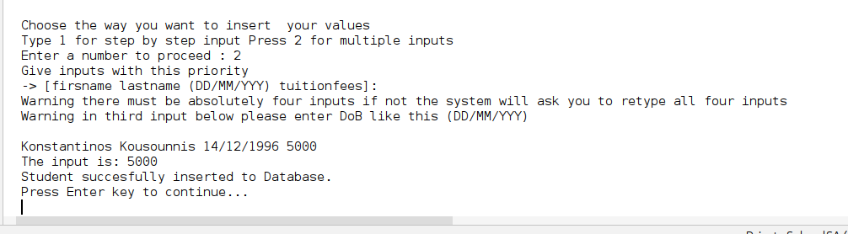
ii. trainers [2 marks]

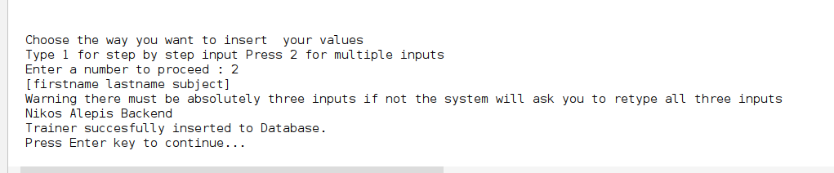

iii. assignments [2 marks]

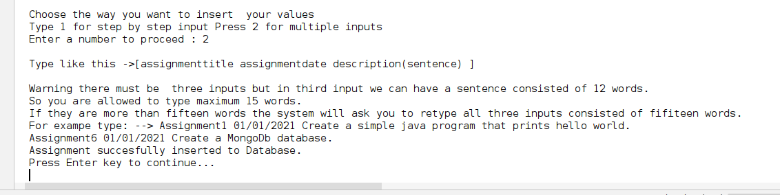
iv. courses [2 marks]

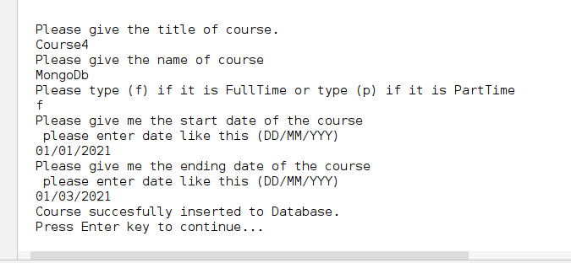
v. students per course [3 marks]

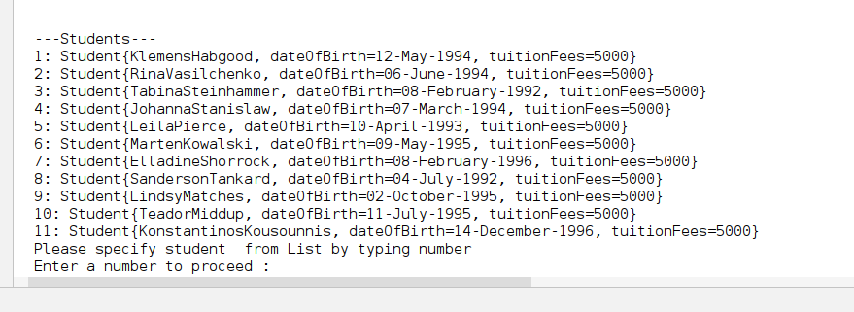
First specify student.

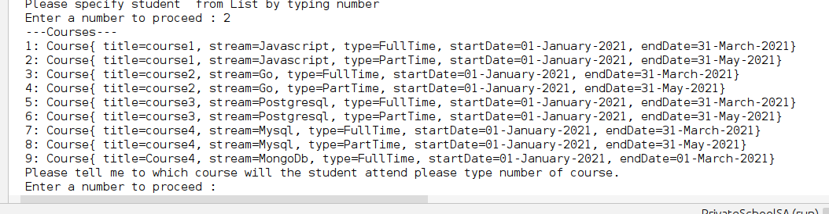
Specify course

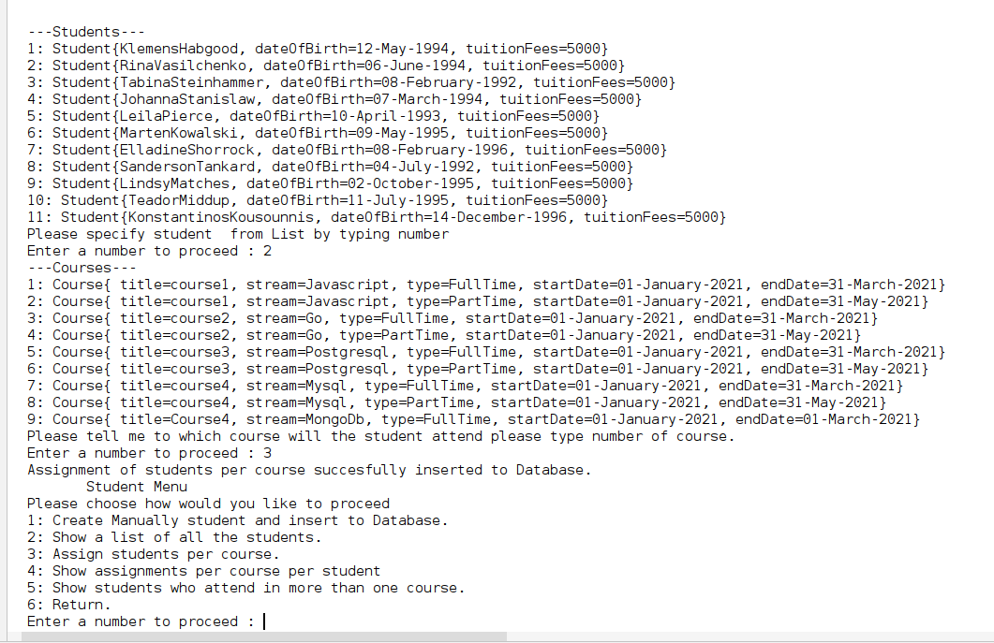

vi. trainers per course [3 marks]

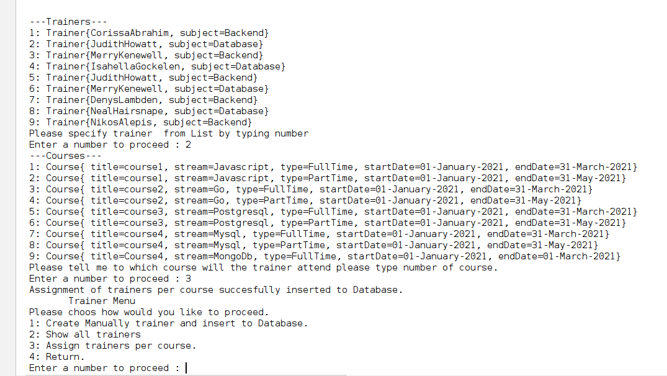
vii. assignments per student per course [3 marks]

