Set up Database

1)Jdbc connector import jar file to libraries

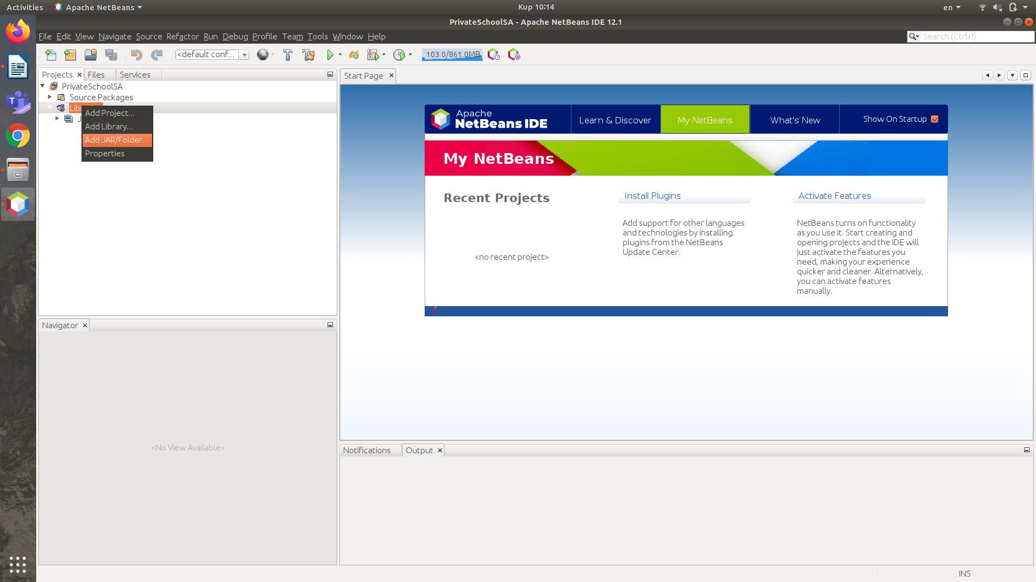

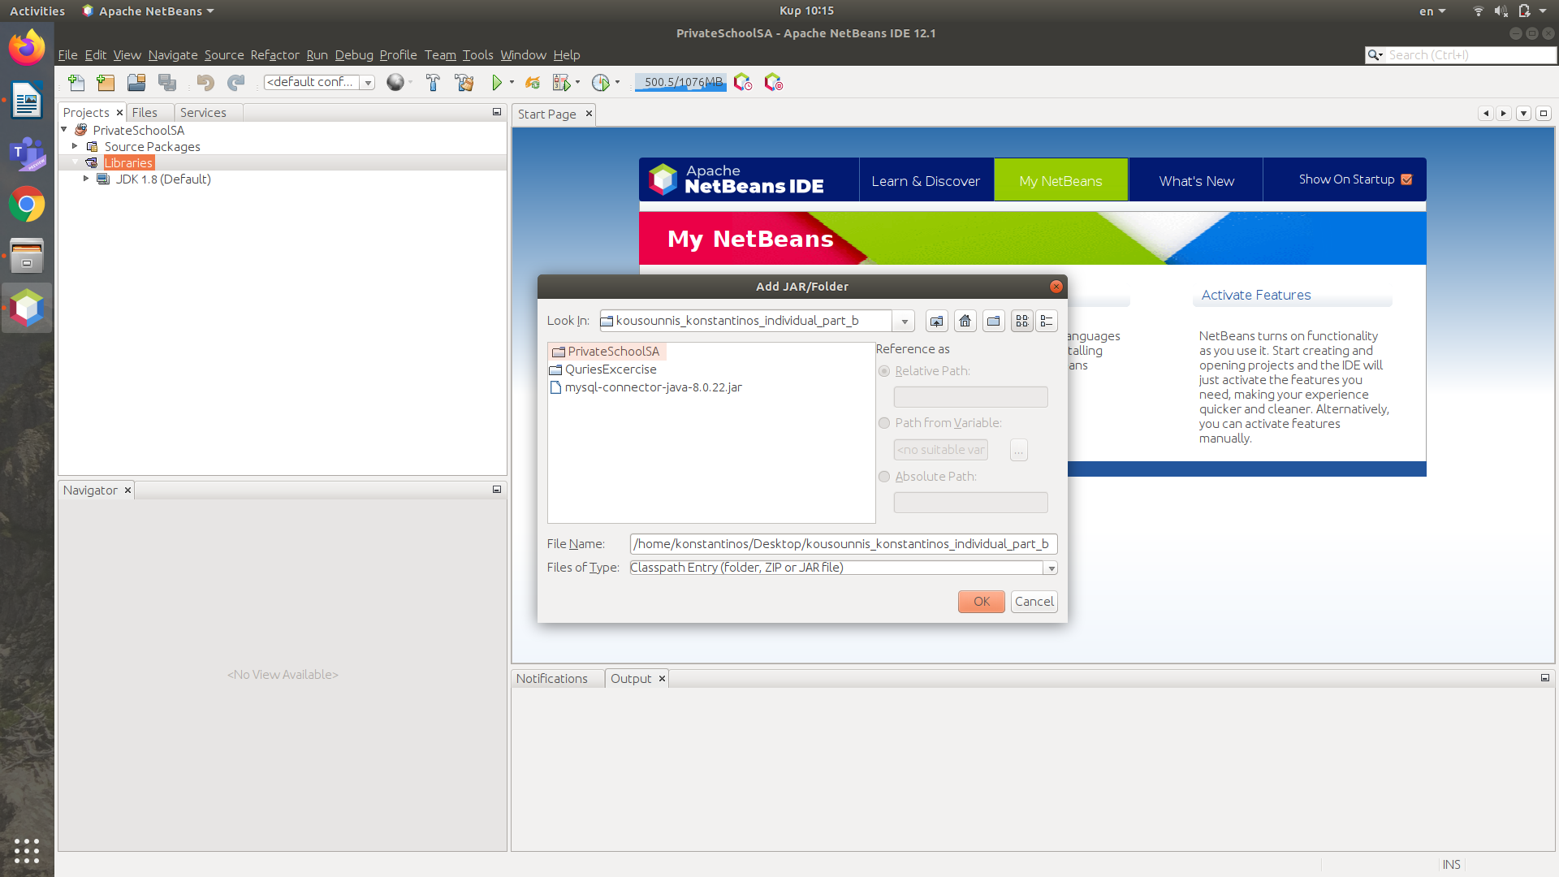
Select from inside folder the /kousounnis_konstantinos_individual_part_b/mysql-connector-java-8.0.22.jar

2)
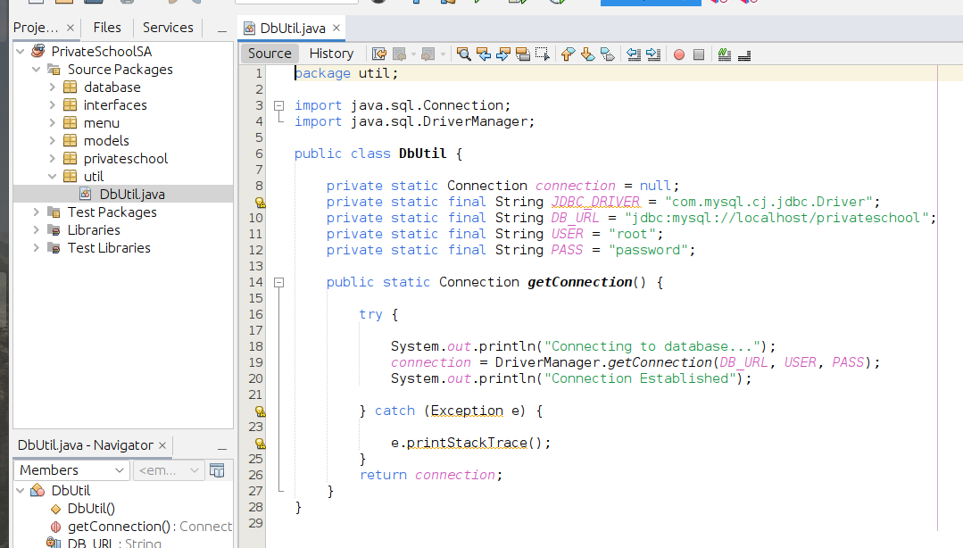
Package:util →Dbutil.java
Se
USER->
Username
PASS->
Password

Specify your database username and password.

PrivateSchoolSA/SourcePackage/util/Dbutil.java

private static final String USER = “username_database”

private static final String PASS = “password_database”

