Konstantinos Kousounnis
Java Application PrivateSchoolSA
Documentation

Project description:
Implementation of a private school structure which will consists of Courses, Students, Trainers, Assignments.

Project requirements

- The application must ask from the command prompt to input data to all the entities and it should give the option to add more than one entry at a time.
- If the user decides not to type any data, the program should use synthetic data.
- A list of all the students.
- A list of all the trainers.
- A list of all the assignments.
- A list of all the courses.
- All the students per course.
- All the trainers per course.
- All the assignments per course.
- All the assignments per student.
- A list of students that belong to more than one courses.
- Lastly, the program should ask from the user a date and it should output a list of
students who need to submit one or more assignments on the same calendar week
as the given date.
  - Explain: The calendar week is considered as Monday to Friday for submissions. For
example, if the user inputs 15/2/2019 you need to check from Monday 11/2/2019
to Friday 15/2/2019.If the user inputs 16/2/2019 (Saturday) or 17/2/2019 (Sunday) you need to check from Monday 11/2/2019 to Friday 15/2/2019.
Design Structure

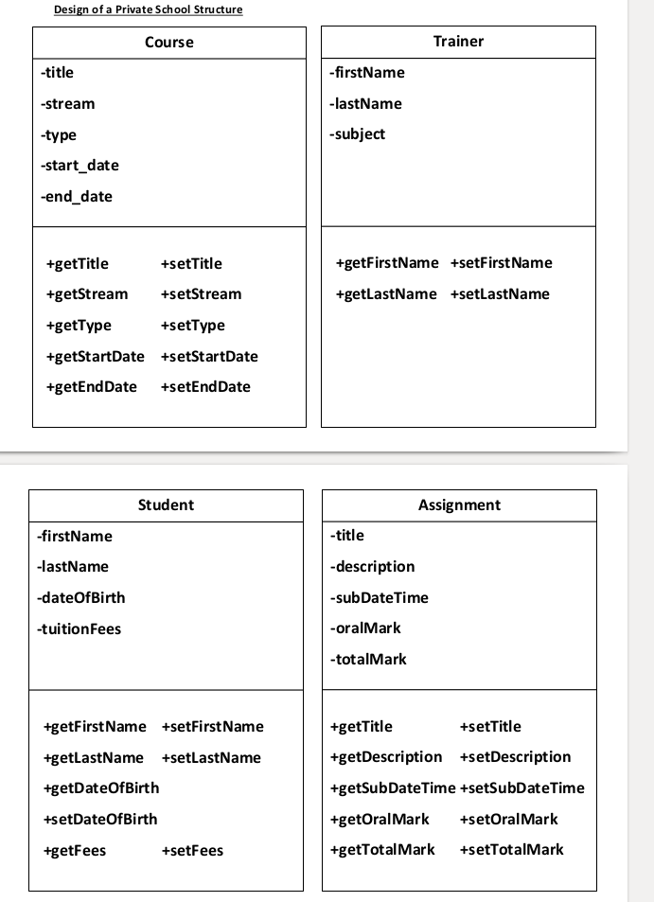
Design Structure PrivateSchoolSA

Documentation Install Project Private SchoolSA

Github

Open a search browser and search with url below.
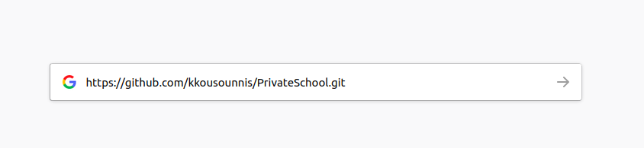
https://github.com/kkousounnis/PrivateSchool

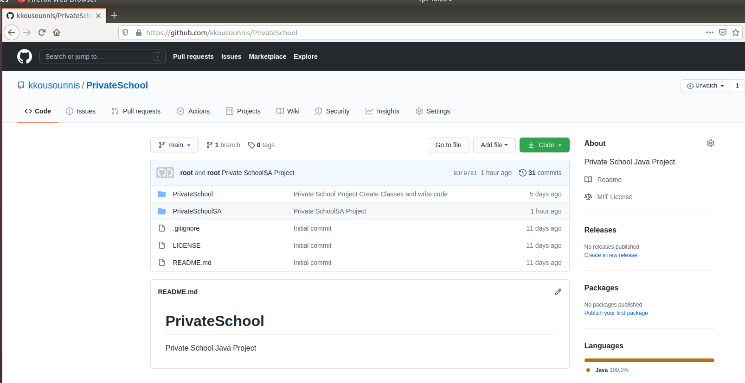
Open git command line or download project from web page.
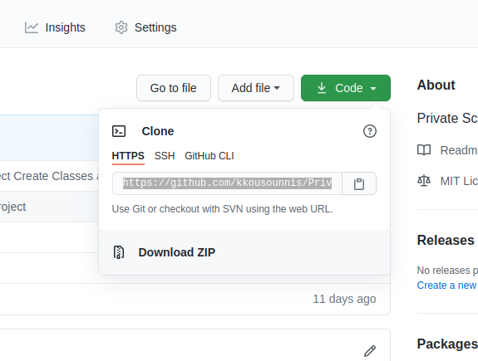

- Command line type
Git clone https://github.com/kkousounnis/PrivateSchool.git
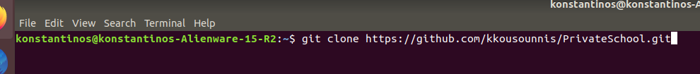
- Download project from github

- Download Zip
- Extract project
- open Netbeans
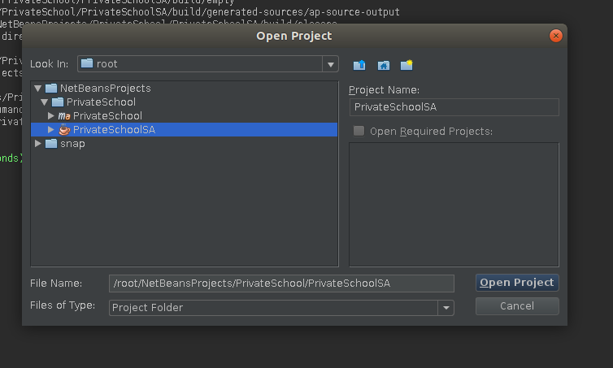
We want to open PrivateSchoolSA project the other one is an older version of the completed project.

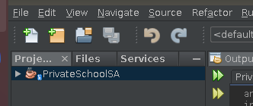

When we are all set we shall see at projects folder PrivateSchoolSA project.

Running Program
First build project.
- shift + alt +f11 one way
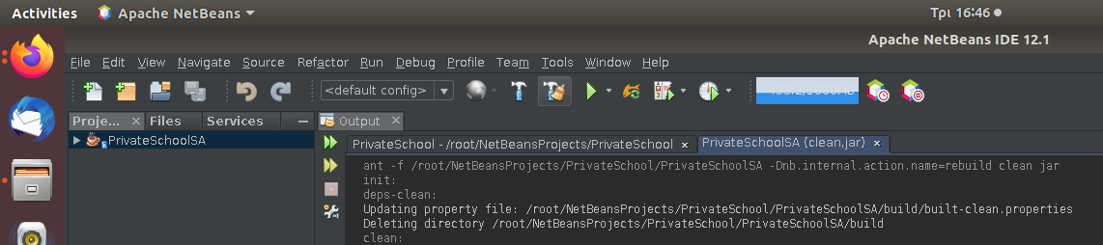
- Clean Build hummer icon choose.

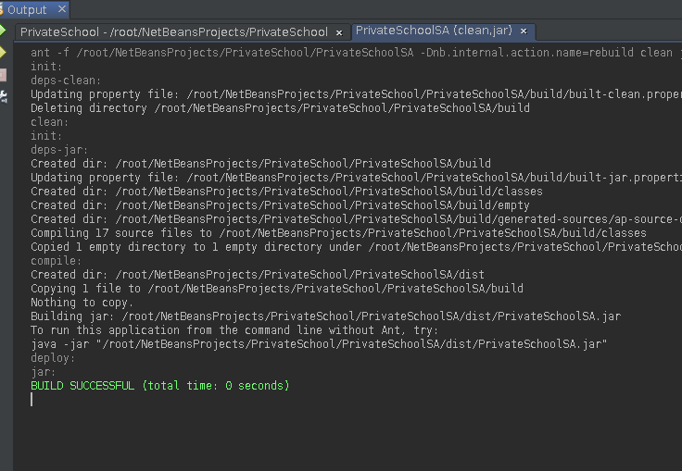
Build succesful.

Now run PrivateSchoolSA
- Press f6
- Select project → right click → run.
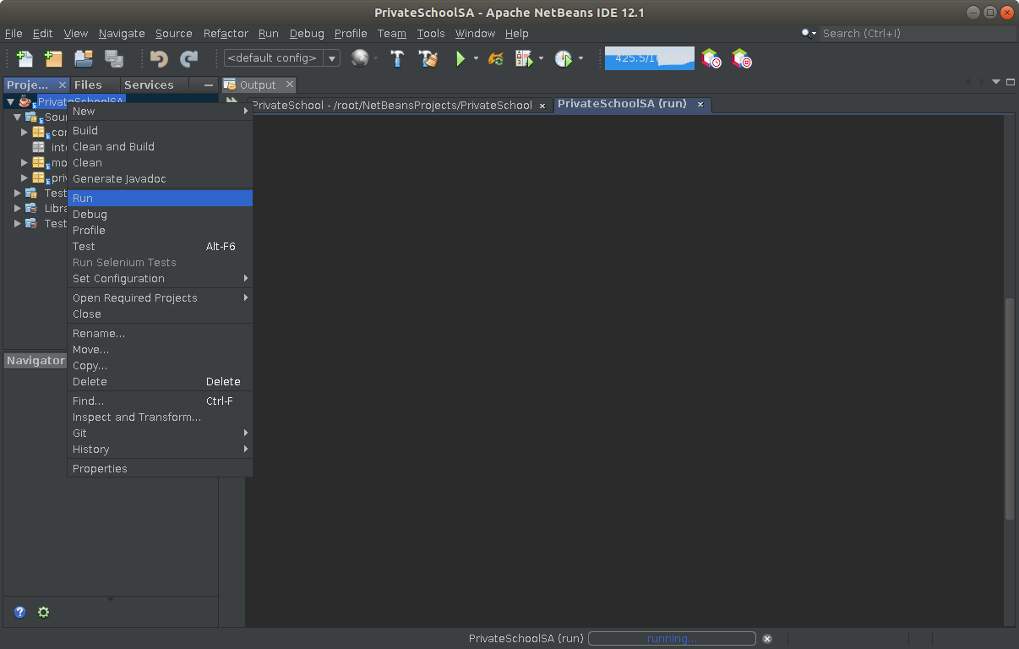
The project now has started and we will our Menu at the command line.

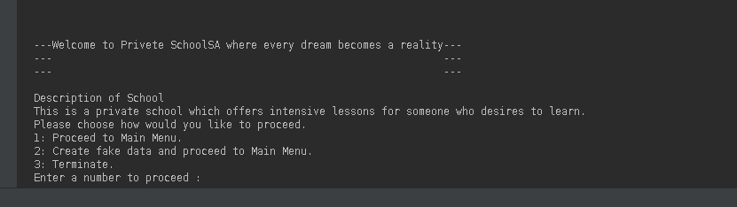
Project Requirements
- The application must ask from the command prompt to input data to all the entities and it should give the option to add more than one entry at a time.
- If the user decides not to type any data, the program should use synthetic data.
We have three choices to meet our requirements.
1st choice continue without any synthetic data the user will have to create all fields manually.
2nd choice continue with synthetic data when selected the java program will create fake data and then user can create more ore can use the ones that have been already made.
3rd choice terminate our program exit application.

Continue First Choice

If we type something else we will be asked to retry.
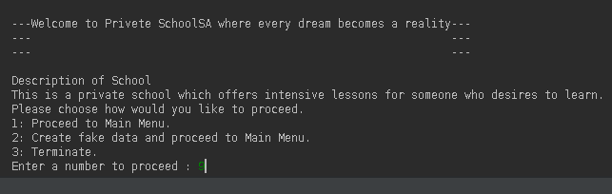
Type 9
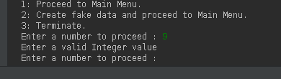

A message will appear to retry as well as if we type sentences instead of a number.
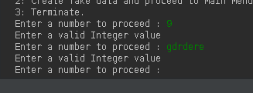

Press 1 and continue.
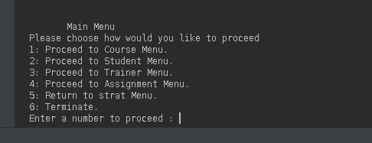

Another Menu appears and gives as 6 choices with the same way we move through our program
Select 1 Course Menu there are security checks to every input.

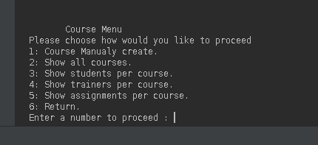

Another menu appears with 6 choices
Because I have no courses yet first I will try to see if I have any courses by typing 2 and I will see a table with no courses.
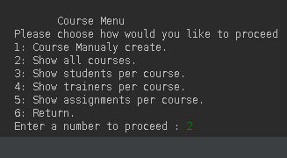
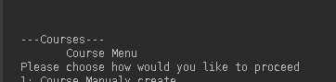

The table ---Courses--- is empty no courses yet

Create a course select 1.
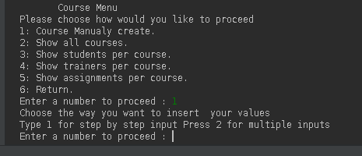

Requirement 2) The application must ask from the command prompt to input data to all the entities and it should give the option to add more than one entry at a time.
We can choose how the user inputs the data

1st select 1 step by step

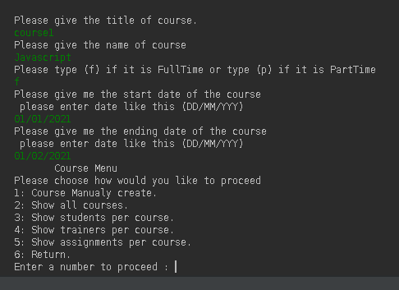

User types step by step by asking him every time for every field
My example is as in screen
- course1
- Javascript
- f (Stands for fulltime)
- 01/01/2021
- 01/02/2021
For every field there is a security check.

I can’t write multiple words to any fields.
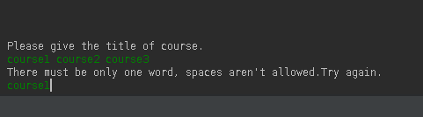

Error message appear please retype.

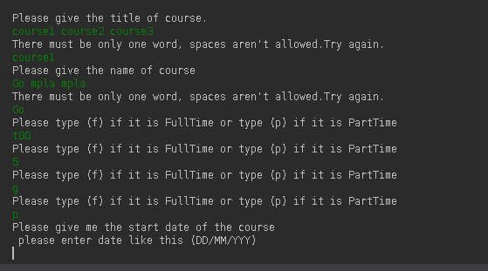
When I select (f) or (p) only those two values are acceptable nothing else as we can see bellow.

Security Check also occurs in date we must type dd/mm/yyyy nothing else will the program accept.
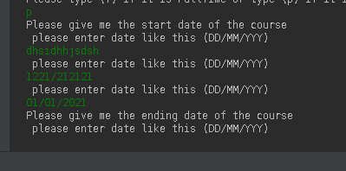

Error message until right input.
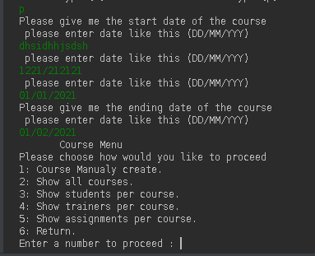
We have returned to Menu after we inserted Course and now select 2 to see course.

I have repeated two times procedure since I wanted to show the security checks.
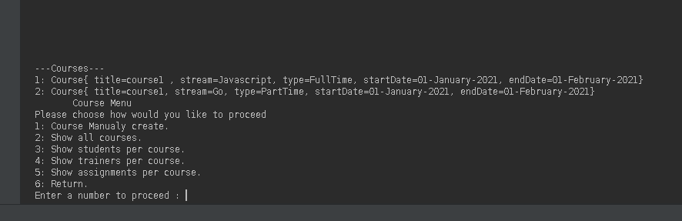
Now we have two courses.

2nd Create courses with multiple choice.

So I will press 1 and the 2 for multiple input.
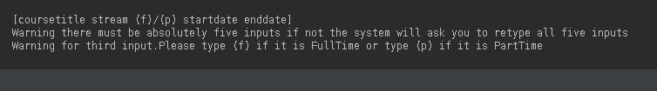
At first line I see how the input must be made.
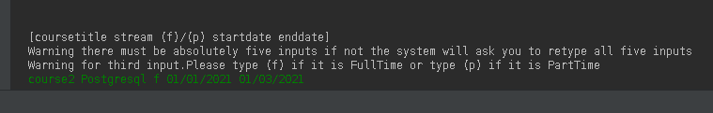
So the way it must be typed is

course2 Postgresql f 01/01/20221 01/03/2021

Security check occer here as well the form is like this we aren’t allowed any other way the words must be five and if fulltime or parttime or date is wrong we will be asked to retype afterwards.
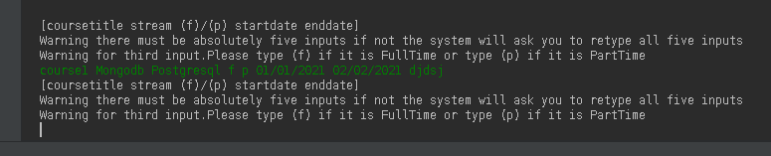
If we type more inputs or less wrong message appear to retype.

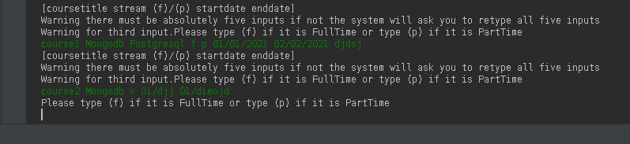
If we type instead of f or p error message retype.

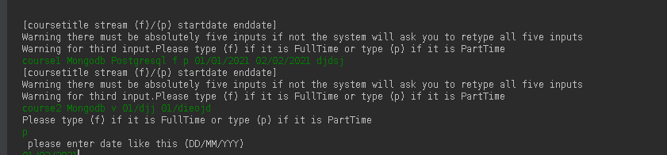
Also date retype if it is not correct. I typed 01/djj and asks me for right format.

The same check occur in all inputs courses, students, trainers, assignments

Only in assignments I allow to input a whole sentence in a field because we we need assignment description.
In the assignment section as explained 15 words are allowed for description section
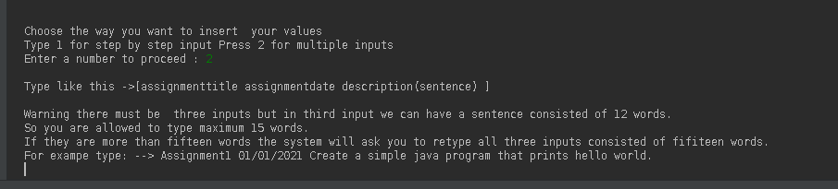
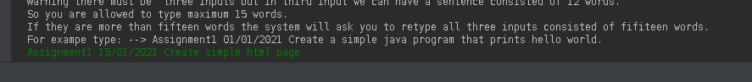
Also afterword I have select to which course it belongs by typing number.
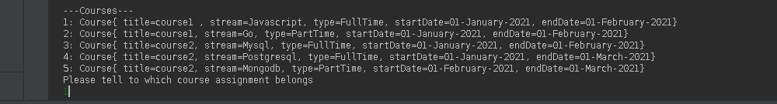
The same procedure occurs for trainers and students.

Print course List.
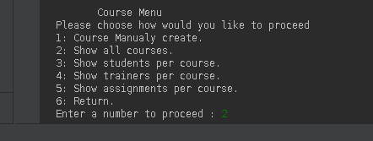

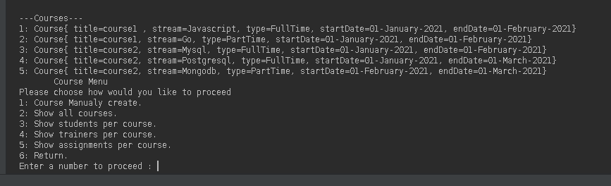
The courses are now printed in a list here we have just made 5 courses and we can see all required fields.

The same procedure to show and create courses, students, trainers, and assignments can execute with the same way.
Example
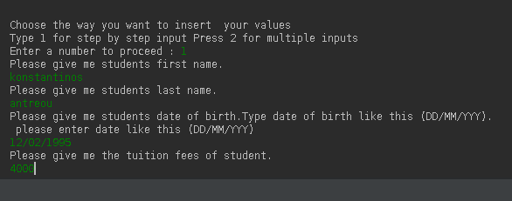
For last field tuition fees security also happens. If we type integer bigger than zero.

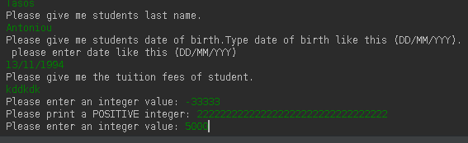
The same procedure is for every other with their security checks.

Show students who have more than one course example without having any course.
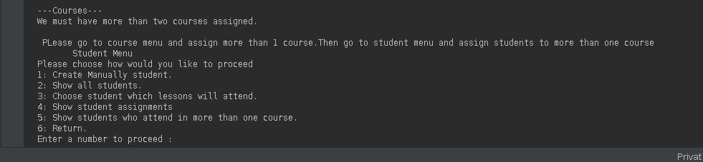
As we can see a message appear that we need more than two courses to see students.
The same messages appear for the other requiremnts that if we have no course we cant execute the task.
Example
Assign assignment to course.
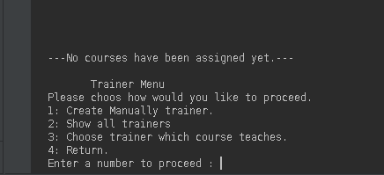

As we see no courses have been assigned yet.

Synthetic Data 2nd Choice

We can create manually everything as we have seen above and see all project requirements.
However we will create and synthetic data so as to see that we are able to execute all project requirements.

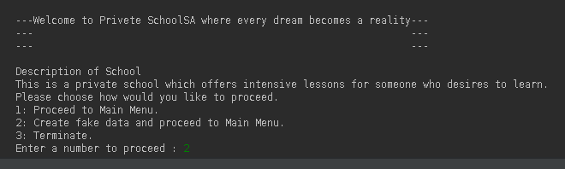
Type 2 and fake data will be created.
A list of all the students.
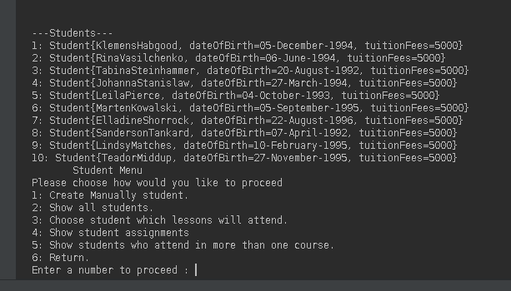
A list of all the trainers.
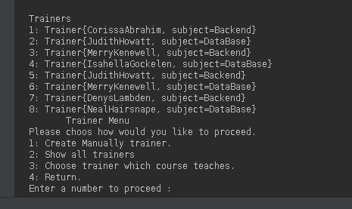

A list of all the assignments.
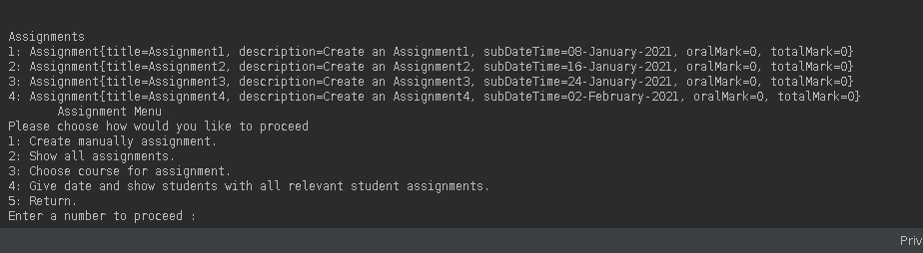
A list of all the courses.
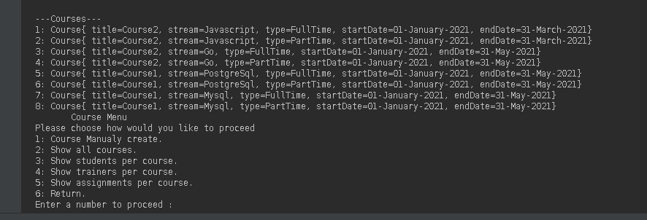
All the students per course.
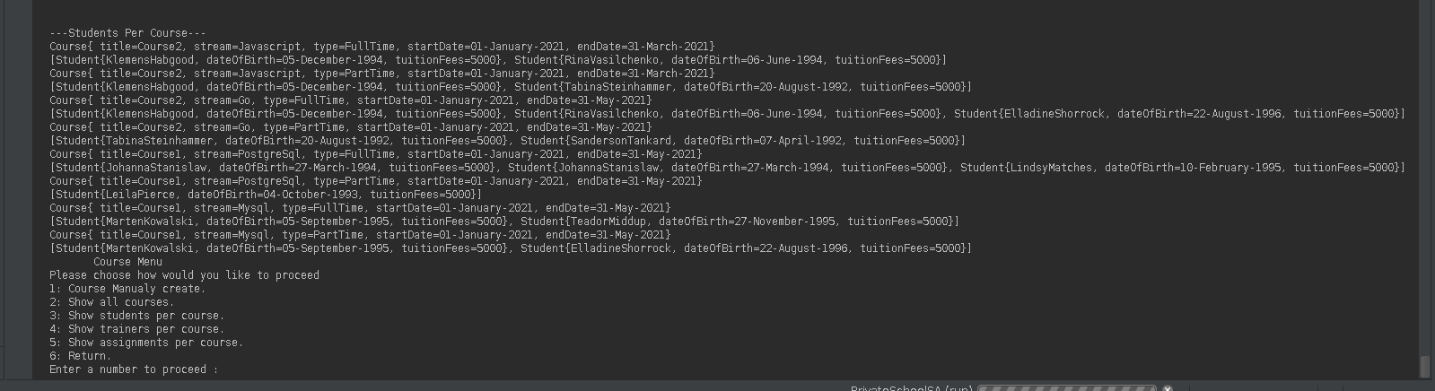
All the trainers per course.
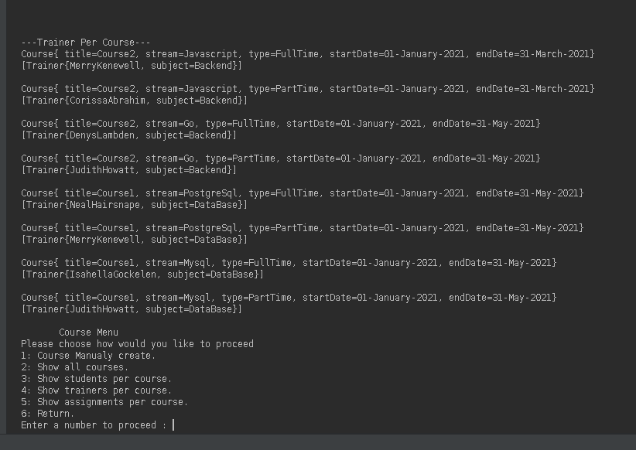
All the assignments per course.
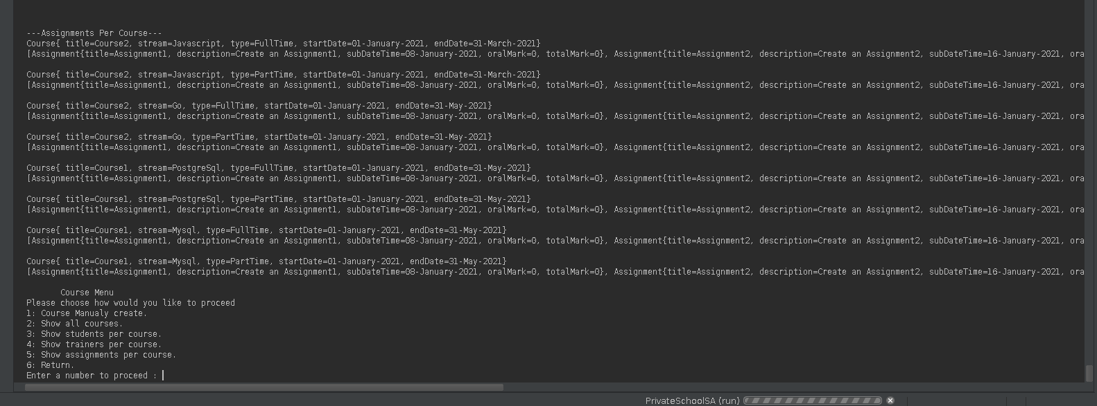
Here in order to see all assignments we must shift right.

All the assignments per student.
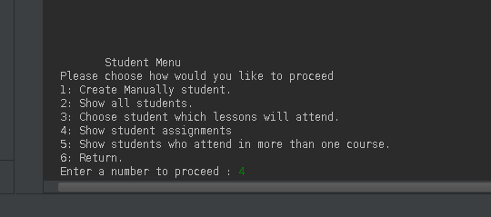

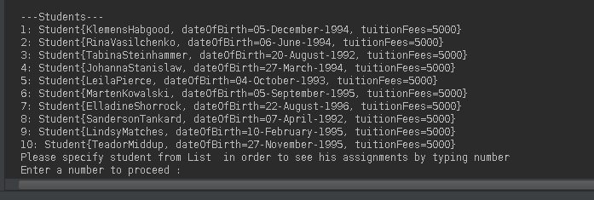
First select student type number.
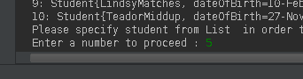

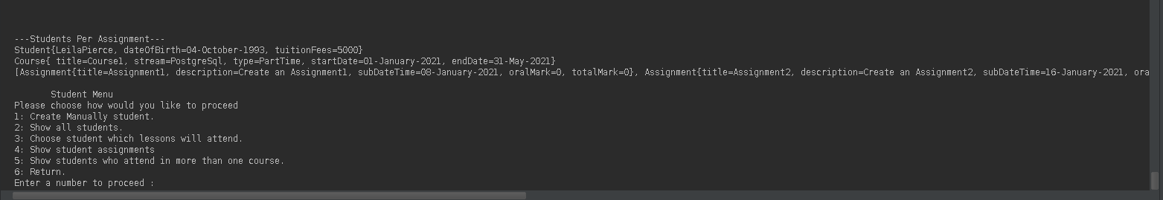
We have besed the student we gave his assignments.
A list of students that belong to more than one courses.
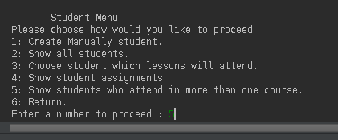

Show students who attend multiple courses.

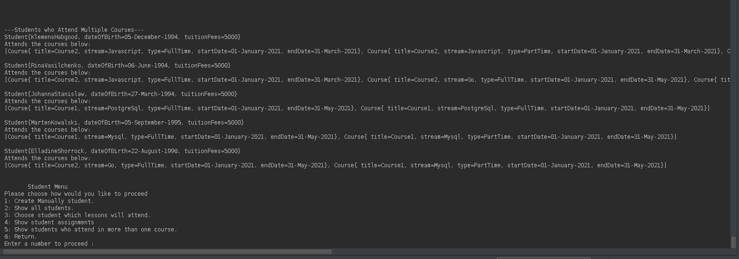
We can see based what courses students have taken if they have multiple courses we see their names.
We can set every time we create a student or trainer or assignment to which course it belong and also we can select to choose from list for multiple.

Example
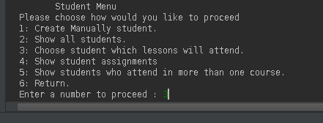

3: Choose student which lesson will attend. We can select multiple courses.
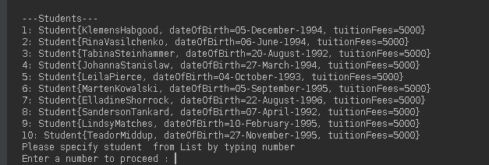
First we choose which students we want by typing number. Example 3
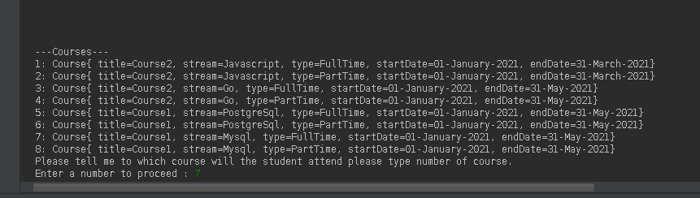

Then we see all courses and we choose which course attends. Example 7
The same procedure for every other requirement assign trainer to course, assignment to course.

Lastly, the program should ask from the user a date and it should output a list of students who need to submit one or more assignments on the same calendar week as the given date.
Select 4 Proceed to Assignment Menu
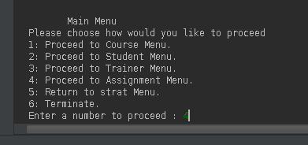

Select 2 to see all dates of assignments locate a date and then typed show we can see some students.
If you type an irrelevant date no students will be printed.
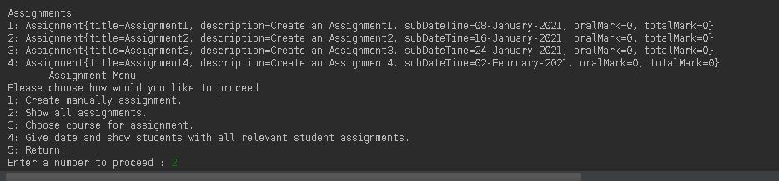

Select 4 for the user to give a date and output a list of students who need to submit one or more assignments on the same calendar week as the given date.
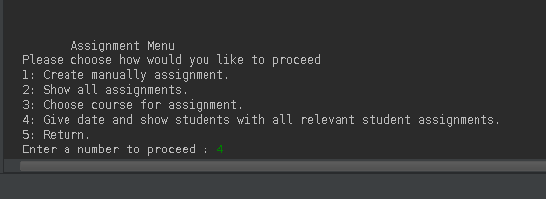

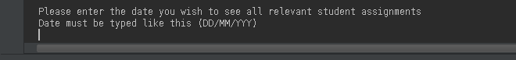
We are asked to give a relevant date.

First lets type an irelevant date
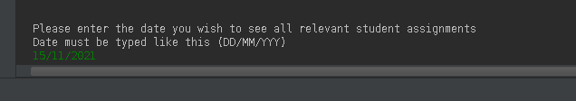
15/11/2021 irelevant date correcty nothing is printed and we have returned to Assignment Menu
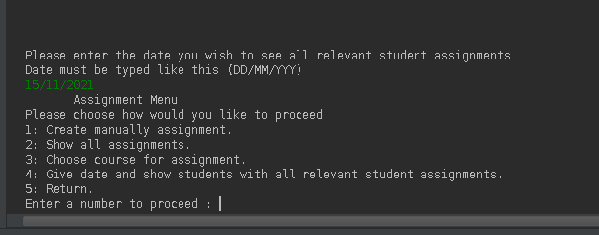
Type relevant date 07/01/2021
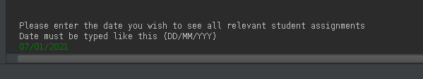
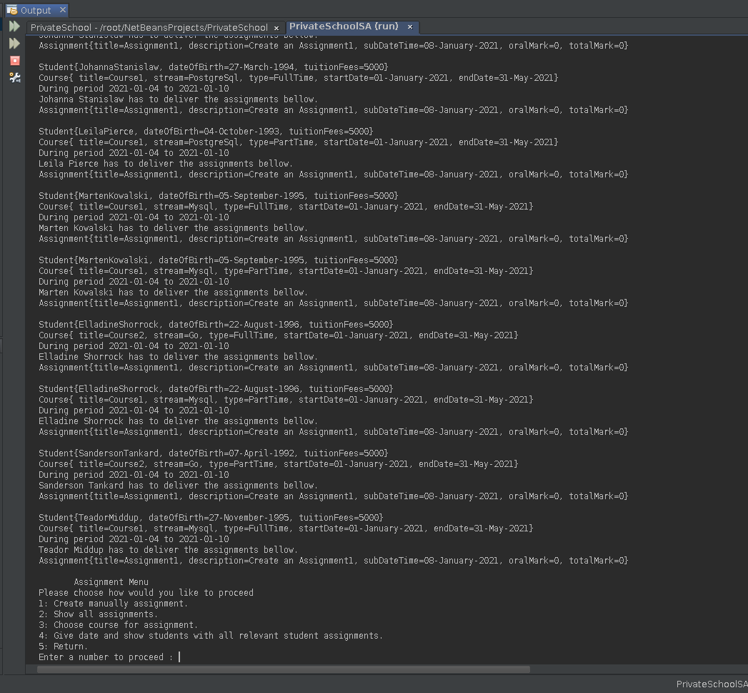
A list has appeared and we can see that with the date that we gave we can see the whole week here is 2021-01-04 to 2021-01-10 and we see all the students and their assignment during that week.

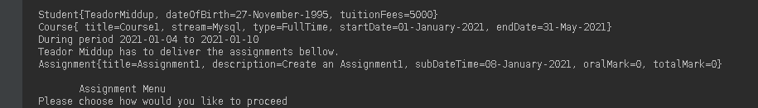
If we see more carefully this is true because we typed 07/01/2021 and we have as an output the right week 2021-01-04 to 2021-01-10 (07/01/2021 is inside this week ) and in the assignment we can see for sure that the SubaDateTime for assignment belongs to that week 08/01/2021(08-january-2021).

