Create new java project

File->New->JAVA PROJECT

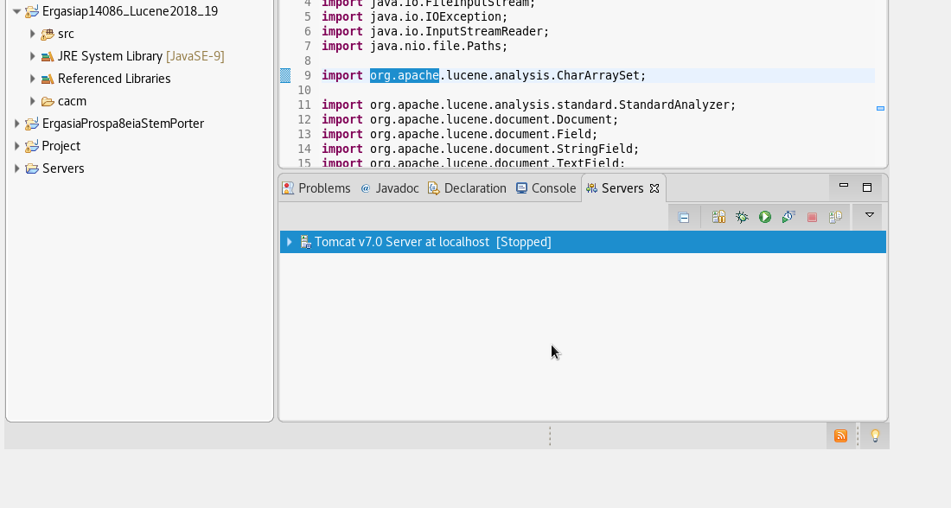

Copy inside project the two files

IndexErgasiaFiles.java, SearchIndex.java

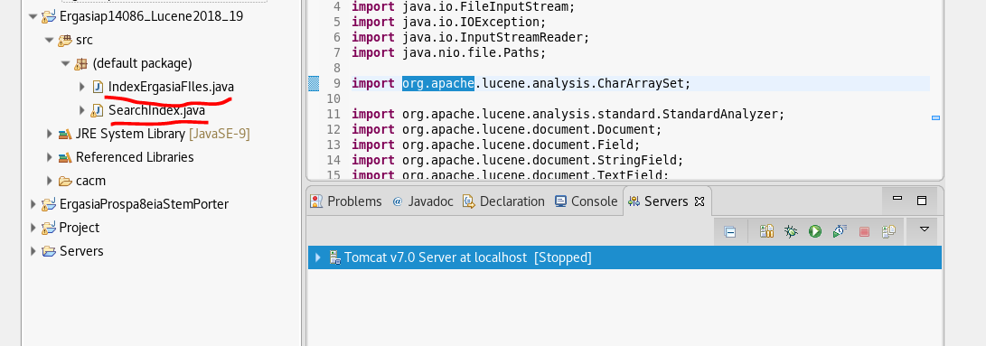

Download from path lucene 7.0.0

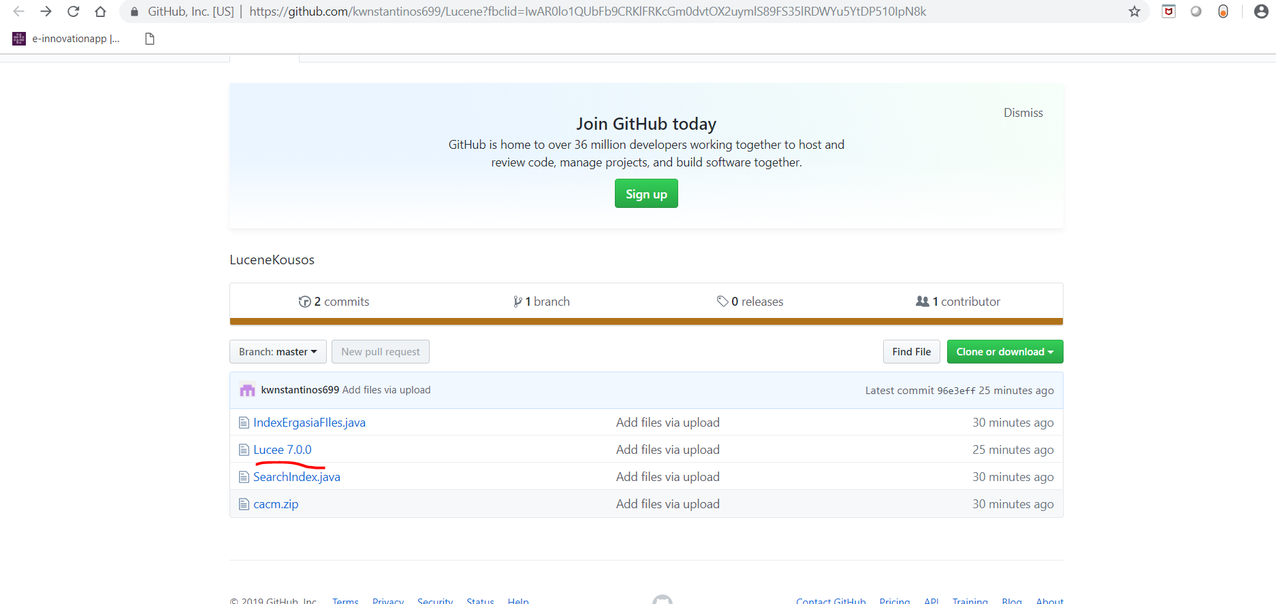

Copy paste link

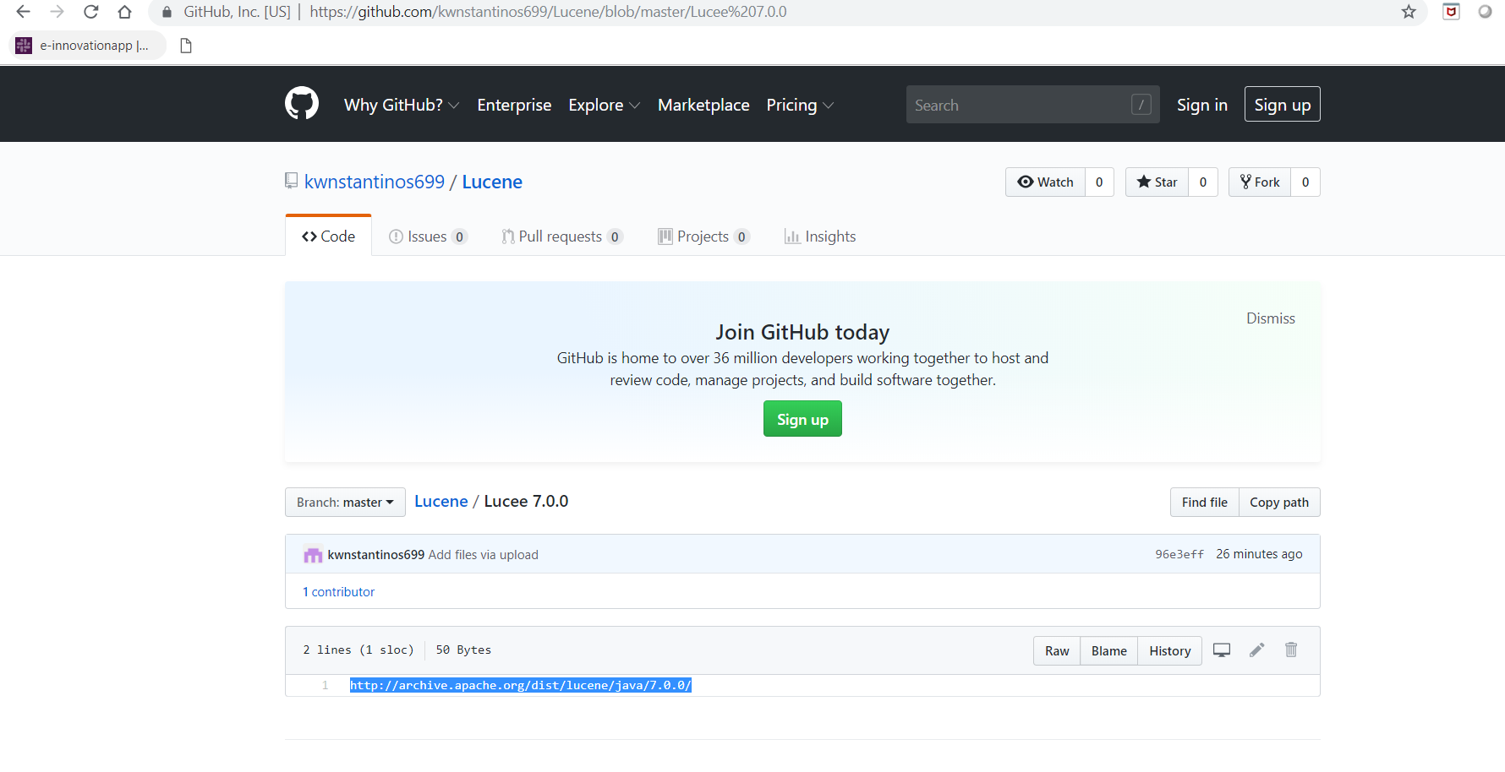

<https://github.com/kwnstantinos699/Lucene/blob/master/Lucee%207.0.0>

Download zip folder

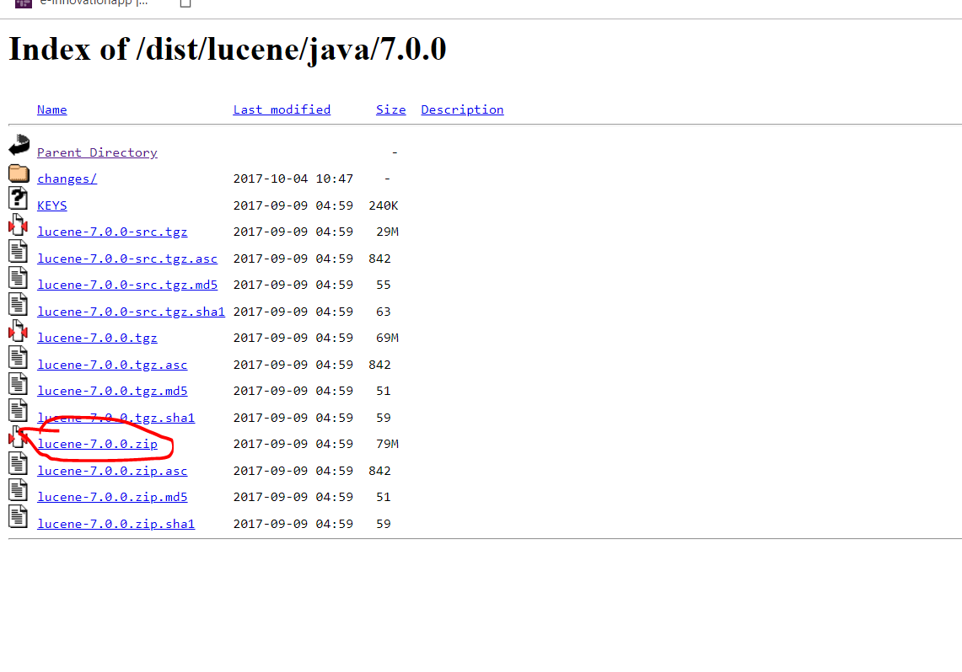

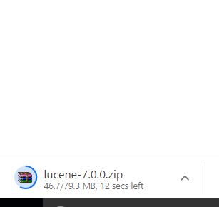

Right click project and import build path

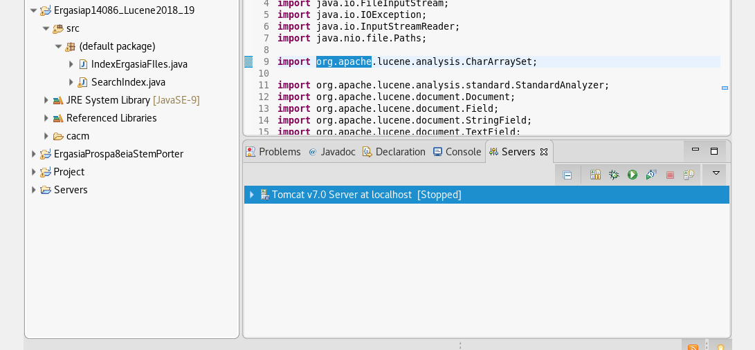

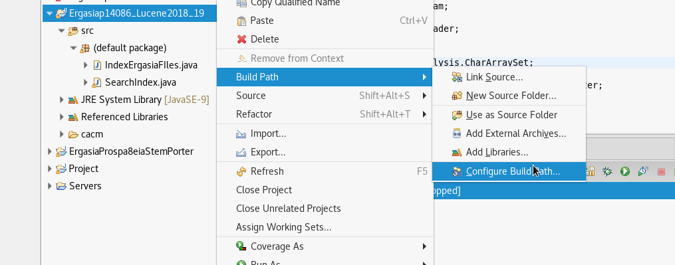

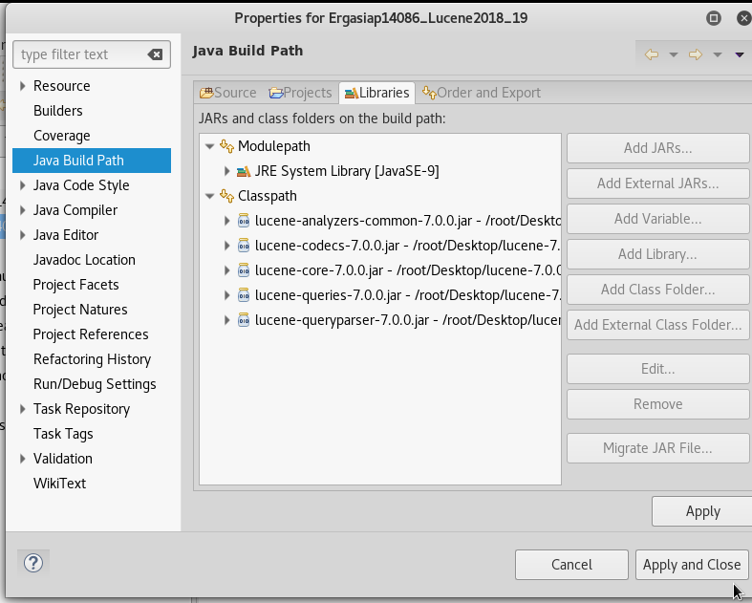

Press add external jars the same as above.

Then copy cacm folder to Project

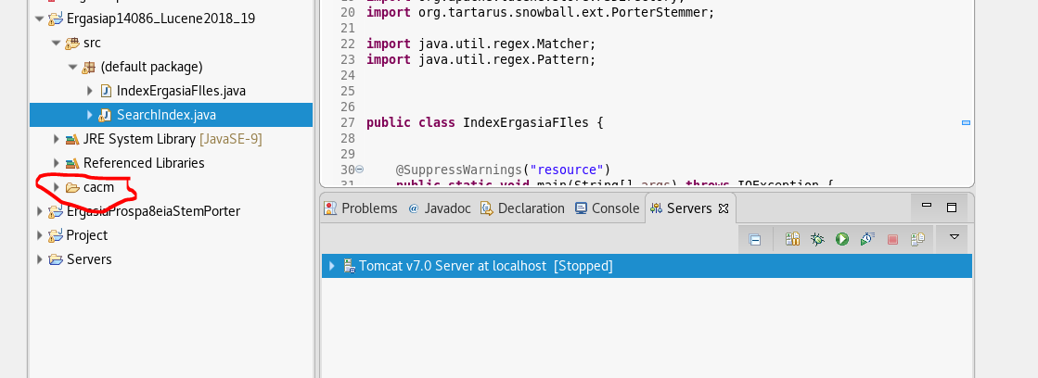

Lastly if you are not on Linux system you must set the right path.

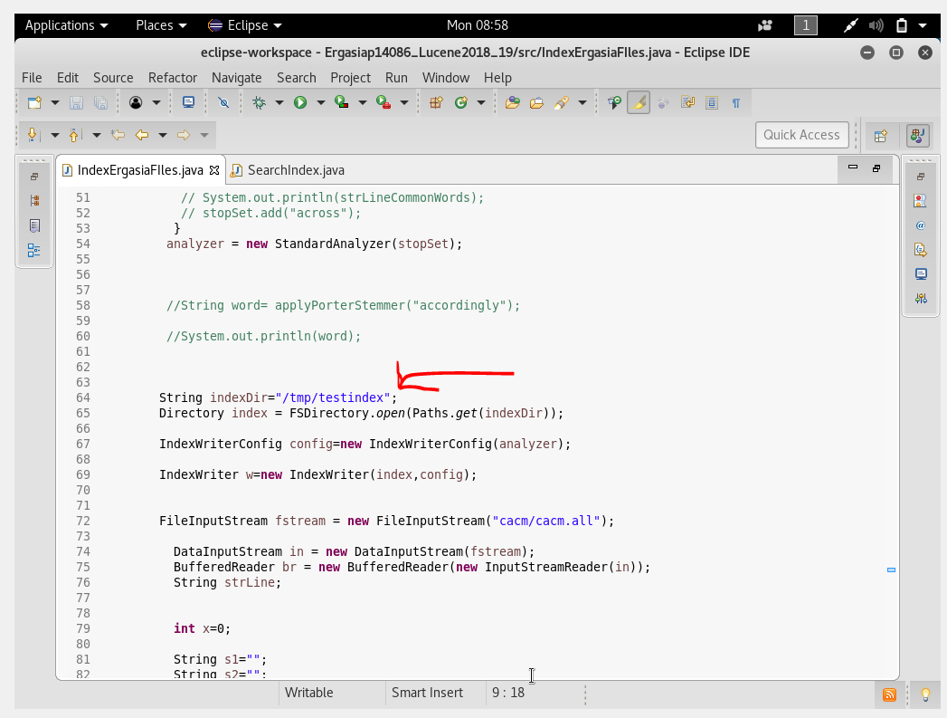

Choose where to store IndexFiles for Lucene

To run Lucene first Run IndexErgasiaFiles.java

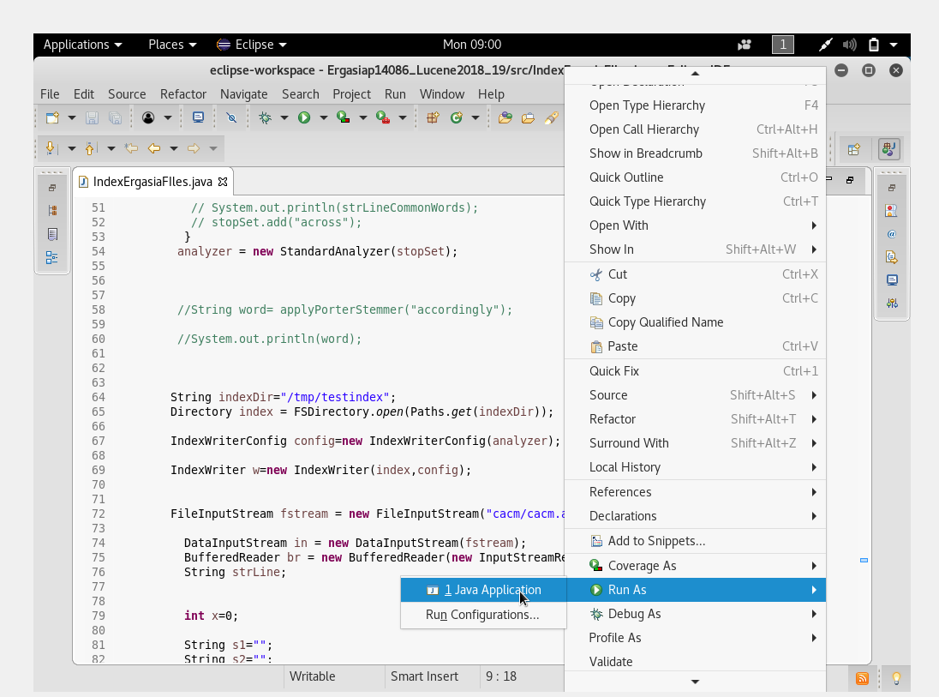

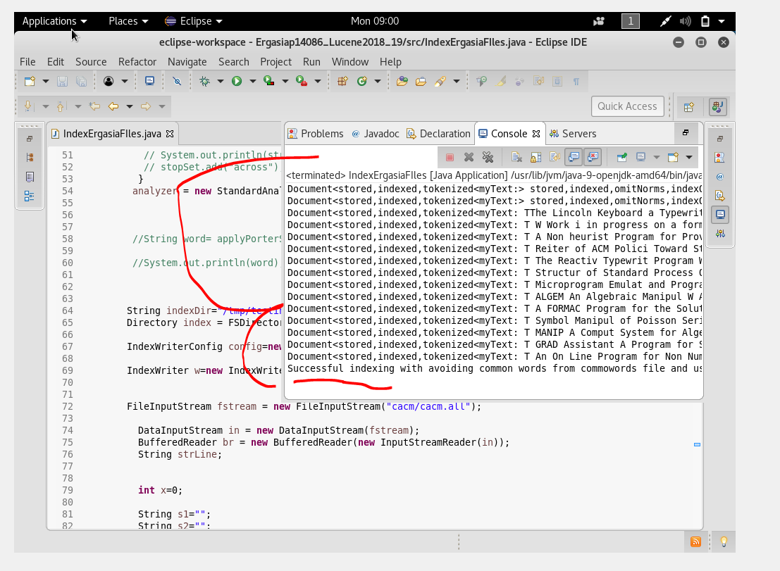

We can see that files have been indexed successfully and stored.

Next Search your query with the SearchIndex.java

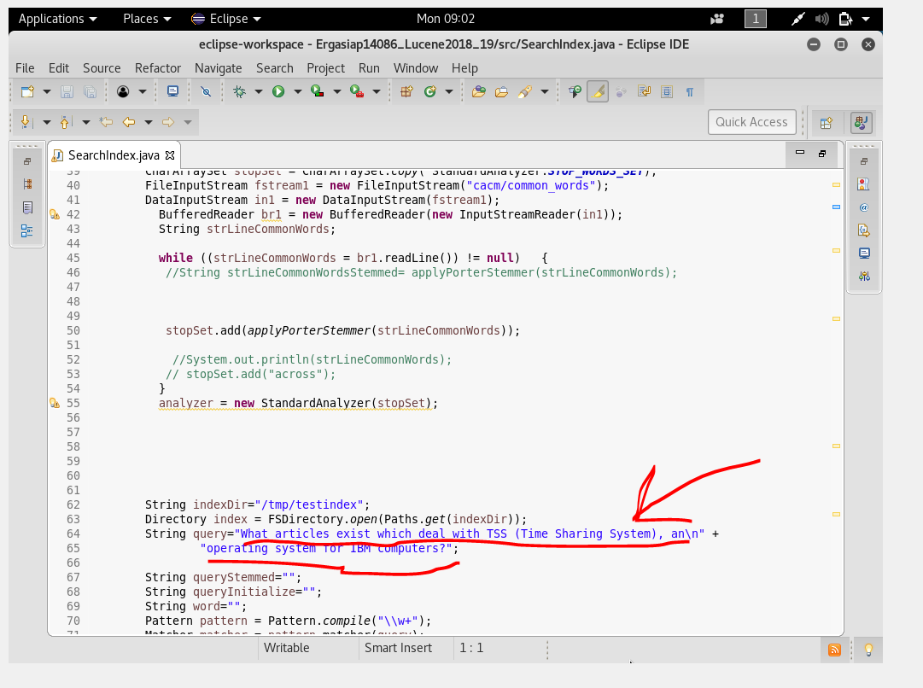

For another search change this variable.

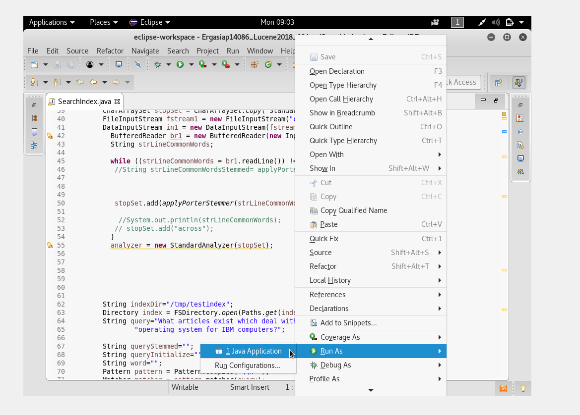

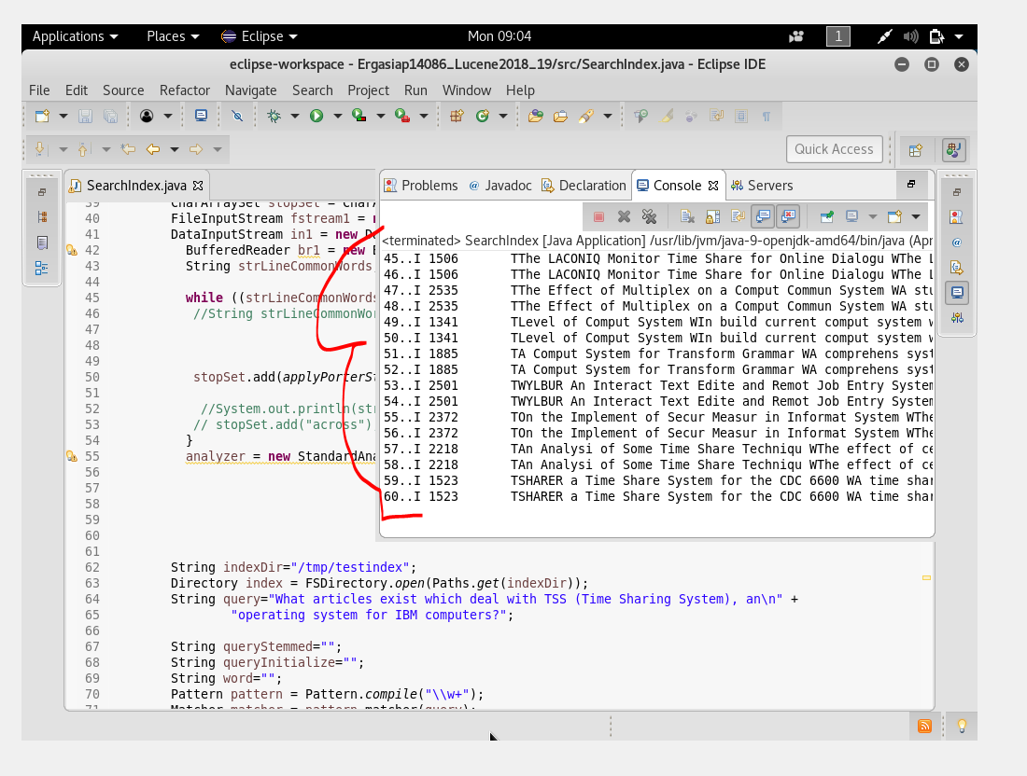

Return in Console all the relevant texts.