Run MongoDB as a Docker Container:

docker run -d -p 27017:27017 --name MONGO_CONTAINER mongo:latest

Start the MongoDB shell:

docker exec -it MONGO_CONTAINER bash

mongosh command

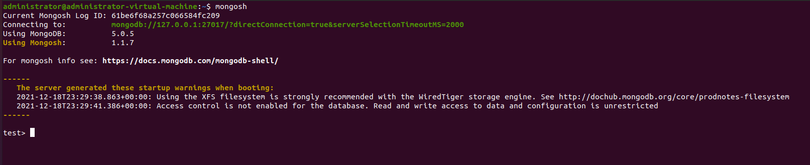
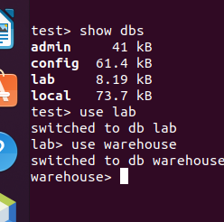
Show dbs → we select the database.

Create and use a new database warehouse.

Create a new collection named Items.
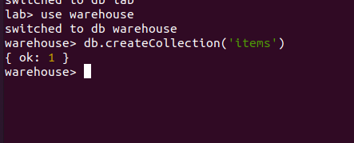

Add a document in the colection:
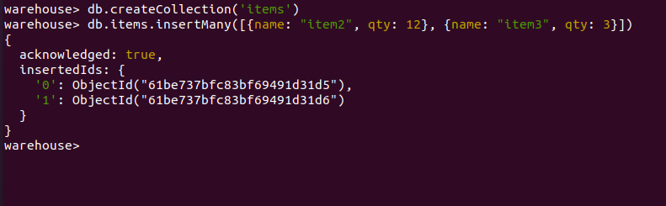

Show all documents in the collection:
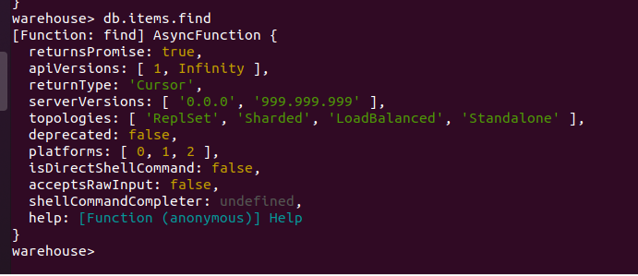

Find a single document by name:
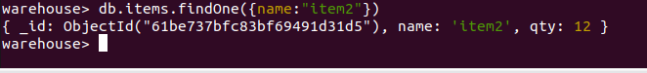

Import the books data set.
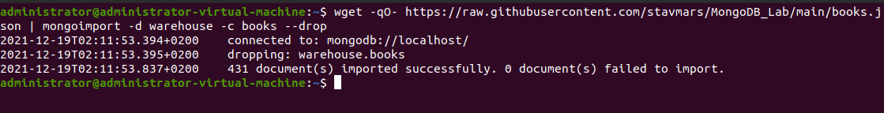

db.books.find().limit(1)

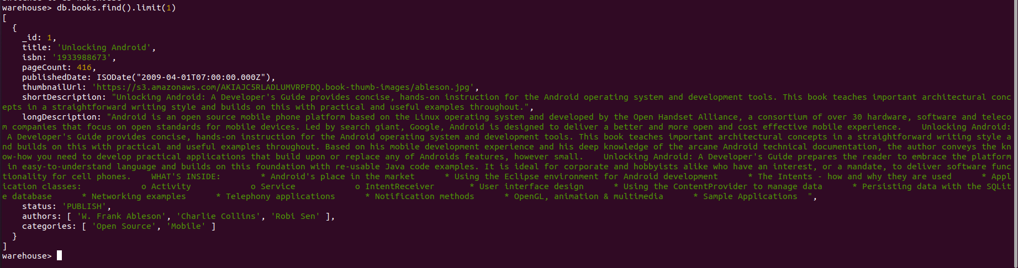

To find the books with a number of pages that is greater or equal than 400 but less than 500, sort them by their publication date descending and print their titles, page
counts and date they were published
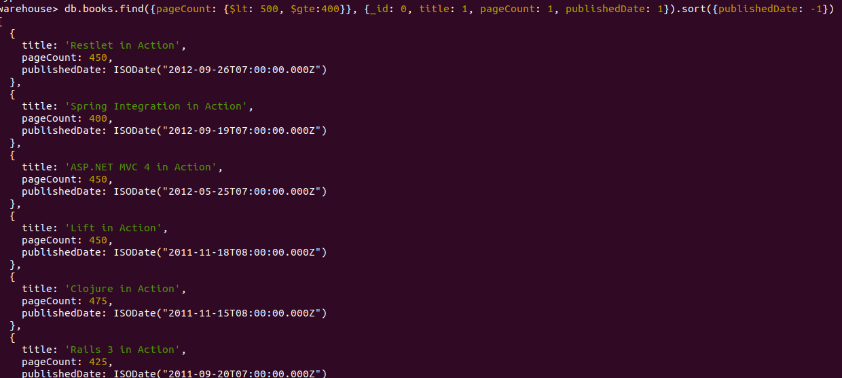

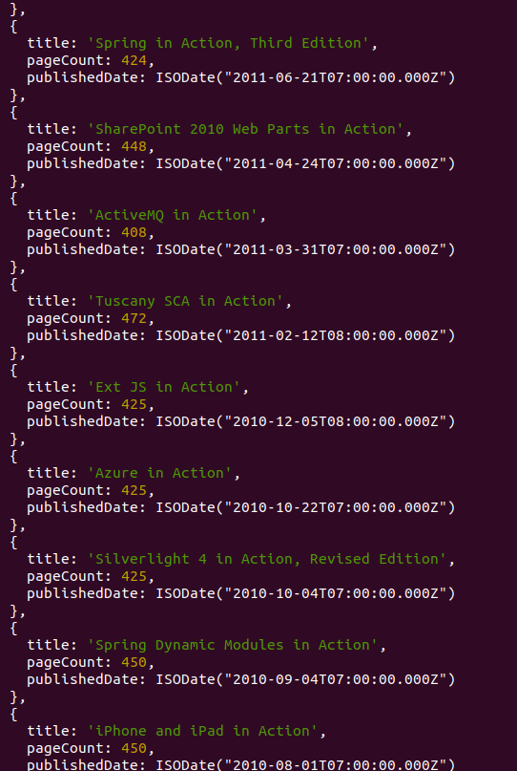

To find all Python books and print their titles and categories we run the following query

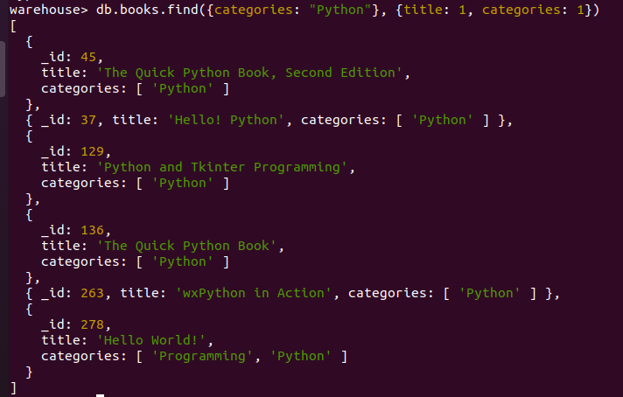

Compare the results of the query above with the following one:

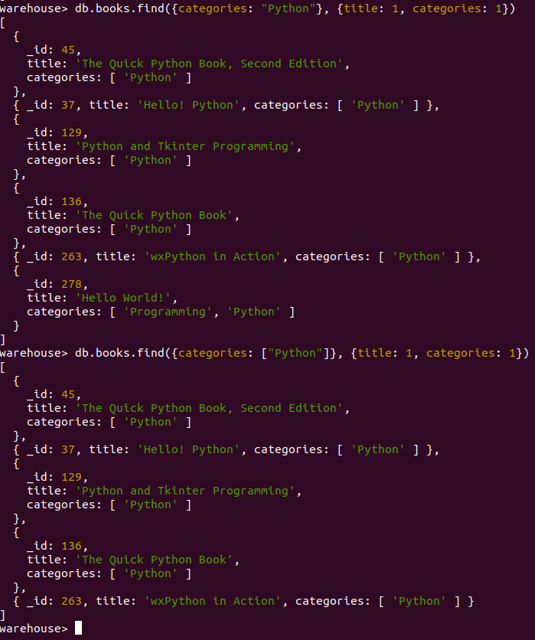

The difference is that in the latter it doesn’t check for the “python” word inside a list.

To find all books that are either about Python or PHP run:

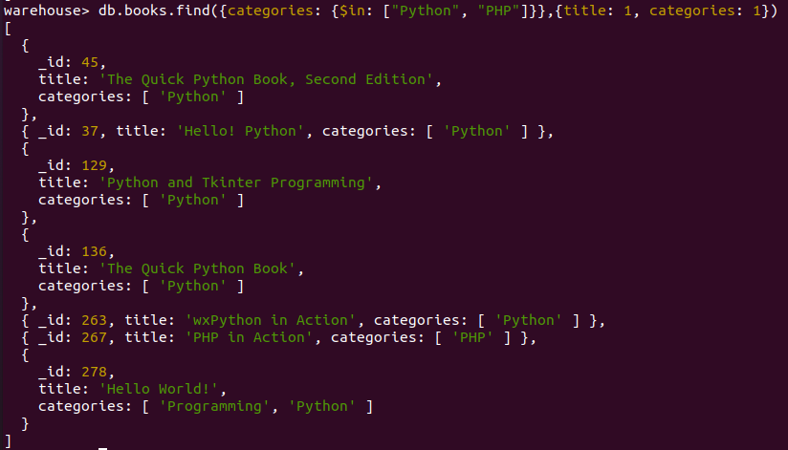
Find the top 5 Python books with the most pages and print their titles, categories and page counts.
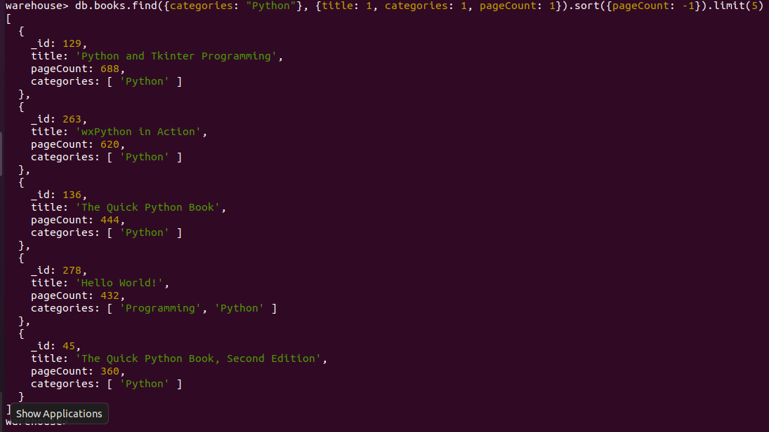

Find the books that have as author either "Marc Harter" or "Alex Holmes" and print their titles, authors and categories.
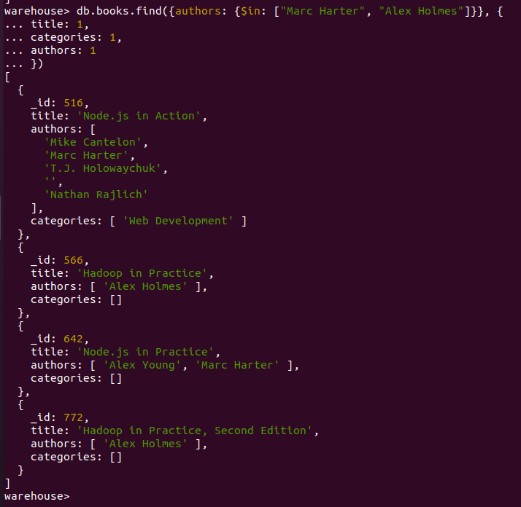

Indexing Documents

To see the indexes available for a collection run:
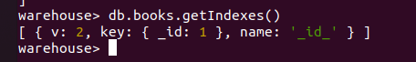

To see how indexing helps query performance run the following query and examine its query plans and execution statistics using explain:
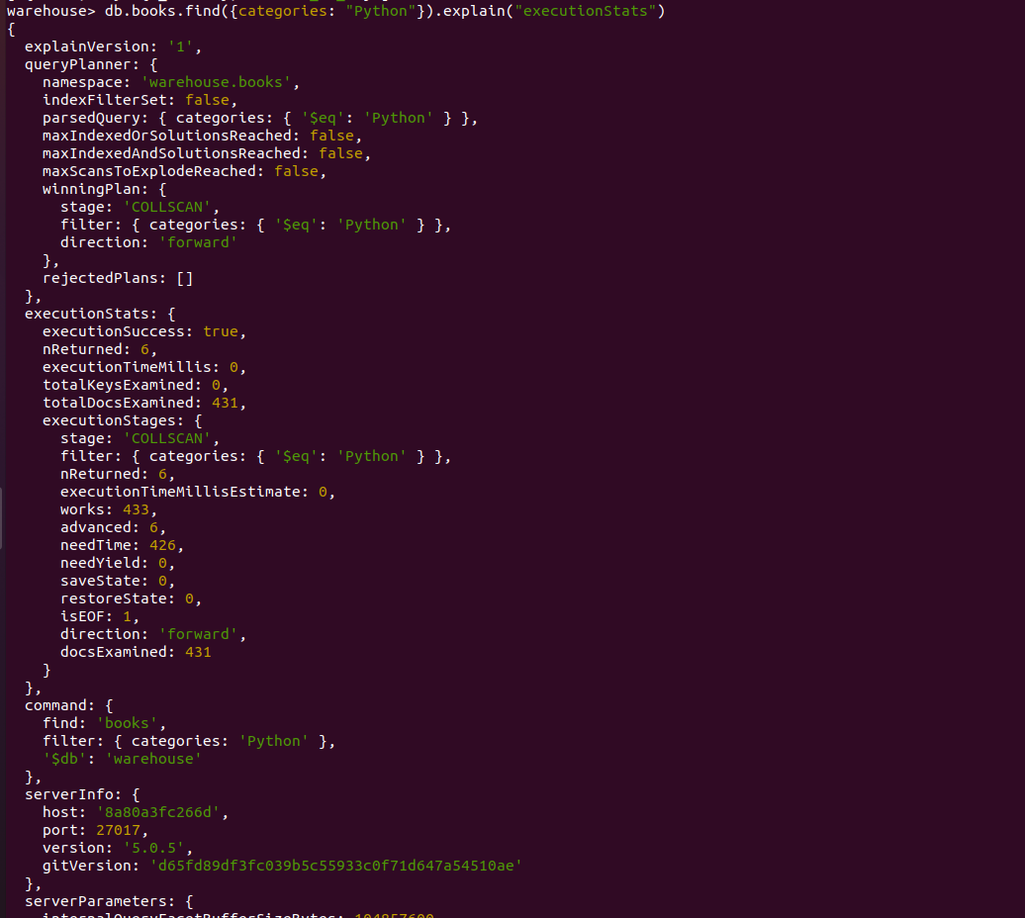

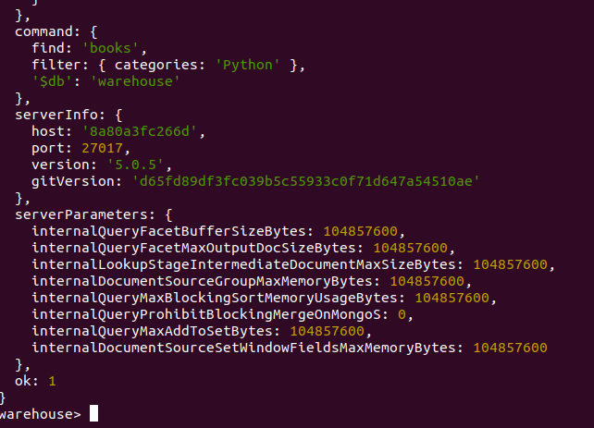
Now add an index on the field categories:
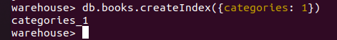

Now run the same query again and compare the execution stats and query plans followed.
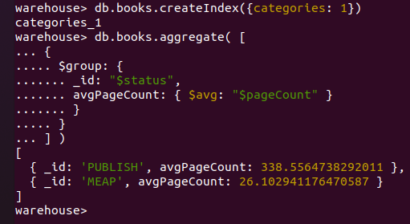

Expand the example above in order to also compute the minimum and maximum number of pages.
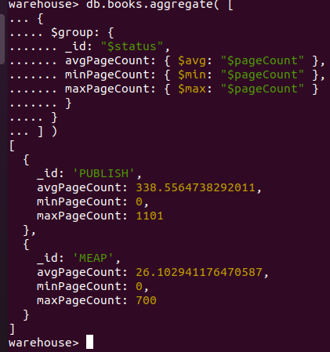

Now we compute the number of books in the database per year. For this we can use the $year operator and add to each document a year field before the $group stage:
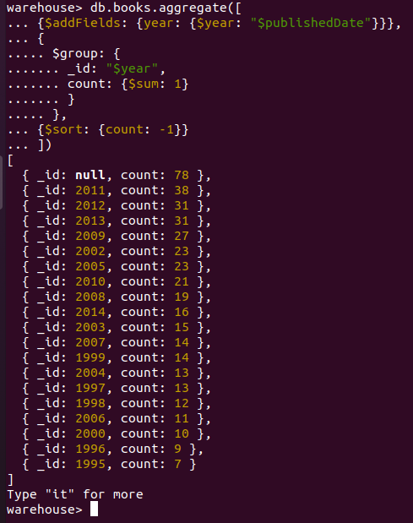

To exclude books with no publication data available, we add a $match aggregation stage:
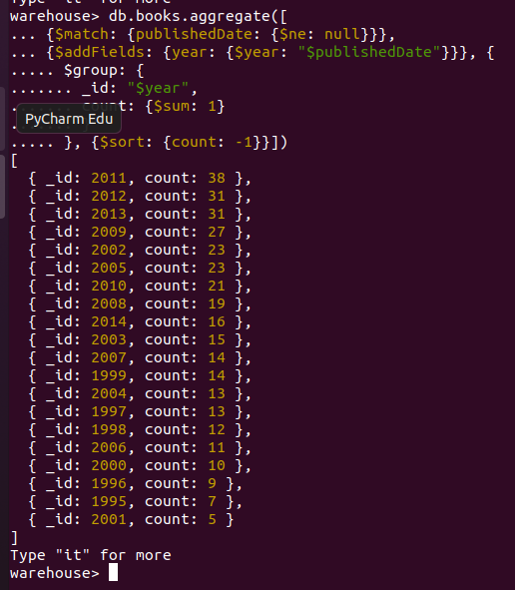

Expand the query above to find the number of books per year and status.

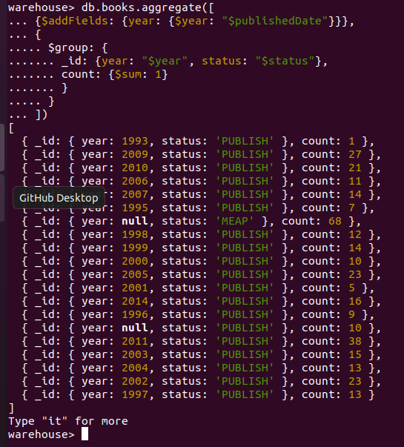

In the following example, we want to find the average number of pages per book category for all books with status="PUBLISH", and sort the results by the average
page count. Remember that categories is an array field with possibly more than one values for every book.

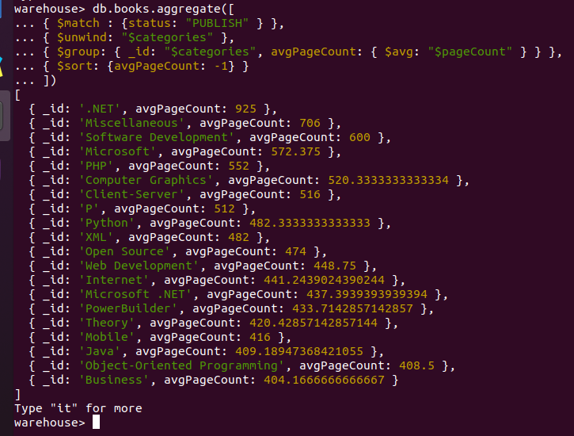

Find the 5 authors with the most books, and print the number of books, as well as the average number of pages for each one.

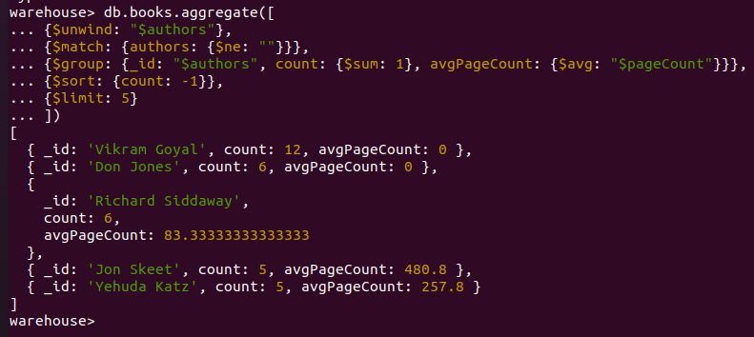

Next, we need to find the average number of authors for all books. We use the $size operator which counts and returns the total number of items in an array.
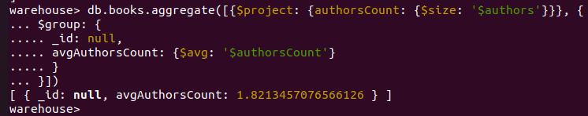
In the same fashion, find the average number of categories for every book.
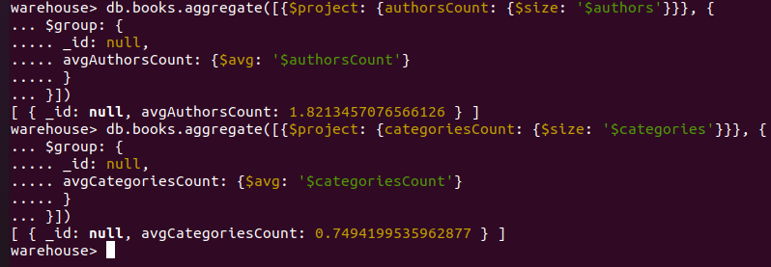

If we wish to find for every author the years that they published a book, we can run the following:

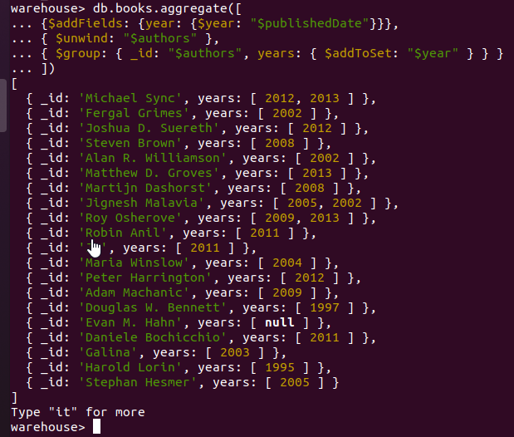

Now, find all the years that there were publications for every category of book:

