# Lab/Activity 4

Course Learning Outcome: CLO3- Create interactive web pages using current standards-compliant client-side web technologies.

Chapters: Chapter 4

Cognitive Levels:APPLY

Aim: The student should be able to:

* Write simple JavaScript programs
* Use input and output statements
* Learn basic memory concepts
* Use arithmetic operators and their precedence
* Learn basic problem solving techniques
* Use the if and if…else, selection statements to choose among alternative actions
* Use the while repetition statement to execute statements repeatedly
* Implement counter-controlled repetition statements and sentinel-controlled repetition
* Use the increment, decrement and assignment operators
* Learn essentials of counter controlled repetition
* Use the for and do…while repetition statements to execute statements in a program repeatedly
* Perform multiple selection using the switch selection statement
* Use the break and continue program control statements
* Use the logical or operators to make decisions
* Use Arrays

Tools: Text Editor, Brackets, Notepad++, Web Browser

Document Revision Control:1.0

|  |  |  |  |  |
| --- | --- | --- | --- | --- |
| Version | Author | Effective Date | Change Description | DRC No |

# [MCQ- APPLY]

1. Which of the following keywords is needed to define a variable in JavaScript?

|  |
| --- |
| 1. var 2. let 3. variable 4. function 5. Which of the following methods is used to access HTML elements using JavaScript? 6. getElementById 7. getElementId 8. getElement 9. getIdByElement |

# Exercise 1- APPLY

*Java Script - Input, Output and Variables –*

*Attempt Exercise6.html from the Lecture and then browse to see the output. See additional tasks.*

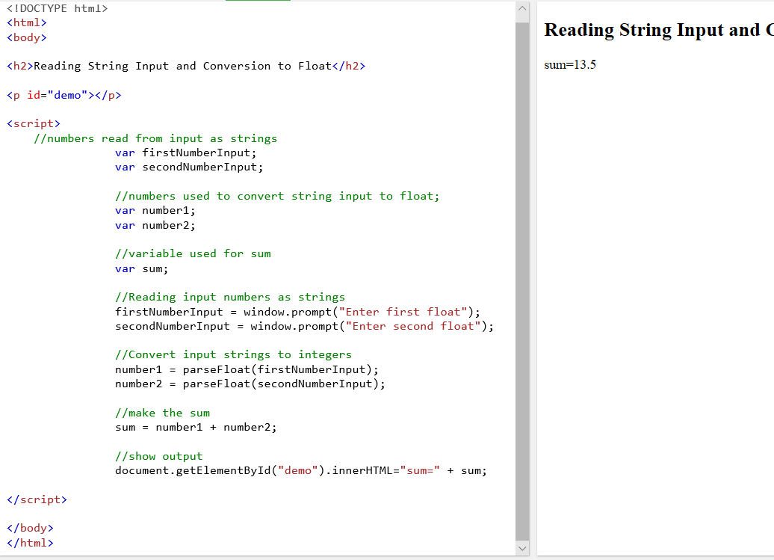

1. *Input a third number into your program*
2. *Subtract this third number from the sum of the other 2 numbers*
3. *Test your output.*

# Exercise 2- APPLY

*JavaScript Control Structures Selection*

*Attempt Exercise8.html from the Lecture and then browse to see the output. See additional tasks.*

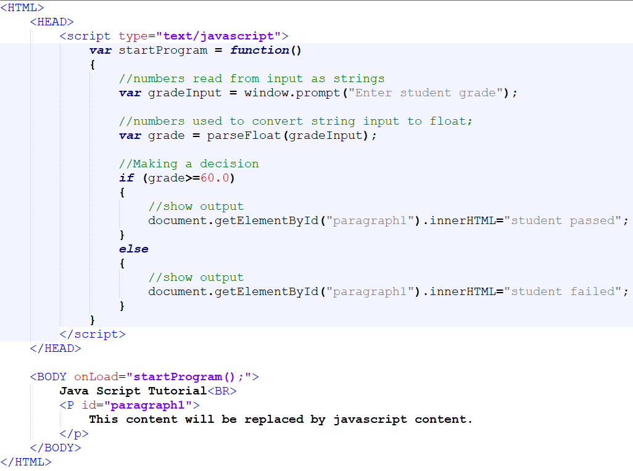

Alter the code to do the following tasks:

1. The first conditional if statement should check if the student grade is less than 60. If less than 60 then the output message should read **(“Apply for a Make up”)**
2. Alter the else statement output to:

**“Well done you have passed”**

1. *Test your output.*

# Exercise 3- APPLY

*JavaScript* ***Control Structures Repetition Statements – For Loop***

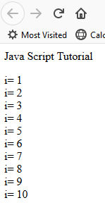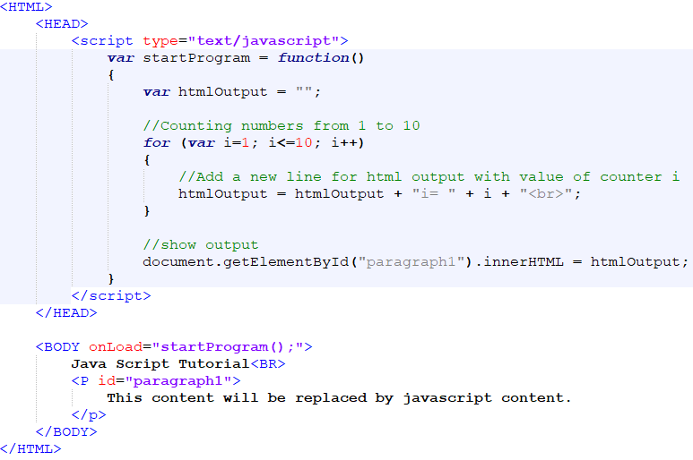*Attempt* ***Exercise11.html*** *from the Lecture and then browse to see the output. See additional tasks.*

Alter the code to do the following tasks:

1. Alter the for loop so that it counts from 2 to 20
2. **Alter the increment so that it increases by 2 each time around the loop**
3. *Test your output.*

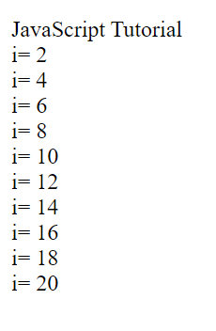

# Exercise 4 - APPLY

*JavaScript* ***Control Structures Repetition Statements – While Loop***

*Attempt* ***Exercise15.html*** *from the Lecture and then browse to see the output. See additional tasks.*

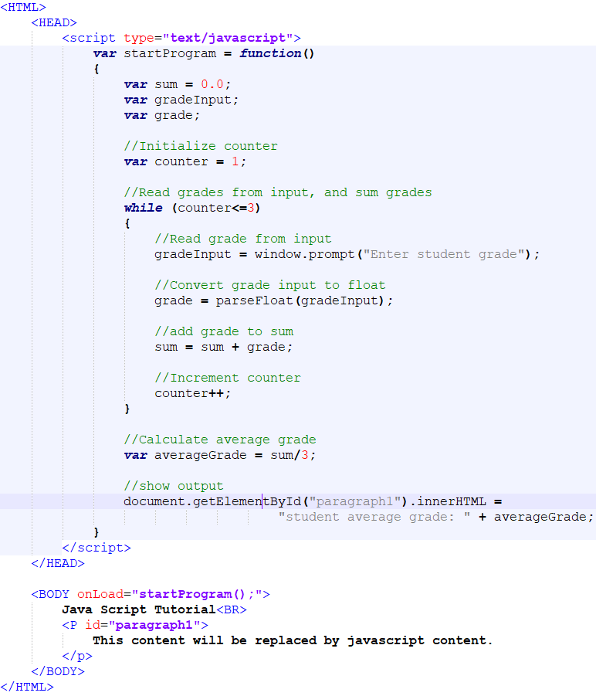

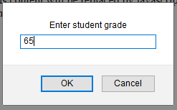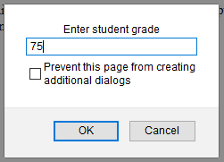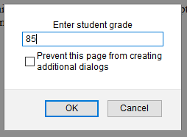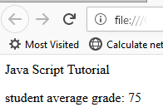

Alter the code to do the following tasks:

1. Alter the code so that repeats the loop 10 times. Set a variable to hold the constant number of students in the class as 10.
2. Output the average of grades for all students in the class.
3. *Test your output.*

# Exercise 5 – APPLY

*JavaScript***– ARRAYS**

*Attempt* ***Exercise22.html*** *from the Lecture and then browse to see the output. Use the code below. See additional tasks to be completed.*

1. *Add another 2 makes of cars to the array called* ***myArray***
2. *Add additional elements (makes of cars) using methods 1, 2 and 3.*
3. *Attempt to add another element(make of car) into your array using splice*

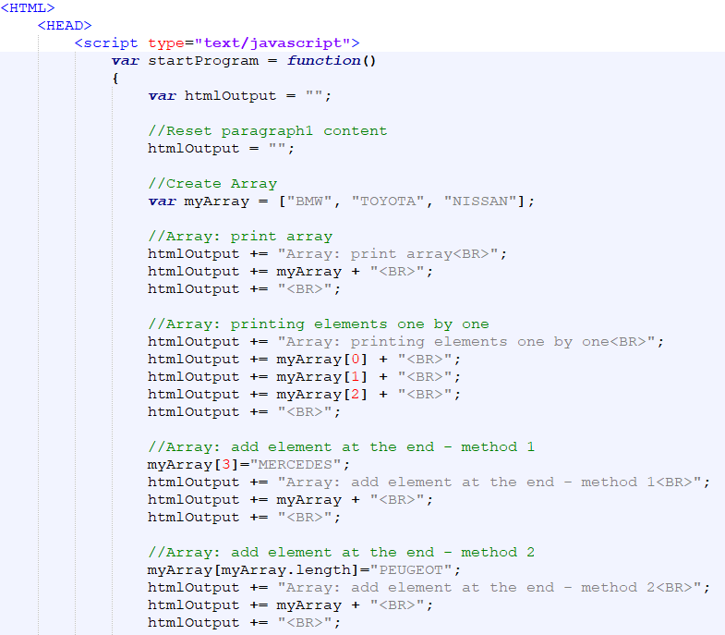

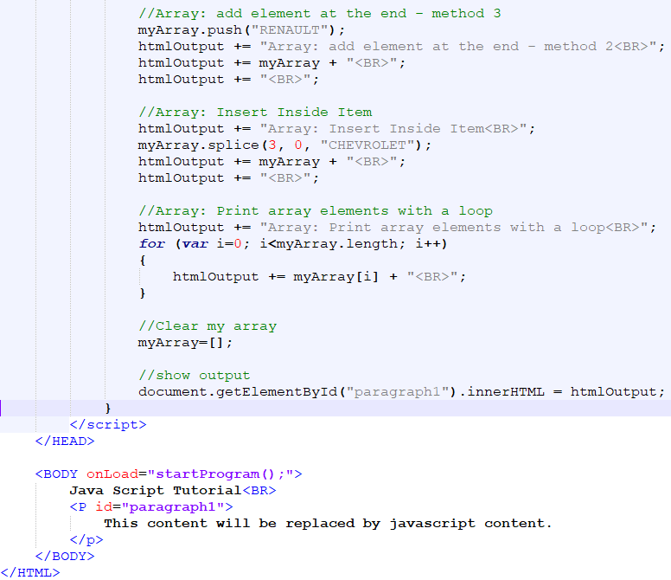

# Exercise 6 – APPLY - HOMEWORK - ADVANCED

**Problem Statement - Using While Loop**

A college offers a course that prepares students for the state licensing exam for real estate brokers.

Last year, 10 of the students who completed this course took the licensing exam. Naturally, the college wants to know how well its students performed. You’ve been asked to write a script to summarize the results. You’ve been given a list of these 10 students. Next to each name is written a 1 if the student passed the exam and a 2 if the student failed.

Your script should analyze the results of the exam as follows:

* Input each test result.
* Display the message enter result on the screen each time the script requests another test result
* Count the number of test results of each type
* Display a summary of test results indicating the number of students who passed and the number of students who failed
* If more than eight students passed the exam, print the message “Bonus to instructor!”
* Create a web page homework.html", type the code below, and test it in the browser.

