# CIA2503: Web Applications Development

# Lab/Activity 6

Course Learning Outcome: CLO3- Create interactive web pages using current standards-compliant client-side web technologies

Chapters: Chapter 6

Cognitive Levels: APPLY

Aim: The student should be able to:

* Use JavaScript and the W3C Document Object Model to create dynamic web pages
* Use the concept of the DOM nodes and DOM trees
* Traverse, edit and modify elements in a HTML5 document
* Change the CSS styles dynamically

Tools: Text Editor, Notepad++, Brackets, Web Browser

Document Revision Control: 001

# Exercise 1- APPLY

Test the code from the Chapter 6 Lecture as seen below to change the content (innerHTML) of the HTML elements. The heading will be altered by accessing the innerHTML for element (id = “header”) in the Document.

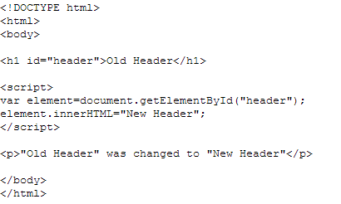

# Exercise 2- APPLY

Test the code from the Chapter 6 Lecture as seen below to change the content (innerHTML) of the HTML elements by appending content to the HTML document body.

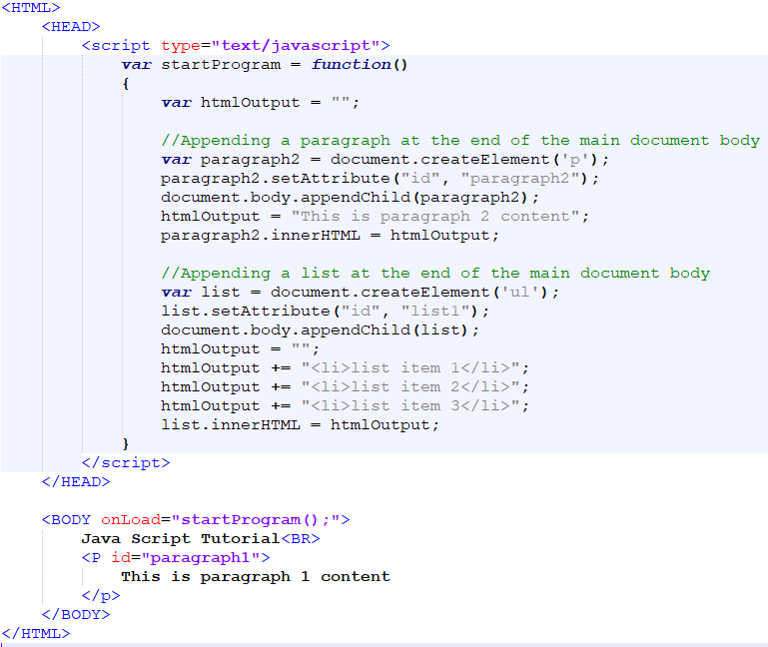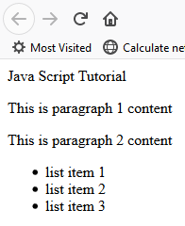

# Exercise 3 - APPLY

Use the DOM to alter the CSS style of the HTML elements using JavaScript. Check the difference in the style for the “p2” element which has been updated dynamically. Element “p1” will remain unchanged. Test the code from the Chapter 6 Lecture as shown below.

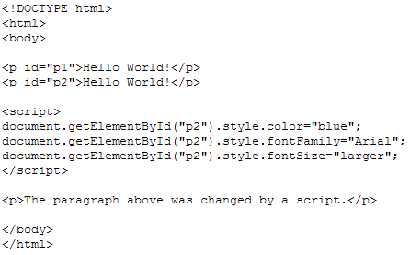

# Exercise 4 – APPLY – HOMEWORK - Advanced

Complete exercise from Chapter 6 Lecture – Slide 19 to 22